CPE434-2021

Homework Chapter 11 – Mass Storage

Watch this video for starters on error correcting codes: <https://www.youtube.com/watch?v=X8jsijhllIA&t=0s>

1. If you wanted to store data on a disk in 512-byte blocks with the ability to detect 2 errors and correct 1 error how many extra bits would be required? Show your calculations.
2. We have a disk drive with 3000 cylinders, which are numbered 0 to 2999. The drive is currently serving a request at cylinder 93, and the previous request was at cylinder 125. The queue of pending requests, in FIFO order, is: 45, 1950, 912, 1090, 130, 10, 2250, 130 Starting from the current head position, what is the total distance (in cylinders) that the disk arm moves to satisfy all the pending requests, for each of the following disk-scheduling algorithms? FCFS SSTF SCAN LOOK C-SCAN
3. FOR GRADUATE STUDENTS ONLY

CAUTION: if you have an SSD drive, I strongly suggest you run this on a moving media drive. In the past my students have worn out SD cards (which do not have wear leveling as discussed in class) but probably are a load on ssd drives. If you have to run this test on ssd drives then I strongly suggest backing them up. If you don’t have a moving media disk on your personal computer, I suggest finding one to run the tests on. DO NOT RUN THIS ON BLACKHAWK, ECHO, OR ANY OF THE ODROIDS OR ANY OTHER UAH COMPUTER UNLESS I HAVE APPROVED IT. VIOLATORS WILL BE PUNISHED.

There is a performance analysis tool called iozone. It produces excel files that can be plotted similar to this figure.

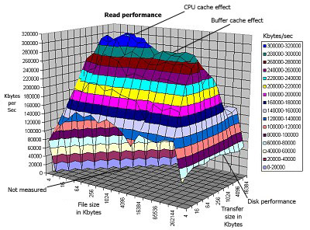

Run this tool on your computer and identify where and why the cpu cache and buffer cache affects appear.