Austin Brown

CPE 434-01

3/29/2021

Lab 11 Part 2

**PreTask**

Limit login attempts, encryption, and multi-factor authentication will all work.

**Subtask 1**

1.

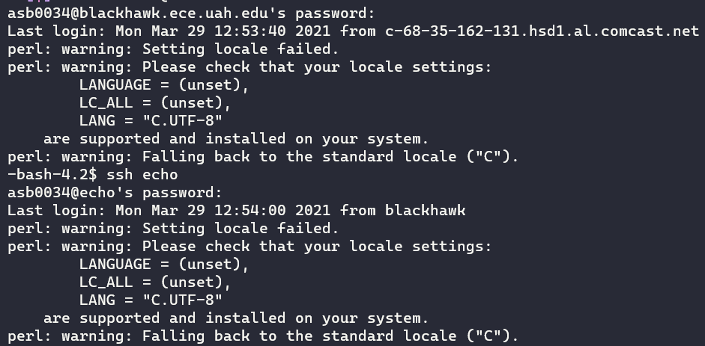

2.

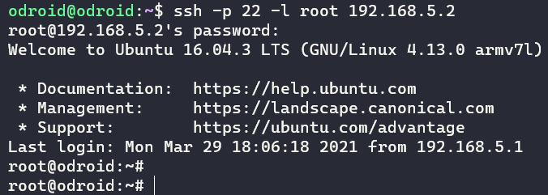

3.

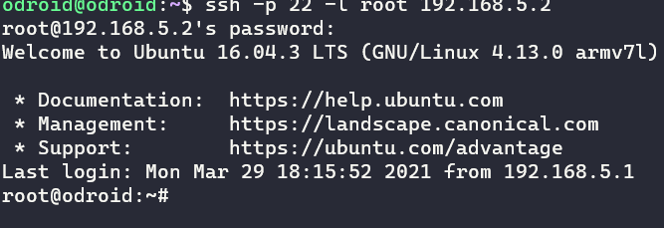

4.

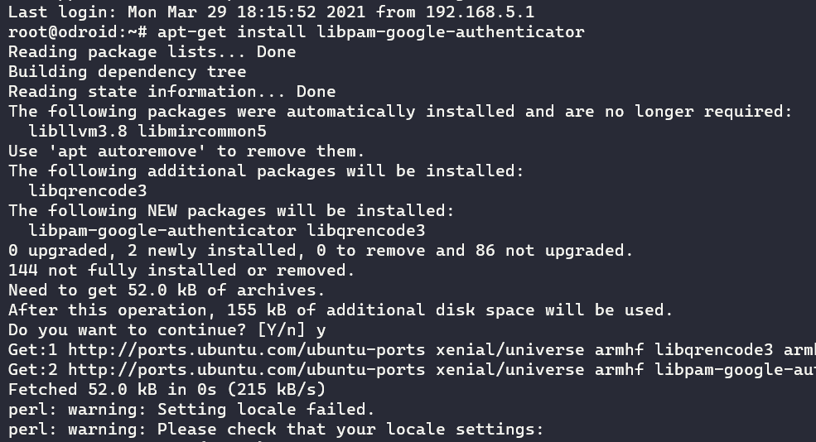

5.

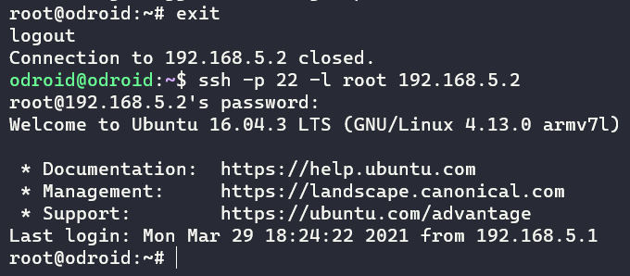

6.

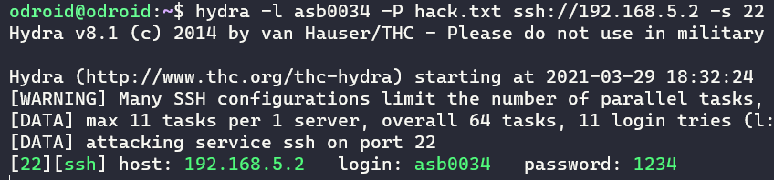

7. I have not changed the password.

8. Installed Authenticator

9.

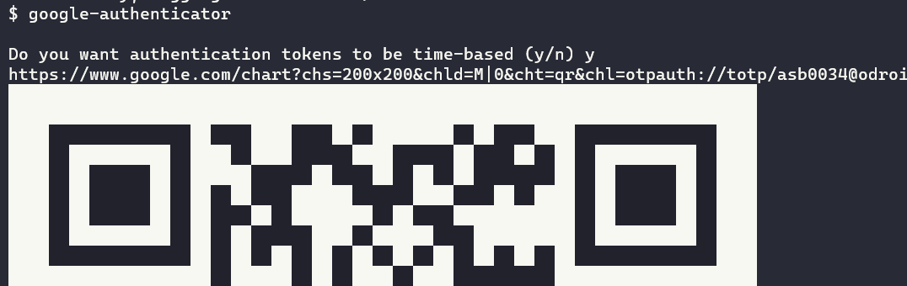

10.

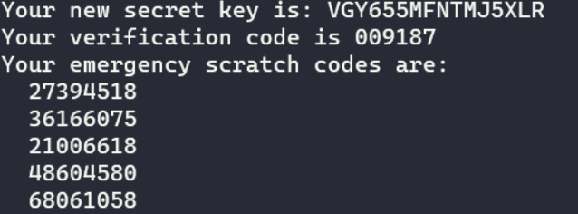

11.

Update file – save info for later

Prevent token from being used more than once – prevent man in the middle

Increase time token is valid – account for latency

Limit login attempts – prevent brute forcing

12.

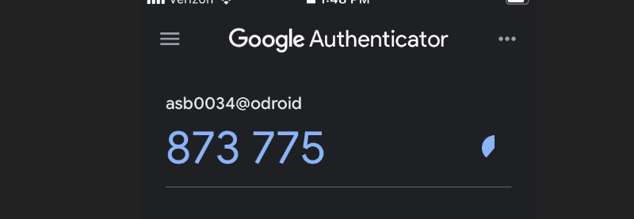

15.

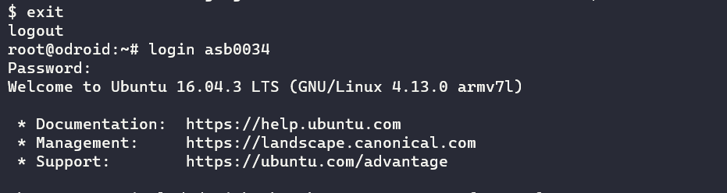

No difference. I could login.

16.

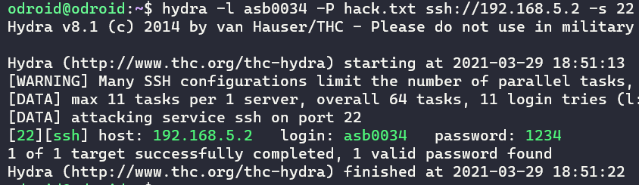

I could get into the account. This is likely because 2FA is not configured yet.

17. Hydra is not installed on guest.

**Subtask 3**

19.

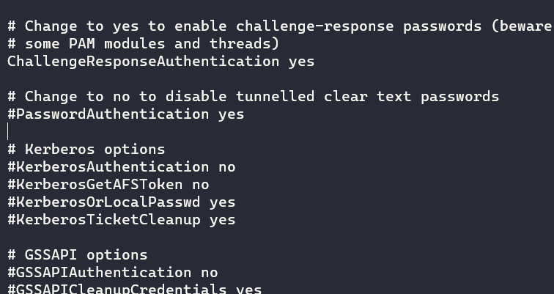

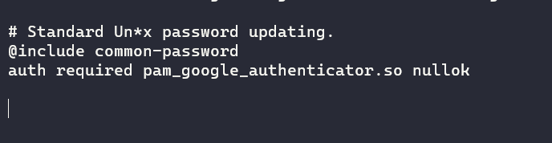

20.

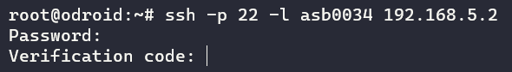

I was not allowed to login until I entered the code from google authenticator.

22.

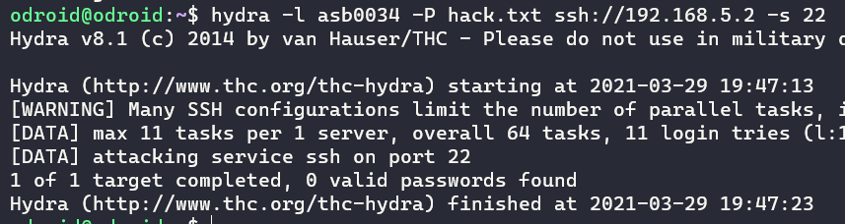

The attack failed because hydra didn’t know the key.

**Tampering**

23.

NTP servers are used to sync times across various systems.

24.

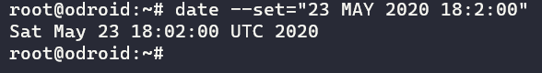



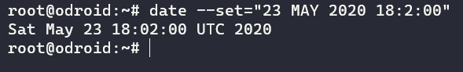

The times are different.

25.

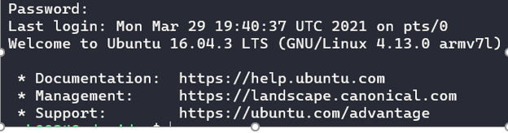

I can login. The date corrects itself.

26

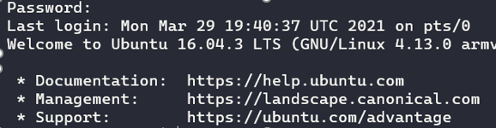

27.

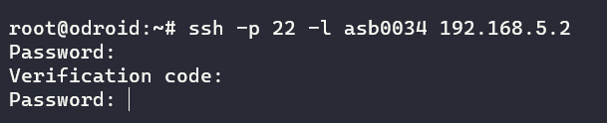

I cannot log in. Entering a verification code does nothing.

**Finishing**

28.

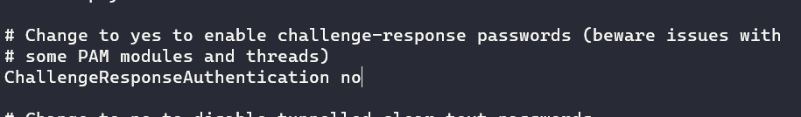

29.

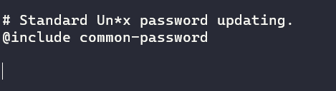

30.

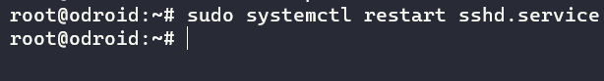

31.

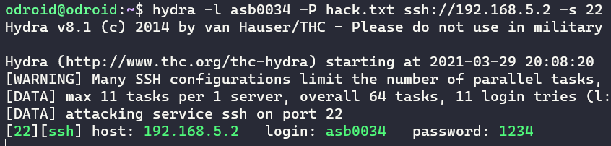

32.