Austin Brown

CPE 434-01

4/1/2021

Lab 12

**Introduction**

Compiler – used to translate a program from a high-level language to an assembly language. It checks for syntax errors.

Assembler – Translates assembly language into relocatable machine code. This is stored in an object file.

Linker – Takes all the object files and combines them to for an executable. It does this by combining all of the object files that are needed.

**Assignment**

2.

It supports 4 UART serial ports.

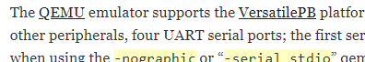

UARTDR is used to transmit and receive.



3.

|  |
| --- |
| volatile unsigned int * const UART0DR = (unsigned int *)0x101f1000;    void print_uart0(const char *s) {   while(*s != '\0') { /* Loop until end of string */   *UART0DR = (unsigned int)(*s); /* Transmit char */   s++; /* Next char */   }  }    void c_entry() {   print_uart0("Hello world!\n");  } |



4.



5.



6.



7.

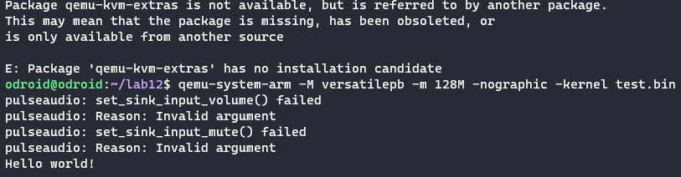

8.

The first step is to run arm-none-eabi-gcc -c -mcpu=arm926ej-s -g test.c -o test.o. This generates an object file of test.c. The next step is to run the same command but with startup.s. This checks for errors and assembles the files into object code.

The linker takes the code that I have written and combines it all together. This includes precompiled library code. The final command creates another executable of a different format.

8.2

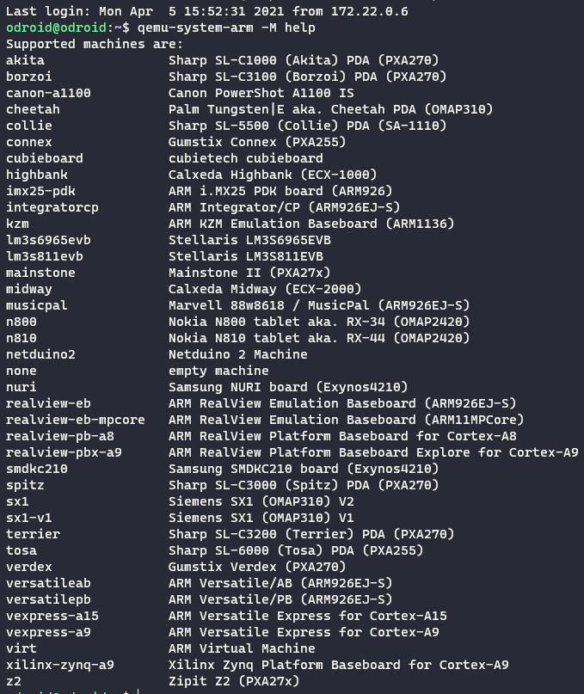

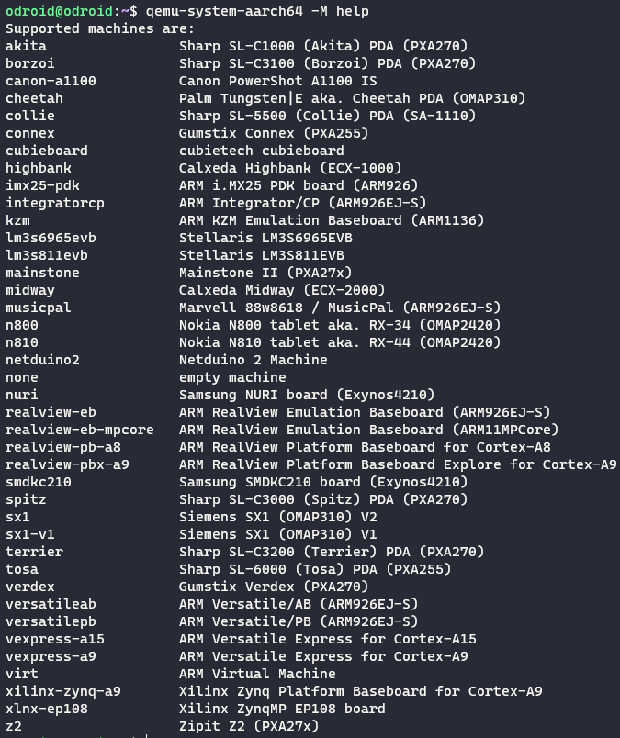

9.

Emulation requires a software bridge. VMs can access hardware directly. Because of this, emulators are faster. VMs are more completed to implement than an emulator is.

10.

Yes. Guest machines can run hypervisors, but they cannot perform full virtualization because they do not have full access to the system’s hardware.