Austin Brown

CPE 434-01

4/12/2021

Lab 13

**Assignment 1**

* Ubuntu 16.04.3 LTS
* 4.9.61+ - The kernel version is 4.
* Lscpu says that there are 8 processors on this machine. Their model number is ARMv7 Processor rev 3 (v7l)

**Assignment 2**

**1.**

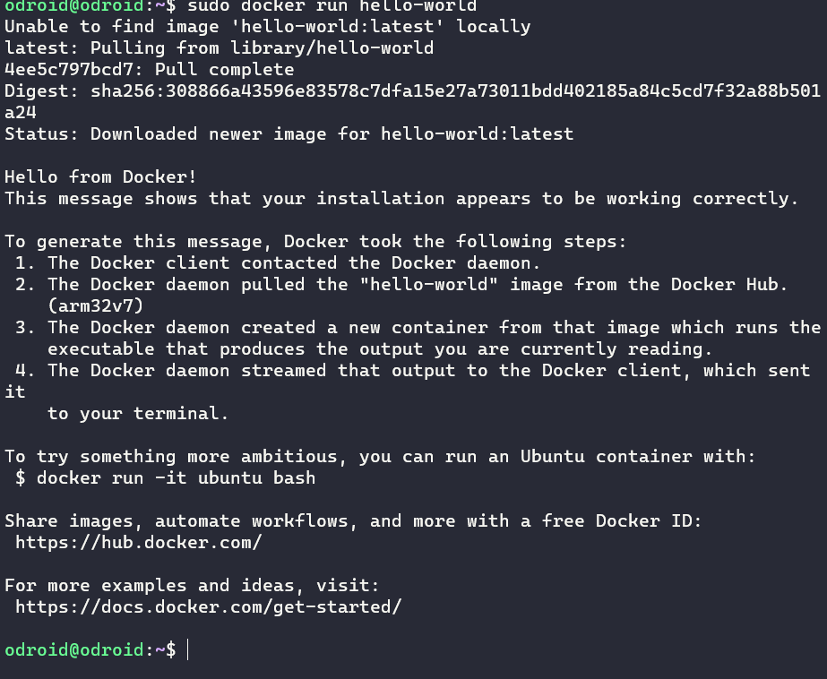

**2.**

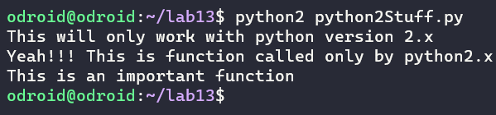

**3.**

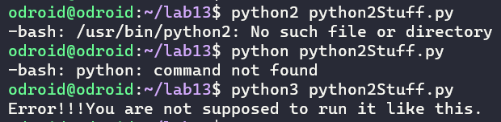

**Assignment 3**

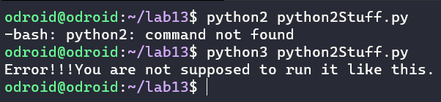

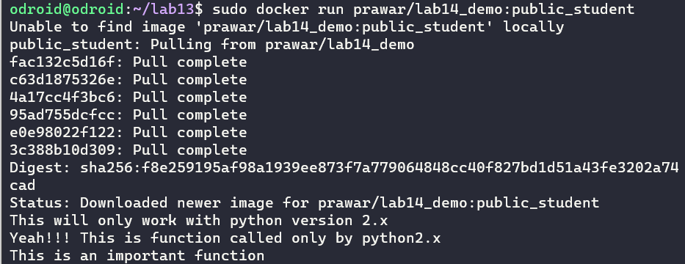

**Assignment 5**

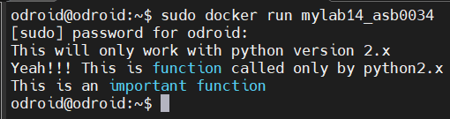

**Appendix**

|  |
| --- |
| **import sys**  **def python2_stuff():**  **print("Yeah!!! This is function called only by python2.x")**  **print("This is an important function")**  **if sys.version_info[0]<3:**  **print("This will only work with python version 2.x")**  **python2_stuff()**  **else:**  **print("Error!!!You are not supposed to run it like this.")** |