**1.** 0x00300000. The normal image base is 0x00400000.

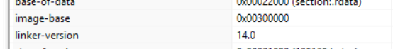

**2.** 135168 bytes

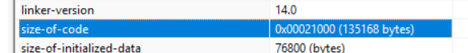

**3.** 0x00001000 PE Studio cannot tell what section it is in. This is likely because it is in section 1337 which is not standard.



**4.** 1337, .rdata, .data, .tls, .reloc. 1337 is not a normal section



**5.** It is some sort of Trojan. When it is run, it drops malicious code into the computer. Virus Total picks up several signatures that indicate that it is a trojan. There is also a file embedded into the main file.



