**Part 1: Decompose Traffic Light System**

1. **What are the actuators?**

The actuators are the LEDs. This includes the three thar are on the breadboard as well as the other three.

1. **What are the sensors?**

N/A

1. **What addressable variables are implemented in the ladder logic?**

|  |  |  |
| --- | --- | --- |
| Name | Type | Location |
| red_ns | BOOL | %QX100.0 |
| yellow_ns | BOOL | %QX100.1 |
| green_ns | BOOL | %QX100.2 |
| red_ew | BOOL | %QX0.0 |
| yellow_ew | BOOL | %QX0.1 |
| green_ew | BOOL | %QX0.1 |
| time_red_ns | INT | %MW0 |
| time_green_ns | INT | %MW2 |
| time_yellow_ns | INT | %MW1 |
| time_red_ew | INT | %MW3 |
| time_green_ew | INT | %MW5 |
| time_yellow_ew | INT | %MW4 |

1. **What data sources are in the HMI?**

|  |  |  |
| --- | --- | --- |
| Name | Type | Offset |
| red_ns | Coil Status | 800 |
| yellow_ns | Coil Status | 801 |
| green_ns | Coil Status | 802 |
| red_ew | Coil Status | 0 |
| yellow_ew | Coil Status | 1 |
| green_ew | Coil Status | 2 |
| time_red_ns | Holding Register | 1024 |
| time_green_ns | Holding Register | 1026 |
| time_yellow_ns | Holding Register | 1025 |
| time_red_ew | Holding Register | 1027 |
| time_green_ew | Holding Register | 1029 |
| time_yellow_ew | Holding Register | 1028 |

1. **What are the wired connections in the network module? (e.g.: PLC to Actuator XYZ)**

The PLC connects to the HMI via Modbus. The PLC connects to red_ns, green_ns, and yellow_ns via a cyber physical link. This is connecting to the Arduino which connects to the breadboard.

**Part 2: Plot the Data Flow Diagram (DFD)**

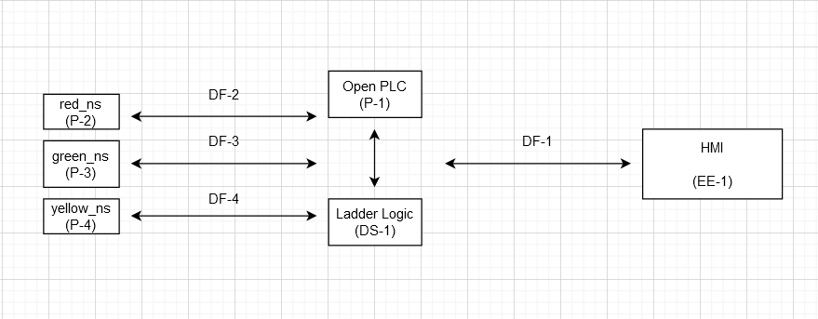

**Part 3: List the Threat Consequences (TC)**

|  |  |  |
| --- | --- | --- |
| Code | Description | Hazard |
| TC-1 | Delay in LED changing | H1, H3, H4 |
| TC-2 | Delay in HMI updating | H4 |
| TC-3 | LEDs on when they shouldn’t be | H1, H3, H4 |
| TC-4 | PLC and Arduino lose connection | H1, H2, H3, H4 |
| TC-5 | HMI and PLC lose connection | H4 |
| TC-6 | No LEDs on at all | H1, H4 |
| TC-7 | Arduino and LEDs lose connection | H1, H2, H3, H4 |
| TC-8 | False values displayed on HMI | H4 |

**Part 4: STRIDE Modeling**

|  |  |  |
| --- | --- | --- |
| **STRIDE** | **Data Flow Element** | **Threat Consequences** |
| **S** | **DF-1** | TC-5, TC-1, TC-3, TC-6 |
| **S** | **DF-2** | **TC-7, TC-4** |
| **S** | **DF-3** | **TC-7, TC-4** |
| **S** | **DF-4** | **TC-7, TC-4** |
| **T** | **EE-1** | **TC-5, TC-8, TC-2** |
| **T** | **P-1** | **TC-4, TC-5, TC-6, TC-7, TC-8** |
| **T** | **P-2** | **TC-4, TC-5, TC-6, TC-7, TC-8** |
| **T** | **P-3** | **TC-4, TC-5, TC-6, TC-7, TC-8** |
| **T** | **P-4** | **TC-4, TC-5, TC-6, TC-7, TC-8** |
| **T** | **DF-1** | **TC-5, TC-2, TC-8** |
| **T** | **DF-2** | **TC-5, TC-6** |
| **T** | **DF-3** | **TC-5, TC-6** |
| **T** | **DF-4** | **TC-5, TC-6** |
| **T** | **DS-1** | **TC-4, TC-5, TC-6, TC-7, TC-8** |
| **R** | **EE-1** | **TC-5, TC-8** |
| **R** | **P-1** | **TC-4, TC-5, TC-6, TC-7, TC-8** |
| **I** | **EE-1** | **TC-5, TC-8** |
| **I** | **P-1** | **TC-4, TC-1, TC-2, TC-9, TC-10** |
| **D** | **DF-1** | **TC-5, TC-1, TC-8, TC-2** |
| **D** | **DF-2** | **TC-5, TC-1, TC-8, TC-2** |
| **D** | **DF-3** | **TC-5, TC-1, TC-8, TC-2** |
| **D** | **DF-4** | **TC-5, TC-1, TC-8, TC-2** |
| **E** | **EE-1** | **TC-4** |
| **E** | **P-1** | **TC-1, TC-2, TC-3,TC-4, TC-5, TC-6, TC-7** |

**Part 5: Define Intrusion Scenario**

One scenario is the attacker gaining access by trying to find the server with a scanner. They could then try to login with the default credentials. The server is running on port 502, so it should be easy to find.

**Part 6: List Known Exploits**

|  |  |  |  |
| --- | --- | --- | --- |
| Compromised Component | Exploit | STRIDE | Description |
| DF-1, EE-1 | MiTM | S, E | Spoof values of the counter |
| EE-1 | Default credentials | E, T | Login using the default credentials |
| DF-1, EE-1 | DoS | D | Flood the server with packets causing loss of service |
| DF-1, EE-1 | MiTM | E, D | Packets could be dropped |

**Part 7: List Attackers’ Goals**

Goal 1: Cause financial loss by burning out the LEDs.

Goal 2: Cause an accident to occur by causing the LEDs to be on at the wrong time.

Goal 3: Cause an accident by making a delay .

**Part 8: Construct Attack Tree**

