University of Alabama in Huntsville

EE315 – Spring 2017

Independent Design Project

Austin Brown

Dr. William Bishop

Intro to Electronic Analysis & Design – EE315

Submission Date: November 21 2019

**Intro:**

The purpose of this project is to take 120 volts ac at 60 hz and convert it to 15 volts plus or minus 1. This voltage should be delivered across a 2500-ohm load resistor. It also cannot have a ripple voltage exceeding 2%. This was accomplished using a transformer, full wave rectifier, and a Zener diode. Computations were done by hand. Multisim was used to verify my calculations. The circuit also has a fuse to protect from surges.

**Hand Computations:**

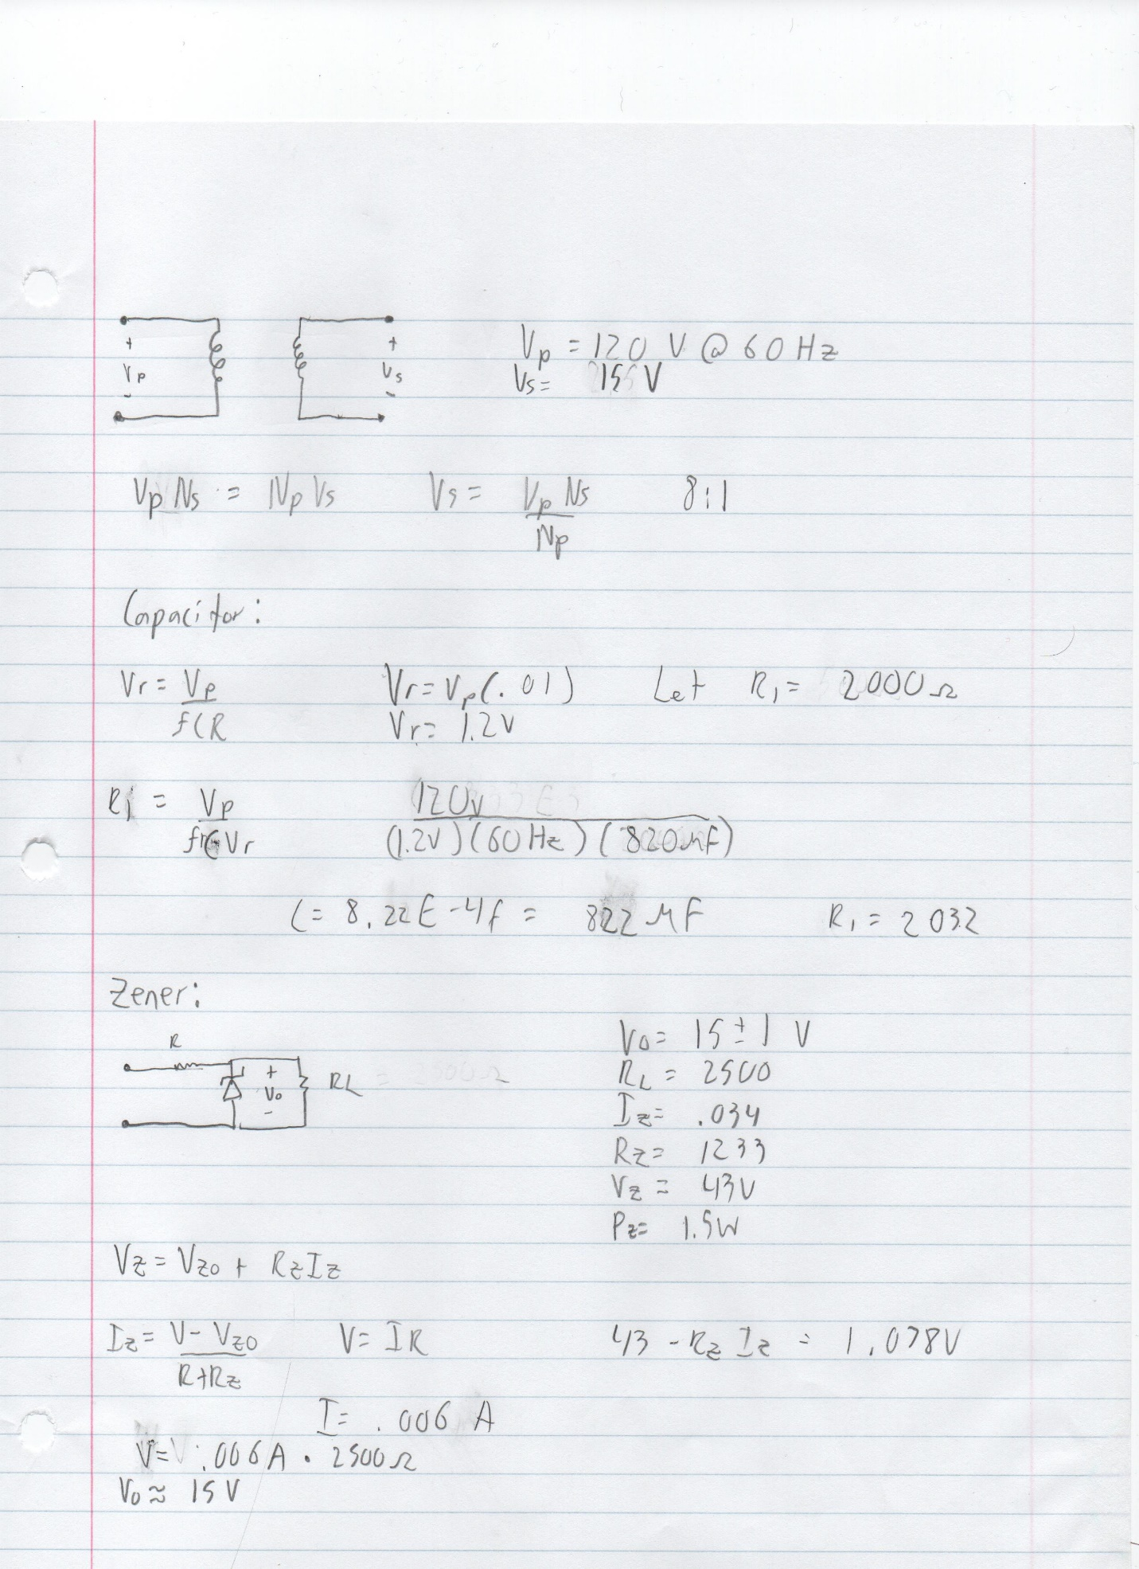

**Simulation:**

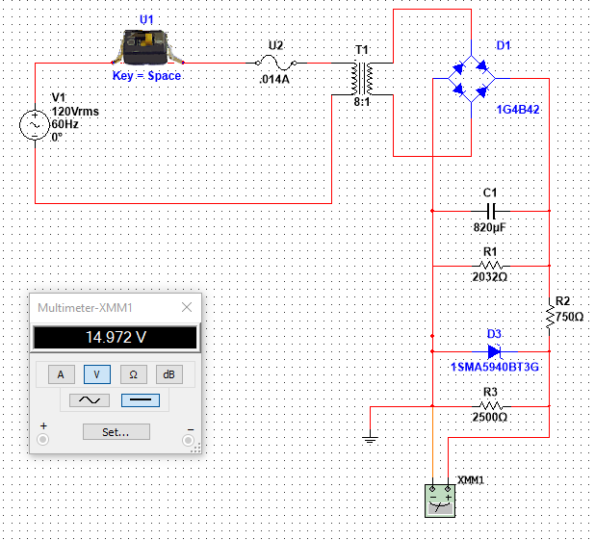

**Requirement Verification:**

As you can see from the simulation, a 120-volt alternating current source is converted to 15 volts plus or minus 1 volt across a 2500-ohm load resistor. The ripple voltage requirement was met as well. The values of C1 and R1 were calculated using a ripple value of 1% even though 2% was required. The Zener diode will also further decrease the ripple voltage.

**Safety:**

A 14-milliamp fuse was used to prevent damage any power surge that may occur. The circuit is properly grounded as well. The circuit should be placed such that it is not out in the open. Whatever casing it is contained in should be child proof. Before working on or around the circuit, turn the switch off and unplug it. Also be sure to check it with a volt meter.

|  |  |  |  |
| --- | --- | --- | --- |
| Component | Cost | Part Number | Link |
| Zener Regulator | $.42 | 1SMA5940  BT3G | <https://www.mouser.com/ProductDetail/ON-Semiconductor/1SMA5940BT3> |
| Rectifier | $3.00 | 1G4B42 | [https://www.questcomp.com/part/4/1g4b42/29045260?](https://www.questcomp.com/part/4/1g4b42/29045260?g) |
| Switch | $3.98 | GSW-18 | <https://www.homedepot.com/p/Gardner-Bender-8-Amp-Single-Pole-Toggle-Switch-1-Pack-GSW-18/100141285> |
| fuse | $4.49 | PST-AC1580 | <https://www.newark.com/littelfuse/0313-010hxp/fuse-cartridge-10ma-6-3x32mm-slo/dp/26K8460> |
| transformer | $36 | PST-AC1580 | <https://www.powerstream.com/ac-1580.htm> |
| Electrolytic capacitor | $.90 | 860160  475026 | <https://www.mouser.com/ProductDetail/Wurth-Elektronik/860160475026?q>  s=sGAEpiMZZMtZ1n0r9vR22em  d73sC8nR%2Fy8H7zwB07h3GysEB0jgSMQ%3D%3D |
| 2032 Ohm Resistor | $.24 | RN732AT  TD2032F50 | <https://www.mouser.com/ProductDetail/KOA-Speer/RN732ATTD2032F50?qs=>  sGAEpiMZZMvdGkrng054t39z9  eKHqyd%252B8pJSZ%252BrgAW  hJ0lo%2F%252BaoNRQ%3D%3D |
| 750 Ohm Resistor | $.33 | RCS12067  50RFKEA | <https://www.mouser.com/Pr>  oductDetail/VishayDale/RCS1206  750RFKEA?qs=sGAEpiMZZM  tlubZbdhIBIAh%252BOLxU8fCr9Z7cozr5qJk%3D |
| 2500 Ohm Resistor | $4.00 | RH0252K500  FE02 | <https://www.mouser.com/ProductDetail/Vishay-Dale/RH0252K500FE02?qs=sGA>  EpiMZZMtlubZbdhIBIMow1WQ9W2ngT1DZEz%252BrSFk%3D |

The total cost is $53.36 dollars.