Electric Circuits & Electronics Design Lab EE 316-08

Lab 1: Circuits Review

By: Austin Brown

**Introduction:**

The purpose of this lab is to review essential concepts such as Ohm’s Law, Kirchhoff’s Current and voltage laws. We will also familiarize ourselves with the Multisim simulation software. The first section of this report is dedicated to hand calculations. The next section is dedicated to simulating the circuits. Then I will discuss the results.

**Theoretical Analysis:**

The first part of the lab is to calculate the branch voltages, mesh currents, node voltages, and loop currents of figure 1.3. First this will be done by using the exact values, then with the resistors being 10% above the exact value, and then with the resistors being 10% below their exact value. The circuit and values are shown below.

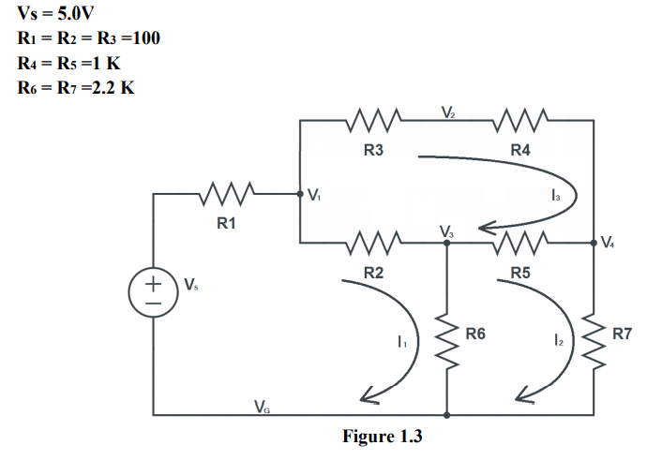

**Hand Computation: Exact Values**

|  |  |  |  |  |  |  |  |  |
| --- | --- | --- | --- | --- | --- | --- | --- | --- |
| Branch Node or Loop Number | Branch Voltage(V) | Branch Currents(mA) | Node Voltages(V) | Loop Currents(mA) |  |  |  |  |
| 1 | .363 | 3.364 | 4.637 | 3.654 |  |  |  |  |
| 2 | 0.272 | 2.719 | 4.545 | 1.650 |  |  |  |  |
| 3 | 0.092 | 0.915 | 4.365 | .916 |  |  |  |  |
| 4 | 0.915 | 0.915 | 3.630 |  |  |  |  |  |
| 5 | 0.735 | .735 |  |  |  |  |  |  |
| 6 | 4.365 | 1.984 |  |  |  |  |  |  |
| 7 | 3.630 | 1.650 |  |  |  |  |  |  |

**Hand Computation: 10% Above Exact**

|  |  |  |  |  |
| --- | --- | --- | --- | --- |
| Branch Node or Loop Number | Branch Voltage(V) | Branch Currents(mA) | Node Voltages(V) | Loop Currents(mA) |
| 1 | .363 | 4.038 | 4.637 | 4.038 |
| 2 | 0.272 | 3.021 | 4.545 | 1.833 |
| 3 | 0.090 | 1.017 | 4.365 | 1.017 |
| 4 | 0.915 | 1.017 | 3.630 |  |
| 5 | 0.735 | 0.816 |  |  |
| 6 | 4.365 | 2.205 |  |  |
| 7 | 3.629 | 1.833 |  |  |

**Hand Computation: 10% Below Exact**

|  |  |  |  |  |
| --- | --- | --- | --- | --- |
| Branch Node or Loop Number | Branch Voltage(V) | Branch Currents(mA) | Node Voltages(V) | Loop Currents(mA) |
| 1 | 0.363 | 3.304 | 4.637 | 3.304 |
| 2 | 0.272 | 2.472 | 4.545 | 1.500 |
| 3 | 0.092 | 0.832 | 4.365 | 0.832 |
| 4 | 0.915 | 0.832 | 3.630 |  |
| 5 | 0.735 | 0.668 |  |  |
| 6 | 4.366 | 1.804 |  |  |
| 7 | 3.630 | 1.500 |  |  |

The next task is to analyze figure 1.4 to determine its Norton and Thevenin equivalent circuits. The work is shown in the appendix.

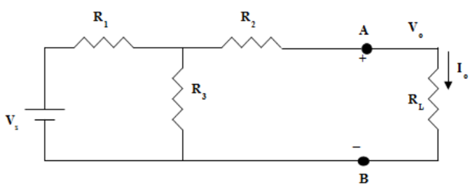

**Simulations:**

In this part of the lab, we use Multisim to simulate the circuits that we just analyzed by hand. I first simulated the circuit from figure 1.

Simulation of exact voltage values

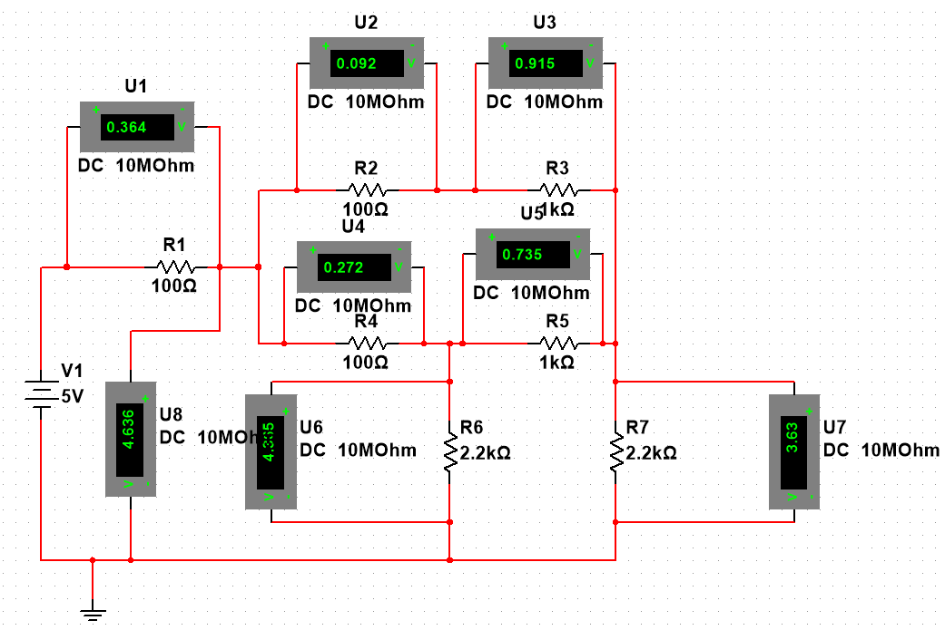

Simulation of exact current readings.

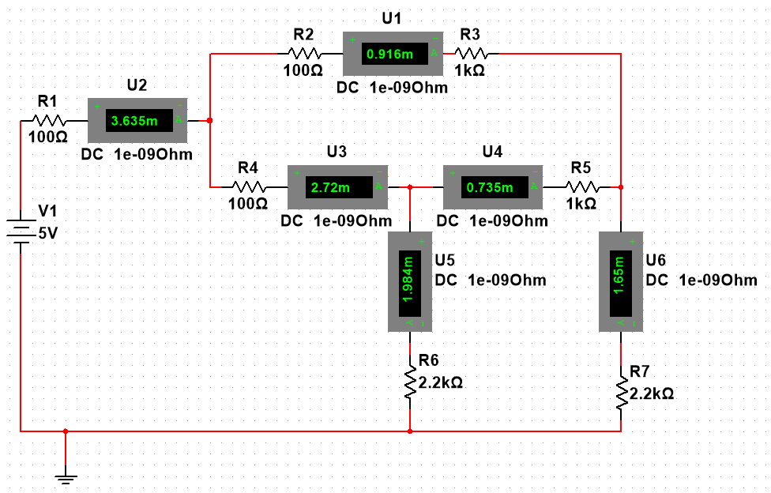

**Exact Values**

|  |  |  |  |  |
| --- | --- | --- | --- | --- |
| Branch Node or Loop Number | Branch Voltage(V) | Branch Currents(mA) | Node Voltages(V) | Loop Currents(mA) |
| 1 | .364 | 3.365 | 4.637 | 3.655 |
| 2 | 0.272 | 2.72 | 4.545 | 1.65 |
| 3 | 0.092 | 0.916 | 4.365 | .916 |
| 4 | 0.915 | 0.916 | 3.63 |  |
| 5 | 0.735 | .735 |  |  |
| 6 | 4.365 | 1.984 |  |  |
| 7 | 3.63 | 1.65 |  |  |

**10% above exact values**

|  |  |  |  |  |
| --- | --- | --- | --- | --- |
| Branch Node or Loop Number | Branch Voltage(V) | Branch Currents(mA) | Node Voltages(V) | Loop Currents(mA) |
| 1 | .363 | 4.039 | 4.637 | 4.039 |
| 2 | 0.272 | 3.021 | 4.547 | 1.833 |
| 3 | 0.090 | 1.017 | 4.365 | 1.017 |
| 4 | 0.915 | 1.017 | 3.63 |  |
| 5 | 0.735 | 0.817 |  |  |
| 6 | 4.365 | 2.204 |  |  |
| 7 | 3.630 | 1.833 |  |  |

**10% below exact values**

|  |  |  |  |  |
| --- | --- | --- | --- | --- |
| Branch Node or Loop Number | Branch Voltage(V) | Branch Currents(mA) | Node Voltages(V) | Loop Currents(mA) |
| 1 | .363 | 3.303 | 4.637 | 3.303 |
| 2 | 0.272 | 2.472 | 4.544 | 1.500 |
| 3 | 0.090 | 0.832 | 4.365 | 0.832 |
| 4 | 0.915 | 0.832 | 3.63 |  |
| 5 | 0.735 | 0.669 |  |  |
| 6 | 4.365 | 1.804 |  |  |
| 7 | 3.630 | 1.500 |  |  |

Below is the Open Circuit Voltage.

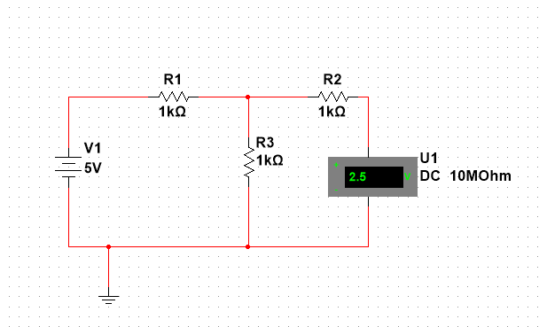

Below is the short circuit current.

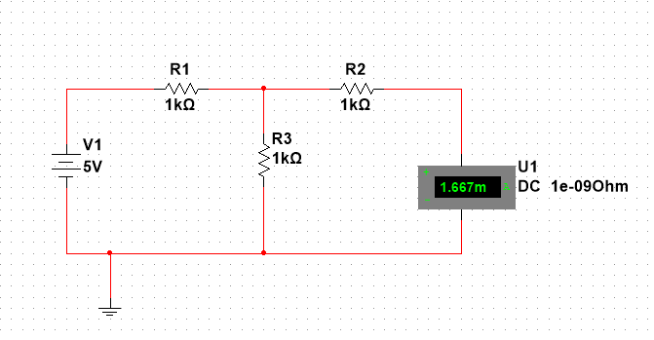

The next task is to set Vs to 5 volts and Rs to 100 Ohms. We will change RL from 10 Ohms to 1k Ohms.

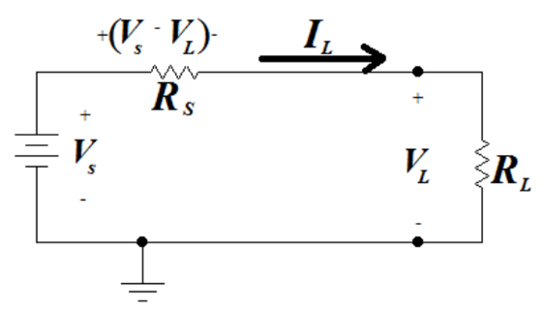

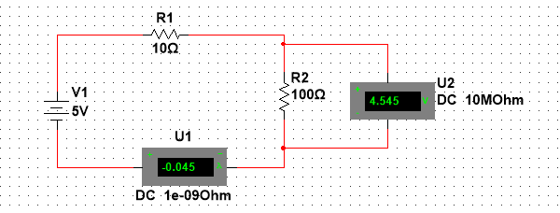

|  |  |  |
| --- | --- | --- |
| RL (Ω) | VL (V) | IL (A) |
| 10 | 0.455 | 0.045 |
| 20 | 0.833 | 0.042 |
| 40 | 1.429 | 0.036 |
| 70 | 2.059 | 0.029 |
| 100 | 2.500 | 0.025 |
| 150 | 3.000 | 0.020 |
| 200 | 3.333 | 0.017 |
| 300 | 3.750 | 0.013 |
| 500 | 4.167 | 0.005 |
| 1000 | 4.545 | 0.005 |

**Results and Discussion:**

In this lab, we analyze several circuits by hand and then simulate them. The purpose of this is to determine if simulation is a valid way of testing and validating a circuit. The hand computations and simulations. The hand computations and simulations closely match each other.

|  |  |  |  |  |  |  |  |  |
| --- | --- | --- | --- | --- | --- | --- | --- | --- |
| Branch Node or Loop Number | Branch Voltage(V) | Branch Currents(mA) | Node Voltages(V) | Loop Currents(mA) |  |  |  |  |
| 1 | .363 | 3.364 | 4.637 | 3.654 |  |  |  |  |
| 2 | 0.272 | 2.719 | 4.545 | 1.650 |  |  |  |  |
| 3 | 0.092 | 0.915 | 4.365 | .916 |  |  |  |  |
| 4 | 0.915 | 0.915 | 3.630 |  |  |  |  |  |
| 5 | 0.735 | .735 |  |  |  |  |  |  |
| 6 | 4.365 | 1.984 |  |  |  |  |  |  |
| 7 | 3.630 | 1.650 |  |  |  |  |  |  |

|  |  |  |  |  |
| --- | --- | --- | --- | --- |
| Branch Node or Loop Number | Branch Voltage(V) | Branch Currents(mA) | Node Voltages(V) | Loop Currents(mA) |
| 1 | .364 | 3.365 | 4.637 | 3.655 |
| 2 | 0.272 | 2.72 | 4.545 | 1.65 |
| 3 | 0.092 | 0.916 | 4.365 | .916 |
| 4 | 0.915 | 0.916 | 3.63 |  |
| 5 | 0.735 | .735 |  |  |
| 6 | 4.365 | 1.984 |  |  |
| 7 | 3.63 | 1.65 |  |  |

The results of this lab also validate Ohm’s law, Kirchhoff’s voltage and currents laws, and Thevenin and Norton circuits. The experiment where we change the resistor value confirms Ohm’s law.

|  |  |  |
| --- | --- | --- |
| RL (Ω) | VL (V) | IL (mA) |
| 10 | 0.455 | 0.045 |
| 20 | 0.833 | 0.042 |
| 40 | 1.429 | 0.036 |
| 70 | 2.059 | 0.029 |
| 100 | 2.500 | 0.025 |
| 150 | 3.000 | 0.020 |
| 200 | 3.333 | 0.017 |
| 300 | 3.750 | 0.013 |
| 500 | 4.167 | 0.005 |
| 1000 | 4.545 | 0.005 |

**Conclusion:**

The purpose of this lab was to verify some fundamental circuit theory. There was almost no difference between the hand computations and the simulations. We also gained experience using the Multisim software.

**Appendix**

