Electric Circuits & Electronics Design Lab EE 316-08

Lab 11_12: MOSFETs

By: Austin Brown

**Introduction:**

In this lab, we will look at Metal Oxide Semiconductor Field Effect Transistors (MOSFETs). We will look at the frequency range and bandwidth of N and P channel MOSFETs. Add more

**Theoretical Analysis:**

A MOSFET has three terminals. It is a unipolar semiconductor. They are different from JFETs in that they their metal oxide gate is insulated from the main conductor. This means that no current flows to the gate. MOSFETs have two modes. They are depletion mode and enhancement mode. Depletion mode is essentially a closed switch. Enhancement mode requires a certain gate voltage to turn the transistor on.

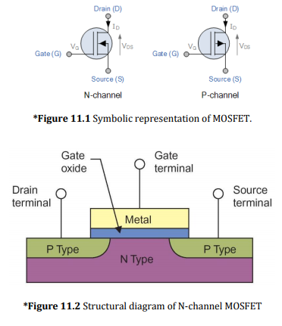

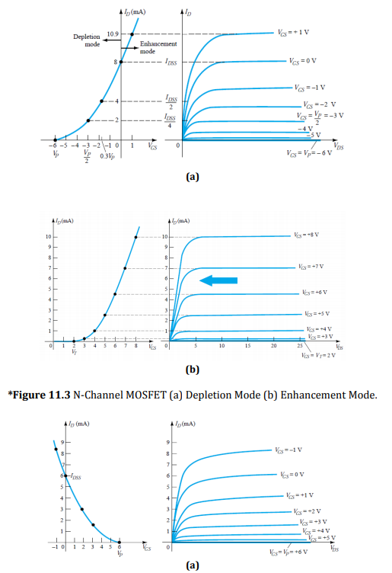

**Simulation:**

**Lab 11**

For this portion of the lab, we built a circuit using the 2N7000 MOSFET. We set V2 to 2.5 and increased V1 until Id saturates. This procedure was also repeated with V2 equaling 3V, 3.5, and 4V.

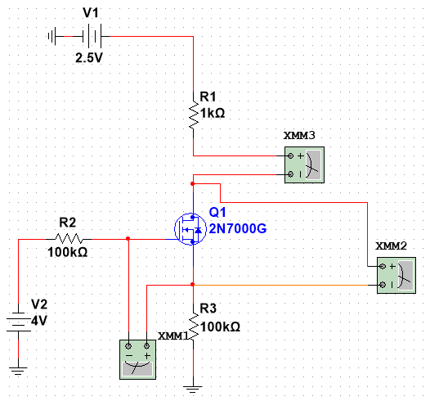

VDS vs ID

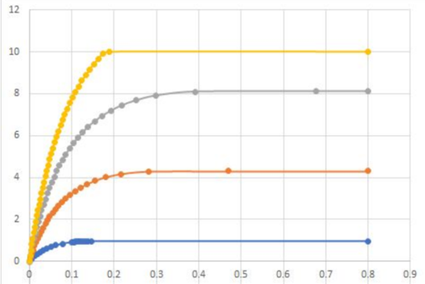

Saturation Region

|  |  |
| --- | --- |
| VGS (V) | VDS (V) |
| 2.4 | 0.146 |
| 2.545 | 0.47 |
| 2.662 | 0.667 |
| 2.951 | 0.189 |

For the next part of lab 11, we set V1 to 22 V. Then we increase V2 from 2 volts to 5.5 V until ID doesn’t change. The results are below.

|  |  |  |
| --- | --- | --- |
| V2 (V) | VGS (V) | ID (mA) |
| 2.0 | 1.98 | 0.000 |
| 2.25 | 2.227 | 0.000 |
| 2.5 | 2.38 | 0.956 |
| 2.75 | 2.472 | 2.533 |
| 3.0 | 2.544 | 4.299 |
| 3.25 | 2.607 | 6.171 |
| 3.5 | 2.662 | 8.112 |
| 3.75 | 2.713 | 10.012 |
| 4.0 | 2.76 | 12.149 |
| 4.25 | 2.830 | 14.023 |
| 4.5 | 2.845 | 16.005 |
| 4.75 | 2.884 | 18.001 |
| 5.0 | 3.006 | 20.011 |
| 5.25 | 3.242 | 20.015 |
| 5.5 | 3.484 | 20.009 |

**Lab 12**

The circuit below amplifies a sinusoid with frequencies ranging from 10 Hz to 3 MHz. The circuit and results are shown below.

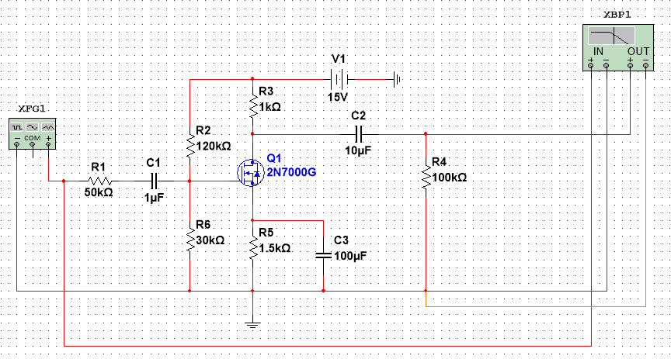

|  |  |  |  |
| --- | --- | --- | --- |
| Frequency (Hz) | Vin (mVPP) | Vout (mV) | Gain |
| 10 | 200 | 284.007 | 3.046 |
| 30 | 200 | 549.352 | 8.776 |
| 60 | 200 | 595.177 | 9.472 |
| 100 | 200 | 609.463 | 9.678 |
| 200 | 200 | 612.295 | 9.719 |
| 500 | 200 | 614.033 | 9.743 |
| 1 K | 200 | 625.191 | 9.900 |
| 2 K | 200 | 754.991 | 11.538 |
| 5 K | 200 | 622.867 | 9.867 |
| 10 K | 200 | 722.067 | 11.151 |
| 15 K | 200 | 735.911 | 11.316 |
| 20 K | 200 | 730.311 | 11.250 |
| 50 K | 200 | 655.855 | 10.316 |
| 75 K | 200 | 595.274 | 9.474 |
| 100 K | 200 | 533.500 | 8.522 |
| 150 K | 200 | Convergence Error | N/A |
| 200 K | 200 | 352.936 | 4.933 |
| 500 K | 200 | 154.514 | -2.241 |
| 750 K | 200 | Convergence Error | N/A |
| 1 M | 200 | 77.495 | -8.235 |
| 1.5 M | 200 | Convergence Error | N/A |
| 2.0 M | 200 | Convergence Error | N/A |
| 3.0 M | 200 | Convergence Error | N/A |

Multisim generated convergence errors for some of the VOUT values. Thus, these do not have a value for gain.

**Results**

**Lab 11**

The simulation confirms that the MOSFET requires approximately 2.25 volts to conduct properly. Based on the results, the 2N7000 MOSFET is a P-channel device.

**Lab 12**

The bandwidth of the device is approximately 30 Hz to 100 KHz. The output waveform is a little out of phase from the input waveform.

**Conclusion**

This lab was purposeful in that we looked at how MOSFETs function. We looked at the 2N7000 MOSFET and examined its bandwidth. We observed the MOSFET’s characteristics in the theoretical and simulation sections.