**Lab 11 Part 1**

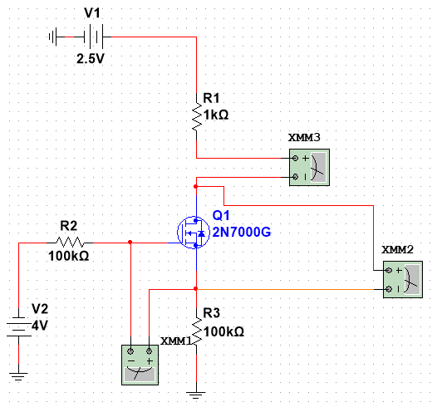

Values For Part 1

|  |  |  |  |  |  |  |  |
| --- | --- | --- | --- | --- | --- | --- | --- |
| V2 = 2.5 V | | | | V2 = 3.0 V | | | |
| VDS (V) | VGS (V) | V1 (V) | ID (mA) | VDS (V) | VGS (V) | V1 (V) | ID (mA) |
| -0.922 µ | 2.475 | 0.00 | -0.022 µ | -0.418 µ | 2.970 | 0.0 | -0.027 µ |
| 4.185 m | 2.467 | 0.10 | 0.087 | 2.886 | 2.953 | 0.2 | 0.197 |
| 8.764 | 2.458 | 0.20 | 0.174 | 5.920 | 2.935 | 0.4 | 0.358 |
| 0.014 | 2.449 | 0.30 | 0.260 | 9.115 | 2.917 | 0.6 | 0.37 |
| 0.019 | 2.441 | 0.40 | 0.346 | 0.012 | 2.899 | 0.8 | 0.716 |
| 0.026 | 2.433 | 0.50 | 0.431 | 0.016 | 2.882 | 1.0 | 0.894 |
| 0.033 | 2.424 | 0.60 | 0.516 | 0.020 | 2.864 | 1.2 | 1.073 |
| 0.041 | 2.416 | 0.70 | 0.599 | 0.024 | 2.846 | 1.4 | 1.251 |
| 0.051 | 2.408 | 0.80 | 0.681 | 0.028 | 2.829 | 1.6 | 1.429 |
| 0.063 | 2.4 | 0.90 | 0.761 | 0.033 | 2.811 | 1.8 | 1.607 |
| 0.078 | 2.392 | 1.00 | 0.838 | 0.038 | 2.794 | 2.0 | 1.784 |
| 0.1 | 2.385 | 1.10 | 0.909 | 0.043 | 2.776 | 2.2 | 1.961 |
| 0.103 | 2.385 | 1.11 | 0.916 | 0.048 | 2.759 | 2.4 | 2.138 |
| 0.106 | 2.384 | 1.12 | 0.922 | 0.055 | 2.741 | 2.6 | 2.314 |
| 0.109 | 2.383 | 1.13 | 0.928 | 0.061 | 2.724 | 2.8 | 2.490 |
| 0.112 | 2.383 | 1.14 | 0.934 | 0.069 | 2.706 | 3.0 | 2.665 |
| 0.116 | 2.382 | 1.15 | 0.940 | 0.077 | 2.689 | 3.2 | 2.839 |
| 0.12 | 2.382 | 1.16 | 0.945 | 0.086 | 2.672 | 3.4 | 3.013 |
| 0.125 | 2.381 | 1.17 | 0.950 | 0.096 | 2.655 | 3.6 | 3.185 |
| 0.131 | 2.381 | 1.18 | 0.954 | 0.108 | 2.638 | 3.8 | 3.357 |
| 0.138 | 2.38 | 1.19 | 0.957 | 0.121 | 2.612 | 4.0 | 3.526 |
| 0.146 | 2.38 | 1.20 | 0.958 | 0.137 | 2.605 | 4.2 | 3.693 |
|  | | | | 0.156 | 2.588 | 4.4 | 3.858 |
| 0.181 | 2.573 | 4.6 | 4.017 |
| 0.216 | 2.558 | 4.8 | 4.167 |
| 0.281 | 2.545 | 5.0 | 4.290 |
| 0.470 | 2.545 | 5.2 | 4.300 |

|  |  |  |  |  |  |  |  |
| --- | --- | --- | --- | --- | --- | --- | --- |
| V2 = 3.5 V | | | | V2 = 4.0 V | | | |
| VDS (V) | VGS (V) | V1 (V) | ID (mA) | VDS (V) | VGS (V) | V1 (V) | ID (mA) |
| -0.307 µ | 3.465 | 0.00 | -0.031 | -0.262 µ | 3.96 | 0.0 | -0.036 µ |
| 2.712 m | 3.439 | 0.30 | 0.270 | 2.012 m | 3.934 | 0.3 | 0.271 |
| 5.540 m | 3.412 | 0.60 | 0.540 | 4.082 m | 3.907 | 0.6 | 0.542 |
| 8.493 m | 3.385 | 0.90 | 0.810 | 6.212 m | 3.880 | 0.9 | 0.812 |
| 0.012 | 3.358 | 1.2 | 1.080 | 8.405 m | 3.853 | 1.2 | 1.083 |
| 0.015 | 3.332 | 1.5 | 1.350 | 0.011 | 3.826 | 1.5 | 1.354 |
| 0.018 | 3.305 | 1.8 | 1.620 | 0.013 | 3.80 | 1.8 | 1.625 |
| 0.022 | 3.278 | 2.1 | 1.889 | 0.015 | 3.773 | 2.1 | 1.895 |
| 0.026 | 3.252 | 2.4 | 2.159 | 0.018 | 3.746 | 2.4 | 2.166 |
| 0.029 | 3.225 | 2.7 | 2.428 | 0.020 | 3.719 | 2.7 | 2.436 |
| 0.034 | 3.198 | 3.0 | 2.697 | 0.023 | 3.692 | 3.0 | 2.706 |
| 0.038 | 3.172 | 3.3 | 2.965 | 0.026 | 3.666 | 3.3 | 2.976 |
| 0.043 | 3.145 | 3.6 | 3.234 | 0.029 | 3.639 | 3.6 | 3.247 |
| 0.048 | 3.119 | 3.9 | 3.502 | 0.032 | 3.612 | 3.9 | 3.517 |
| 0.053 | 3.092 | 4.2 | 3.770 | 0.035 | 3.585 | 4.2 | 3.787 |
| 0.059 | 3.066 | 4.5 | 4.037 | 0.038 | 3.559 | 4.5 | 4.056 |
| 0.065 | 3.039 | 4.8 | 4.305 | 0.041 | 3.532 | 4.8 | 4.326 |
| 0.071 | 3.013 | 5.1 | 4.571 | 0.045 | 3.505 | 5.1 | 4.596 |
| 0.079 | 2.986 | 5.4 | 4.838 | 0.048 | 3.479 | 5.4 | 4.865 |
| 0.086 | 2.960 | 5.7 | 5.103 | 0.052 | 3.452 | 5.7 | 5.134 |
| 0.095 | 2.934 | 6.0 | 5.368 | 0.056 | 3.425 | 6.0 | 5.404 |
| 0.104 | 2.908 | 6.3 | 5.632 | 0.060 | 3.399 | 6.3 | 5.672 |
| 0.115 | 2.882 | 6.6 | 5.896 | 0.064 | 3.372 | 6.6 | 5.941 |
| 0.126 | 2.856 | 6.9 | 6.158 | 0.069 | 3.346 | 6.9 | 6.210 |
| 0.139 | 2.830 | 7.2 | 6.419 | 0.074 | 3.319 | 7.2 | 6.478 |
| 0.154 | 2.804 | 7.5 | 6.679 | 0.079 | 3.292 | 7.5 | 6.746 |
| 0.172 | 2.779 | 7.8 | 6.935 | 0.084 | 3.266 | 7.8 | 7.014 |
| 0.193 | 2.754 | 8.1 | 7.188 | 0.090 | 3.239 | 8.1 | 7.282 |
| 0.218 | 2.729 | 8.4 | 7.438 | 0.096 | 3.213 | 8.4 | 7.549 |
| 0.252 | 2.705 | 8.7 | 7.680 | 0.102 | 3.187 | 8.7 | 7.816 |
| 0.299 | 2.682 | 9.0 | 7.910 | 0.109 | 3.160 | 9.0 | 8.083 |
| 0.391 | 2.663 | 9.3 | 8.099 | 0.116 | 3.134 | 9.3 | 8.349 |
| 0.677 | 2.662 | 9.6 | 8.112 | 0.124 | 3.107 | 9.6 | 8.614 |
|  | | | | 0.133 | 3.081 | 9.9 | 8.879 |
| 0.142 | 3.055 | 10.2 | 9.144 |
| 0.152 | 3.029 | 10.5 | 9.407 |
| 0.163 | 3.003 | 10.8 | 9.670 |
| 0.175 | 2.977 | 11.1 | 9.931 |
| 0.189 | 2.951 | 11.4 | 0.01 volts |

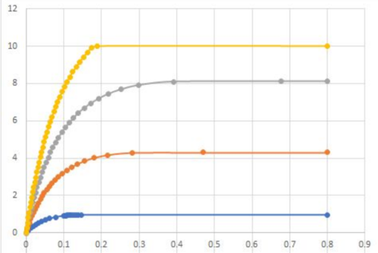

Saturation Region

|  |  |
| --- | --- |
| VGS (V) | VDS (V) |
| 2.4 | 0.146 |
| 2.545 | 0.47 |
| 2.662 | 0.667 |
| 2.951 | 0.189 |

**Part 2**

|  |  |  |
| --- | --- | --- |
| V2 (V) | VGS (V) | ID (mA) |
| 2.0 | 1.98 | 0.000 |
| 2.25 | 2.227 | 0.000 |
| 2.5 | 2.38 | 0.956 |
| 2.75 | 2.472 | 2.533 |
| 3.0 | 2.544 | 4.299 |
| 3.25 | 2.607 | 6.171 |
| 3.5 | 2.662 | 8.112 |
| 3.75 | 2.713 | 10.012 |
| 4.0 | 2.76 | 12.149 |
| 4.25 | 2.830 | 14.023 |
| 4.5 | 2.845 | 16.005 |
| 4.75 | 2.884 | 18.001 |
| 5.0 | 3.006 | 20.011 |
| 5.25 | 3.242 | 20.015 |
| 5.5 | 3.484 | 20.009 |

**Lab 12**

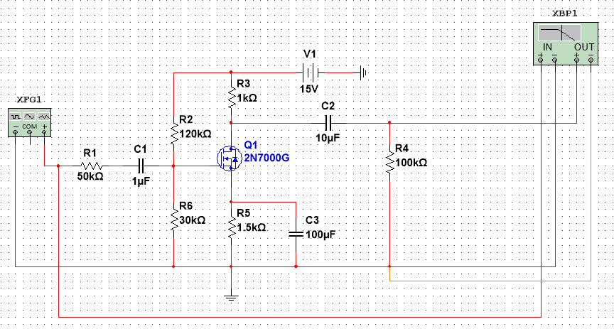

|  |  |  |  |
| --- | --- | --- | --- |
| Frequency (Hz) | Vin (mVPP) | Vout (mV) | Gain |
| 10 | 200 | 284.007 | 3.046 |
| 30 | 200 | 549.352 | 8.776 |
| 60 | 200 | 595.177 | 9.472 |
| 100 | 200 | 609.463 | 9.678 |
| 200 | 200 | 612.295 | 9.719 |
| 500 | 200 | 614.033 | 9.743 |
| 1 K | 200 | 625.191 | 9.900 |
| 2 K | 200 | 754.991 | 11.538 |
| 5 K | 200 | 622.867 | 9.867 |
| 10 K | 200 | 722.067 | 11.151 |
| 15 K | 200 | 735.911 | 11.316 |
| 20 K | 200 | 730.311 | 11.250 |
| 50 K | 200 | 655.855 | 10.316 |
| 75 K | 200 | 595.274 | 9.474 |
| 100 K | 200 | 533.500 | 8.522 |
| 150 K | 200 | Convergence Error | N/A |
| 200 K | 200 | 352.936 | 4.933 |
| 500 K | 200 | 154.514 | -2.241 |
| 750 K | 200 | Convergence Error | N/A |
| 1 M | 200 | 77.495 | -8.235 |
| 1.5 M | 200 | Convergence Error | N/A |
| 2.0 M | 200 | Convergence Error | N/A |
| 3.0 M | 200 | Convergence Error | N/A |

Multisim gave an error for 150 KHz, 750 KHz, 1.5 MHz, and 3.0 MHz. The plot bellow shows the frequency vs gain.