Prelab 2

Austin Brown

**Inverting Op-Amp**

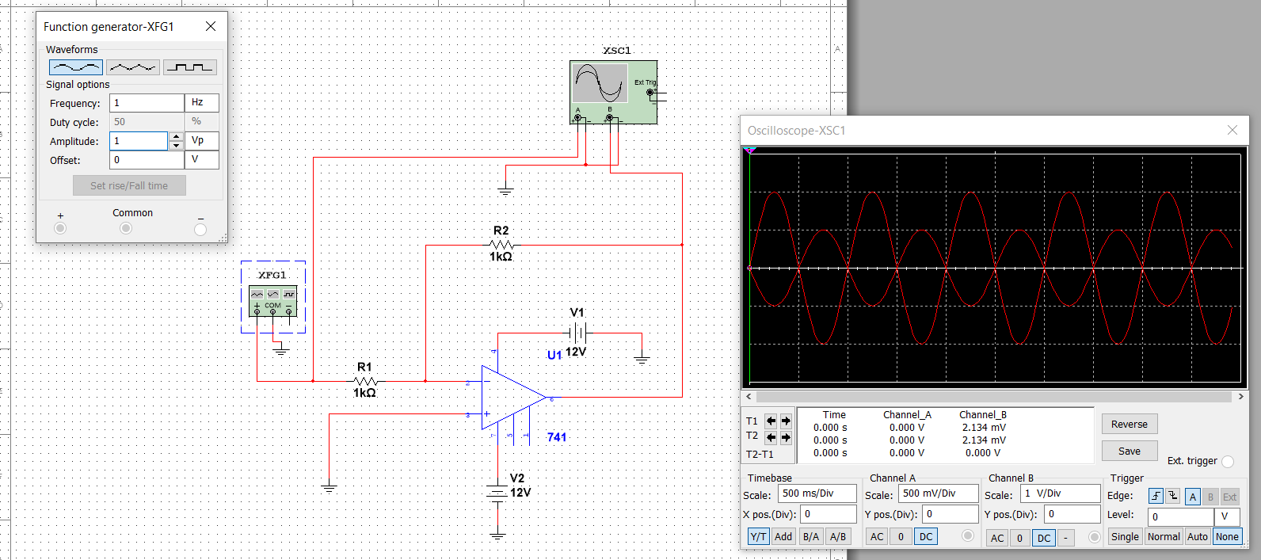

**Simulation results for non-inverting op-amp**

|  |  |  |  |  |  |
| --- | --- | --- | --- | --- | --- |
| Vin, pp (V) | Rin (kΩ) | RF (kΩ) | Vout, pp(V) Oscilloscope | Gain (V/V) | Vout, pp (V) Multimeter |
| 2 | 1 | 0.5 | -0.99 | -0.49 | -0.354 |
| 1 | -2.00 | -1.00 | -0.708 |
| 2 | -3.99 | -1.99 | -1.420 |
| 3 | -5.98 | -2.99 | -2.125 |
| 4 | -7.99 | -3.99 | -2.832 |

**Non-Inverting Op-Amp**

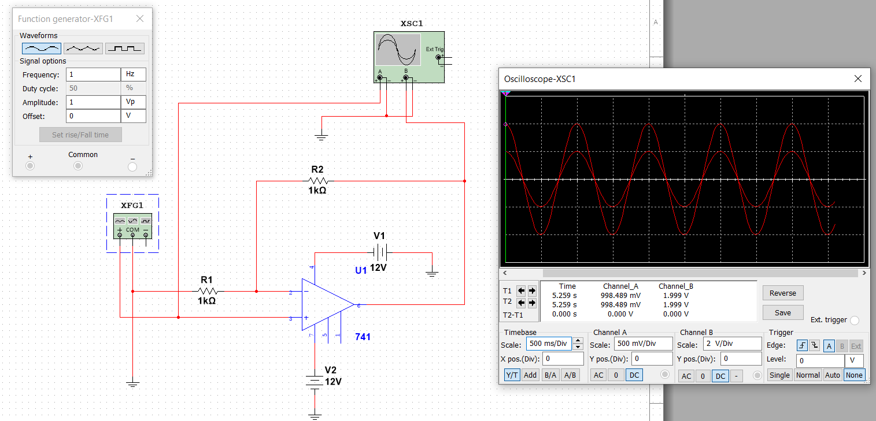

|  |  |  |  |  |  |
| --- | --- | --- | --- | --- | --- |
| Vin, pp (V) | Rin (kΩ) | RF (kΩ) | Vout, pp(V) Oscilloscope | Gain (V/V) | Vout, pp (V) Multimeter |
| 2 | 1 | 0.5 | 2.99 | 1.49 | 1.061 |
| 1 | 3.99 | 1.99 | 1.414 |
| 2 | 5.97 | 2.98 | 2.121 |
| 3 | 7.95 | 3.97 | 2.828 |
| 4 | 9.98 | 4.99 | 3.535 |