Electric Circuits & Electronics Design Lab EE 316-08

Lab 1: Circuits Review

By: Austin Brown

**Intro**

The purpose of this lab is to analyze op-amps in both inverting and noninverting configurations. These configurations will be analyzed using both hand computations as well as using Multisim to simulate them. We will analyze them by varying the value of the load resistor. This report will be broken into several sections. They include Theoretical Analysis, Simulations, Results and Discussion, Conclusion, and the appendix. In the Theoretical Analysis I will perform hand computations of the circuits. The Simulation section will show simulation results. The Results and Discussion section will compare the results form the two previous sections.

**Theoretical Analysis**

The operational amplifier or op-amp for short is ad device that subtracts its two input voltages and multiplies that by its gain. The formula for the output of an op-amp: . A basic op-amp is shown below.

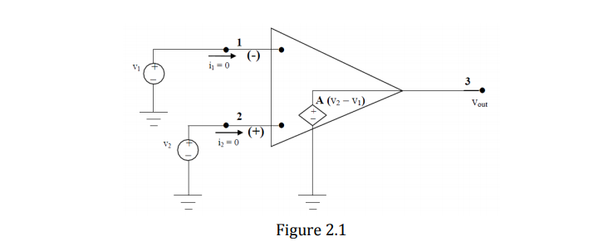

The ideal input voltages are zero. This makes the input impedance infinite. The output voltage equals A(V2 – V1). The output impedance is also zero.

**Inverting Amplifier**

Below is the schematic for a basic inverting amplifier.

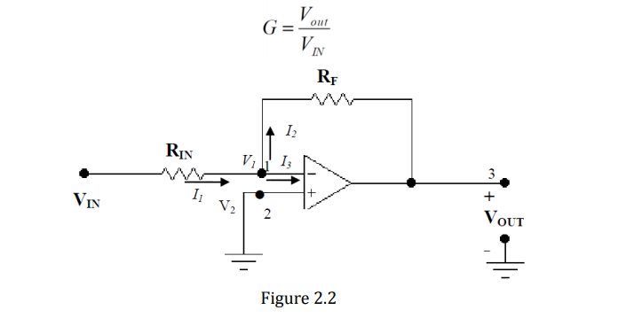

The “inverting” means that in DC, the that the output voltage is of an opposite polarity to the input. In AC, this means that the output will be out of shifted by 180 degrees from the input. The formula to calculate the gain is shown below.

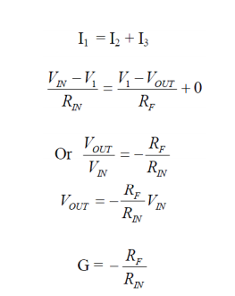

**Non-Inverting Amplifier**

The key difference between the inverting and non-inverting amplifier is that the non-inverting amplifier is in phase. The gain is positive. The setup is shown below.

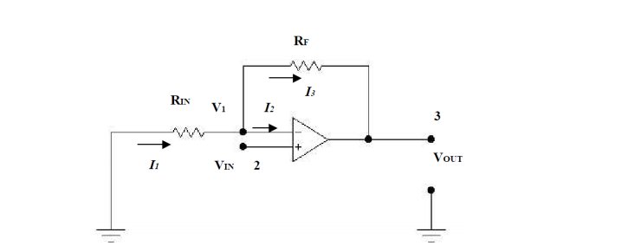

The non-inverting voltage is supplied to the noninverting terminal. Rn is connected to the inverting terminal. The voltage output and gain are shown below.

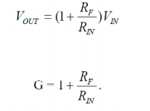

**Hand Calculations**

Inverting Op-amp

|  |  |  |  |  |  |
| --- | --- | --- | --- | --- | --- |
| Vin, pp (V) | Rin (kΩ) | RF (kΩ) | Vout, PP(V) | Gain (V/V) | Vout, RMS |
| 2 | 1 | 0.5 | -1 | -0.5 | -0.354 |
| 1 | -2 | -1 | -0.707 |
| 2 | -4 | -2 | -1.414 |
| 3 | -6 | -3 | -2.121 |
| 4 | -8 | -4 | -2.828 |

Non-Inverting

|  |  |  |  |  |  |
| --- | --- | --- | --- | --- | --- |
| Vin, pp (V) | Rin (kΩ) | RF (kΩ) | Vout, PP(V) | Gain (V/V) | Vout, RMS (V) |
| 2 | 1 | 0.5 | 3 | 1.5 | 1.061 |
| 1 | 4 | 2 | 1.414 |
| 2 | 6 | 3 | 2.121 |
| 3 | 8 | 4 | 2.828 |
| 4 | 10 | 5 | 3.536 |

**Simulations**

In this section, I set up the inverting and non-inverting op-amps in Multisim. The results are shown below.

**Inverting Op-Amp**

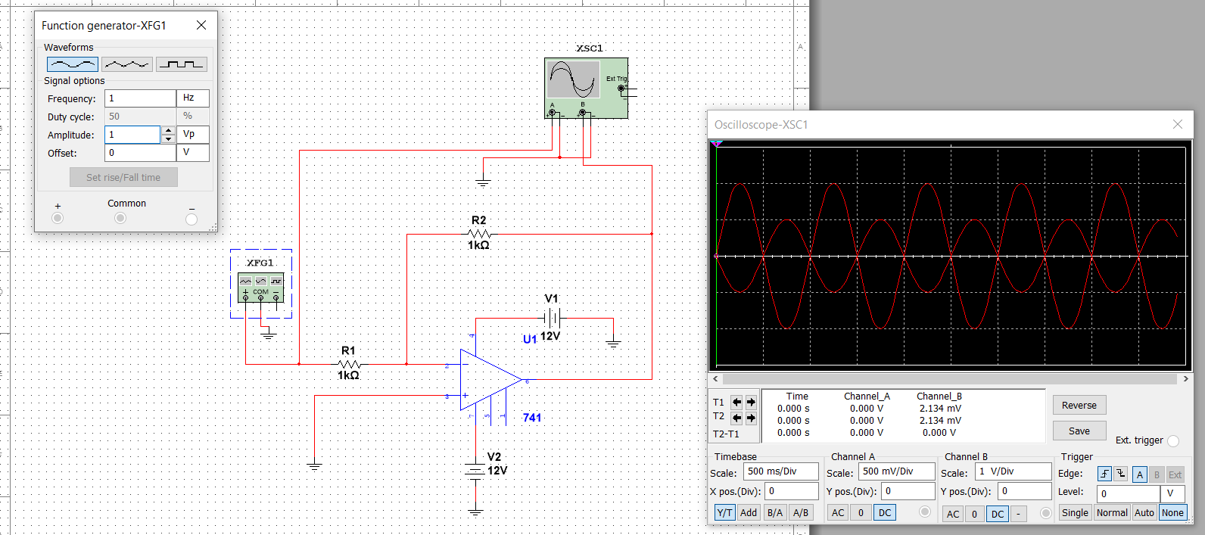

**Simulation results for non-inverting op-amp**

|  |  |  |  |  |  |
| --- | --- | --- | --- | --- | --- |
| Vin, pp (V) | Rin (kΩ) | RF (kΩ) | Vout, pp(V) Oscilloscope | Gain (V/V) | Vout, pp (V) Multimeter |
| 2 | 1 | 0.5 | -0.99 | -0.49 | -0.354 |
| 1 | -2.00 | -1.00 | -0.708 |
| 2 | -3.99 | -1.99 | -1.420 |
| 3 | -5.98 | -2.99 | -2.125 |
| 4 | -7.99 | -3.99 | -2.832 |

**Non-Inverting Op-Amp**

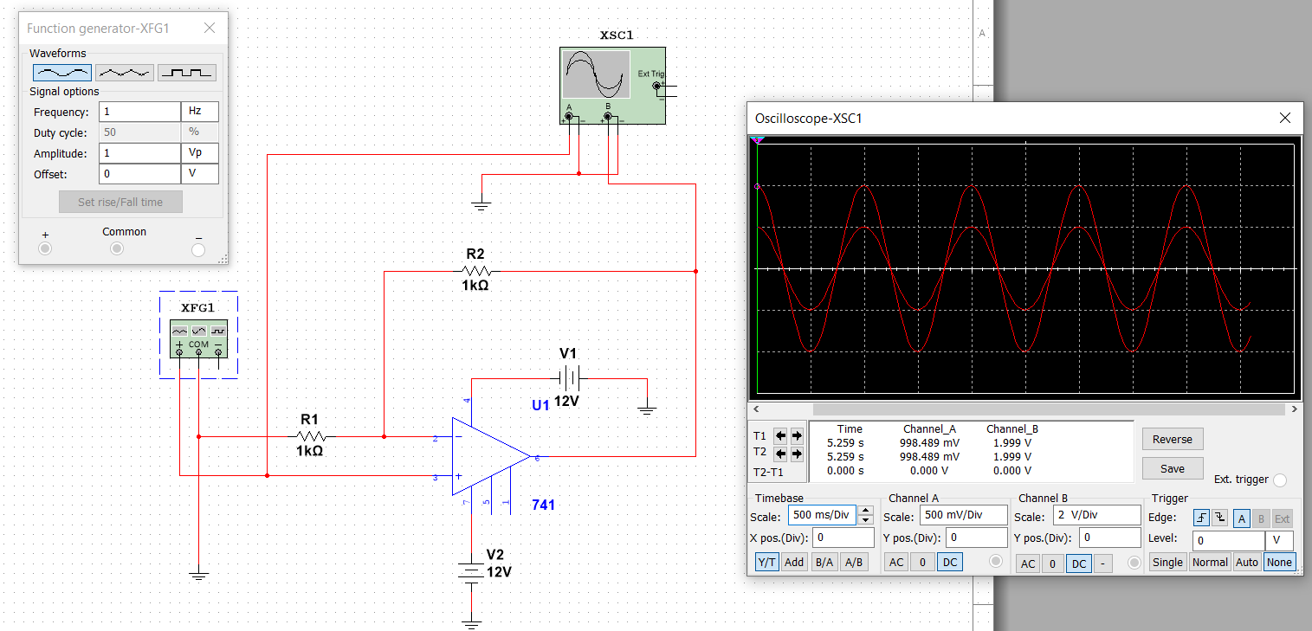

|  |  |  |  |  |  |
| --- | --- | --- | --- | --- | --- |
| Vin, pp (V) | Rin (kΩ) | RF (kΩ) | Vout, pp(V) Oscilloscope | Gain (V/V) | Vout, pp (V) Multimeter |
| 2 | 1 | 0.5 | 2.99 | 1.49 | 1.061 |
| 1 | 3.99 | 1.99 | 1.414 |
| 2 | 5.97 | 2.98 | 2.121 |
| 3 | 7.95 | 3.97 | 2.828 |
| 4 | 9.98 | 4.99 | 3.535 |

**Results and Discussion**

The purpose of this section is to compare the hand calculations and the and the simulation results. The results for the inverting op-amp are below.

**Hand Calculations**

|  |  |  |  |  |  |
| --- | --- | --- | --- | --- | --- |
| Vin, pp (V) | Rin (kΩ) | RF (kΩ) | Vout, PP(V) | Gain (V/V) | Vout, RMS |
| 2 | 1 | 0.5 | -1 | -0.5 | -0.354 |
| 1 | -2 | -1 | -0.707 |
| 2 | -4 | -2 | -1.414 |
| 3 | -6 | -3 | -2.121 |
| 4 | -8 | -4 | -2.828 |

**Simulation**

|  |  |  |  |  |  |
| --- | --- | --- | --- | --- | --- |
| Vin, pp (V) | Rin (kΩ) | RF (kΩ) | Vout, pp(V) Oscilloscope | Gain (V/V) | Vout, pp (V) Multimeter |
| 2 | 1 | 0.5 | -0.99 | -0.49 | -0.354 |
| 1 | -2.00 | -1.00 | -0.708 |
| 2 | -3.99 | -1.99 | -1.420 |
| 3 | -5.98 | -2.99 | -2.125 |
| 4 | -7.99 | -3.99 | -2.832 |

Below are the results for the nan-inverting op-amp.

**Hand Calculations**

|  |  |  |  |  |  |
| --- | --- | --- | --- | --- | --- |
| Vin, pp (V) | Rin (kΩ) | RF (kΩ) | Vout, PP(V) | Gain (V/V) | Vout, RMS (V) |
| 2 | 1 | 0.5 | 3 | 1.5 | 1.061 |
| 1 | 4 | 2 | 1.414 |
| 2 | 6 | 3 | 2.121 |
| 3 | 8 | 4 | 2.828 |
| 4 | 10 | 5 | 3.536 |

**Simulations**

|  |  |  |  |  |  |
| --- | --- | --- | --- | --- | --- |
| Vin, pp (V) | Rin (kΩ) | RF (kΩ) | Vout, pp(V) Oscilloscope | Gain (V/V) | Vout, pp (V) Multimeter |
| 2 | 1 | 0.5 | 2.99 | 1.49 | 1.061 |
| 1 | 3.99 | 1.99 | 1.414 |
| 2 | 5.97 | 2.98 | 2.121 |
| 3 | 7.95 | 3.97 | 2.828 |
| 4 | 9.98 | 4.99 | 3.535 |

The results match each other very closely. If this experiment were done in the real world, then the results would likely vary. This could occur if the voltage source was not exactly 2 volts. Also, components have certain tolerances All in all, the simulations verify my hand calculations.

**Conclusion**

In this lab, we looked at inverting and non-inverting configurations for operational amplifiers. First, we did hand calculations, and we then verified those calculations using Multisim. This lab verified some core concepts behind op-amps.

**Appendix**

