Electric Circuits & Electronics Design Lab EE 316-08

Lab 3: Op-Amp Integrator and Differentiator Circuits

By: Austin Brown

**Introduction**

In this lab we introduce the idea op-amp integrator and differentiator circuits. These circuits are simple to build. All you need is an op-amp, a resistor, and a capacitor. We use sinusoidal, triangle, and square waves as inputs to the integrator and differentiator. This report will be broken into a theory section where had calculations will be done, a simulation section which will show the simulation results, and discussion section which will compare the simulation and hand calculations.

**Theory**

The integrator circuit is set up similarly to the inverting op-amp circuit discussed in the previous lab. The difference is that the feedback resistor is replaced with a capacitor. The circuit configuration and output equation are shown below.

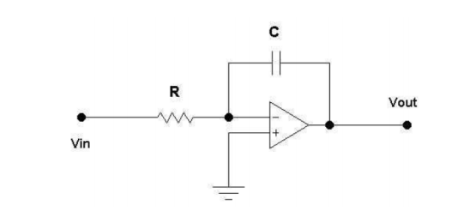

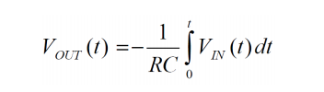

It is assumed that the capacitor is initially uncharged. The integrator can be used to turn a square wave into a triangle wave or turn triangle waves into sine waves.

The differentiator can be created by switching the resistor and capacitor. The output is simply the derivative of the input. The configuration and equation are shown below. 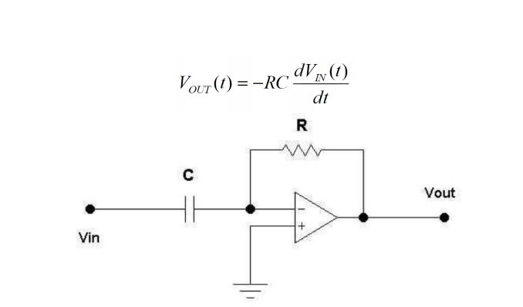

**Simulations**

**Integrator Circuit**

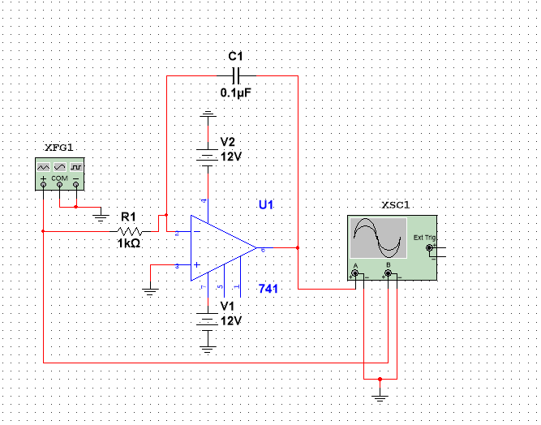

Sign Wave Integrator with 0.1 microfarad capacitor

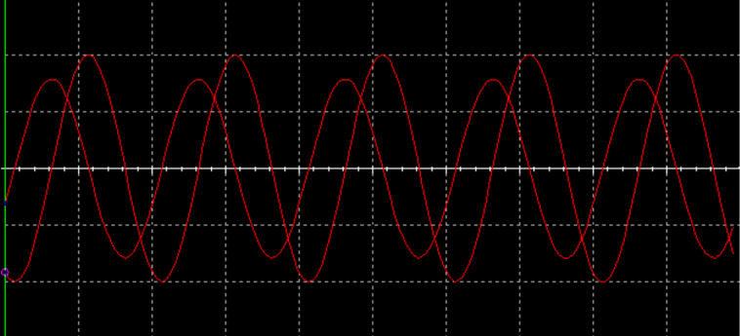

Triangle Wave Integrator with 0.1 microfarad capacitor

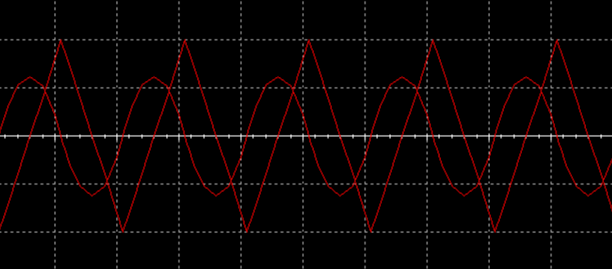

Square Wave Integrator with 0.1 microfarad capacitor

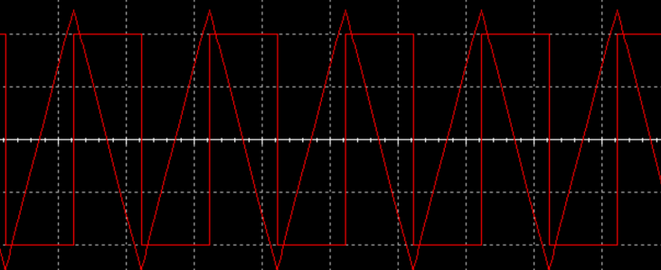

Sign Wave Integration with a 1 microfarad capacitor

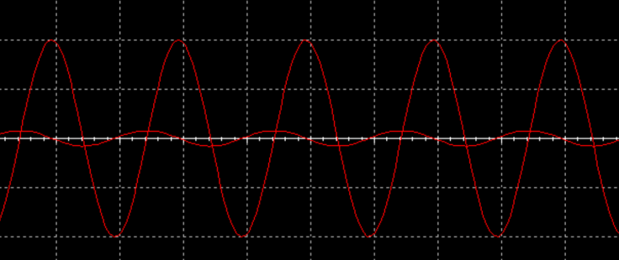

Triangle Wave Integration with a 1 microfarad capacitor

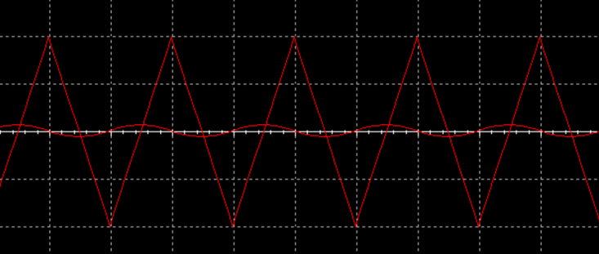

Square Wave Integration with a 1 microfarad capacitor

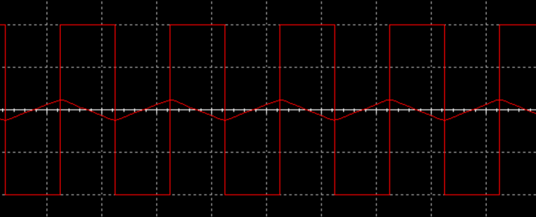

**Differentiator Circuit**

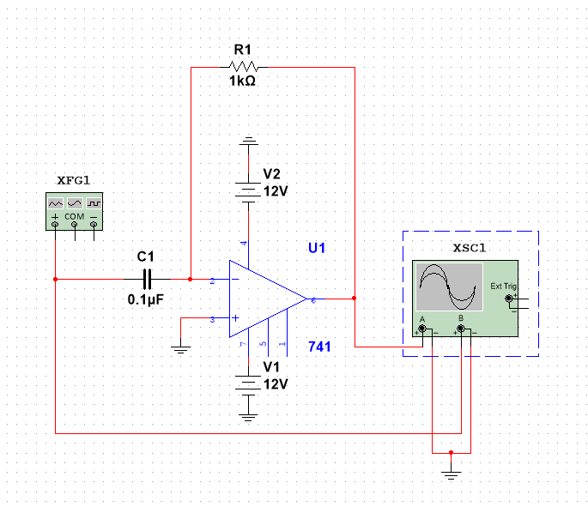

Sign Wave Differentiator with 0.1 microfarad capacitor

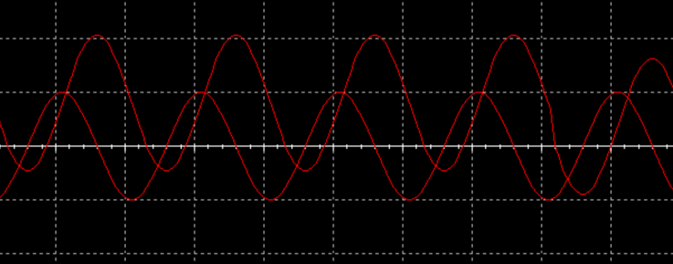

Triangle Wave Differentiator with 0.1 microfarad capacitor

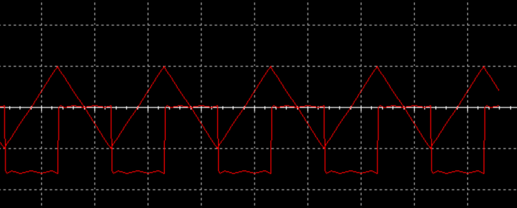

Square Wave Differentiator with 0.1 microfarad capacitor

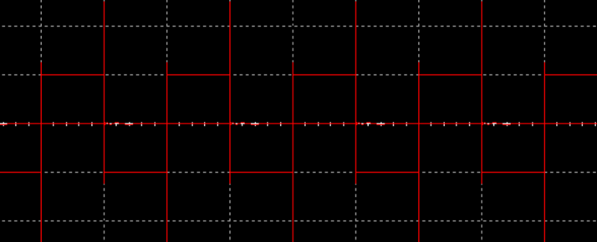

Sign Wave Differentiator with 1 microfarad capacitor

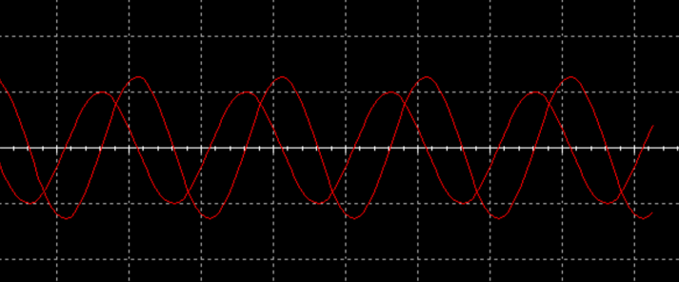

Triangle Wave Differentiator with 1 microfarad capacitor

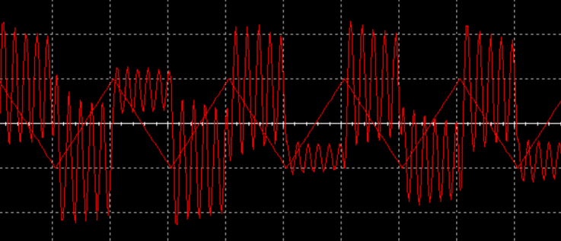

Square Wave Differentiator with 1 microfarad capacitor

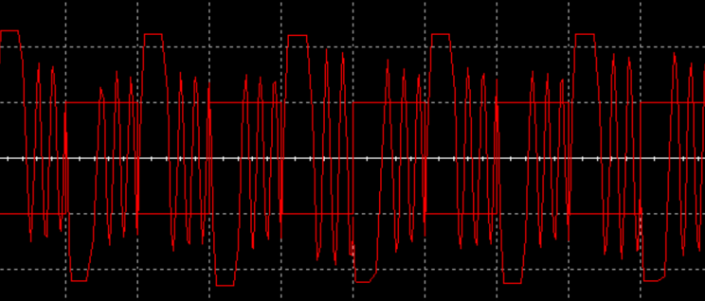

The larger the capacitor, the smaller the gain. The relationship between inputs and outputs is shown below.

|  |  |  |
| --- | --- | --- |
| Input | Integrator | Differentiator |
| Sine | Phase Shifted Sine | Voltage Shifted Sine |
| Triangle | Sine | Voltage Shifted Square |
| Square | Triangle | Impulse |

**Results and Discussion**

The table below shows the relationship between the inputs and outputs.

|  |  |  |
| --- | --- | --- |
| Input | Integrator | Differentiator |
| Sine | Phase Shifted Sine | Voltage Shifted Sine |
| Triangle | Sine | Voltage Shifted Square |
| Square | Triangle | Impulse |

The two circuits behaved exactly as expected in the simulator. However, if these experiments were performed with actual components, then some variance would be expected.

**Conclusion**

The purpose of this lab was to experiment if integrator and differentiator configurations of op-amp circuitry. The expectation of the simulation was given by the table shown in the results section. The simulation verifies this table. This lab verified the important ideas behind integrators and differentiators.