Prelab 3

Austin Brown

**Integrator Circuit**

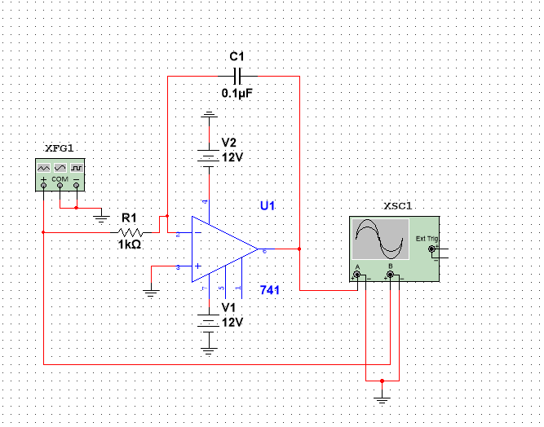

Sign Wave Integrator with 0.1 microfarad capacitor

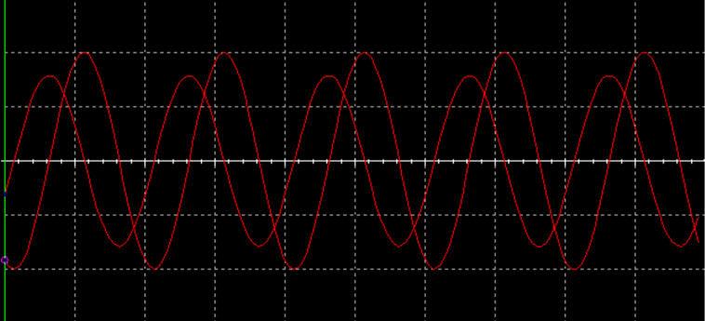

Triangle Wave Integrator with 0.1 microfarad capacitor

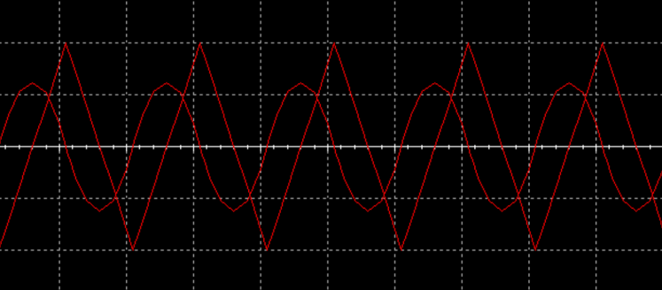

Square Wave Integrator with 0.1 microfarad capacitor

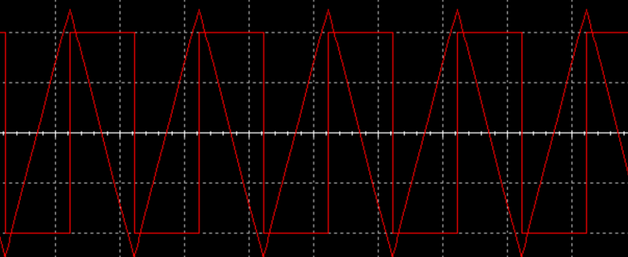

Sign Wave Integration with a 1 microfarad capacitor

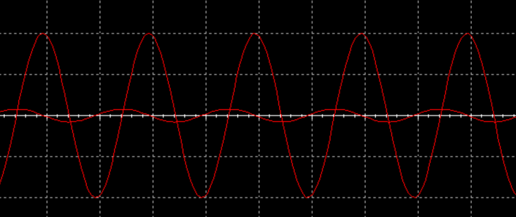

Triangle Wave Integration with a 1 microfarad capacitor

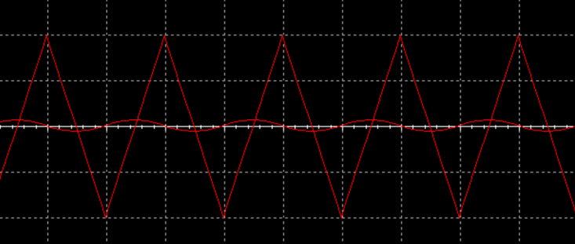

Square Wave Integration with a 1 microfarad capacitor

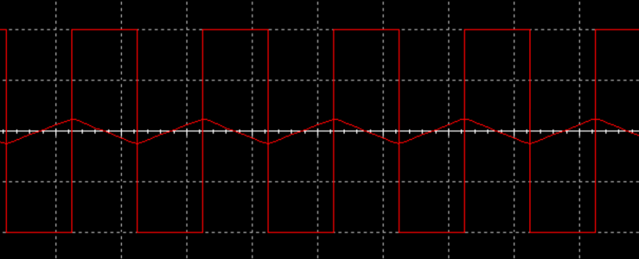

**Differentiator Circuit**

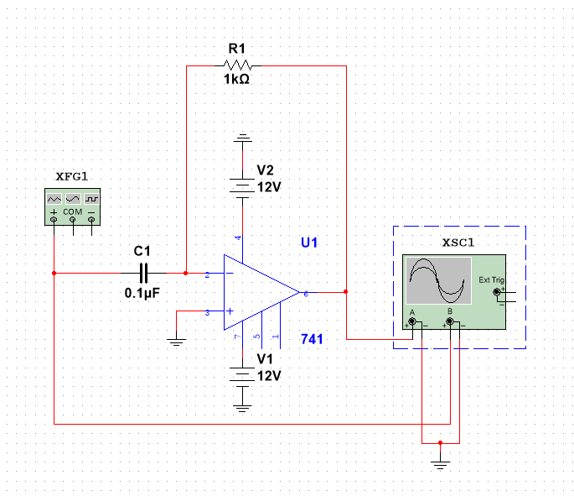

Sign Wave Differentiator with 0.1 microfarad capacitor

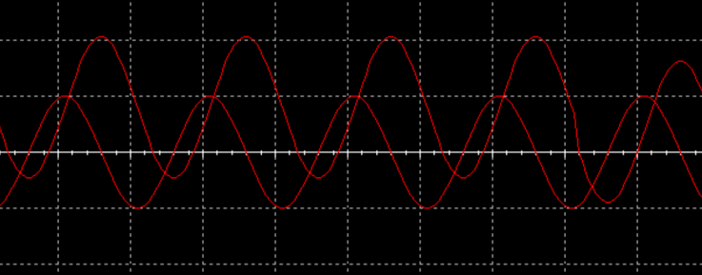

Triangle Wave Differentiator with 0.1 microfarad capacitor

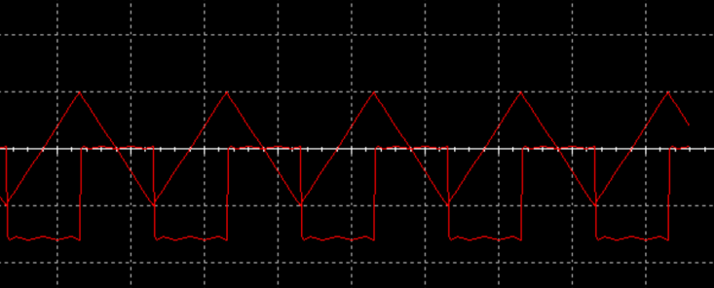

Square Wave Differentiator with 0.1 microfarad capacitor

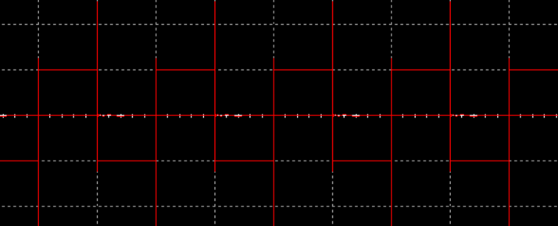

Sign Wave Differentiator with 1 microfarad capacitor

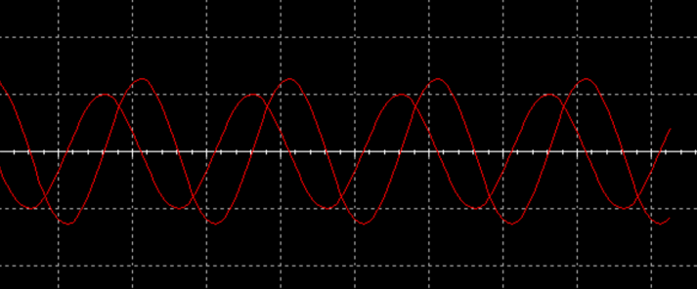

Triangle Wave Differentiator with 1 microfarad capacitor

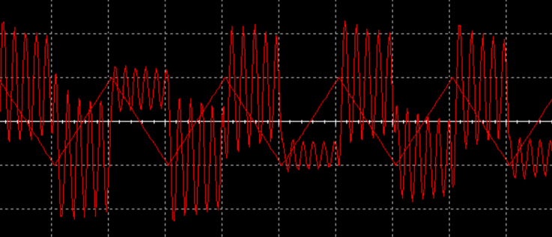

Square Wave Differentiator with 1 microfarad capacitor

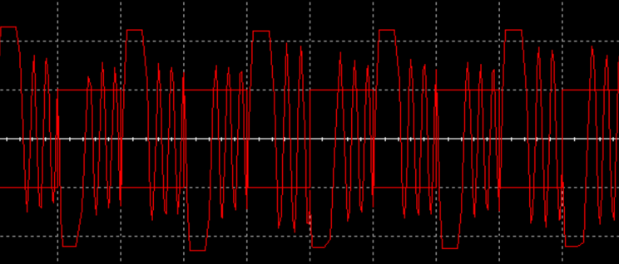

The larger the capacitor, the smaller the gain. The relationship between inputs and outputs is shown below.

|  |  |  |
| --- | --- | --- |
| Input | Integrator | Differentiator |
| Sine | Phase Shifted Sine | Voltage Shifted Sine |
| Triangle | Sine | Voltage Shifted Square |
| Square | Triangle | Impulse |