Austin Brown

Prelab 4

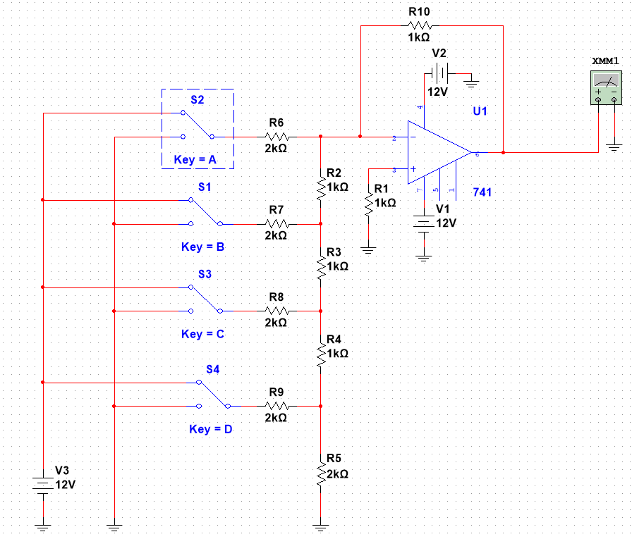

|  |  |  |  |  |  |
| --- | --- | --- | --- | --- | --- |
| Input State | | | | | Simulation |
|  | VA | VB | VC | VD | VO (V) |
| 0 | 0 | 0 | 0 | 0 | 0.002 |
| 1 | 0 | 0 | 0 | 1 | -0.310 |
| 2 | 0 | 0 | 1 | 0 | -0.623 |
| 3 | 0 | 0 | 1 | 1 | -0.935 |
| 4 | 0 | 1 | 0 | 0 | -1.248 |
| 5 | 0 | 1 | 0 | 1 | -1.56 |
| 6 | 0 | 1 | 1 | 0 | -1.975 |
| 7 | 0 | 1 | 1 | 1 | -2.185 |
| 8 | 1 | 0 | 0 | 0 | -2.498 |
| 9 | 1 | 0 | 0 | 1 | -2.81 |
| 10 | 1 | 0 | 1 | 0 | -3.123 |
| 11 | 1 | 0 | 1 | 1 | -3.435 |
| 12 | 1 | 1 | 0 | 0 | -3.748 |
| 13 | 1 | 1 | 0 | 1 | -4.06 |
| 14 | 1 | 1 | 1 | 0 | -4.373 |
| 15 | 1 | 1 | 1 | 1 | -4.685 |