Electric Circuits & Electronics Design Lab EE 316-08

Lab 5: Basic Filters and Frequency Response

By: Austin Brown

**Intro**

The purpose of this lab is to examine the implementation and effects of low and high pass filters. We will observe things such as cutoff frequency, phase, and amplitude. This lab will be broken into a theory section in which we will examine how filters work and perform some hand calculations. We will then look at the simulation results. Finally, we will compare the hand calculations and simulation results.

**Theory**

A filter is a circuit or device that blocks or passes a certain range of frequencies. In this lab, we will discuss lowpass and highpass filters. A lowpass filter passes lower frequencies and rejects higher frequencies. An ideal lowpass filter will reject everything above the cutoff frequency and pass everything below however they are impossible to realize. It is simple to design a lowpass filter. The configuration is below.

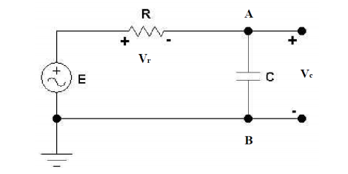

The voltage across the capacitor is:

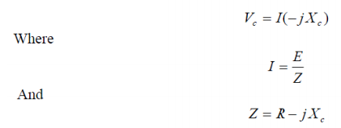

Once you substitute Vc you get:

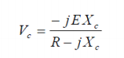

Recalling that:



After substituting we get:

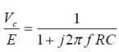

Then we take the magnitude and get:

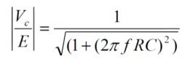

Based on the above equation, we can see that the gain increases as the frequency increase. The phase angle is shown below.



Highpass filters do the opposite of lowpass filters. They pass frequencies above a certain threshold and reject frequencies below a threshold. Just like with lowpass filters, ideal highpass are impossible to realize. The setup is shown below.

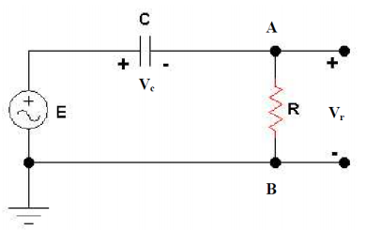

The voltage across the resistor is:

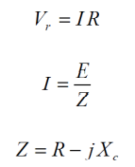

After making some substitutions:

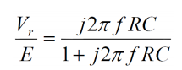

Using the definition of gain you get:

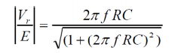

The phase angle is calculated below:



The cutoff frequency is the frequency where magnitude of the gain equals $\frac{1}{\sqrt{2}}$. Thus, we have:

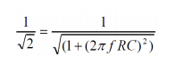

When you replace f with fc you get:



Lowpass Filter Results

|  |  |  |
| --- | --- | --- |
|  | **Theoretical** | |
| f (Hz) | Gain (dB) | Phase Angle (degrees) |
| 25 | -0.105 | -8.938 |
| 50 | -0.409 | -17.418 |
| 75 | -0.877 | -25.210 |
| 100 | -1.442 | -32.143 |
| 150 | -2.757 | -43.316 |
| 200 | -4.110 | -51.452 |
| 300 | -6.577 | -62.051 |
| 500 | -10.371 | -72.365 |
| 600 | -11.835 | -75.172 |
| 700 | -13.073 | -77.177 |
| 800 | -14.199 | -78.724 |
| 900 | -15.189 | -79.985 |
| 1000 | -16.082 | -80.959 |

Lowpass Filter Gain Vs Frequency

Lowpass Filter Phase Vs Frequency

|  |  |  |
| --- | --- | --- |
|  | **Theoretical** | |
| f (Hz) | Gain (dB) | Phase Angle (degrees) |
| 25 | -16.193 | 81.074 |
| 50 | -10.458 | 72.536 |
| 75 | -7.412 | 64.744 |
| 100 | -5.482 | 57.869 |
| 150 | -3.274 | 46.696 |
| 200 | -2.136 | 38.503 |
| 300 | -1.081 | 27.960 |
| 500 | -0.418 | 17.647 |
| 600 | -0.291 | 14.840 |
| 700 | -0.220 | 12.834 |
| 800 | -0.167 | 11.230 |
| 900 | -0.131 | 10.027 |
| 1000 | -0.105 | 9.053 |

Highpass Filter Gain Vs Frequency

Highpass Filter Phase Vs Frequency

**Simulations**

In this part of the lab, we simulate the circuits that were described in the theory section. To accomplish this, we use the Multisim software. First, I will show the simulation of the lowpass filter and then the highpass filter.

Lowpass Filter Circuit

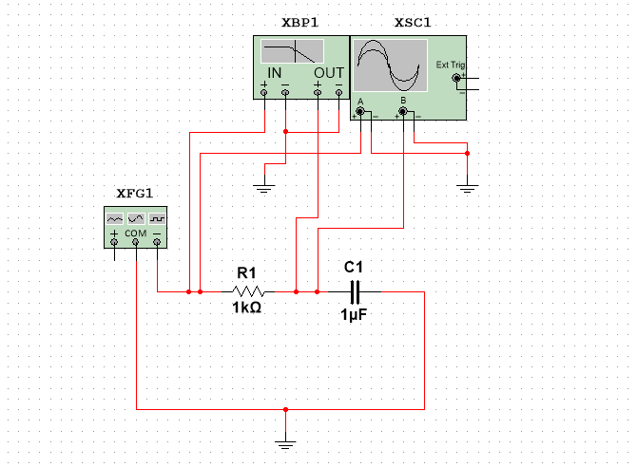

Voltage Output

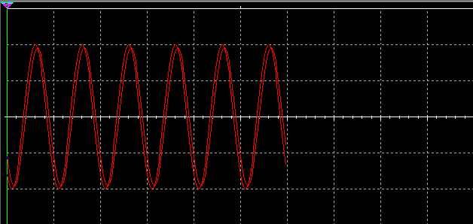

Bode Plot

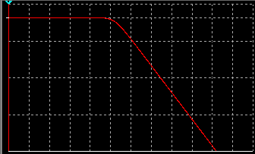

Phase

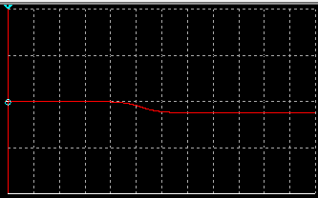

High Pass Filter Circuit

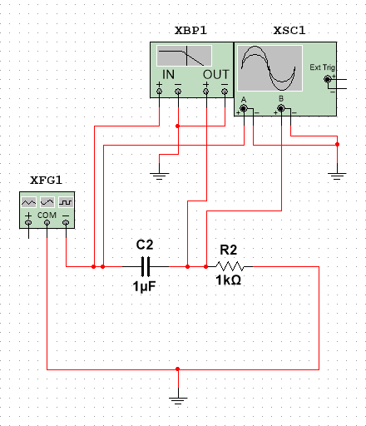

Voltage Output

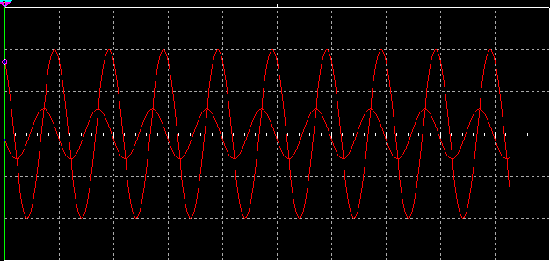

Bode Plot

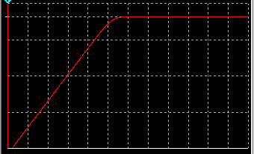

Phase

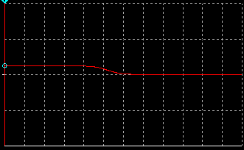

**Results and Discussion**

This section will discuss the results of the hand calculations and the simulations. Below is the plot of the gain vs frequency plot.

We know that the cutoff frequency is 160 Hz, but cutoff is not instant. This is since the filter is not ideal. An ideal lowpass filter is shown below.

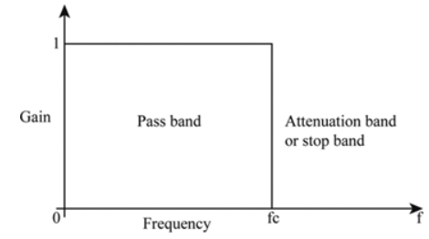

For a lowpass filter, as frequency increases, phase should approach 90 degrees.

The highpass filter is the opposite. The gain vs frequency is shown below.

Much like the lowpass filter, this response is not ideal. The ideal highpass filter is shown below.

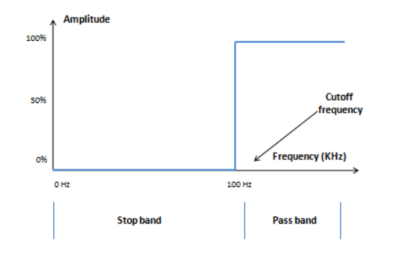

Like the lowpass filter, the phase should approach 90 degrees as the input frequency increases.

**Conclusion**

In this lab, we looked at lowpass and highpass filters. We verified the expectations of gain and phase that we got from hand calculations by using the simulator. This lab helped me understand the core ideas behind lowpass and highpass filters.

**Appendix**

Calculations for Lowpass filter

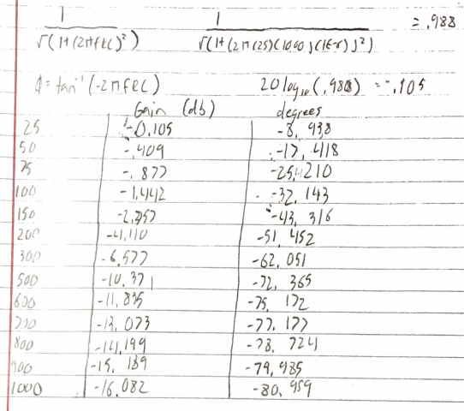

Calculations for Highpass Filter

