Austin Brown

Prelab 6

Simulation 1

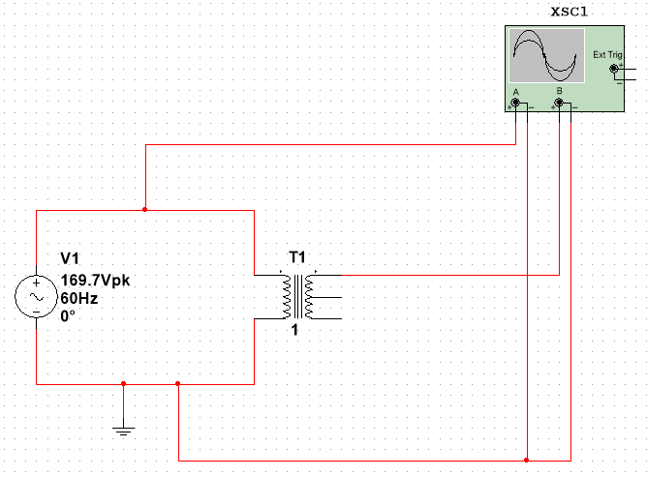

The period of the waveforms is 16.7 milliseconds. The frequency is 59.88 Hz. This is close to 60 Hz. Some variance is expected.

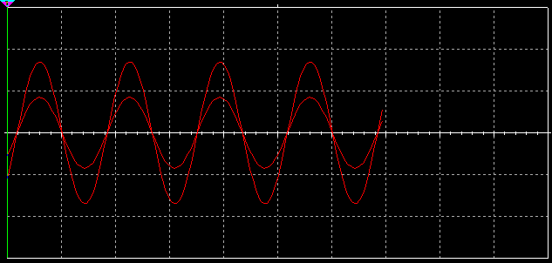

Simulation 2

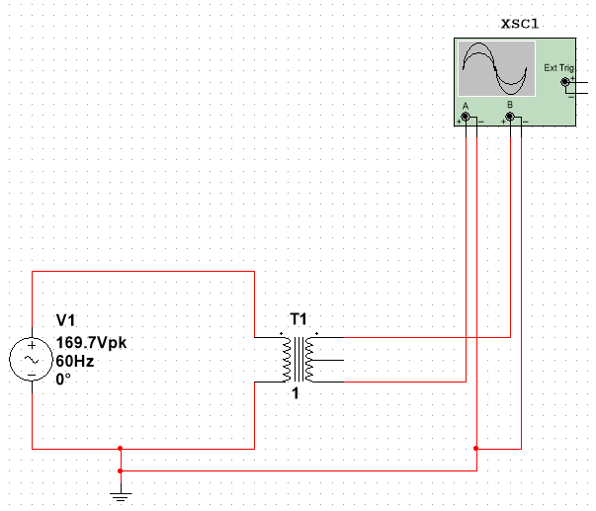

In this example, the polarity of the transformer is reversed. This is what causes the phase shift.

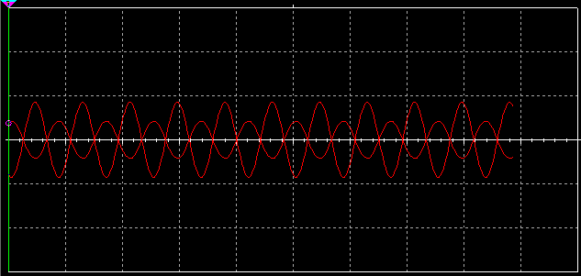

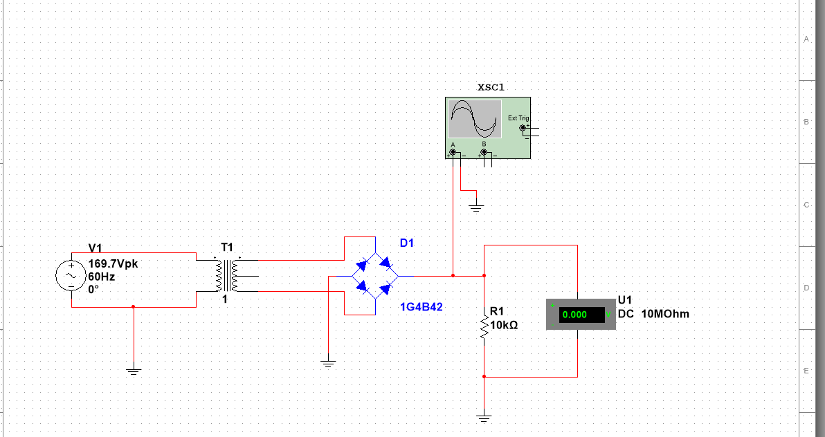

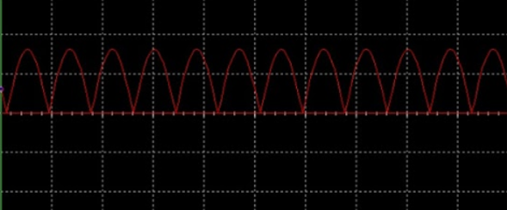

The peak output voltage is 16 volts. This means that the RMS voltage is 11.312. The ripple period is 8.33 milliseconds which means the frequency is 120 Hz. The voltage across the 10k resistor was measured to be 10.2 volts.