Electric Circuits & Electronics Design Lab EE 316-08

Lab 6: AC Signals, Transformers and Bridge Rectifiers

By: Austin Brown

**Intro:**

The purpose of this lab is to discuss transformers, and diodes and how they affect AC signals. This lab will be broken into several sections. The first section is the theory section. Here, we will discuss the concepts used in the lab. Next, we have the simulation section where we will show the simulation results. After that, I will discuss the results of the simulation.

**Theory**

The most basic concept in this lab is the AC waveform. There are several ways to quantify an AC waveform. One way is to use the peak of the waveform. This should be measured from 0. A more common way is to use root-mean-squared (RMS). The definition is shown below.

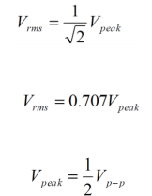

RMS is used because it is used in power equations.

A transformer is a device that takes advantage of Faraday’s Law of Induction. They use two or more coils that have been coupled together to step up or step down AC signals. The configuration of a simple transformer is shown below.

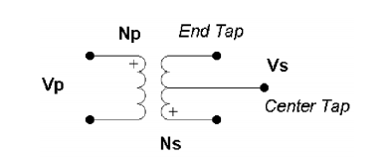

The input is known as the primary, and the output is the secondary. Np and Ns are the number of primary and secondary turns, respectively. Vp and Vs are the primary and secondary voltages, respectively. The equations for an ideal transformer are:

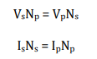

In this lab, we are using a full wave bridge rectifier. This setup requires four diodes. This will convert the sinusoid into a ripple. This ripple will then be smoothed out with a capacitor. The output of the wave bridge rectifier is shown below.

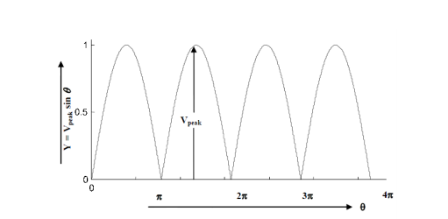

The formula to calculate the average DC output of a wave bridge rectifier is shown below.

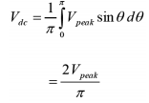

Ripple frequency is also defined below:



In the figure below, points A, B, C, and D are 10K ohms. The turns ratio is 10. The frequency is 10 Hz, and the peak voltage is 120 volts RMS. The peak-to-peak voltage is 2 volts.

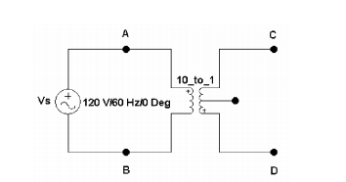

The output waveforms are shown below.

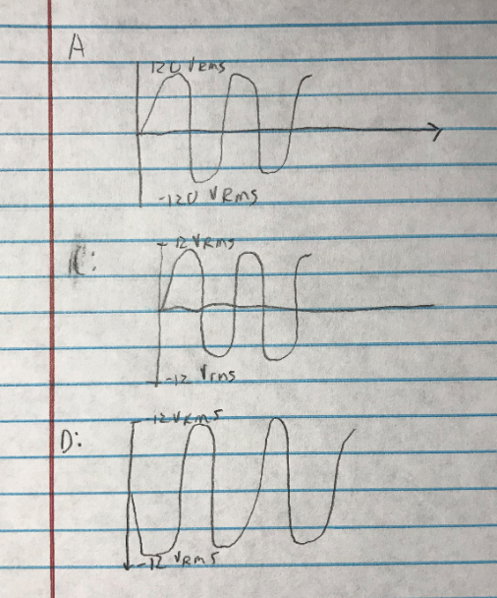

The DC value was calculated to be 7.639 volts. The ripple frequency is 120 Hz. The ripple frequency would be 60 Hz if a half wave rectifier were used.

**Simulations**

A transformer was setup in Multisim. The primary coil is 100 mH, and the secondary coil is 1 mH. The input voltage is 120 volts RMS. The transformer steps the voltage down by a factor of ten.

The first channel is connected to node and the second channel is connected to node c.

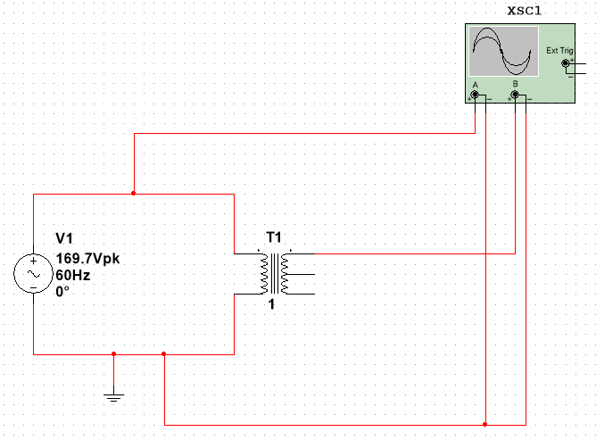

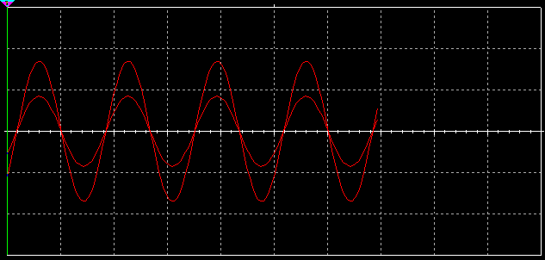

In the figure below, we attach channel a to node d.

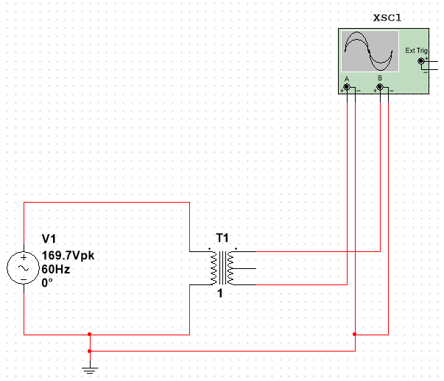

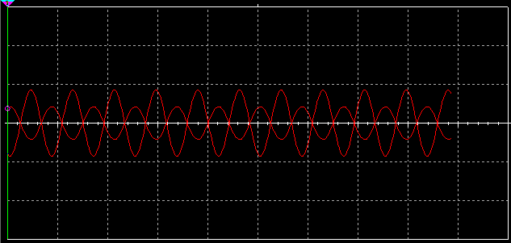

A full wave bridge rectifier is shown below.

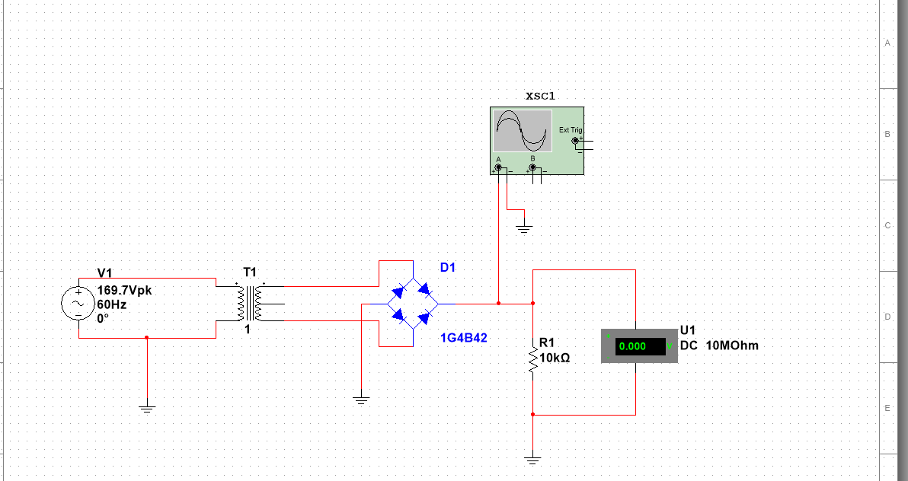

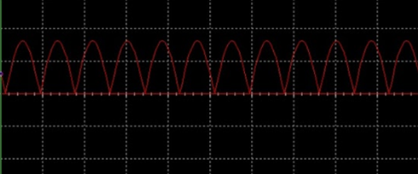

**Discussion and Results**

In simulation 1, the input voltage was stepped down by a factor of 10. The output waveform was in phase with the input waveform. In simulation 2, the output was also stepped down by a factor of 10, however, they are out of phase. This is because the transformer’s polarity has been reversed. In the full wave bridge rectifier, the peak output is 16 volts. This is equal to 11.312 volts RMS. The ripple period is 8.33 ms. The voltage across the resistor was measured to be 10.2 volts. The ripple voltage could be smoothed by using a capacitor. This would bring the output much closer to being DC. The output could be further smoothed by using a Zener diode as a voltage regulator. These additions would make the circuit very close to a DC output.

**Conclusion**

The point of this lab was to examine AC signals, diodes, transformers, and how they can be used to turn an AC signal into DC. We examined these concepts by using Multisim to simulate the circuits and observe the waveforms. This laboratory helped us to better understand the purpose of transformers and diodes.