**Lab 7**

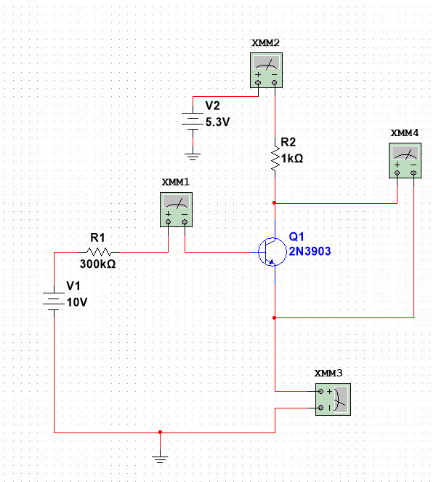

|  |  |  |  |  |  |  |
| --- | --- | --- | --- | --- | --- | --- |
| V1 (V) | V2 (V) | Ib (µA) | Ic (mA) | Ie (mA) | Vce (V) | 𝛽 |
| 4 | 0.0 | 11.500 | 0.003 | 0.015 | 0.008 | 0.261 |
| 0.2 | 11.284 | 0.134 | 0.145 | 0.077 | 11.875 |
| 0.4 | 11.214 | 0.309 | 0.320 | 0.102 | 27.555 |
| 0.6 | 11.175 | 0.493 | 0.504 | 0.119 | 44.116 |
| 0.8 | 11.147 | 0.697 | 0.690 | 0.132 | 60.913 |
| 1.0 | 11.126 | 0.866 | 0.877 | 0.145 | 77.836 |
| 1.2 | 11.109 | 1.052 | 1.063 | 0.159 | 94.698 |
| 1.4 | 11.095 | 1.236 | 1.247 | 0.175 | 111.402 |
| 1.6 | 11.084 | 1.411 | 1.422 | 0.200 | 127.301 |
| 1.8 | 11.076 | 1.543 | 1.554 | 0.268 | 139.310 |
| 2.0 | 11.075 | 1.558 | 1.569 | 0.453 | 140.677 |
| 2.2 | 11.075 | 1.562 | 1.573 | 0.649 | 141.038 |
| 2.4 | 11.075 | 1.566 | 1.577 | 0.845 | 141.400 |
| 2.6 | 11.075 | 1.570 | 1.581 | 1.041 | 141.761 |
| 6 | 0.0 | 18.118 | 0.007 | 0.025 | 0.011 | 0.386 |
| 0.3 | 17.891 | 0.286 | 0.286 | 0.083 | 14.980 |
| 0.7 | 17.827 | 0.577 | 0.595 | 0.107 | 32.367 |
| 1.0 | 17.789 | 0.894 | 0.912 | 0.123 | 50.256 |
| 1.3 | 17.763 | 1.214 | 1.232 | 0.137 | 68.344 |
| 1.7 | 17.743 | 1.534 | 1.552 | 0.150 | 86.457 |
| 2.0 | 17.726 | 1.853 | 1.871 | 0.165 | 104.536 |
| 2.3 | 17.712 | 2.168 | 2.186 | 0.183 | 122.403 |
| 2.7 | 17.701 | 2.469 | 2.487 | 0.215 | 139.484 |
| 3.0 | 17.695 | 2.628 | 2.646 | 0.390 | 148.517 |
| 3.3 | 17.695 | 2.639 | 2.657 | 0.712 | 149.138 |
| 3.7 | 17.695 | 2.651 | 2.669 | 1.034 | 149.816 |
| 4.0 | 17.695 | 2.662 | 2.680 | 1.356 | 150.438 |
| 8  8 | 0.0 | 24.752 | 0.012 | 0.037 | 0.013 | 0.485 |
| 0.5 | 24.516 | 0.436 | 0.461 | 0.088 | 17.784 |
| 1.0 | 24.454 | 0.913 | 0.937 | 0.112 | 37.335 |
| 1.5 | 24.417 | 1.396 | 1.420 | 0.129 | 57.173 |
| 2.0 | 24.391 | 1.881 | 1.905 | 0.143 | 77.119 |
| 2.5 | 24.371 | 2.367 | 2.391 | 0.158 | 97.124 |
| 3.0 | 24.354 | 2.850 | 2.874 | 0.175 | 117.024 |
| 3.5 | 24.340 | 3.324 | 3.348 | 0.200 | 136.565 |
| 4.0 | 24.330 | 3.715 | 3.739 | 0.309 | 152.692 |
| 4.5 | 24.330 | 3.745 | 3.769 | 0.779 | 153.925 |
| 5.0 | 24.330 | 3.769 | 7.793 | 1.255 | 154.912 |
| 5.5 | 24.330 | 3.793 | 3.817 | 1.731 | 155.898 |
| 6.0 | 24.330 | 3.817 | 3.841 | 2.207 | 156.885 |
| 10 | 0.0 | 31.393 | 0.017 | 0.048 | 0.014 | 0.541522 |
| 1.0 | 31.118 | 0.927 | 0.958 | 0.104 | 29.790 |
| 2.0 | 31.056 | 1.899 | 1.930 | 0.013 | 61.148 |
| 3.0 | 31.019 | 2.877 | 2.908 | 0.154 | 92.750 |
| 4.0 | 30.993 | 3.850 | 3.881 | 0.181 | 124.222 |
| 5.0 | 30.974 | 4.769 | 4.800 | 0.262 | 153.968 |
| 6.0 | 30.973 | 4.881 | 4.912 | 1.149 | 157.589 |
| 7.0 | 30.973 | 4.943 | 4.974 | 2.088 | 159.591 |
| 8.0 | 30.973 | 5.004 | 5.035 | 3.027 | 161.560 |
| 9.0 | 30.973 | 5.065 | 5.095 | 3.966 | 163.530 |

Characteristic Curves

Q Point

|  |  |  |
| --- | --- | --- |
| V1 (V) | Current (mA) | Voltage (V) |
| 4 | 4.6 | 6 |
| 6 | 3.67 | 9 |
| 8 | 2.68 | 9.8 |
| 10 | 1.6 | 10 |

**Lab 8**

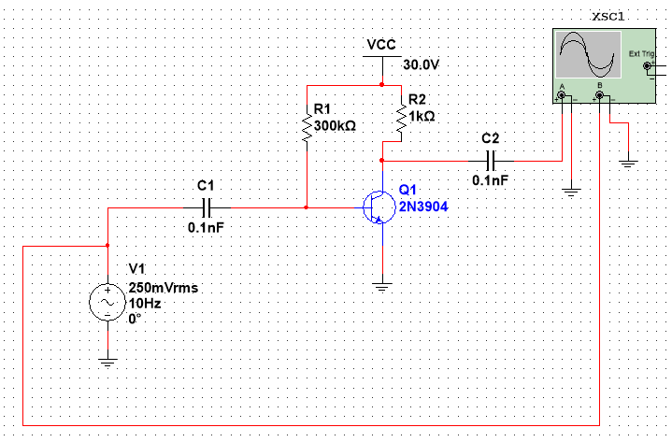

|  |  |  |
| --- | --- | --- |
| Frequency | Vout | Gain (dB) |
| 10 Hz | 0.250 mV | -60.000 |
| 30 Hz | 0.751 mV | -50.441 |
| 60 Hz | 1.499 mV | -44.443 |
| 100 Hz | 2.504 mV | -39.986 |
| 200 Hz | 5.011 mV | -33.960 |
| 500 Hz | 12.639 mV | -25.925 |
| 1 kHz | 25.182 mV | -19.937 |
| 2 kHz | 50.308 mV | -13.926 |
| 5 kHz | 125.563 mV | -5.982 |
| 10 kHz | 251.249 mV | 0.043 |
| 15 kHz | 373.498 mV | 3.487 |
| 20 kHz | 505.217 mV | 6.111 |
| 50 kHz | 1.266 | 14.090 |
| 75 kHz | 1.787 | 17.084 |
| 100 kHz | 2.335 | 19.407 |
| 150 kHz | 3.679 | 23.356 |
| 200 kHz | 4.704 | 25.491 |
| 500 kHz | 6.531 | 28.341 |
| 750 kHz | 8.179 | 30.295 |
| 1 MHz | 8.346 | 30.471 |
| 1.5 MHz | 8.363 | 30.592 |
| 2.0 MHz | 8.492 | 30.621 |

**Frequency Vs Gain**

10 Hz

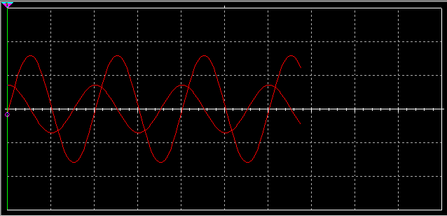

2 MHz

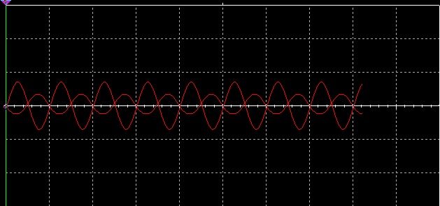

The 2 MHz waveform is clipped at the peaks. Vcc is not supplying enough power. The output voltage must be less than 8 volts for it to be unclipped. The output is also clipped at 700 kHz. Vcc must be at least 30 volts for a proper output to occur. Basically, the solution is to increase Vcc. This will increase the gain at upper frequencies.