Electric Circuits & Electronics Design Lab EE 316-08

Lab 7_8: Characteristics of BJT and Amplification Behavior

By: Austin Brown

**Introduction**

In this lab we will look at bipolar junction transistors (BJT). This report will be broken into a theory section where we will look at how BJTs work, a simulation section which will display the simulation results, the discussion section will discuss the simulation results, and the conclusion.

**Theory**

The BJT has a collector, an emitter, and a base. The base allows current to flow to the collector and emitter. There are 2 different configurations. They are NPN and PNP. NPN has a base with a P type material. The collector and emitter are N type. PNP is the opposite. It has a N type material for the base. The emitter and collector are P type.

BJTs also have 2 operating modes. They are forward and reverse active mode. Forward mode is where the current flows in the direction of the base collector. Reverse active mode is where current flows in the opposite direction on the base.

The schematic and appearance of the BJT is shown below.

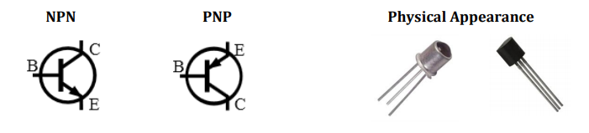

The output characteristic is shown below.

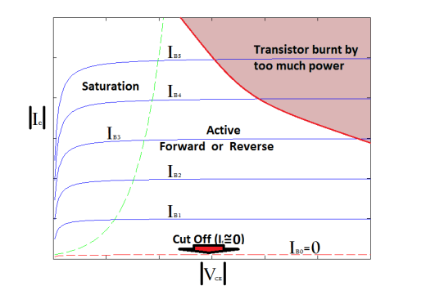

The common collector configuration:

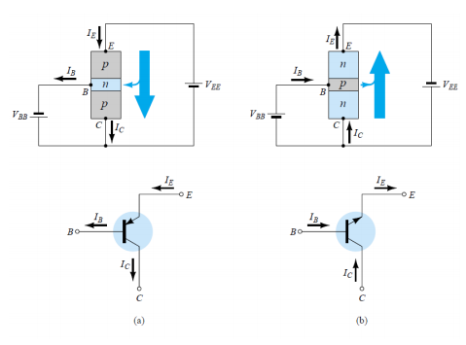

The equations below are used throughout the lab.

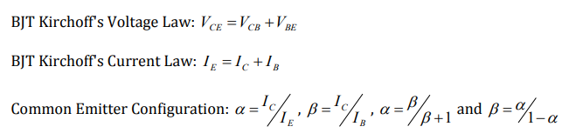

**Simulation**

Lab 7

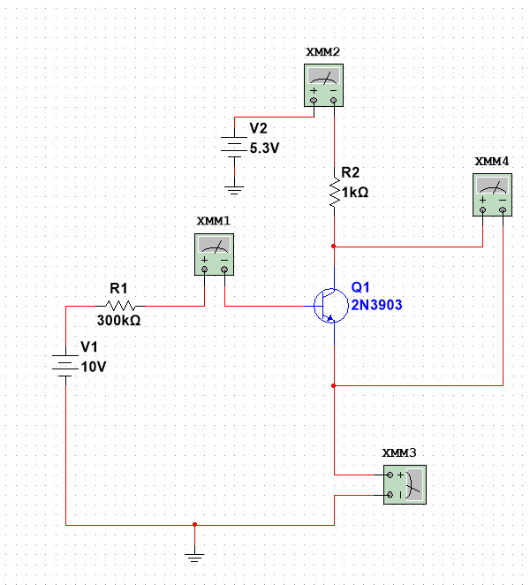

|  |  |  |  |  |  |  |
| --- | --- | --- | --- | --- | --- | --- |
| V1 (V) | V2 (V) | Ib (µA) | Ic (mA) | Ie (mA) | Vce (V) | 𝛽 |
| 4 | 0.0 | 11.500 | 0.003 | 0.015 | 0.008 | 0.261 |
| 0.2 | 11.284 | 0.134 | 0.145 | 0.077 | 11.875 |
| 0.4 | 11.214 | 0.309 | 0.320 | 0.102 | 27.555 |
| 0.6 | 11.175 | 0.493 | 0.504 | 0.119 | 44.116 |
| 0.8 | 11.147 | 0.697 | 0.690 | 0.132 | 60.913 |
| 1.0 | 11.126 | 0.866 | 0.877 | 0.145 | 77.836 |
| 1.2 | 11.109 | 1.052 | 1.063 | 0.159 | 94.698 |
| 1.4 | 11.095 | 1.236 | 1.247 | 0.175 | 111.402 |
| 1.6 | 11.084 | 1.411 | 1.422 | 0.200 | 127.301 |
| 1.8 | 11.076 | 1.543 | 1.554 | 0.268 | 139.310 |
| 2.0 | 11.075 | 1.558 | 1.569 | 0.453 | 140.677 |
| 2.2 | 11.075 | 1.562 | 1.573 | 0.649 | 141.038 |
| 2.4 | 11.075 | 1.566 | 1.577 | 0.845 | 141.400 |
| 2.6 | 11.075 | 1.570 | 1.581 | 1.041 | 141.761 |
| 6 | 0.0 | 18.118 | 0.007 | 0.025 | 0.011 | 0.386 |
| 0.3 | 17.891 | 0.286 | 0.286 | 0.083 | 14.980 |
| 0.7 | 17.827 | 0.577 | 0.595 | 0.107 | 32.367 |
| 1.0 | 17.789 | 0.894 | 0.912 | 0.123 | 50.256 |
| 1.3 | 17.763 | 1.214 | 1.232 | 0.137 | 68.344 |
| 1.7 | 17.743 | 1.534 | 1.552 | 0.150 | 86.457 |
| 2.0 | 17.726 | 1.853 | 1.871 | 0.165 | 104.536 |
| 2.3 | 17.712 | 2.168 | 2.186 | 0.183 | 122.403 |
| 2.7 | 17.701 | 2.469 | 2.487 | 0.215 | 139.484 |
| 3.0 | 17.695 | 2.628 | 2.646 | 0.390 | 148.517 |
| 3.3 | 17.695 | 2.639 | 2.657 | 0.712 | 149.138 |
| 3.7 | 17.695 | 2.651 | 2.669 | 1.034 | 149.816 |
| 4.0 | 17.695 | 2.662 | 2.680 | 1.356 | 150.438 |
| 8  8 | 0.0 | 24.752 | 0.012 | 0.037 | 0.013 | 0.485 |
| 0.5 | 24.516 | 0.436 | 0.461 | 0.088 | 17.784 |
| 1.0 | 24.454 | 0.913 | 0.937 | 0.112 | 37.335 |
| 1.5 | 24.417 | 1.396 | 1.420 | 0.129 | 57.173 |
| 2.0 | 24.391 | 1.881 | 1.905 | 0.143 | 77.119 |
| 2.5 | 24.371 | 2.367 | 2.391 | 0.158 | 97.124 |
| 3.0 | 24.354 | 2.850 | 2.874 | 0.175 | 117.024 |
| 3.5 | 24.340 | 3.324 | 3.348 | 0.200 | 136.565 |
| 4.0 | 24.330 | 3.715 | 3.739 | 0.309 | 152.692 |
| 4.5 | 24.330 | 3.745 | 3.769 | 0.779 | 153.925 |
| 5.0 | 24.330 | 3.769 | 7.793 | 1.255 | 154.912 |
| 5.5 | 24.330 | 3.793 | 3.817 | 1.731 | 155.898 |
| 6.0 | 24.330 | 3.817 | 3.841 | 2.207 | 156.885 |
| 10 | 0.0 | 31.393 | 0.017 | 0.048 | 0.014 | 0.541522 |
| 1.0 | 31.118 | 0.927 | 0.958 | 0.104 | 29.790 |
| 2.0 | 31.056 | 1.899 | 1.930 | 0.013 | 61.148 |
| 3.0 | 31.019 | 2.877 | 2.908 | 0.154 | 92.750 |
| 4.0 | 30.993 | 3.850 | 3.881 | 0.181 | 124.222 |
| 5.0 | 30.974 | 4.769 | 4.800 | 0.262 | 153.968 |
| 6.0 | 30.973 | 4.881 | 4.912 | 1.149 | 157.589 |
| 7.0 | 30.973 | 4.943 | 4.974 | 2.088 | 159.591 |
| 8.0 | 30.973 | 5.004 | 5.035 | 3.027 | 161.560 |
| 9.0 | 30.973 | 5.065 | 5.095 | 3.966 | 163.530 |

Characteristic Curves

Q Point

|  |  |  |
| --- | --- | --- |
| V1 (V) | Current (mA) | Voltage (V) |
| 4 | 4.6 | 6 |
| 6 | 3.67 | 9 |
| 8 | 2.68 | 9.8 |
| 10 | 1.6 | 10 |

Lab 8

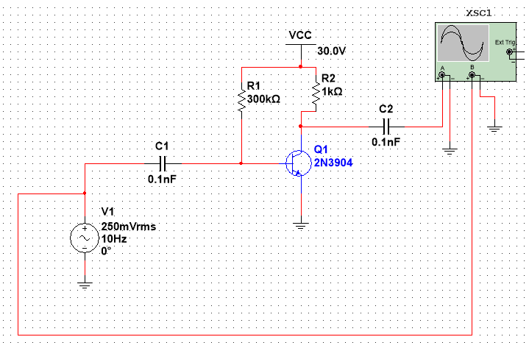

|  |  |  |
| --- | --- | --- |
| Frequency | Vout | Gain (dB) |
| 10 Hz | 0.250 mV | -60.000 |
| 30 Hz | 0.751 mV | -50.441 |
| 60 Hz | 1.499 mV | -44.443 |
| 100 Hz | 2.504 mV | -39.986 |
| 200 Hz | 5.011 mV | -33.960 |
| 500 Hz | 12.639 mV | -25.925 |
| 1 kHz | 25.182 mV | -19.937 |
| 2 kHz | 50.308 mV | -13.926 |
| 5 kHz | 125.563 mV | -5.982 |
| 10 kHz | 251.249 mV | 0.043 |
| 15 kHz | 373.498 mV | 3.487 |
| 20 kHz | 505.217 mV | 6.111 |
| 50 kHz | 1.266 | 14.090 |
| 75 kHz | 1.787 | 17.084 |
| 100 kHz | 2.335 | 19.407 |
| 150 kHz | 3.679 | 23.356 |
| 200 kHz | 4.704 | 25.491 |
| 500 kHz | 6.531 | 28.341 |
| 750 kHz | 8.179 | 30.295 |
| 1 MHz | 8.346 | 30.471 |
| 1.5 MHz | 8.363 | 30.592 |
| 2.0 MHz | 8.492 | 30.621 |

**Frequency Vs Gain**

10 Hz

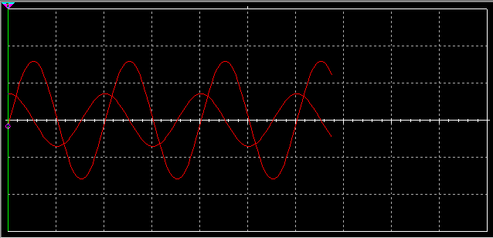

2 MHz

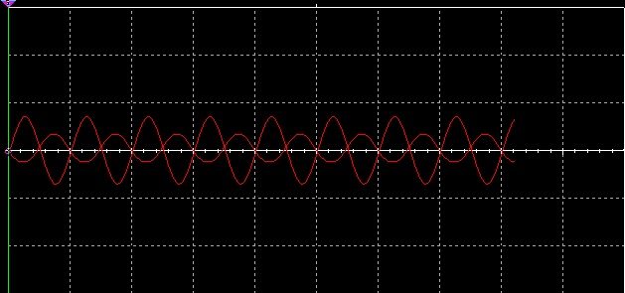

**Discussion**

The 2 MHz waveform is clipped at the peaks. Vcc is not supplying enough power. The output voltage must be less than 8 volts for it to be unclipped. The output is also clipped at 700 kHz. Vcc must be at least 30 volts for a proper output to occur. Basically, the solution is to increase Vcc. This will increase the gain at upper frequencies.

**Conclusion**

The purpose of this lab was to examine BJTs. We looked at NPN and PNP construction. We looked at the constants and equations in BJTs as well as how the work by simulating.