**Lab 9:**

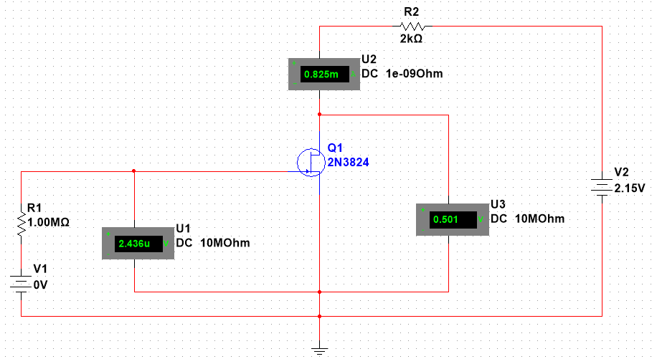

|  |  |  |  |
| --- | --- | --- | --- |
| Drain Characteristics | | | |
|  | Vgs = 0V | Vgs = -0.5V | Vgs = -1V |
| Vds (V) | Id (mA) | Id (mA) | Id (mA) |
| 0 | 0 | 0 | 0 |
| 0.5 | 0.825 | 0.606 | 0.387 |
| 1 | 1.434 | 1.000 | 0.565 |
| 2 | 2.004 | 1.183 | 0.572 |
| 4 | 2.037 | 1.195 | 0.578 |
| 8 | 2.077 | 1.220 | 0.590 |
| 12 | 2.119 | 1.245 | 0.602 |
| 16 | 2.164 | 1.272 | 0.615 |
| 20 | 2.196 | 1.297 | 0.629 |

|  |  |
| --- | --- |
|  | VDS = 6 V |
| VGS (V) | Id (mA) |
| 0.0 | 2.056 |
| -0.5 | 1.208 |
| -1 | 0.584 |
| -1.5 | 0.184 |
| -2.0 | 0.009 |
| -2.5 | 0.001 |

**Lab 10:**

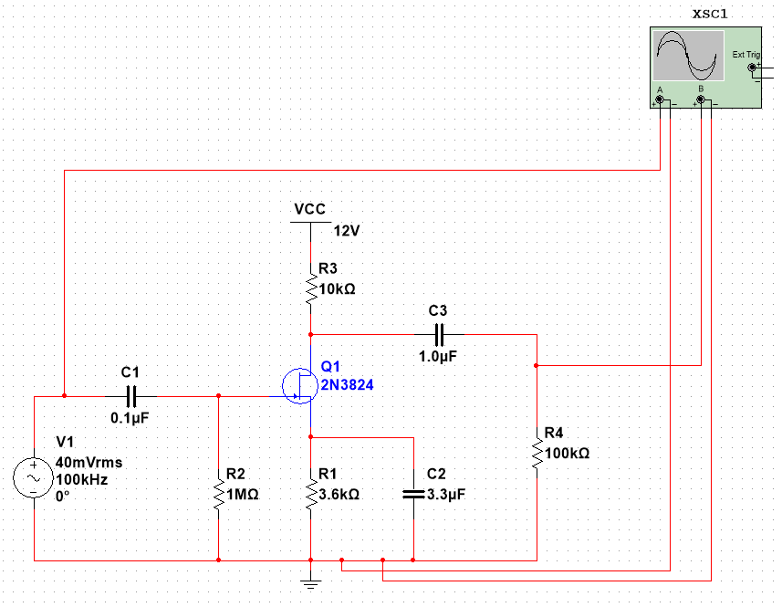

|  |  |  |
| --- | --- | --- |
| Frequency (Hz) | Vout (mV) | Gain |
| 30 | 0.280 | -37.077 |
| 45 | 0.603 | -30.414 |
| 60 | 0.987 | -26.134 |
| 100 | 2.226 | -19.070 |
| 200 | 5.300 | -11.535 |
| 500 | 11.697 | -4.659 |
| 1,000 | 16.037 | -1.918 |
| 10,000 | 19.488 | -0.225 |
| 100,000 | 19.297 | -0.310 |
| 500,000 | 19.269 | -0.323 |
| 1,000,000 | 19.265 | -0.325 |
| 1,500,000 | 19.286 | -0.315 |
| 2,000,000 | 19.392 | -0.268 |
| 3,000,000 | 19.537 | -0.203 |
| 4,000,000 | 19.319 | -0.300 |
| 5,000,000 | 19.250 | -0.331 |
| 7,000,000 | 19.588 | -0.180 |
| 10,000,000 | 19.453 | -0.240 |
| 11,000,000 | 19.257 | -0.328 |
| 12,000,000 | 19.564 | -0.191 |
| 15,000,000 | 19.534 | -0.204 |
| 16,000,000 | 19.522 | -0.210 |