Electric Circuits & Electronics Design Lab EE 316-08

Lab 9 and 10: Operating Characteristics of JFETs

By: Austin Brown

**Introduction**

In this lab we will look at junction field effect transistors (JFET). We will look at both NPN and PNP configurations. JFETs are exceptionally good for small signal amplification. This is because they have high impedance and low noise. This lab report covers both lab 9 and 10. Lab 9 discusses the way that JFETs work, and lab 10 covers small signal amplification.

**Theory**

A JFET has four parts. It has a body, a gate, a drain, and a source. There are 2 configurations. The N-channel has a body made of P material. The drain and source are both N materials. The p-channel is the opposite of this. The structure of both configurations is shown below.

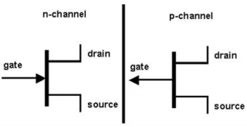

JFETs support a linear operating mode. This means that current flows through the body region. For this to work you must reach a certain voltage. This is the threshold voltage. JFETs also have a saturation and pinch-off mode. The pinch off voltage is the point at which the source current is constant. Below if the output characteristic.

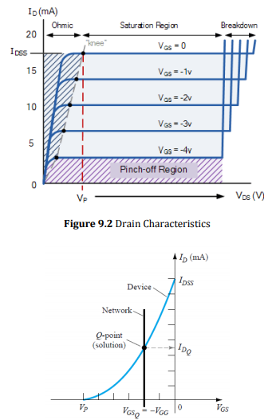

**Simulation**

**Lab 9**

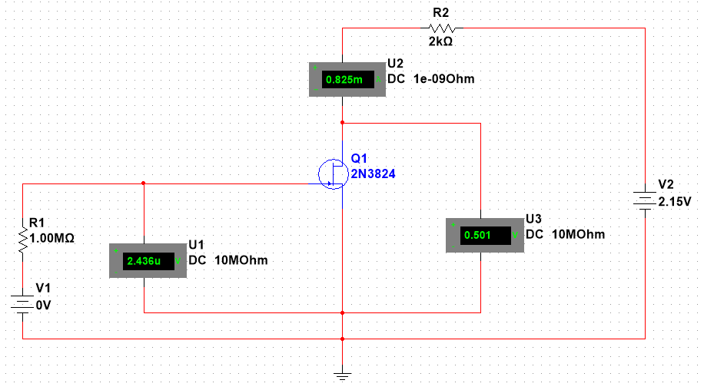

Data was obtained from the circuit to create the characteristic curve. The data can be seen below and drain characteristic can be seen below.

|  |  |  |  |
| --- | --- | --- | --- |
| Drain Characteristics | | | |
|  | Vgs = 0V | Vgs = -0.5V | Vgs = -1V |
| Vds (V) | Id (mA) | Id (mA) | Id (mA) |
| 0 | 0 | 0 | 0 |
| 0.5 | 0.825 | 0.606 | 0.387 |
| 1 | 1.434 | 1.000 | 0.565 |
| 2 | 2.004 | 1.183 | 0.572 |
| 4 | 2.037 | 1.195 | 0.578 |
| 8 | 2.077 | 1.220 | 0.590 |
| 12 | 2.119 | 1.245 | 0.602 |
| 16 | 2.164 | 1.272 | 0.615 |
| 20 | 2.196 | 1.297 | 0.629 |

This data was used to create the transfer characteristic plot.

|  |  |
| --- | --- |
|  | VDS = 6 V |
| VGS (V) | Id (mA) |
| 0.0 | 2.056 |
| -0.5 | 1.208 |
| -1 | 0.584 |
| -1.5 | 0.184 |
| -2.0 | 0.009 |
| -2.5 | 0.001 |

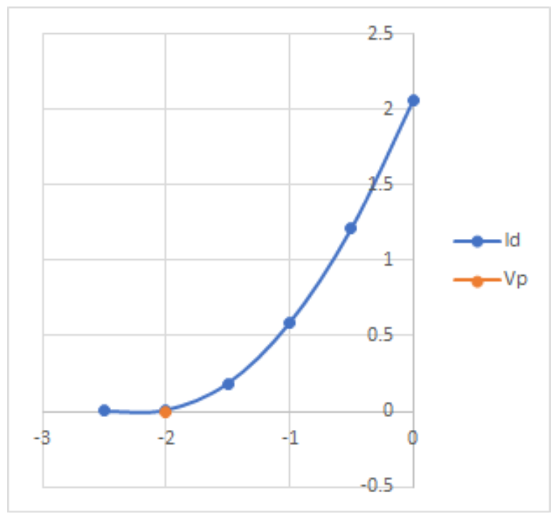

**Lab 10**

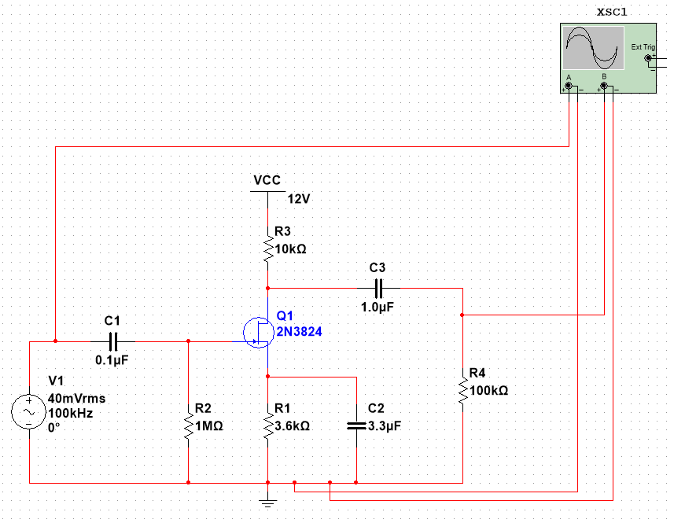

Values for voltage gain:

|  |  |  |
| --- | --- | --- |
| Frequency (Hz) | Vout (mV) | Gain |
| 30 | 0.280 | -37.077 |
| 45 | 0.603 | -30.414 |
| 60 | 0.987 | -26.134 |
| 100 | 2.226 | -19.070 |
| 200 | 5.300 | -11.535 |
| 500 | 11.697 | -4.659 |
| 1,000 | 16.037 | -1.918 |
| 10,000 | 19.488 | -0.225 |
| 100,000 | 19.297 | -0.310 |
| 500,000 | 19.269 | -0.323 |
| 1,000,000 | 19.265 | -0.325 |
| 1,500,000 | 19.286 | -0.315 |
| 2,000,000 | 19.392 | -0.268 |
| 3,000,000 | 19.537 | -0.203 |
| 4,000,000 | 19.319 | -0.300 |
| 5,000,000 | 19.250 | -0.331 |
| 7,000,000 | 19.588 | -0.180 |
| 10,000,000 | 19.453 | -0.240 |
| 11,000,000 | 19.257 | -0.328 |
| 12,000,000 | 19.564 | -0.191 |
| 15,000,000 | 19.534 | -0.204 |
| 16,000,000 | 19.522 | -0.210 |

Voltage vs. Gain

**Results and Discussion**

**Lab 9**

Vp was remarkably close to the expected values. Vp was within the margin of error given by the drain and transfer characteristic plots. It is worth noting that Vgs dampens Id. That is to say that as Vds increases and Vgs decreases, the value of Id grows at a slower rate.

**Lab 10**

The gain of Vout slows at 10 kHz, and its value becomes relatively constant. The input and output are 180 degrees out of phase with each other. The bandwidth is 30 Hz to 1 kHz. The cutoff is 10 kHz.

**Conclusion**

The point of this lab was to introduce us to the JFETs. We explored the core concepts such as NPN and PNP constructions, as well as the various variable associated with JFETs. We also used them for small signal amplification.