1. A. I created a normal distribution of 30 points with a mean of 533.3 and a standard deviation of 309.5.

1.B.

Normal with mean = 533.3 and standard deviation = 309.5

|  |  |
| --- | --- |
| x | P( X ≤ x ) |
| 333.3 | 0.259074 |

Normal with mean = 533.3 and standard deviation = 309.5

|  |  |
| --- | --- |
| x | P( X ≤ x ) |
| 457.7 | 0.403513 |

Normal with mean = 533.3 and standard deviation = 309.5

|  |  |
| --- | --- |
| x | P( X ≤ x ) |
| 672.4 | 0.673441 |

The probabilities are not .25, .50, and .75 because the sample size is small. If you had a larger size, it would be closer.

1.C.

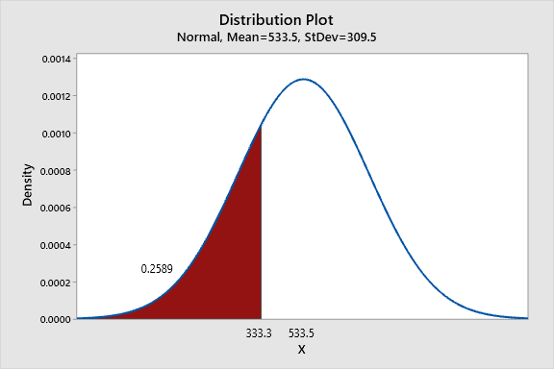

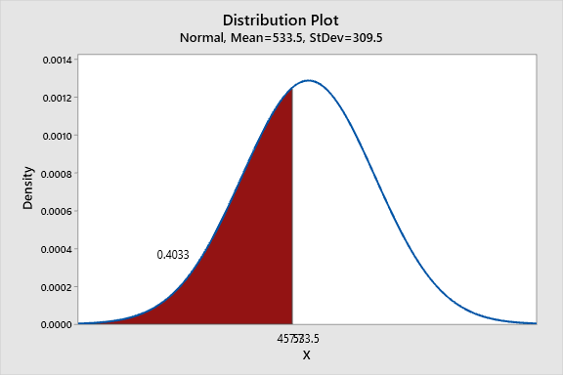

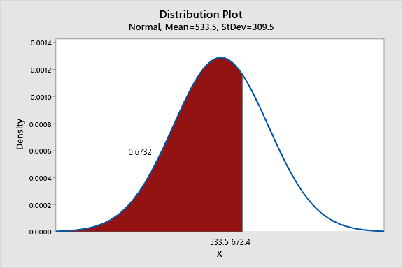

**1.D. Conf Int. for 95%: (356.8, 570.0) Conf Int. for 85%: (386.3, 540.5)**

I used a T test because the data set has only 30 points. If it had more, I would use a z test. The confidence interval increased because you are using a less precise interval.

**1.E.** The data is normally distributed because the P value is above .05.

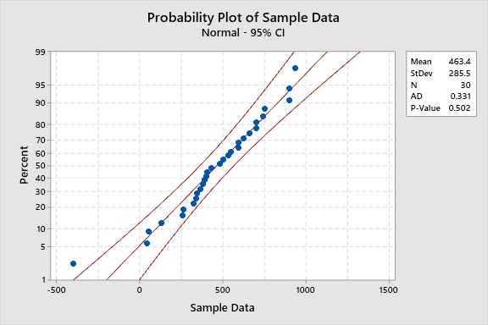

2.A.

I created a uniform distribution of 50 points with a mean of 533.3 and a standard deviation of 309.5.

2.B. The probabilities are not .25, .50, and .75 because the sample size is small. If you had a larger size, it would be closer.

Continuous uniform on 18.6249 to 995.337

|  |  |
| --- | --- |
| x | P( X ≤ x ) |
| 326.2 | 0.314909 |

Continuous uniform on 18.6249 to 995.337

|  |  |
| --- | --- |
| x | P( X ≤ x ) |
| 534.6 | 0.528278 |

Continuous uniform on 18.6249 to 995.337

|  |  |
| --- | --- |
| x | P( X ≤ x ) |
| 832.4 | 0.833178 |

**2.C.**

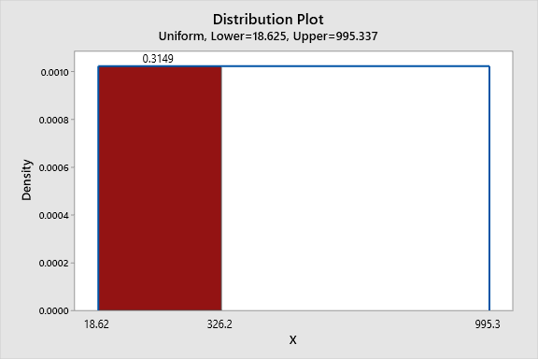

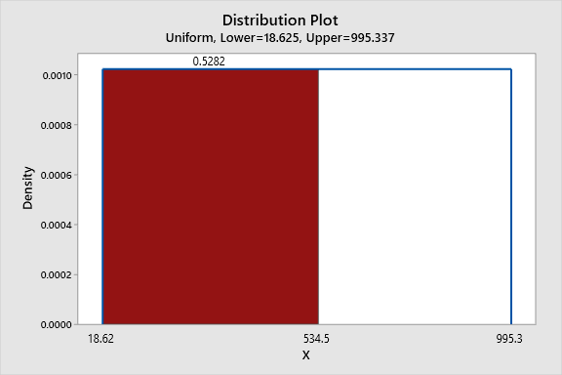

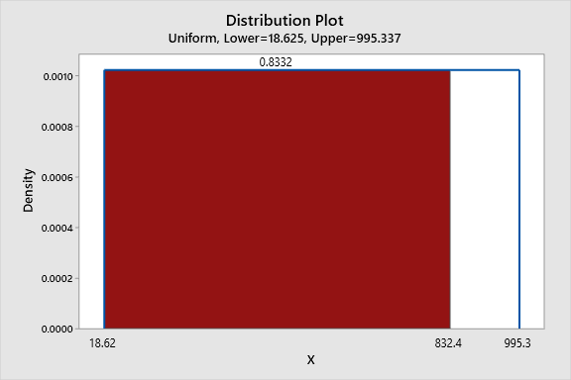

**2.D. . Conf Int. for 95%: (453.8, 625.3) Conf Int. for 85%: (426.8, 652.3)**

I used a z test here because there are over 30 points in my data set. The confidence interval increased because you are using a less precise interval. It is wrong because the distribution is uniform. A confidence interval assumes a normal distribution.

**2.E.** It is not normally distributed because it is a uniform distribution. It passes as normal because the sample size is small.

