CHAPTER 2
SERVICE STRATEGY

CHAPTER QUIZ QUESTIONS
True/False
- A characteristic of the overall cost leadership strategy is the incurring of start-up losses to build market share. (T)
- On-line networks between suppliers and their customers create a barrier to entry. (T)
- When pursuing a differentiation strategy, a service firm should work to ensure that the service being offered is standardized. (F)
- Service winners are the competitive dimensions used by customers to decide among qualified service providers. (T)
- Quality is considered to be a structural element of the strategic service concept. (F)
- Service industries have low entry barriers because economy-of-scale opportunities are limited. (F)
- The use of micromarketing has the potential to create customer concerns about invasion of privacy. (T)
- Implementing a low-cost strategy can sometimes revolutionize an industry. (T)
- A cost-leadership strategy often involves customizing a standard service. (F)
- The competitive dimension of dependability is a likely candidate for becoming a service loser. (T)
- Selling information and developing new services are examples of the role that information technology plays in generating revenue. (F)
- Information technology can be used to promote customer loyalty. (T)
- The IRS has identified frequent-user programs as anti-competitive. (F)
- American Airlines' early development of the SABRE reservation system became the foundation for its yield management innovation. (T)
- Information databases are an asset, because they represent a source of revenue. (T)
- Information is a substitute for inventory. (T)
- Focus is a competitive strategy that creates a service perceived as being unique. (F)
- Service encounter, quality, information, and capacity planning are all managerial elements of a strategic service concept. (F)

- Ordering from L.L. Bean by telephone is an example of a service firm maximizing opportunities for economies of scale. (T)
- A firm facing serious competition for the first time is in the journeyman stage of a service firm's competitiveness. (T)
- World-class service operations strive to replace workers with enhanced automation. (F)
- Firms classified as "available for service" view quality improvement efforts with disdain. (T)
- For a firm achieving "journeyman" competitive status, the back-office function is considered an activity that plays an important role in service delivery. (F)
- In a world-class service firm, the front-line management controls the process. (F)
- The job design premise in a world-class service organization is division of labor. (F)
- Porter’s five forces analysis is used at the industry level to determine competitive intensity. (T)
- SWOT analysis is objective with easily agreed upon results. (F)
- Scalability is a measure of how unit variable cost relates to transaction volume. (T)
- Infinite scalability can occur only when the variable cost is zero. (T)
- Healthcare is an example of a service that exhibits high scalability. (F)
- A highly scalable firm such as Kelly Blue Book (kkb.com) requires a call center. (F)
- Scalability is enhanced with self-service. (T)
- Customers seldom take note of firms that are leaders in the sustainability movement. (F)
- Recycling paper and reducing energy usage often is the first step towards sustainability. (T)
Multiple Choice
1. The qualifier for an airline offering short commuter flights is:
- quality of the meals.
- safety record.*
- politeness of the crew.
- on-time performance.

2. Place the McDonald's fast food chain within the following matrix:
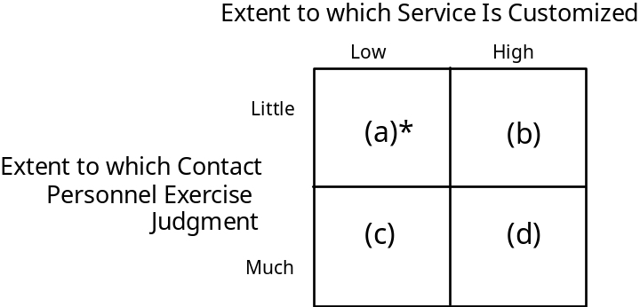
3. A difficult economic environment exists for service industries for all but one of the following reasons.
- Relatively high overall entry barriers*
- Product substitution
- Minimal opportunities for economies of scale
- Exit barriers.
4. A personal training facility that is located in the exclusive Beverly Hills area with only one other competitor could adopt a service strategy that emphasizes ________.
- overall cost leadership
- differentiation*
- focus
- personalization
5. Of the nine dimensions of service competition, three are regarded as most likely to become service losers. Which of the following is not one of those three vulnerable dimensions?
- Speed
- Price*
- Dependability
- Personalization

6. Which of the following is not identified as a strategy common to many successful service providers?
- Close coordination between the marketing and operations
- The exploitation of information to generate new business
- A project-oriented organizational structure*
- Redirection of the strategic service vision inward to focus on employees
7. Which of the following usually is not a good idea with respect to an overall cost leadership strategy?
- Offer as many different services as possible to spread overhead costs.*
- Concentrate on routine/standardized services.
- Replace labor with capital where possible.
- Perform some service activities off-line at a centralized site.
8. The nature of the service act depends on to whom or to what the service is directed and the degree of "tangibility" of the service provided. An example of a tangible service directed to the possessions of a customer would be:
- a stay in a hotel.
- an investment advising session.
- a fortune telling session.
- a full-service car wash.*
9. Which one of the following is not a key characteristic that leads to a difficult competitive environment for service industries?
- Low barriers to entry
- Lack of sustainable competitive advantage
- Lack of government regulation and oversight*
- Low switching costs for customers

10. In which of the following cases does the use of information raise ethical issues?
- Yield management
- Selling information
- Micromarketing
- All of the above*
11. American Airlines' SABRE reservation system fills the following strategic role of information:
- Revenue generation
- Productivity enhancement
- Creation of barriers to entry*
- Data base asset
12. Services can create barriers to entry by __________
- using economies of scale.
- creating switching costs.
- using databases and information technology.
- all of the above.*
13. Which of the following is an example of the competitive use of information in generating revenue?
- Reservation systems
- Data envelopment analysis
- Micromarketing*
- Expert systems
14. Which of the following is not a role of information technology?
- Creating a barrier to entry for competitors
- Generating revenues
- Displacing workers*
- Managing multisite operations

15. Using the dimensions of strategic focus and competitive use of information can identify four strategic roles of information. Which of the following is not a strategic role of information?
- Create barriers to entry.
- Generate revenue.
- Create a data base asset.
- Provide global communications.*
16. Real-time information technologies that have a focus on internal operations can play a competitive role in increasing revenue opportunities. Which one of the following uses of information does not play a role in generating revenue?
- Yield management
- Point of sale
- Expert systems*
- Sale of information
17. Bar coding and checkout scanner technology have created a wealth of consumer buying information that can be used to target customers with precision. This process is an example of:
- service development.
- micromarketing.*
- data envelopment analysis.
- point of sale.
18. Kraft targeted its cream cheese flavors to match the tastes of a store’s customers using off-line analysis of POS (point-of-sale) data. This is an example of:
- yield management
- expert systems
- data envelopment analysis
- micromarketing*
19. Service firms use information technology to create barriers to entry, generate revenue, enhance productivity, and serve as data base assets. Where does productivity enhancement fit in the diagram below?
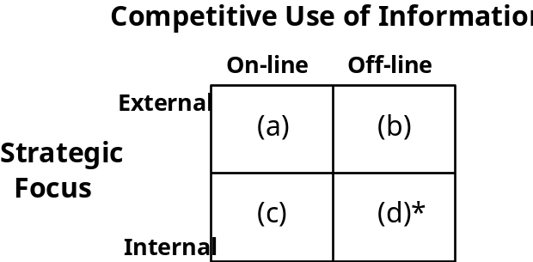
20. Which of the following service quality descriptions would be considered "World Class?"
- It raises the customer's expectations and improves continuously.*
- It exceeds the customer's expectations and is consistent on many dimensions.
- It is less important than cost and is highly variable.
- It contributes to service and plays an important role in total service.
21. Not satisfied with just meeting customer expectations, this category of service firms expands upon the expectations to levels that competitors find difficult to meet.
- Available-for-service
- Journeyman
- Distinctive competence achieved
- World class service delivery*

22. The innovation of moving from a "country" store where the proprietor fills the shopper's list with items that are kept behind the counter to a self-service supermarket where the shopper fills a cart with items represents a move between which of the following pairs of competitive stages?
- From available-for-service to journeyman
- From available-for-service to distinctive competence achieved*
- From journeyman to distinctive competence achieved
- From distinctive competence achieved to world class service delivery
23. Which of the following stages of a firm's competitiveness describes customers who seek out a firm based upon its sustained reputation for meeting customer expectations?
- Available-for-service
- Journeyman
- Distinctive competence achieved*
- World class service delivery
24. Which one of the following does SWOT analysis not have as its aim?
- Reveal competitive advantages
- Determine the competitive intensity*
- Analyze prospects
- Development of contingency plans
25. Porter’s five forces analysis does not include which one of the following considerations.
- Pricing power*
- Potential new entrants
- Threat of substitutes
- Bargaining power of suppliers

26. Which one of the following is not a dimension of scalability?
- Information vs. goods content
- Degree of self-service*
- Cost of after-sales service
- Shipping and handling costs
27. Which of the following is not considered a criterion for evaluating the triple bottom line?
a. social progress
b. economic growth
c. environmental stewardship
d. market share*

