ProPresenter Lighting Controller

# Fixtures

Each fixture has a DMX address and a profile for the DMX channels, they are defined separately in the config as seen below.

## Fixture Profiles

The fixture profiles can be configured using the following fields:

|  |  |
| --- | --- |
| name | The name of the fixture |
| dmx_length | The total number of DMX channels this fixture uses |
| address_map | A list of color values that correspond to each fixture |

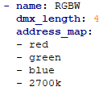

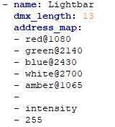Valid color values for the *address_map:*

* Red, green, blue, white, or amber
* An RGB hex code color
* A color temperature
* Intensity
* A simple number between 0 and 255
* A blank line to indicate 0

Suffix any color value with an @ symbol followed by lumens to compensate for bulb intensity

## Fixture Addresses

The fixture addresses is where you define how the lights are actually hooked up to the DMX system.

Use the following fields to define the address:

|  |  |
| --- | --- |
| name | The name of the fixture |
| start­_address | The DMX address of the first light fixture |
| count | The number of light fixtures at this address |

# Scenes