# Installation

This is a JavaScript app can be run in Node environment. Please install Node.js at <https://nodejs.org/en/download/>

# Libraries used

This project uses Jasmine testing framework

# Running the tests

Open Visual Studio 2019, open “Test Explorer”, run all the tests:

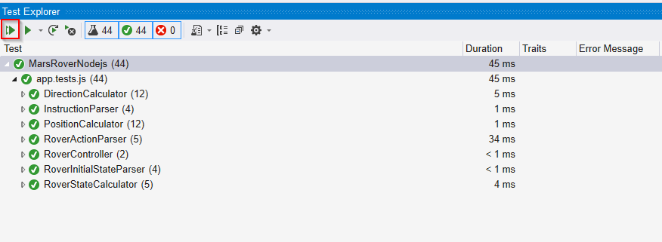

# Debug the code

Set the break point and right-click the test and select “Debug”:

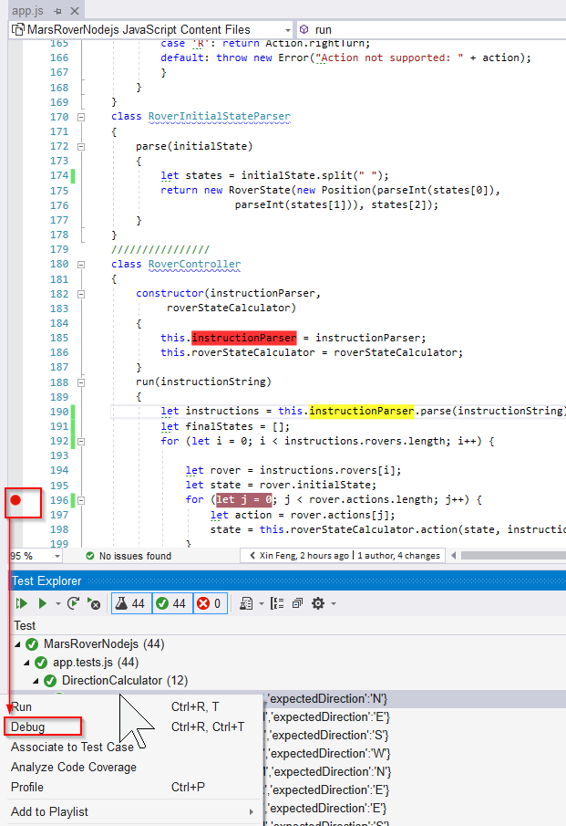

# Assumptions

Rovers should not go outside of plateau area.

Error handling: many error handling situations should usually be business requirements. In the description of rovers problem, there is not much information about how to handle error situations such as bad rover instructions “K” instead of “L”, “R” and “M”. So I just throw exception for now.

# Run the program

The starting point of the program is class **RoverController**