

**AHSANULLAH UNIVERSITY OF SCIENCE & TECHNOLOGY**

**Department of CSE**

**Bank Management System**

Section: B

Group: B-1

**Submitted To**

Mohammad Imrul Jubair

Safrun Nesa Saira

**Submitted By**

Md. Musad Al Rubayet 15-01-04-069

**Other Members:**

Fairuz Shadmani Shishir 15-01-04-082

Md. Jahid Shah Shiamun 15-01-04-071

**Objective:**

Our project is Bank Management System. It is necessary for the banks to keep track of the day-to-day activities & records of the transaction. All of these information must be managed in an efficient and cost wise fashion so that an Bank’s resources may be effectively utilized. Our objective is to automate the management of the Bank making it more efficient & error free. Here we can get the information of any client who is under which client_manager, the date of transaction, the information of all clients, the information of all client_manager, all transaction in each account_id etc.

We use fragments to keep the information of different sites of the management system. This system consists multiple copies of data, fragmentation information which is beneficial to keep the track of all data.

**ER Diagram:**

This is the entity relationship diagram of our Bank management system having 6 tables namely Bank, Branch, Client, Client Manager, Account_Information and transaction.

The figure is given below:

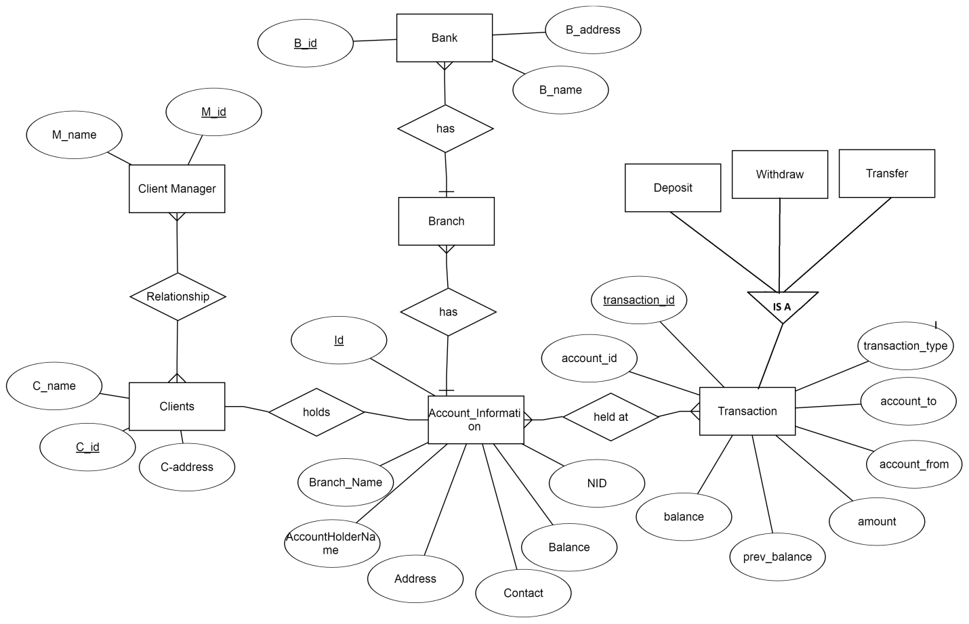

**Allocation schema:**

|  |  |  |
| --- | --- | --- |
| **Table Name** | **Attributes** | **Allocation** |
| Account_Information | Branch_Name, AccountHolderName, Address, Contact, Balance , NID | Server |
| Clients | C_Name,C_Id,C_Address | Server |
| Client manager | M_Name,M_Id | Server |
| Bank | B_Name,B_Id,B_Address | Server |
| Branch | Branch_name.Branch_id,Branch_address | Site |
| Transaction | transaction_id, balance, prev_balance, amount, account_to, account_from, transaction_type | Site |

**Features:**

Our project consists of many operations. They are:

* Fragmentations (done by me)
* Procedures(4 procedures,last two is done by me)
* Operator tree(done by me)
* Canonical Expression(done by me)
* Database Profile
* Packages
* Trigger etc.

**Fragmentation:**

In this project, we use fragments for transaction and Account_Information table.

For transaction table, the fragmentations are:

* transaction11 (balance>=50000tk)
* transaction11 (balance<50000tk)

For Account_Information table, the fragmentations are:

* Account_Information (balance>=50000tk)
* Account_Information (balance<50000tk)

**Procedures(done by me):**

1. **Withdraw money:**

It is a procedure where a client can withdraw money from his/her account.It is a type of transaction having 7 attributes.

1. **Transfer money:**

This procedure shows the amount of money transferred from one account to another account. After transferring the money the updated balance will be shown in the clients account. It is also a kind of transaction having 7 attributes.

**Operator tree (done by me):** this is the operator tree for the given expression:

Find the Id where more than 50000tk has been deposited on 10.10.2018.

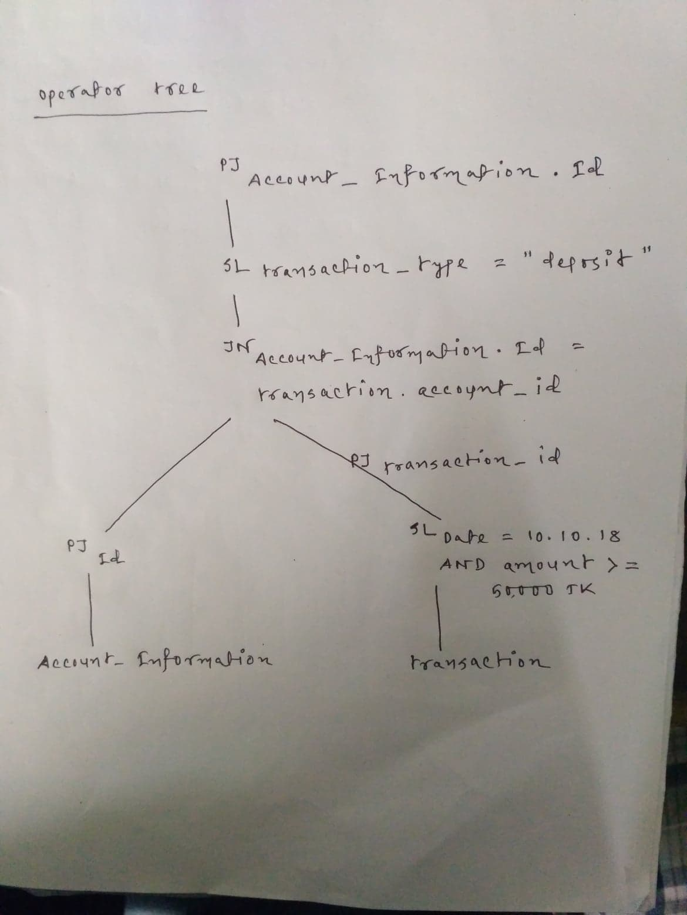

**Canonical expression (done by me):** A canonical expression is implemented so that we can measure the efficiency of DDB.

This is the canonical expression for the previous operator tree.

.

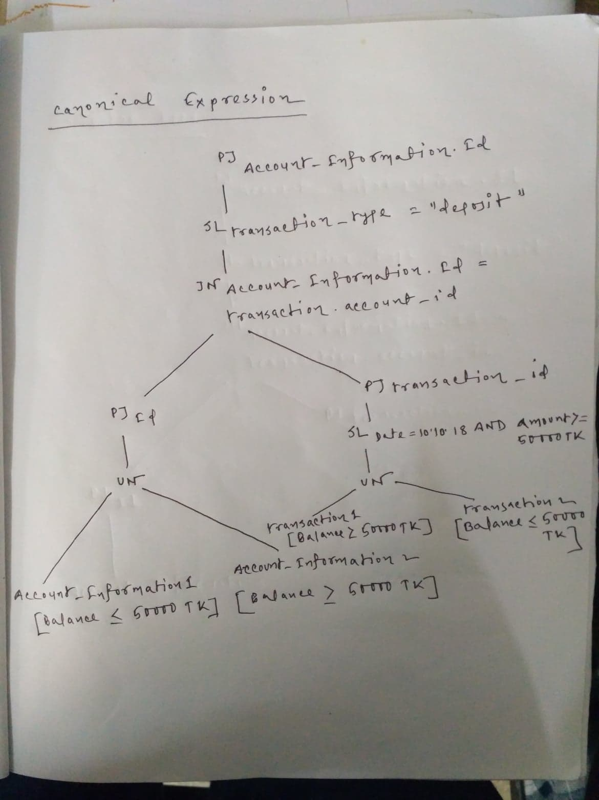

**Conclusion:** Our project consists of many information of clients and client manager, transactions, branches etc. So we have to fragment these two tables mainly. We have worked on fragmentation, procedures, packages, triggers etc.

The aim of our project is to provide an efficient banking system. We want to computerize all details regarding clients, client manager and all kind of transactions such as deposit, withdraw and transfer. The information of the bank will be kept up to date and. I hope this system will be helpful to clients and bankers to have a efficient banking system.