**A new ecosystem for microtonal computer music exploration and composition**

Warren Burt, independent composer

Over the past year or so, a number of new programs have emerged which make the composing and exploring of microtonal music much more easy and efficient. In the interaction of these programs, a new eco-system to support microtonal music has come together, and these, with the tools and abilities they imply have greatly expanded the possibilities for microtonal performance, especially in real-time. This paper looks at several of these programs, and how they interact to create a new, more powerful composing environment. The principal programs that allow this program to flourish are MTS-ESP by Oddmusic, Wilsonic by Marcus Hobbs, and VCV-Rack Pro by Andrew Belt and associates. As more developers have come on board supporting the MTS-ESP standard, the number of instruments that are now microtonally capable has expanded greatly. Also, “framework” programs, such as Ableton Live, Bitwig Studio, and Reaper, make the implementation of this ecosystem quite easy.

1. MTS-ESP – the technology that allows all this to happen:

ODDSound is a British company consisting of Oli Cash, Damon Hancock and Dave Gamble. Initial design help with the initial concept of MTS-ESP also came from Richard James (Aphex Twin). The idea behind this program was to find a way to implement the MTS (MIDI Tuning Standard) Single Note Change message. Once this was done, a single Master Tuning Table could be made which provided tuning information to all the compatible synthesizers on the system. Implementing this in various softwares proves relatively easy. The MTS-ESP library is a simple but versatile C/C++ library for adding microtuning support to audio and MIDI plugins. Connection between a master and clients is automatic and invisible. Integration of the code with the existing synthesizer code is simple and typically takes less than half an hour.  (*ODDSOUND*, n.d.)

As a program., MTS-ESP consists of three sub-programs. MTS-ESP Master is the program in which tuning information is defined, and operations on existing tunings are made. The program can hold up to 128 different tunings at any one time, all of them instantly accessible under MIDI control. The program has a number of other capabilities, such as the ability to morph and mutate between tunings. For more information consult the ODDSound website, oddsound.com. There are two other parts to the program. MTS-ESP MIDI Client allows one to use the existing tuning table and apply it to other synthesizers with differing tuning standards, and MTS-ESP Mini is a free auxiliary program that allows the capabilities of MTS-ESP Master to be applied to any number of synthesizers, but with only one scale at a time. Taken together, these programs provide a powerful means of microtuning computer instruments. (Additionally, ODDSound, in collaboration with the VCV project, has made a set of MTS-ESP modules which enable using the MTS-ESP standard in conjunction with the virtual analog VCV environment. And the Surge-Synth Team has developed the CLAP plugin standard which enables, among other things, MTS-ESP control of all the plugin synths in Bitwig Studio. More on this later in the paper.)

2. Wilsonic

Wilsonic is a project of Marcus Hobbs and friends that allows one to explore the tuning universe of Ervin Wilson (1928-2016), the Mexican-American music theorist who extended tuning theories established by Harry Partch into a huge and multi-faceted universe. (*A BIOGRAPHY of ERV WILSON*, n.d) It originally existed as an iOS app for the iPad, and fed its tuning information into two iOS synthesizers: Audiokit Synth One and Digital D1. It provided an extremely low-cost and easy-to-use introduction to the tuning universe of Ervin Wilson. (‎*Wilsonic*, 2019) I’ve used this in a number of pieces of mine. (*Warren Burt Performs “6 Wilson Tunings” at the Make It up Club*, n.d.)

The new version of Wilsonic is several of orders of magnitudes more powerful. (*Wilsonic: Interactive Emotional Palettes of Music*, n.d.) Still in beta, as this is being written, it’s already made available a very powerful set of compositional tools. Currently available on both Mac and PC platforms, it currently consists of 11 pages, each of which encompasses many variations on the larger categories covered by Wilson’s work. On each page, each scale has a number of factors that can be changed in real time, and these changes can be recorded in the DAW used as a framework for the program. For example, in the Combination Product Set page, each CPS is made by multiplying a number of factors to make the overall structure of the scale. Any of these factors can be changed, using push-buttons, or by typing in the numbers themselves, and these changes will be recorded by the DAW software and the changes will then be displayed and the changes made available to the current scale. In this way, you can establish a sense of modulation and harmonic progression in family of scales being generated. (*Microtonality and the Tuning Systems of Erv Wilson*, n.d.)

The eleven currently existing pages (more are yet to come) are

Wilson’s Garden – a curated selection of Wilson’s scales from the people behind the program.

Moments of Symmetry – the generalized mathematical prototype for the diatonic scale available in an infinity of variations. This page also generates generalized keyboard patterns for the scale being worked on.  (*INTRODUCTION to ERV WILSON’S MOMENTS of SYMMETRY*, n.d.)

Persian 17 North Indian – Wilson’s theory of the derivation of North Indian ragas from a 17 note Persian master scale.

Combination Product Sets – many scales produced by multiplications of basic harmonic factors multiplied against each other.  (*WILSON ARCHIVES - COMBINATION PRODUCT SETS - CPS*, n.d.)

Euler Genus 6 – a twenty note scale made from 6 factors, and all the subsets of that particular scale, which have 15, 10, 6, or 5 elements.

Recurrence Relations – the Fibonacci series is the recurrent sequence prototype here, but there are many different recurrence relations available, each with many generating factors.  (Wilson, 1993)

Equal Temperaments – not just octave related, but any number of divisions of any interval up to 128. All variations are recorded in real-time for changing temperaments.

Tritriadic Scales – a generalisation of John Chalmers’ method of generating scales. Again, all variations can be recorded in real time for changing scales.

Scala – a utility for accessing scales derived from Scala files. The “complete” Scala archive (5158 scales in the most recent version) is available in the “bundled” page, and the “user” page allows you to add your own. Any changes in scales made during a piece can be recorded, allowing for continually changing modulations.

Co-Prime Grid – this sets up a grid of criss-crossing harmonic and subharmonic relations. The tonality diamonds of Partch and Novarro are the prototype here. This diagram will also allow those with touch-screens to play these scales as if on a touch-sensitive keyboard. (Wilson, 1999)

Diamonds – these are cross sets of all the ratios of between 3 and 8 factors. Each page then has the complete scale and all the harmonic and subharmonic subsets available in that scale. Again, any changes made during performance will be recorded allowing for far-reaching progressions and modulations. (Wilson, 1970)

It can be seen from even these brief descriptions that the tuning universe of Erv Wilson is immense, and this program allows you to start exploring that world in some detail. For a deeper look, go to wilsonic.co and download the current beta version of the program for your relevant platform.

3a. Manufacturers coming on board with the MTS-ESP standard.

All these capabilities would not be useful if there was not an adoption of the MTS-ESP standard by a large portion of the industry. Happily, this has been the case. Many manufacturers have adopted the MTS-ESP standard, meaning their softsynths immediately adapt to the tuning of the moment. If the scale changes, the tuning of the scale in the synth immediately changes as well, reflecting the current tuning. Here’s a brief list of companies who have adopted the MTS-ESP standard for their synthesizers, and the names of those synthesizers. Some of these are free, and some are paid products, but all that I have tested respond immediately to changes in tuning in the MTS-ESP Master, or in Wilsonic. This list is current as of July 21, 2023. Other makers will undoubtedly join this list soon. The rapid adoption of the standard has been quite gratifying to see. For the most recent updated list, go to https://oddsound.com/usingmtsesp.php.

Antares: Auto-Tune Slice

Audio Damage: Continua / Phosphor / Slice

Audio Nebula: Aurora FM

Audiorealism: Bass Line 3 / ReDominator

Arturia: Augmented Strings / Augmented Grand Piano / Augmented Brass / Augmented Voices / Buchla Easel V / Clavinet V / CMI V / CS80 V / CZ V / DX7 V / Emulator II V / Jun-6 V / Jup 8 V / MS 20 V / OP Xa V / Piano 3 V / Pigments 4 / Prophet 5 V / Prophet VS V / SQ80 V / Stage 73 V / Synthi V / Vocoder V

bitKlavier: bitKlavier

ChowDSP: Chow Kick

CWITec: TX16Wx

discoDSP: OP-Xd

DMG Audio: EQuilibrium / Pitch Funk

DS: Thorn

Entonal Studio: Entonal Studio

Expert Sleepers: Silent Way

FabFilter: Twin 3

Full Bucket Music: FB-7999 / Fury 800 / Grain Strain / ModulAir / WhispAir / Bucket One / Qyooo / Scrooo / MPS (and others)

Hy-Plugins: HyPoly

Infinitone: Infinitone DMT

Modartt: Pianoteq

Monoplugs: Monique

Nakst: Altitude / Apricot / Integrate / Fluctus / Regency

Newfangled Audio: Generate / Pendulate

NuSofting: Sinmad / Sunnah

Plogue: Bidule / Chipsynth MD / Chipsynth OPS7 / Chipsynth PortaFM / Chipsyntth SFC

Rhizomatic: Plasmonic

SoundDyan: Interstellar Waterphone / Zanza amd Kalimba

Surge: Surge XT / MTS-ESP to Note Expression CLAP

TAL Togu Audio Line: TAL-BassLine 101 / TAL J-8 / TAL-MOD / TAL Sampler / TAL-U-No-LX

u-He: ACE / Bazille / Beatzille / Colour Copy / Diva / Hive 2 / Podolski / Repro / MFM2.5 / Triple Cheese / Zebra 2 / Zebra CM / Zebralette / Zebra HZ

Unfiltered Audio: Lion

Virtual CZ: Virtual CZ

Wilsonic: Wilsonic

Xfer: Serum

3B: VCV Rack and Oddsound:

Oddsound have made a family of modules for VCV Rack Pro 2. (*VCV Rack 2 - Virtual Eurorack Studio*, n.d.) These enable external MIDI signals to travel into and out of the VCV Rack environment, while conforming to the Master MTS-ESP tuning table. This enables a function –it enables you to patch any synthesizer within VCV and have it play in tune with the Master tuning table.

Diagram 1: Simple microtonal patch in VCV Rack Pro 2

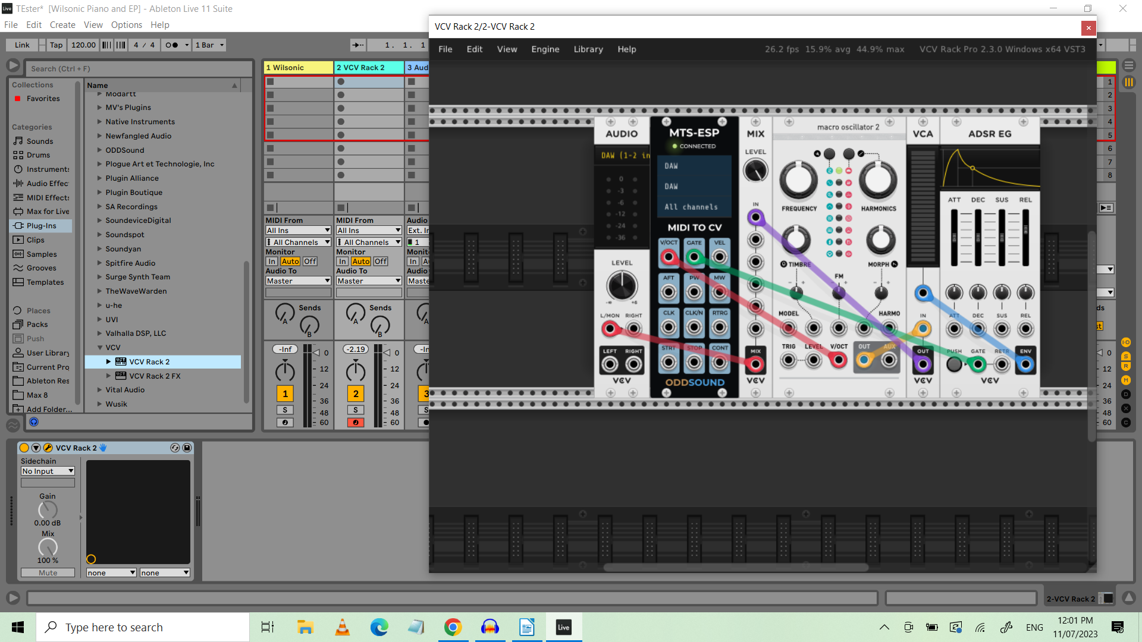

In this patch, VCV Rack Pro 2 exists as a plug-in in Ableton Live (in Mixer channel 2). Here’s a very simple patch which plays microtonally in VCV Rack. Much more complex patches are, of course, possible. The MTS-ESP Module substitutes for the normal VCV Midi-CV module. Polyphony is set on the back (right-click) of module, making the patch polyphonic. The Voltage/Oct signal goes into the V/Oct input of an oscillator or sampler module (in this case Audible Instruments mscro oscillator 2.) The Gate output on the Midi-to-CV goes to the Gate Input on the ADSR EG module, which controls the level on the VCA. The tuning accuracy of the oscillator modules in VCV is fantastic. Very fine control of pitch is made possible with the virtual analogue modules controlled by the MTS-ESP standard. Patching like this in VCV is limited to 15 voice polyphony, but many instances of the VCV Rack Pro 2 plugin can exist in an Ableton patch at the same time.

4. Frameworks for this. In this work, I’ve used 2 programs as a framework for this, Ableton Live, (Ableton, 2019) and Reaper. (*REAPER | Audio Production without Limits*, n.d.) I am also assured that Bitwig Studio will also work for this, and in fact, the teams that developed Surge XT and Bitwig Studio have recently collaborated on a new plugin standard called CLAP that is fully MTS-ESP compatible, which makes all the plugin synthesizers in Bitwig microtonally retunable. (*Bitwig | Home | Bitwig*, n.d.) . I look forward to hearing from other folks as to what DAW programs they are using to host this work. For my purposes, the algorithmic resources available in programs like MusicWonk (*MusicWonk Overview*, n.d.) and Max 8  (Cycling '74, 2020) , as well as all the possibilities in the new Max for Live modules, when combined with the timbral and tuning resources available in the Wilsonic / MTS-ESP environment, will provide me with compositional possibilities for quite a while.

5. An example of a piece made in this environment: “Pentadic Diamond 3 9 17 29 47 Canon” is a piece made using the Pentadic Diamond available on the “Diamonds” page in Wilsonic. The Pentadic Diamond is a 21 note scale made of all the ratio pairs of 5 factors plus a 1/1 in the centre. So, for example A/B is reflected by its inversion B/A, and this applies to all 10 possible ratios of the five factors. The page will play the complete scale of 21 notes, and also all 10 subsets of 5 notes in the related scales. The notes are selected by a program in MusicWonk, in which a single Random Walk module makes random walks that traverse a range of 43 values. This random walk, when applied to the 21 note scale, covers just over a 2 octave range. However, when applied to any of the five-note subset scales, then these scales are articulated over a range of 8 octaves. The rhythms are generated with a probability generator making patterns of 8, 16, and 24 pulses. This melody is then played and accompanied by two delayed versions of itself – the delays consisting of 386 and 784 pulses – making a three part canon with each voice delayed by about 10 seconds. Sections of the piece are delineated by changing which scale is playing on the page. This is done in real-time, and the result is part of the piece’s recording.

The piece opens with 1 minute of the 21 note scale, covering the two-octave range. This is followed by 10 sections of 30 seconds each – each of these 10 sections plays in one of the five-note subset scales. Each of these covers a range of 8 octaves. Complexity is added by having the three voices delayed by 10 seconds each. After all 10 five-note scales are played for 30 seconds each, the piece returns to a final minute of the 21-note scale. The three voices are played by three different softsynths, each of which has a different piano type timbre. The three instruments are an Arturia DX7 clone, the basic Piano timbre in Pianoteq 8, and the Surge XT electric piano timbre. Because all three synths are MTS-ESP compatible, the three synths being absolutely in tune poses no problems. The structure is actually a very simplistic one, but the kinds of rhythms generated and the canonic structure gives the piece what to my ear is an “ear-catching” kind of cross-rhythm and registral change. It’s a rather simple piece, but it shows some of the compositional possibilities now available with this new microtonal composing eco-system.

Diagram 2: The Pentadic Diamond page in the Wilsonic “Diamonds” structure.

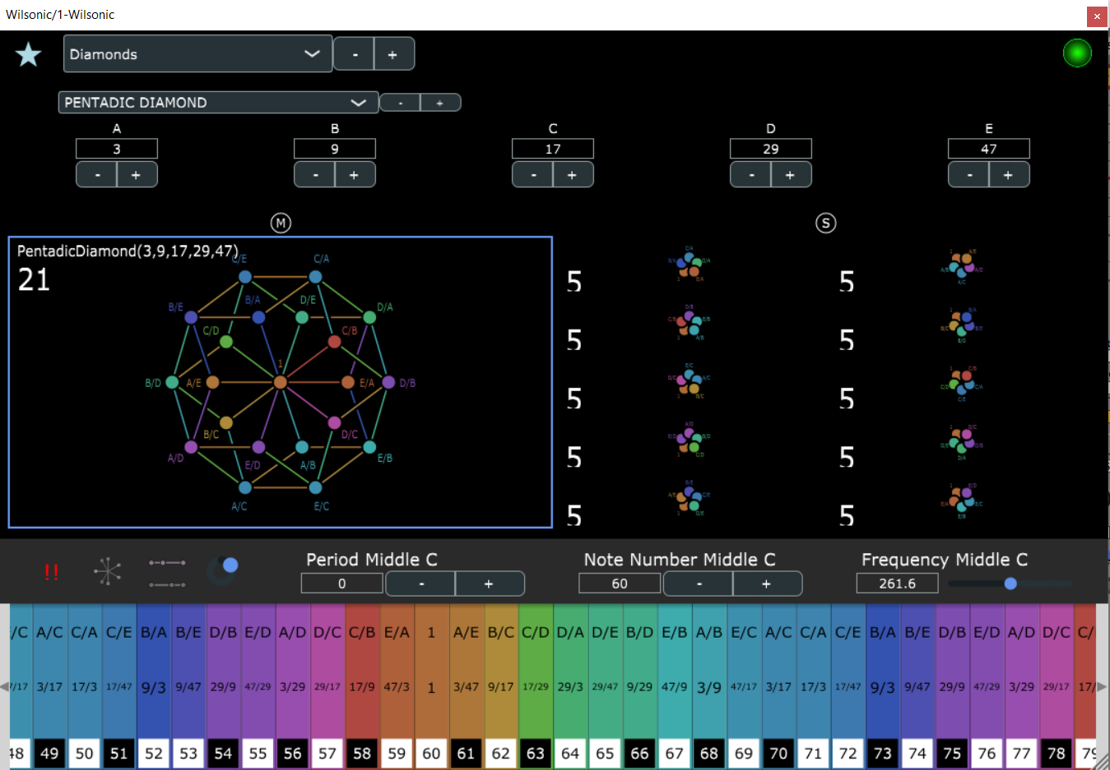

*REFERENCES*

*A BIOGRAPHY OF ERV WILSON*. (n.d.). Www.anaphoria.com. Retrieved September 21, 2023, from https://www.anaphoria.com/wilsonbio.html

*ODDSOUND*. (n.d.). Oddsound.com. https://oddsound.com/usingmtsesp.php

*Wilsonic*. (2019, March 5). App Store. https://apps.apple.com/us/app/wilsonic/id848852071

*Warren Burt performs “6 Wilson Tunings” at The Make It Up Club*. (n.d.). Www.youtube.com. Retrieved September 21, 2023, from https://www.youtube.com/watch?v=9MGEA3s5Bk8

*Wilsonic: Interactive emotional palettes of music*. (n.d.). Wilsonic - Interactive Musical Scale Design. Retrieved September 21, 2023, from https://www.wilsonic.co

*Microtonality and the Tuning Systems of Erv Wilson*. (n.d.). Routledge & CRC Press. Retrieved September 21, 2023, from https://www.routledge.com/Microtonality-and-the-Tuning-Systems-of-Erv-Wilson/Narushima/p/book/9781138857568

*INTRODUCTION TO ERV WILSON’S MOMENTS OF SYMMETRY*. (n.d.). Www.anaphoria.com. Retrieved September 21, 2023, from https://www.anaphoria.com/wilsonintroMOS.html

*WILSON ARCHIVES - COMBINATION PRODUCT SETS - CPS*. (n.d.). Www.anaphoria.com. Retrieved September 21, 2023, from https://www.anaphoria.com/wilsoncps.html

Wilson, E. (1993). *The Scales of Mt Meru* [Review of *The Scales of Mt Meru*]. Anaphoria.com. (n.d.). Anaphoria.com. https://www.anaphoria.com/meruone.pdf

Wilson, E. (1999, November 26). *CoPrime Square Grid* [Review of *CoPrime Square Grid*]. Anaphoria.com.

Wilson, E. (1970). *Triadic Diamond* [Review of *Diamond Formations*]. https://www.anaphoria.com/diamond.pdf

*VCV Rack 2 - Virtual Eurorack Studio*. (n.d.). Vcvrack.com. https://vcvrack.com/Rack

Ableton. (2019). *New in Live: Discover the new features Ableton Live 10 has to offer | Ableton*. Ableton.com. https://www.ableton.com/en/live/

*REAPER | Audio Production Without Limits*. (n.d.). Www.reaper.fm. https://www.reaper.fm/

*Bitwig | Home | Bitwig*. (n.d.). Www.bitwig.com. https://www.bitwig.com/

*MusicWonk Overview*. (n.d.). Algoart.com. Retrieved September 21, 2023, from http://algoart.com/help/musicwonk4/MusicWonk/intro.htm

Cycling '74. (2020). *What is Max? | Cycling ’74*. Cycling74.com. https://cycling74.com/products/max