The Rhizomatic Improvisation System.

Roger Alsop

Faculty of Fine Arts and Music

University of Melbourne

Aug 6, 2023

This paper discusses the Rhizomatic Improvisation System for various instruments and electronics. I have performed works in Melbourne and Prague under the pseudonym Delusion Guitari, playing guitar into this system which comprises of randomly timed delays and effects with the signal from each delay and effects being broadcast through a multi speaker system.

The random delay times may be from one millisecond to 20 minutes, and the feedback for each delay is infinite. This results in an improvisation system in which every improvised action is perpetually re-played into the performance environment at an unpredictable time. For the improviser this creates a situation in which each action becomes part of each subsequent and preceding action, and as these actions concatenate and coincide a sonic environment is built.

The idea behind the development of this system is to create an improvisational environment in which memory and intention are linked to prediction and responsibility.

# Introduction

There is no concise or explicit research question being explored or intended to be answered in this paper, it is more a discussion considering one personal approach to improvisation. I will first discuss the terms ‘rhizome’ and ‘improvisation’ as they are considered here and where appropriate include the thinking that informed the uses of the terms. I then discuss the philosophical positions informing the creation of the Rhizomatic Improvisation System, then the system itself, and then how it has been used and experienced in performance.

## The Rhizome

Here the term rhizome references Deleuze and Guattari’s discussions in ‘A Thousand Plateaus; Capitalism and Schizophrenia’ (2005, pp. 3–25). This discussion does not provide a concise or pithy definition of the term as used by Deleuze and Guattari, but instead offers many possible ways to understand their use of the term, a few of which are listed here. The rhizome is: a “*multiple that must be made*” (6), where any point can and must be connected to anything other (7); something that “ceaselessly establishes connections between semiotic chains, organizations of power, and circumstances relative to the arts, sciences, and social struggles.” (7), it has no points or positions (8), and is “anti-genealogy” (11). It is “not amenable to any structural or generative mode”, (12), but something that “intersect[s] roots and sometimes merge[s] with them” (13), and so on. They also state that “[R]ats are rhizomes” (6).

The Rhizomatic Improvisation System embraces these understandings. It creates an outcome that must be made and is made in its multiple ways of making, where all points are connected and these connections become semiotic chains that make organizations of power even though the points and positions of each element made are individually powerless and are ephemeral and momentary in time and space, the generation of structures are created in the making, through the continuously merging and intersecting of the ephemeral elements.

## Improvisation

Improvisation, in music it is often understood as ‘making it up as you go along’ and is therefore made in its making. While this is primarily true, there is much that underlies, informs, and constrains that process. Steinweg (2012, p. 23) defines it as **“**a framed spontaneous performance that is constituted by embodied discursive power relationships.” Sutton (2001, p. 1) hypothesizes that “free musical improvisation is like conversation.” Miles Davis is quoted as saying “If you’re not making a mistake, it’s a mistake.”; that and other quotes by Davis can be found at (Western, 2023). David Toop (2008, p. 121) saw differences in improvisation styles and approaches, saying “Dutch improvisation was associated with humour, for example; German with high energy free jazz; American with either the jazz tradition or the influence of John Cage and indeterminacy; British with a more intellectual, finely detailed approach.”

The discussion above ranges across many possible topics within musical improvisation, raising questions such as: is improvisation an embodiment of discursive power relationships; is it a musical practice in which mistakes are made; is it a conversation with non-lexical sounds; and/or is it culturally based? This is just scratching the surface.

As well as these discussions there are also many systems of improvisation, such as the Indian rag, George Russell (1974)and Barry Harris’ (Ciacca, n.d., pp. 6–23) systems of jazz improvisation, Derek Bailey’s curatorial approach (Childs et al., 1982, p. 20) and Ornette Coleman’s Harmolodics (1983). Each of these systems, which can be considered training, and therefore possibly constraining, systems, has their own strengths, both conceptually and in practice, but they also localize and prescribe inherent possibilities of improvisation and direct the improvisor.

My personal approach is that improvisation is very much like a conversation. Within this conversation there are discursive power relationships that are exercised, mistakes (or events are interpreted/considered as mistakes by the creator and/or the respondent/listener) are made (and possibly ameliorated), and this occurs within specific cultures and tastes. All of these things may seem invisible when in the act of improvising, however they are, to greater or lesser extents, present, embraced, and exploited by the musicians.

The act of improvising, regardless of style, intention, or context, requires attention to events that have happened, are happening, and may happen in future. This capacity to predict the future is vital for the improviser, and this ability, or the exercising of it, may be intuitive, or at the other extreme, completely conscious and representative of or constrained by training.

When improvising in traditional musical contexts such as jazz the sonic context is mostly predictable, for example: shared expectations and assumptions that there be: specific tunings, predictable periodic divisions of time, and often known harmonic fields are used. Of course, within these contexts a lot of freedoms are assumed and taken, but the constraints significantly outweigh the freedoms.

In freer forms of musical improvisation, such as those of Fred Frith, Cecil Taylor, Mary Halvorson, or Peter Brötzmann, a particular context, or style, is expected of each of these improvisors, and therefore there is some form of predictability for collaborators and audience. This predictability exists within micro and macro contexts, such as capacities of the performers and their instruments, within the improvisation as it is happening, and the contexts of the technical/physical/social environment. These contexts may provide greater assumed freedoms within a set of possibly/potentially reduced constraints. However, the constraints exist, even if they are simply the limits of the improvisor’s imagination and physical capacity, the expectations of their audience, and/or the limits of their instrument.

The rhizomatic improvisation performed by Delusion Guitari plays with the ideas of predictability within frameworks. While there are inherent constraints, such as those provided by the instrument and capacity of the performer and the duration of the performance other constraints, such as a known or imposed framework, are absent. Instead, a set of parameters relating to time and spatial placement are generated, the improvisor sounds which will be played back into the environment at an unknown time and location. Every sound is replayed indefinitely and the improvisor must respond to and engage with the context(s) they have created. Through this process a network of past, present, and potential is made in its making. In this way a self-reflexive or rotating conversation is generated for and by the improviser, one in which all past actions and their potential future reactions are constantly apparent, present, and active.

# Philosophy informing the Rhizomatic Improvisation System.

The rhizome can be considered a metaphor for a network of connections that can be made between any points, regardless of their order or position. By forming a non-hierarchical, non-linear, and open-ended context it challenges the model of a temporally fixed and vertical and/or horizontal structure with a single and clear direction.

Most musical improvisation has a fixed structure, and while this structure may not be vertical it is certainly temporally lineal, and with a clear direction. Musical improvisation based upon western tonal systems, has an inherent sense of direction based on the guidelines of functional harmony that is both obvious and well known to the improvisor and listener (Drabkin, 2002; Rink, 1993; Schenker, 1954).

This was subverted to some extent by Schönberg’s 12 tone system and the subsequent theories and compositional approach that underly and then stem from it, but the sensibility of direction is maintained.

Ornette Coleman defined his concept of Harmolodics as "the use of the physical and the mental of one's own logic made into an expression of sound to bring about the musical sensation of unison executed by a single person or with a group. [Where] harmony, melody, speed, rhythm, time, and phrases all have equal position in the results that come from the placing and spacing of ideas".This may be seen as an extension of Shönberg’s 12 tone system, where initially each of the 12 notes of the equal tempered musical system have equal value, therefore conceptually subverting the inherent hierarchies and linear direction of Western tonal music. For Coleman, every aspect of music, except for timbre, is accounted for and given “equal position in the results that come from the placing and spacing of ideas". This equal position may be considered as an equal value, and an expansion of Shönberg’s approach, but what (arguably) requires is an enhanced responsibility in the improvisor/creator.

The approach used in rhizomatic improvisation is to consider the past, present, and potential/future activity as contexts that that have an equal structural value and influence. The improvisor must consider any possible future results of any action, deliberate or not, with the absolute understanding that that action will revisit at an unexpected time. Therefore, it will recontextualizing the structural value all other past, current, and future actions.

This approach has a further overarching context, which focuses on responsibility. It can be argued, for example, that a great many of the current environmental problems needing to be addressed now are a result of actions that were taken over the past 100 or so years. They are the consequence of not considering, or deliberately ignoring or hiding, the potential effect of those actions. Globally, this approach is now coming back to bite. This is just one example of the consequences of not considering all possible outcomes of actions.

The Rhizomatic Improvisation System creates a context for the musician(s) where each of their actions will revisit them at an unknown time and from an unknown location (when using multiple speaker systems), this revisitation will continue unabated until the performance is stopped. This causes the musician(s) to consider every action through the lenses of: ‘how will this action influence an action I might make in the future (this future may become apparent at any time)’, ’how can I create a context that will enable other creative acts’, ‘how can I act now in a way that will enhance future potentials or the future I am creating’, and ‘how will I improvise within it and respond to the contexts I have created’.

# The Rhizomatic Improvisation System

The rhizomatic improvisation system, shown in Figure 1 was developed in Max and is essentially quite simple. It is a group of delays, Figure 2, a spatialization arrangement, Figure 3, a sound movement system, Figure 4, a delay and spatializing randomizer, Figure 5,an effects and output system, Figure 7, and a composition design interface, Figure 8. The system shown in the images was used in the Divaldo Inspirace theatre space and sound broadcast through a Timax soundhub (Out Board, 2023) system that ensured phase coherence in the ambisonic sound dispersion. There are 19 possible audio sources, eight delay sounds, 10 reverb (or other effect) sounds, and one through signal from the instrument. In this version a 16-speaker broadcast system was used, with speakers in the places shown in Figure 3. These positions can be changed as needed, as can the number of broadcast speakers and their configuration.

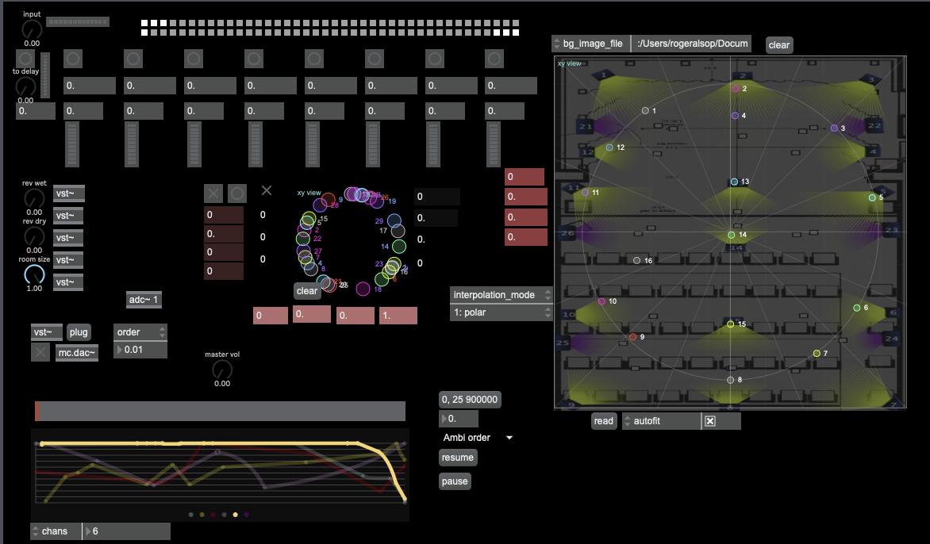

Figure 1: Rhizomatic Improvisation System

Figure 1 shows the entire interface of the Rhizomatic Improvisation System as used in performance in the Divaldo Inspirace, Prague. It is designed to allow quick access to important user controls, and to give clear feedback of the changes in parameters and that occur during performance.

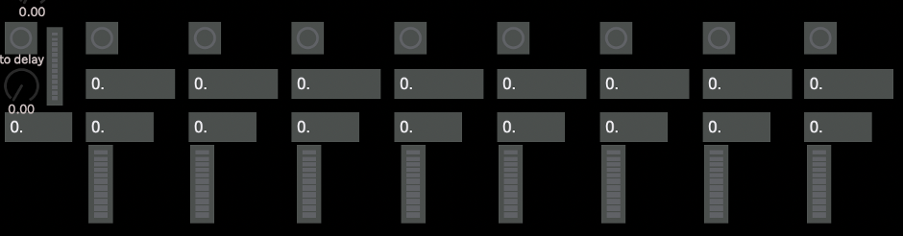

Figure 2 Delay section

Figure 2 shows the delay section prior to delay times being set. From left to right we see a button to turn off all delays, underneath that is a dial to control the signal to the delay systems, then a global feedback setting (which is usually set to 1 to create infinite repeats), and a meter to show signal level to the delay system. To the right of these controls are eight repeating controls/indicators relating to each delay line. These are, a button to turn off that specific delay, the delay time, the feedback for that delay line. The delay time is usually randomly set through the delay spatialization randomizer system, shown in figure 5.

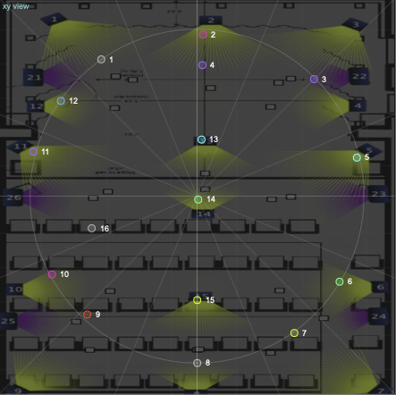

Figure 3: Speaker spatialization outline

Figure 3 shows the approximate placement of speakers in the Divaldo Inspirace. The speaker positions can be moved according to the systems that are being used. It is also possible to increase or decrease the number of speakers for sound to be broadcast through end accordance with the technology is available.

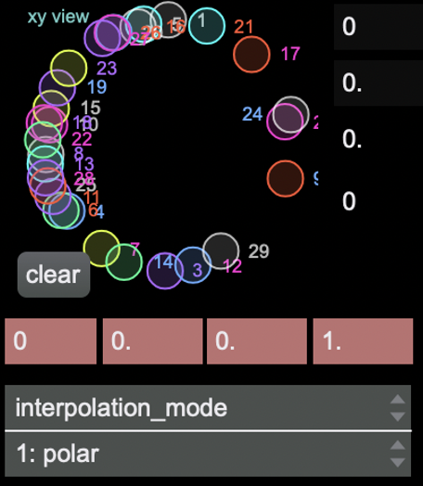

Figure 4: sound movement system

Figure 4 is an example of the positioning of sounds within the speaker system shown in Figure 3. In this case twenty-nine possible sound sources were moved within the speaker positions shown in Figure 3. It is not intended that the sound source is related directly to positions of the speakers, for example sound source seventeen being broadcast somewhere between speakers two and three. Instead, it was assumed that this particular sound would move through the speaker system, but its exact location may not relate directly to its position within the circle shown in Figure 4. The intention here was to have the sound sources continually moving, and for the musician to not be able to predict with any accuracy where a sound source may come from; this would add to the sense of, and requirement for, immediate re-activeness by the improviser.

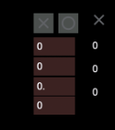

Figure 5: delay and spatialization randomizer

The delay and spatialization randomizer section is the most important part of the Rhizomatic Improvisation System. Here the delay times and spatial movement of sounds data is generated. The numbers in red are, from top to bottom: the number of random possibilities, the multiplication of those possibilities, the number of presets, and the time taken to generate those possibilities.

An example of how this works is: if 700 were chosen as the number of random possibilities, and the multiplication number was set to 100, delay times of between 100 and 70 thousand milliseconds would be generated, trajectories of sounds would move from one position to another (within a modulo of 360 degrees) and the movement from one position to another may take anywhere between 100 and 70 thousand milliseconds. The number of presets sets how many presets may be generated, and the number of presets used may be selected by the improviser. As there are only eight delays only eight of the 700 possible delay time presets are used as delay times. If the number of presets is set to 18 only 18 of the possible 700 positions for sound will be used, and only 18 of the possible transit times between one sound position and another will be used.

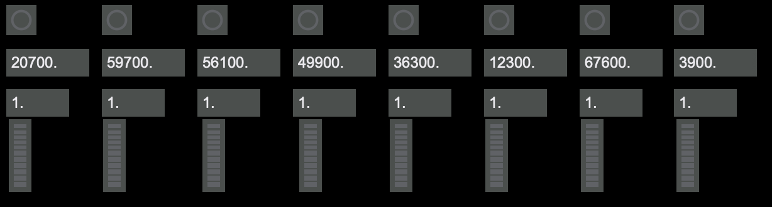

Figure 6: Example of possible delay times

An example of the possible delay times generated with this set of numbers is shown in Figure 6**.** Here the delay times range from 3.9 seconds to 59.7 seconds, and with a feedback quotient of 1, which means that the delays will continue until the system is turned off. It is possible to lower the feedback level, resulting in fewer repeats; this would be at the discretion of the improviser.

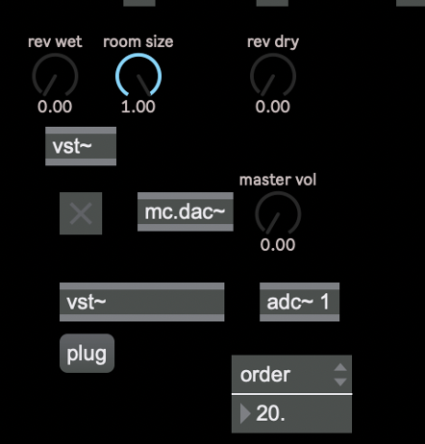

Figure 7: Effects and output

Figure 7 shows the effects an output system. In this case the TAL-Reverb-2 (TAL Software, 2023). It is possible for any software effect to be used here. The rev wet, room size, and rev dry controls relate specifically to that software. There are five effects units engaged in this version of the Rhizomatic Improvisation System and in this case each effect unit used the TAL-Reverb-2 software. It is also possible have different effects used in each of the five VST slots however this would require adjustment to the controls shown and what they effect. Here the dry signal from the input and signals from the delay units go into the effect units.

Figure 8: Composition design interface

Figure 8 provides an interface that can be used to affect some of the variables in the automatic improvisation system. Here the variables are: Ambi(sonic) order, rev wet (amplitude of the reverberation signal), rev dry (amplitude of the dry signal coming from the reverberation units), ambi motion speed (the speed at which the sounds move around within the space), master amp (the overall level of the output to all of the speakers), these are represented by the different coloured lines.

Ambi order sets the width of the sound in the speaker system, which creates a focused location of the sound within the speaker system. Figure 9, shows an order of 20 which would create a very located image of the sound, and Figure 10, with an order of 0, would create very diffused image of the sound.

Figure 9: Ambi order of 20

Figure 10: Ambi order of 0

In Figure 8 we see the Ambi order (the yellow line) at a high level that then reduces towards the end of the time allocated for performance. In this case the performance lasts for nine hundred seconds, or 15 minutes, and the master amp is used to fade in and fade out at the beginning and end of the performance.

# In performance

The Rhizomatic Improvisation System provides an experimentation process that produces new forms of expression and experience. Improvisation, whether collaborative or solo, “ceaselessly establishes connections between semiotic chains, organizations of power (diatonic harmony), and circumstances (contexts)…” and when at its freest is “not amenable to any structural or generative mode”. It is designed to provide processes of becoming that are always in motion, always changing, and always creating new options/possibilities.

While the inherent processes in the Rhizomatic Improvisation System are quite simple: delays, effect, and spatialization, the impact on the performance process is designed to create an essential sense in the performer of simultaneously attending to the past, present, and future(s) in each action.

When performing the performer is aware of the audience and, if present, collaborators. this awareness may manifest as between willful ignoring to pandering. When improvising, and particularly when improvising without a pre-ordained structure or context, there is a heightened awareness of the actions of collaborators. This awareness then forms sets of possibilities that the improviser may use, but this awareness is based on the improvisor’s short term/working memory (about 15 to 30 seconds (Atkinson & Wickens, 1971)) of recent actions/events and a consequent sense of forthcoming potential events afforded by those actions/events and how these may fit withing the developing contexts that are made.

A primary function in the performance and enjoyment of music is predicting the future. In improvisation there is a “need for real-time adaptation and mutual prediction based on information exchange between interacting individuals,” (Wiltshire & Fairhurst, 2022, p. 2). In western composition there is the use of rhythmic, melodic, and harmonic cadences. For example, the phrase

Figure 11: Melody fragment

creates a prediction of subsequent notes to be heard in both the performer and the listener. If this prediction is not fulfilled a variety of reactions may take place, ranging from frustration and disappointment to joy. This reaction will depend on the context and the character of the performer and/or the listener.

When performing with the rhizomatic improvisation system I was acutely aware that every action I make, such as the choice and articulation of a note, an unintended error, or even a change of volume or tone, will form future contexts, and these actions may be from a past that resides beyond my short-term memory. However, I could, for example, create melodies, harmonies, and/or rhythms that could form a somewhat predictable future, but this is impossible as I have no idea of *when* the past melody, harmony, or rhythm would be articulate and what would accompany from the other melodies, harmonies, and/or rhythms I had played previously.

This causes a sense of trepidation that must be overcome, and in doing so a faith that past actions will coalesce to form a coherent outcome must be developed. Attention to the changing contexts and their rhythms develops, forming a relationship between an unremembered past and present actions, and at the same time a sense of future contexts become apparent. The process is that each the contexts that are created become known as they develop, and I gain are stronger understanding of the context(s) that I have created. Often this requires simply listening to what has been created without necessarily contributing to it, and this way I become the simultaneous creator and audience.

In performance an inner sense of ‘flow’ that reflects the two conditions of flow[1] and engages the six characteristics of being in a subjective state of flow[2] (Nakamura & Csikszentmihalyi, 2002, p. 90), with oscillation between the three parts of the original model of the flow state, anxiety, flow, and boredom (2002, p. 94) is created. As the performance develops it becomes easier enter this state, as the constant state of flux between each of the sounds, along with their continually rotating interactions, form a hypnotic experience when performing is enhanced by the sense of each action adding to and interacting within that rotating flux.

# Conclusion

The rhizomatic improvisation system is one that creates a holistic work through the simultaneous exposition of the improvisors’ past and present acts. This causes an outcome in which all the acts made are simultaneously represented. The gaps between acts become sonic spaces that can be filled with previous or future acts, and the temporal placement of each act is decided by the performer and by the system.

While no overt research question was presented in this paper, as a performer and improviser the question that I was asking myself was ‘how I can represent my past and present acts in such a way that they inform all future acts that I find satisfactory. The rhizomatic improvisation system is an approach which enables and begins to explore that question.

# References

Atkinson, R. C., & Wickens, T. D. (1971). Human memory and the concept of reinforcement. *The Nature of Reinforcement*, 66–120. Retrieved from Google Scholar

Childs, B., Hobbs, C., Austin, L., Prevost, E., Rowe, K., Bailey, D., … Schwartz, E. (1982). Improvisation. *Perspectives of New Music*, 26–111. Retrieved from Google Scholar

Ciacca, A. (n.d.). Barry Harris: The Art of Teaching Jazz. Retrieved from Google Scholar

Coleman, O. (1983). Prime time for harmolodics. *Down Beat*, *7*, 54–55.

Deleuze, G., & Guattari, F. (2005). *A Thousand Plateaus: Capitalism and Schizophrenia*. Retrieved from Google Scholar

Drabkin, W. (2002). Heinrich Schenker. Retrieved from Google Scholar

Jones, O., & Russell, G. (1974). A New Theory for Jazz. *The Black Perspective in Music*, 63–74. Retrieved from Google Scholar

Nakamura, J., & Csikszentmihalyi, M. (2002). The concept of flow. In C. R. Snyder & S. J. Lopez (Eds.), *Handbook of positive psychology* (pp. 89–105). Oxford University Press. Retrieved from Google Scholar

Out Board. (2023). *TiMax soundhub*. Retrieved from https://www.timaxspatial.com/

Rink, J. (1993). Schenker and improvisation. *Journal of Music Theory*, *37*(1), 1–54. Retrieved from Google Scholar

Schenker, H. (1954). *Harmony* (Vol. 1). University of Chicago Press. Retrieved from Google Scholar

Steinweg, D. A. (2012). *Improvisational music performance: On-stage communication of power relationships*. University of South Florida. Retrieved from Google Scholar

Sutton, J. P. (2001). *‘The Invisible Handshake’: An Investigation of Free Musical Improvisation as a Form of Conversation*. Citeseer. Retrieved from Google Scholar

TAL Software. (2023). *TAL-Reverb-2*. TAL Software. Retrieved from https://tal-software.com/products/tal-reverb

Toop, D. (2008). SEARCH AND REFLECT: THE CHANGING PRACTICE OF IMPROVISATION. *New Sound: International Magazine for Music*, (32). Retrieved from Google Scholar

Western, D. (2023, April 10). 42 Ingeniously Motivational Miles Davis Quotes. Retrieved 9 July 2023, from https://wealthygorilla.com/16-motivational-miles-davis-quotes/

Wiltshire, T. J., & Fairhurst, M. T. (2022). Collaborative creativity: Information-driven coordination dynamics and prediction in movement and musical improvisation. In *The Routledge International Handbook of Creative Cognition* (pp. 624–645). Routledge. Retrieved from Google Scholar

1. Perceived challenges, or opportunities for action, that stretch (neither overmatching nor underutilizing) existing skills; a sense that one is engaging challenges at a level appropriate to one’s capacities, and clear proximal goals and immediate feedback about the progress that is being made.
2. Intense and focused concentration on what one is doing in the present moment

   Merging of action and awareness

   Loss of reflective self-consciousness (i.e., loss of awareness of oneself as a social actor)

   A sense that one can control one’s actions; that is, a sense that one can in principle deal with the situation because one knows how to respond to whatever happens next

   Distortion of temporal experience (typically, a sense that time has passed faster than normal)

   Experience of the activity as intrinsically rewarding, such that often the end goal is just an excuse for the process.