Network Traffic Management Report
Evaluation of Existing Network and Solution
Project: Darvycom Brisbane Engineering Laboratory Network & DSP Upgrade
Location: Blocks A and B, Brisbane Engineering Laboratory
Project Manager: Leonardo Matias Ciarcia
Document ID: C6-NET-TM-01
Version: 1.0
Prepared: 02 March 2026
Baseline: 24 weeks / AUD 184,800

1. Executive summary
This report evaluates traffic management across Darvycom Australia's two documented network systems: the existing Network 1 and the selected Network 3. Network 1 is a small two-block environment with limited segmentation and no integrated monitoring. Network 3 introduces a VPN edge, firewall, Layer 3 core, four managed PoE access switches, VLANs, QoS and PRTG monitoring. The design review and completed simulations show that Network 3 provides materially better visibility, isolation, scalability and control of voice, video and data traffic.
Conclusion: Network 3 is the preferred production design. Its VLAN and QoS controls reduce broadcast scope and protect real-time services, while PRTG provides the evidence needed to manage availability, latency, packet loss and interface utilisation.

2. Systems evaluated
Feature | Network 1 - existing | Network 3 - selected
Topology | Two blocks, separate routers and access switches | Internet/ISP -> VPN router -> firewall -> Layer 3 core -> four PoE access switches
Endpoints | 16 PCs and 8 analogue phones | 20 PCs, 20 IP phones, 40 headsets, video endpoint and servers
Voice | Legacy Panasonic PBX; separate analogue service | Cisco 2911 CME/IP-PBX and voice VLANs
Segmentation | Block A 192.168.10.0/24; Block B 192.168.20.0/24; limited policy separation | VLANs 10, 20, 30, 40, 50, 60, 110, 120 and 130 with inter-VLAN routing and policy boundaries
Monitoring | No central performance platform documented | PRTG sensors for ping, interface traffic, system health and alarms
Traffic control | Best-effort forwarding | QoS classification, priority for voice/video, managed uplinks and threshold-based alerting

3. Traffic-management method
The assessment uses five management dimensions: reachability, utilisation, delay/packet loss, segmentation and operational response. Packet Tracer validates the logical controls. PRTG provides representative operational evidence from a home-lab router and Windows monitoring host; this evidence demonstrates the monitoring method but must not be described as a measurement taken on Darvycom production equipment.
Metric | Collection method | Project interpretation | Suggested threshold
Availability | PRTG Ping sensor and device status | Confirms that routers, servers and key endpoints respond | Warning after 2 failed intervals; down after 3
Latency | Ping/Ping Jitter sensor | Identifies delay changes affecting calls and video | Investigate sustained >100 ms; voice target <150 ms one way
Packet loss | Ping and traffic sensors | Indicates congestion, interference or link faults | Investigate >1%; urgent for sustained >3%
Interface utilisation | SNMP Traffic 64-bit sensor | Shows inbound/outbound load and congestion risk | Warn at 70%; critical at 85%
Errors/discards | SNMP interface channels | Detects cabling, duplex or congestion faults | Any rising trend requires investigation

4. Test scenarios and results
ID | Scenario | Network 1 expectation | Network 3 result/status | Evidence
TM-01 | PC-to-gateway and cross-VLAN connectivity | Basic reachability; broad trust between services | Packet Tracer connectivity succeeded after correcting VLAN, trunk, gateway and interface settings | Packet Tracer screenshots and final ping output
TM-02 | Voice and data coexistence | Analogue voice is outside IP QoS; no unified view | Voice VLAN and QoS design protect Cisco CME calls while data remains available | Phone registration/call screenshots; QoS configuration
TM-03 | Video-to-server traffic | No integrated video service | Video endpoint 10.10.40.10 reaches Server1 10.10.60.10 through controlled routing | Successful ping/service test screenshot
TM-04 | Router availability monitoring | Manual fault discovery | PRTG Ping sensor records response time, uptime and packet loss | Embedded representative PRTG evidence
TM-05 | Interface bandwidth monitoring | No central traffic graph | PRTG SNMP traffic sensor displays inbound, outbound and total traffic | Embedded representative PRTG evidence
TM-06 | Monitoring-server capacity | Not available | PRTG System Health sensor records CPU and available memory | Embedded representative PRTG evidence

5. Comparative evaluation
Criterion | Network 1 | Network 3 | Evaluation
Broadcast control | Large per-block subnets | Function-based VLANs | Network 3 reduces unnecessary broadcast exposure
Real-time priority | No IP voice policy | QoS for voice/video | Network 3 supports predictable real-time performance
Fault isolation | Manual and device-by-device | PRTG alarms plus segmented paths | Network 3 shortens detection and diagnosis
Security | Limited internal boundaries | Firewall, VPN, VLANs and ACL-ready design | Network 3 supports least privilege and controlled remote access
Scalability | Little documented headroom | Managed access/core hierarchy | Network 3 can expand without redesigning the whole network

6. Management recommendations
- Retain Network 3 as the approved baseline and document every VLAN, trunk, gateway and QoS change.
- Create PRTG device groups for the VPN router, firewall, core, four access switches, two data servers, Cisco CME voice server, access points and video endpoint.
- Apply 60-second scanning to critical reachability sensors and a longer interval to lower-priority capacity sensors.
- Configure warning and error thresholds for utilisation, latency, packet loss, interface errors and sensor health.
- Run a controlled busy-network test, save before/during/after screenshots and record the time, device and expected result.
- Review PRTG trends weekly during stabilisation and monthly after operational acceptance.

7. Evidence register
Evidence item | What it proves | Status / action
PRTG Ping sensor screen | Reachability, response time, packet loss and uptime collection | Available below; representative home-lab method
PRTG SNMP traffic graph | Inbound/outbound traffic measurement on a monitored router interface | Available below; representative home-lab method
PRTG System Health graph | Monitoring host CPU and memory capacity | Available below; representative home-lab method
Packet Tracer final pings | Network 3 routing and VLAN corrections succeeded | Attach final successful screenshots
VoIP registration and call | Cisco CME and voice VLAN operation | Attach phone registration and active-call screenshots
PRTG outage and recovery | Alarm transition and recovery timing | Perform controlled Wi-Fi/router outage and attach before/down/recovery screens

Representative PRTG evidence
production measurements.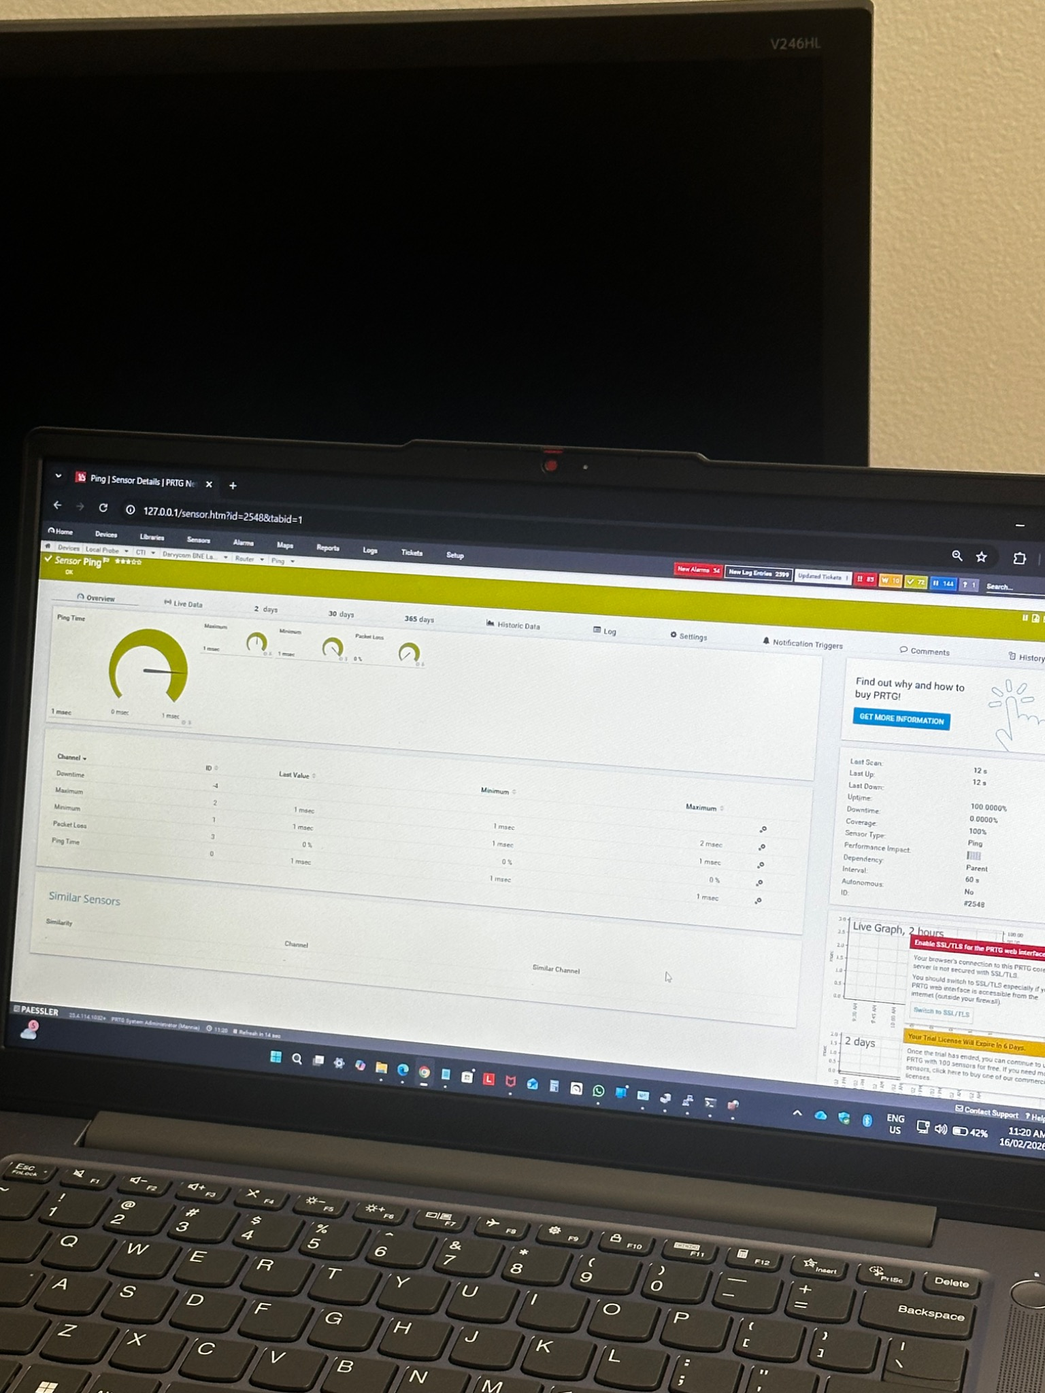
PRTG Ping sensor showing approximately 1 ms response time, 0% packet loss and 100% uptime in the representative router test.
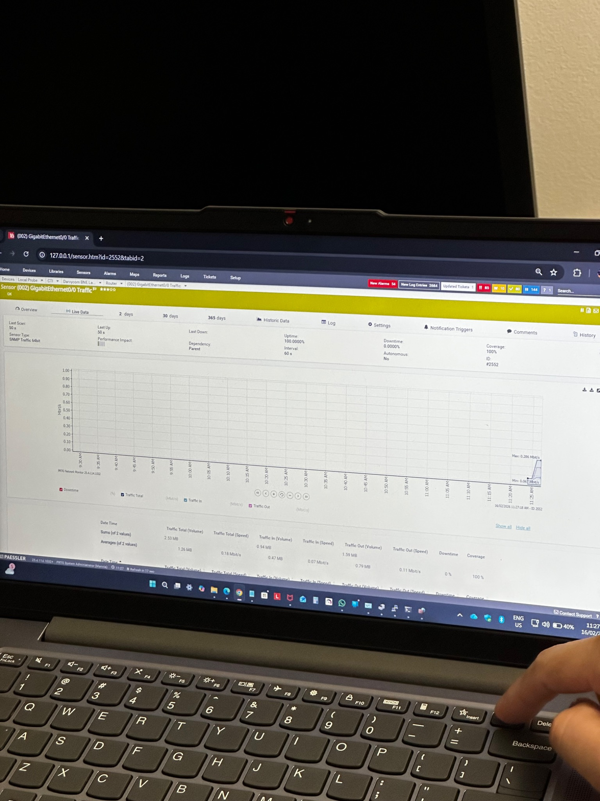
PRTG SNMP Traffic 64-bit graph showing traffic-in, traffic-out, total traffic, uptime and coverage for a monitored router interface.
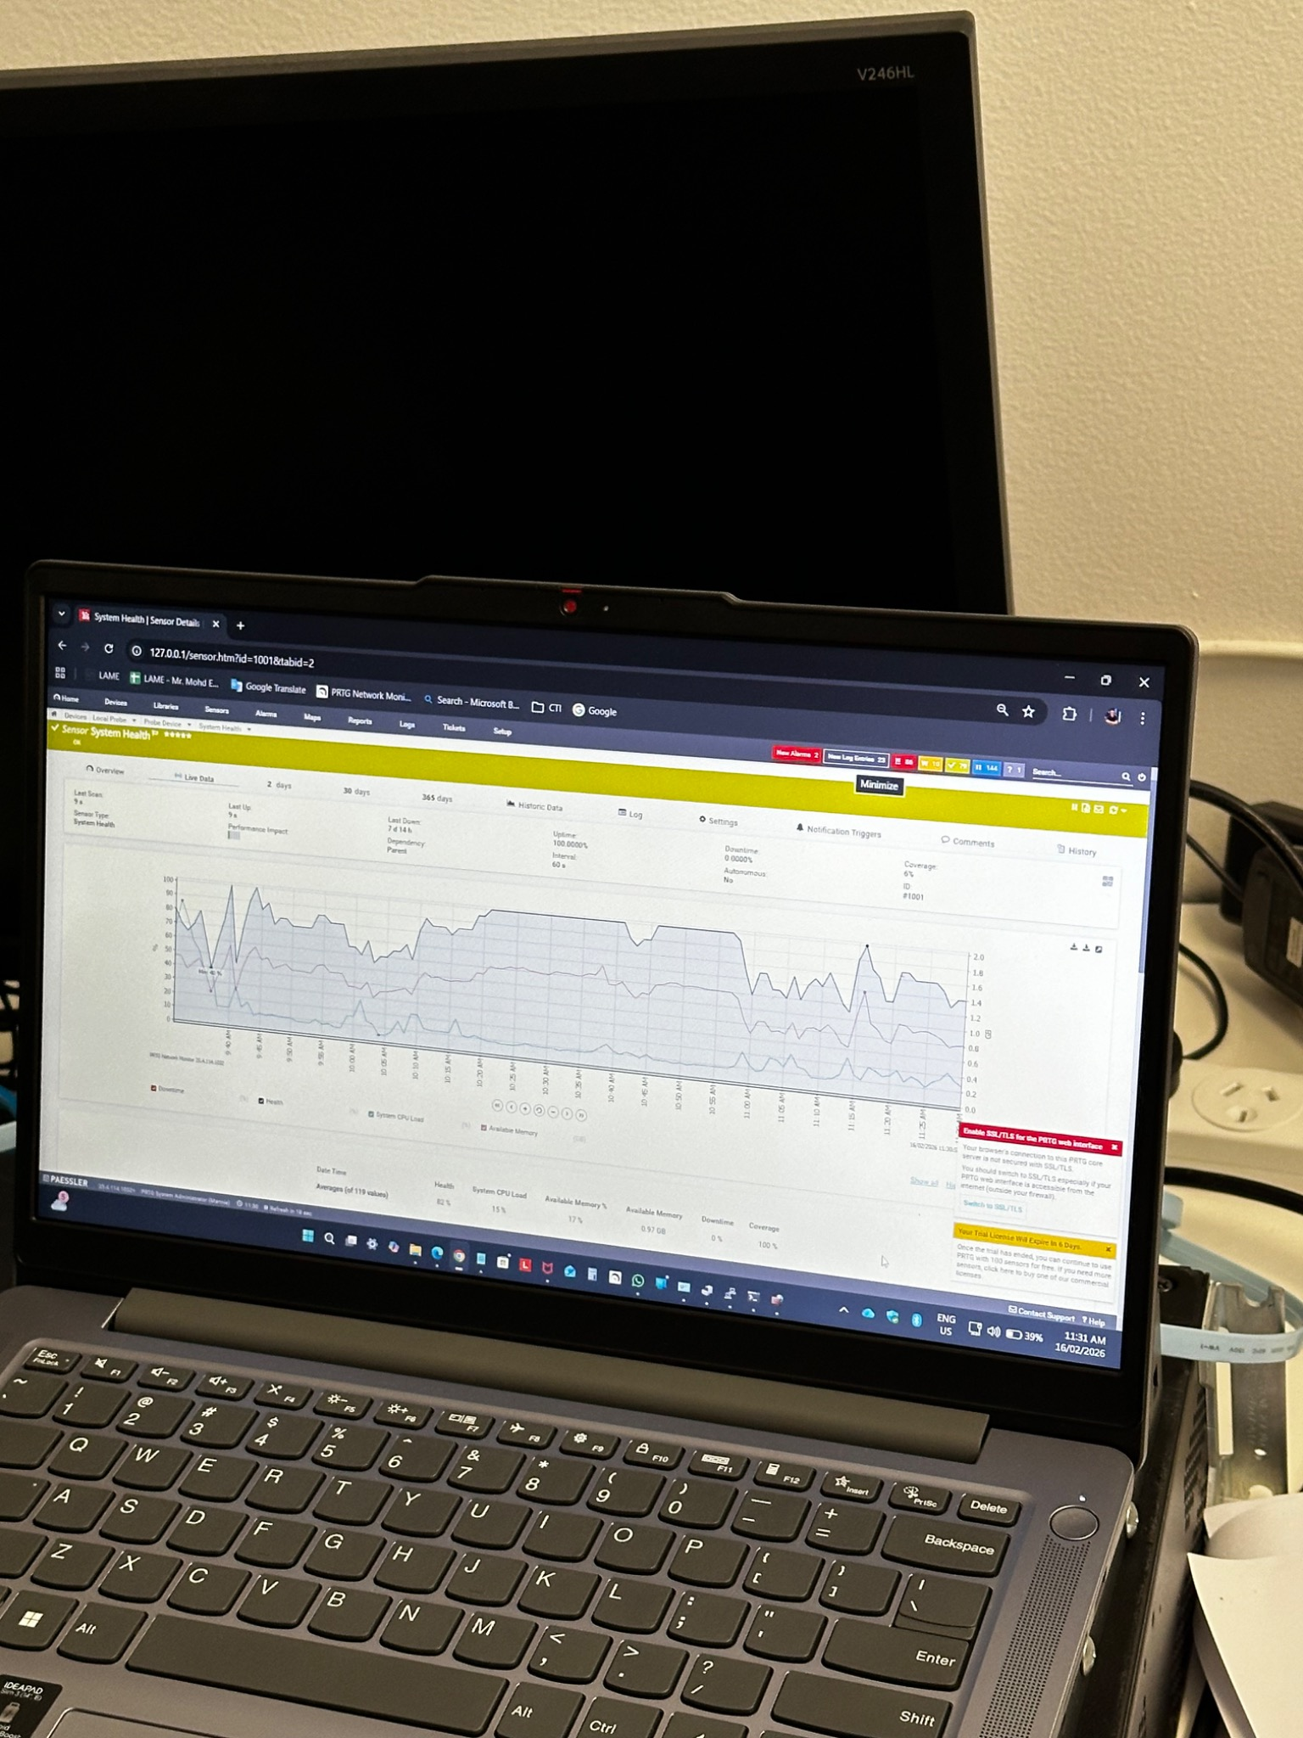
PRTG System Health graph showing monitoring-host health, CPU load and available memory channels.

Sign-off
Role | Name | Decision | Date
Prepared by | Leonardo Matias Ciarcia | Completed | 02/03/2026
Technical reviewer | Tommy | Approved | 02/03/2026
Project sponsor | Dijo | Accepted | 02/03/2026

