PV4/IPV6 MONITORING AND INTEROPERABILITY TEST PLAN
Project: A-Plus Institute Enterprise Network Upgrade
Network Design: Network Option 2 – Final Selected Network
Prepared by: Leonardo Matias Ciarcia
Role: Network Technical Specialist
Date: 7 October 2025
Version: 1.0
Status: Proposed controlled test plan
- PURPOSE
This document provides a plan for monitoring and testing interoperability between IPv4 and IPv6 in the A-Plus Institute network.
The approved Network Option 2 design currently operates with IPv4. IPv6 will first be introduced in a controlled dual-stack test environment. The existing IPv4 service must remain available while IPv6 addressing, routing, name resolution, monitoring and security controls are tested.
- SCOPE AND LIMITATIONS
The test environment will represent:
- The Brisbane five-level campus.
- The separate Rookwood campus.
- BRI-RTR-FINAL and ROO-RTR-FINAL.
- The Brisbane and Rookwood Layer 3 core switches.
- Staff, student, server, management and wireless VLANs.
- An IPv4-only legacy client.
- An IPv6-only test client.
- Dual-stack clients and servers.
- DNS A and AAAA records.
- IPv4 and IPv6 monitoring methods.
The IPv6 addresses in this document use 2001:db8::/32, which is reserved for documentation and examples. These addresses must not be treated as an actual public allocation. A production IPv6 prefix must be obtained from 3TTech or the appropriate provider.
- INTEROPERABILITY APPROACH
Dual stack is the selected test approach. Dual-stack interfaces and devices have both an IPv4 address and an IPv6 address and can forward traffic according to the destination protocol.
The test environment will include:
Device type | Address capability | Purpose
Existing legacy client | IPv4 only | Confirm existing IPv4 devices continue to operate
Dual-stack client | IPv4 and IPv6 | Confirm access to both address families
IPv6-only test client | IPv6 only | Confirm native IPv6 operation
Dual-stack server | IPv4 and IPv6 | Provide A and AAAA records and services for both client types
Routers and Layer 3 cores | IPv4 and IPv6 | Route and monitor both protocols
DNS service | A and AAAA records | Resolve IPv4 and IPv6 service addresses
An IPv6-only device cannot communicate directly with an IPv4-only service unless a translation service such as NAT64/DNS64 is introduced. NAT64/DNS64 is not included in the current design. Therefore, failure between those two endpoint types is an expected limitation rather than a network fault.
- PROTOCOLS AND SERVICES
Function | IPv4 | IPv6 | Monitoring requirement
Network addressing | IPv4 | IPv6 | Confirm correct address and prefix
Local address resolution | ARP | Neighbor Discovery using ICMPv6 | Inspect ARP and IPv6 neighbour tables
Control and error reporting | ICMPv4 | ICMPv6 | Monitor reachability, loss and delay
Automatic addressing | DHCPv4 | SLAAC and, where required, DHCPv6 | Confirm correct address, gateway and DNS information
Name resolution | DNS A record | DNS AAAA record | Test A and AAAA responses separately
Static routing | IPv4 static route | IPv6 static route | Confirm route and next hop
Dynamic routing if introduced later | OSPFv2 | OSPFv3 | Check neighbours and advertised routes
Multicast membership | IGMP | MLD | Monitor only if multicast services are introduced
Transport services | TCP and UDP over IPv4 | TCP and UDP over IPv6 | Compare application response and retransmissions
Security filtering | IPv4 ACL | IPv6 traffic-filter ACL | Apply equivalent policy to both protocols
Internet address translation | NAT/PAT normally used | Normally no NAT required | Ensure IPv6 is not unintentionally exposed
Inter-campus security | Existing IPv4 IPsec VPN | Requires separate validation before production | Do not send production IPv6 traffic through an unapproved path
- PROPOSED IPV6 ADDRESSING PLAN
The existing IPv4 addressing will remain unchanged.
Brisbane IPv4 networks:
- 10.10.10.0/24 – Management.
- 10.10.20.0/24 – Staff.
- 10.10.30.0/24 – Students.
- 10.10.40.0/24 – Servers.
- 10.10.60.0/24 – Corporate wireless.
- 10.10.70.0/24 – Guest wireless.
Rookwood IPv4 networks:
- 10.20.10.0/24 – Management.
- 10.20.20.0/24 – Staff.
- 10.20.30.0/24 – Students.
- 10.20.40.0/24 – Servers.
- 10.20.60.0/24 – Corporate wireless.
- 10.20.70.0/24 – Guest wireless.
Proposed test IPv6 networks:
Location and VLAN | Proposed IPv6 subnet | Proposed gateway
Brisbane VLAN 10 – Management | 2001:db8:10:10::/64 | 2001:db8:10:10::1
Brisbane VLAN 20 – Staff | 2001:db8:10:20::/64 | 2001:db8:10:20::1
Brisbane VLAN 30 – Students | 2001:db8:10:30::/64 | 2001:db8:10:30::1
Brisbane VLAN 40 – Servers | 2001:db8:10:40::/64 | 2001:db8:10:40::1
Brisbane VLAN 60 – Corporate Wi-Fi | 2001:db8:10:60::/64 | 2001:db8:10:60::1
Brisbane VLAN 70 – Guest Wi-Fi | 2001:db8:10:70::/64 | 2001:db8:10:70::1
Rookwood VLAN 110 – Management | 2001:db8:20:110::/64 | 2001:db8:20:110::1
Rookwood VLAN 120 – Staff | 2001:db8:20:120::/64 | 2001:db8:20:120::1
Rookwood VLAN 130 – Students | 2001:db8:20:130::/64 | 2001:db8:20:130::1
Rookwood VLAN 140 – Servers | 2001:db8:20:140::/64 | 2001:db8:20:140::1
Rookwood VLAN 160 – Corporate Wi-Fi | 2001:db8:20:160::/64 | 2001:db8:20:160::1
Rookwood VLAN 170 – Guest Wi-Fi | 2001:db8:20:170::/64 | 2001:db8:20:170::1
Proposed example server addresses:
Device | Existing IPv4 | Proposed test IPv6
BRI-SRV-01 | 10.10.40.10 | 2001:db8:10:40::10/64
BRI-NAS-01 | 10.10.40.30 | 2001:db8:10:40::30/64
BRI-NMS-01 | 10.10.40.40 | 2001:db8:10:40::40/64
ROO-SRV-01 | 10.20.40.10 | 2001:db8:20:140::10/64
ROO-NAS-01 | 10.20.40.30 | 2001:db8:20:140::30/64
Where IPv6 HSRP is supported, the Brisbane virtual IPv6 gateway will use ::1, while BRI-CORE-L3-A and BRI-CORE-L3-B use ::2 and ::3. If the simulator does not support IPv6 HSRP, Core A will use ::1 for the controlled test and the simulator limitation will be documented.
- MIXED-ENVIRONMENT DESIGN
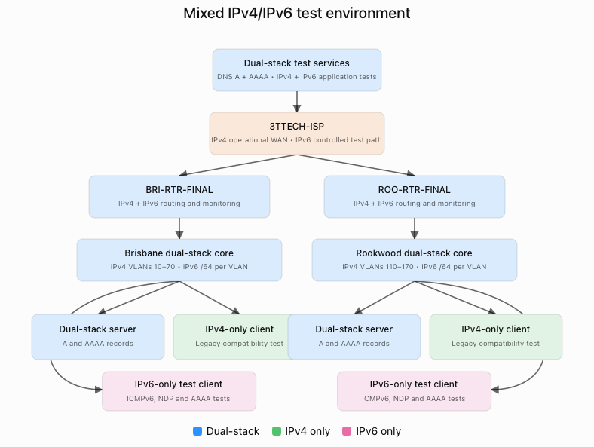
Figure 1 – A-Plus Institute mixed IPv4/IPv6 test environment
The design shows the 3TTech test path connecting dual-stack Brisbane and Rookwood routing devices. Each campus includes dual-stack services, an IPv4-only client and an IPv6-only test client.
The IPv6 inter-campus path is for controlled simulation only. Production IPv6 must not be enabled across the WAN until routing, filtering, monitoring and encrypted transport have been approved.
- TEST METHODS
Test ID | Test method | Procedure | Expected result
IP01 | IPv4 address validation | Use ipconfig /all and show ip interface brief | Existing IPv4 addressing remains correct
IP02 | IPv6 address validation | Use ipconfig /all and show ipv6 interface brief | Correct global, link-local and prefix information appears
IP03 | IPv4 local gateway test | Ping the relevant 10.10.x.1 or 10.20.x.1 gateway | Successful IPv4 response
IP04 | IPv6 local gateway test | Ping the relevant 2001:db8 gateway | Successful IPv6 response
IP05 | IPv6 neighbour discovery | Use show ipv6 neighbors and capture ICMPv6 | A valid neighbour entry is created
IP06 | IPv4 route test | Use show ip route and traceroute | Correct IPv4 route and next hop displayed
IP07 | IPv6 route test | Use show ipv6 route and IPv6 traceroute | Correct IPv6 route and next hop displayed
IP08 | IPv4-only compatibility | Access the dual-stack server using its IPv4 address or A record | Service succeeds over IPv4
IP09 | IPv6-only compatibility | Access the dual-stack server using its IPv6 address or AAAA record | Service succeeds over IPv6
IP10 | Dual-stack client test | Test the same server explicitly over IPv4 and IPv6 | Both protocol tests succeed independently
IP11 | DNS interoperability | Query the service A and AAAA records | Both approved records are returned
IP12 | Unsupported direct translation | Test IPv6-only client to IPv4-only service without NAT64 | Failure is recorded as expected
IP13 | Policy equivalence | Test protected and guest access using IPv4 and IPv6 | Both protocols enforce equivalent restrictions
IP14 | Monitoring test | Generate approved IPv4 and IPv6 traffic | Both protocol families appear in logs or captures
IP15 | Failure and recovery test | Remove an approved test IPv6 route and restore it | Alert occurs, traffic fails and then recovers
IP16 | Regression test | Repeat existing IPv4 tests after enabling test IPv6 | Existing IPv4 services remain operational
- MONITORING COMMANDS AND FILTERS
Cisco IOS commands:
Command | Purpose
show ip interface brief | Display IPv4 interface status
show ipv6 interface brief | Display IPv6 interface status
show ip route | Display the IPv4 routing table
show ipv6 route | Display the IPv6 routing table
show arp | Display IPv4 address-resolution entries
show ipv6 neighbors | Display IPv6 neighbour entries
show ipv6 traffic | Display IPv6 traffic and error counters
ping | Test an IPv4 destination
ping ipv6 or ping <IPv6-address> | Test an IPv6 destination
traceroute | Test the IPv4 path
traceroute ipv6 | Test the IPv6 path where supported
Wireshark filters:
Filter | Purpose
ip | Display IPv4 packets
ipv6 | Display IPv6 packets
arp | Display IPv4 address-resolution traffic
icmp | Display ICMPv4 traffic
icmpv6 | Display ICMPv6 and neighbour-discovery traffic
dhcp | Display DHCPv4 traffic
dhcpv6 | Display DHCPv6 traffic
dns | Display A and AAAA queries and responses
- MONITORING SCHEDULE
Frequency | IPv4/IPv6 monitoring activity
Every 5 minutes during testing | Check IPv4 and IPv6 reachability to critical test gateways and servers
Continuous during a test | Collect approved syslog and packet-capture information
Daily during the pilot | Review IPv4 and IPv6 interface, route and neighbour status
Weekly | Test A and AAAA records and compare IPv4/IPv6 application access
Weekly | Review IPv4 and IPv6 packet loss, latency and interface errors
Monthly | Compare IPv4 and IPv6 policy enforcement and update the issue register
After a configuration change | Repeat all affected IPv4 and IPv6 tests
Before production approval | Complete security, WAN, VPN, failover and monitoring validation
- SECURITY REQUIREMENTS
IPv6 must not be enabled without equivalent security and monitoring. The implementation must:
- Apply IPv6 ACLs separately from IPv4 ACLs.
- Prevent guest IPv6 clients from reaching protected internal networks.
- Monitor Router Advertisements and unexpected IPv6 addressing.
- Disable IPv6 on interfaces where it is not required.
- Restrict network-device management to authorised networks.
- Use secure monitoring methods wherever supported.
- Avoid publicly routing the documentation addresses used in this plan.
- Confirm secure inter-campus transport before production IPv6 use.
- Protect packet captures and logs containing addressing or user information.
- ACCEPTANCE CRITERIA
The interoperability test will be accepted when:
- Existing IPv4 services continue to operate.
- Approved dual-stack devices receive valid IPv4 and IPv6 addresses.
- IPv4-only clients can access dual-stack services over IPv4.
- IPv6-only clients can access dual-stack services over IPv6.
- DNS returns correct A and AAAA records.
- IPv4 and IPv6 routes are present and stable.
- Equivalent access restrictions are applied to both protocols.
- Monitoring detects IPv4 and IPv6 availability and failures.
- All unexpected results are documented and resolved or formally accepted.
- The project sponsor approves any production IPv6 implementation.

