A-PLUS INSTITUTE
ICTNPL413 – EVALUATE NETWORKING REGULATIONS AND LEGISLATION FOR THE TELECOMMUNICATIONS INDUSTRY
ANNOTATED WORKPLACE DOCUMENT REVIEW
Prepared by: Leonardo Matias Ciarcia
Student ID: CTI20221062
Project role: Assistant IT Manager / Telecommunications Technical Specialist
Prepared for: A-Plus Institute
Date: 18/05/2026
Version: 1.0
- PURPOSE OF THE REVIEW
The purpose of this review is to analyse complex written and visual workplace documents associated with the A-Plus Institute Network Solution. The review identifies important business, technical, legislative, security and operational requirements and evaluates whether these requirements have been addressed in the proposed solution.
The documents reviewed were:
- A-Plus Institute case study and role-play information.
- A-Plus Institute project requirements.
- Current network diagram.
- Final Network Solution diagram.
- Network configuration and IP addressing information.
- Security, privacy, site-access and sustainability requirements included in the case study.
- Australian telecommunications legislation and regulatory requirements relevant to the project.
- ANNOTATED REVIEW OF THE WRITTEN CASE STUDY

Annotation 1 – Business growth
Case-study extract:
“A-Plus Institute has witnessed a rapid increase in its client base and candidate enrolments.”
Your annotation:
Key finding: Increased enrolments and business activities will increase internet traffic, wireless connections, file access and the number of IP addresses required. The existing network may not have sufficient capacity.

Annotation 2 – Additional levels
Case-study extract:
“A-Plus Institute has acquired two more floors of the building complex.”
Your annotation:
Key requirement: The final Network Solution must support five Brisbane levels—three existing levels and two new classroom levels. The server room is located within Existing Level 1.

Annotation 3 – Wireless coverage
Case-study extract:
“Provide the two new floor classrooms with enterprise wireless local area network coverage.”
Your annotation:
Key requirement addressed: The Network Solution includes managed wireless access points for the five Brisbane levels and centralised wireless management through the WLAN controller.

Annotation 4 – Rookwood campus
Case-study extract:
“Establish a campus network for Rookwood and connect the campus network to the main campus in Brisbane.”
Your annotation:
Key requirement addressed: The Network Solution includes a separate Rookwood network connected securely to Brisbane through a site-to-site IPsec VPN.

Annotation 5 – 3TTech
Case-study extract:
“A-Plus Institute will prefer to keep the same ISP, 3TTech, for the Rookwood Campus Network.”
Your annotation:
Risk identified: Using the same provider for both campuses simplifies support but creates dependency on one ISP. Backup connectivity or a temporary connection method should be documented.

Annotation 6 – Performance and security
Case-study extract:
“The new enterprise network must be future-proof and bottleneck-free. It must meet the need for optimum network performance, scalability and security.”
Your annotation:
Design response: The Network Solution uses two redundant Layer 3 core switches, managed access switches, VLAN segmentation, access controls, centralised services, monitoring and an encrypted VPN.

Annotation 7 – Inconsistent information
Highlight the sections where the documents use different numbers of employees or additional floors.
Your annotation:
Clarification required: The assessment documents contain inconsistent staffing and floor figures. The approved Network Solution uses five Brisbane levels—three existing and two new. The final number of users should be confirmed with the client before completing capacity calculations.

- ANNOTATED REVIEW OF THE NETWORK SOLUTION DIAGRAM
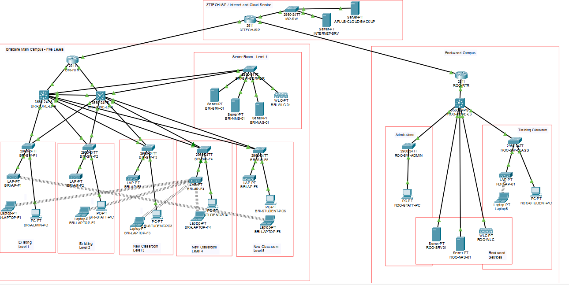

Callout 1 – Brisbane levels
Five Brisbane levels confirmed: three existing levels and two new classroom levels.

Callout 2 – Core switches
Redundant Layer 3 core switches provide inter-VLAN routing and improve network availability.

Callout 3 – Server room
The central server room is located within Existing Level 1 and supports DHCP, DNS, file, backup and monitoring services.

Callout 4 – Wireless infrastructure
Managed access points provide wireless coverage for students, staff and trainers across the Brisbane levels.

Callout 5 – Inter-campus connection
The site-to-site IPsec VPN protects authorised communication between the Brisbane and Rookwood campuses.

Callout 6 – ISP risk
Both campuses depend on 3TTech. An independent backup connection is recommended to reduce the single-provider risk.

Callout 7 – Network segmentation
VLANs and access controls separate administrative, staff, student, guest, server and management traffic.

- REVIEW OF POLICIES AND PROCEDURAL REQUIREMENTS
Information Security and Access-Control Requirements
Key point:
Access to network devices, servers and confidential information must be limited to authorised users.
Finding:
Network segmentation and access controls are included in the Network Solution. A formal user-access review and administrator-account procedure should also be maintained.
Privacy and Data-Handling Requirements
Key point:
Student and staff information must be protected from loss, misuse and unauthorised access.
Finding:
Encrypted communication, secure backups, access controls and incident-response procedures are required. Data-retention periods and secure deletion should also be documented.
Backup and Recovery Requirements
Key point:
Important configurations and business information must be recoverable after equipment failure or a security incident.
Finding:
Configuration backups, data backups and restoration testing must form part of ongoing network management.
Site-Access Requirements
Key point:
Only authorised personnel should enter restricted areas or perform site work.
Finding:
Sign-in, visitor identification, escort arrangements, server-room restrictions and photography approval must be recorded.
Cabling and Installation Requirements
Key point:
Fixed telecommunications cabling must be performed or supervised by an appropriately registered cabler.
Finding:
The project must retain cabler registration information, test results, cable labels, as-built drawings and the Telecommunications Cabling Advice form.
Change-Management Requirements
Key point:
Network changes must be authorised, tested, recorded and capable of being reversed.
Finding:
The project requires configuration backups, change approval, scheduled implementation, testing and rollback instructions.
Monitoring and Incident-Management Requirements
Key point:
Network performance, failures and security events must be monitored and investigated.
Finding:
The Network Solution includes monitoring capability. Alert thresholds, escalation contacts and incident-record requirements must be documented.
Sustainability Requirements
Key point:
Equipment selection and network operation should support energy efficiency and responsible lifecycle management.
Finding:
Energy use, cooling, equipment reuse, supported lifecycle and electronic-waste disposal should be included in procurement decisions.
- MAIN FINDINGS
The document analysis identified the following main findings:
- The business need for the project is clearly supported by increased enrolments, staff and network demand.
- The confirmed Brisbane scope is five operational levels.
- The server room is located within Existing Level 1.
- The Network Solution addresses scalability through redundant core switching and managed access infrastructure.
- Enterprise wireless coverage is included for the additional classroom levels.
- The Rookwood connection is included through a site-to-site IPsec VPN.
- Dependence on 3TTech creates a service-continuity risk.
- Security and privacy controls are included but require supporting policies and operational procedures.
- Cabling, site access, WHS and equipment compliance evidence must be collected before implementation.
- Different figures in the case-study and role-play material require client clarification.
- The final diagram requires consistent labelling, version control, subnet information and a legend.
- Trainer review, feedback and signature are required to demonstrate completion.
- RECOMMENDED ACTIONS
A-Plus Institute should:
- Confirm the final staffing and user numbers with the client.
- Maintain the approved five-level Brisbane scope.
- Confirm that Rookwood is the remote campus represented in the Network Solution.
- Obtain written service details from 3TTech.
- Document the VLAN, subnet, link and device information on the diagram.
- Show the network boundary between A-Plus Institute and 3TTech.
- Include backup connectivity in the continuity plan.
- Complete wireless testing for all levels.
- Use registered cablers and retain compliance evidence.
- Finalise security, privacy, backup, monitoring and change-management procedures.
- Add document-control information to all diagrams and reports.
- Obtain client and trainer approval before implementation.
- CONCLUSION
The written and visual workplace documents contain sufficient information to establish the principal business and technical requirements of the project. The Network Solution responds to the main requirements through five-level Brisbane coverage, redundant core infrastructure, managed wireless services, centralised network resources and a secure Rookwood connection.
The review also identified matters requiring clarification and supporting evidence, particularly inconsistent staffing and floor information, regional service availability, dependency on 3TTech, policy documentation and diagram labelling.
The Network Solution is suitable to progress after these matters are reviewed with the client and the annotated documents are approved and signed by the trainer.

