NETWORK TEST IMPLEMENTATION AND RESULTS REPORT
Project: A-Plus Institute Enterprise Network Upgrade
Network Design: Network Option 2 – Final Selected Network
Prepared by: Leonardo Matias Ciarcia
Role: Network Technical Specialist
Test date: 10/10/2025
Version: 1.0
Status: Test execution record – evidence to be completed
- PURPOSE
This report documents the setup, execution and results of tests performed on the A-Plus Institute final network design.
The tests verify:
- Switch-to-switch connectivity.
- Access-port and VLAN assignments.
- Loop prevention.
- Private VLAN behaviour in a separate supported test scenario.
- Switch virtual interfaces.
- Inter-VLAN routing.
- HSRP redundancy.
- DHCP and DNS.
- Internet and inter-campus connectivity.
- Secure and guest wireless access.
- ACL security.
- IPv4/IPv6 interoperability.
- Network monitoring and configuration persistence.
Actual test results must be entered from the real Packet Tracer, IOS, Wireshark or wireless-tool output. A test must not be marked Pass without corresponding evidence.
- TEST ENVIRONMENT
Item | Test environment
Main simulation software | Cisco Packet Tracer
Test file | Copy of APlus_Network3_Final.pkt, labelled Network Option 2 in the report
Network | A-Plus Institute Brisbane and Rookwood final design
Brisbane routing | BRI-RTR-FINAL, BRI-CORE-L3-A and BRI-CORE-L3-B
Brisbane access layer | BRI-SW-F1 to BRI-SW-F5 and BRI-SW-SERVER
Rookwood routing | ROO-RTR-FINAL and ROO-CORE-L3
Rookwood access layer | ROO-SW-ADMIN and ROO-SW-CLASS
Servers | BRI-SRV-01, BRI-NAS-01, BRI-NMS-01, ROO-SRV-01 and ROO-NAS-01
Wireless | Brisbane and Rookwood WLCs, APs, APlus-Secure and APlus-Guest
WAN | 3TTECH-ISP, INTERNET-SRV and APLUS-CLOUD-BACKUP
Packet analysis | Wireshark on an authorised real network or supported capture source
Wireless testing | NetSpot and TamoGraph using actual survey readings
IPv6 testing | Separate dual-stack copy of the simulation
Wireshark, NetSpot and TamoGraph outputs must be identified as separate real-network or field evidence. They must not be described as traffic captured directly from Packet Tracer.
3.TEST EXECUTION AND RESULTS
Test T01 – Device and interface status
Procedure:
- On the routers and Layer 3 core switches, run show ip interface brief.
- Inspect the Packet Tracer topology for red links.
- Confirm that required interfaces are up/up.
Expected result:
All required interfaces are up/up. A redundant Layer 2 uplink may be amber because STP has placed it in a blocking state.
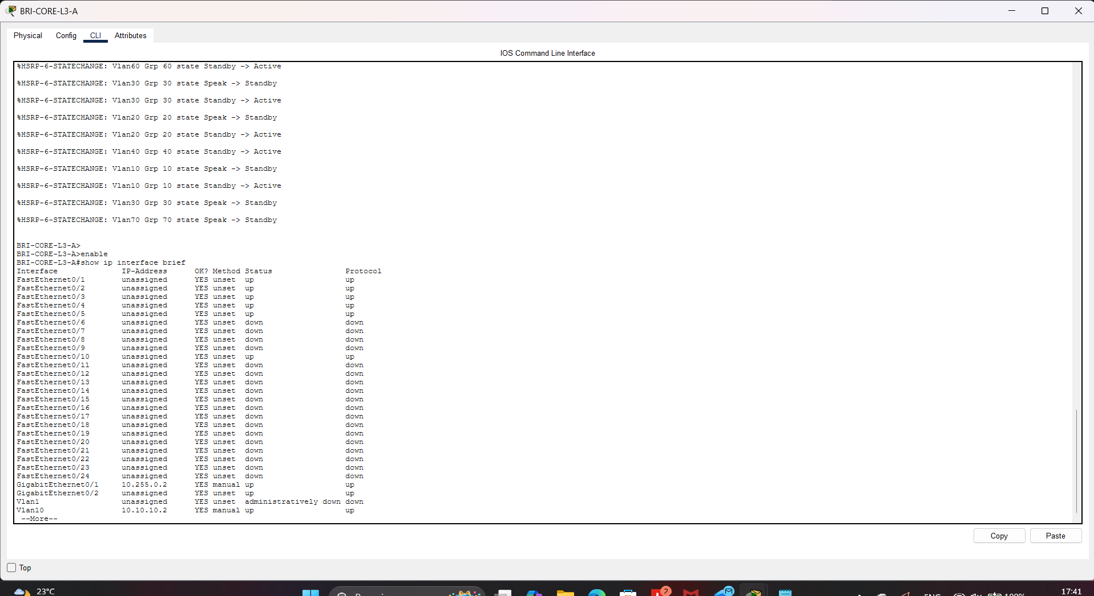
BRI-CORE-L3
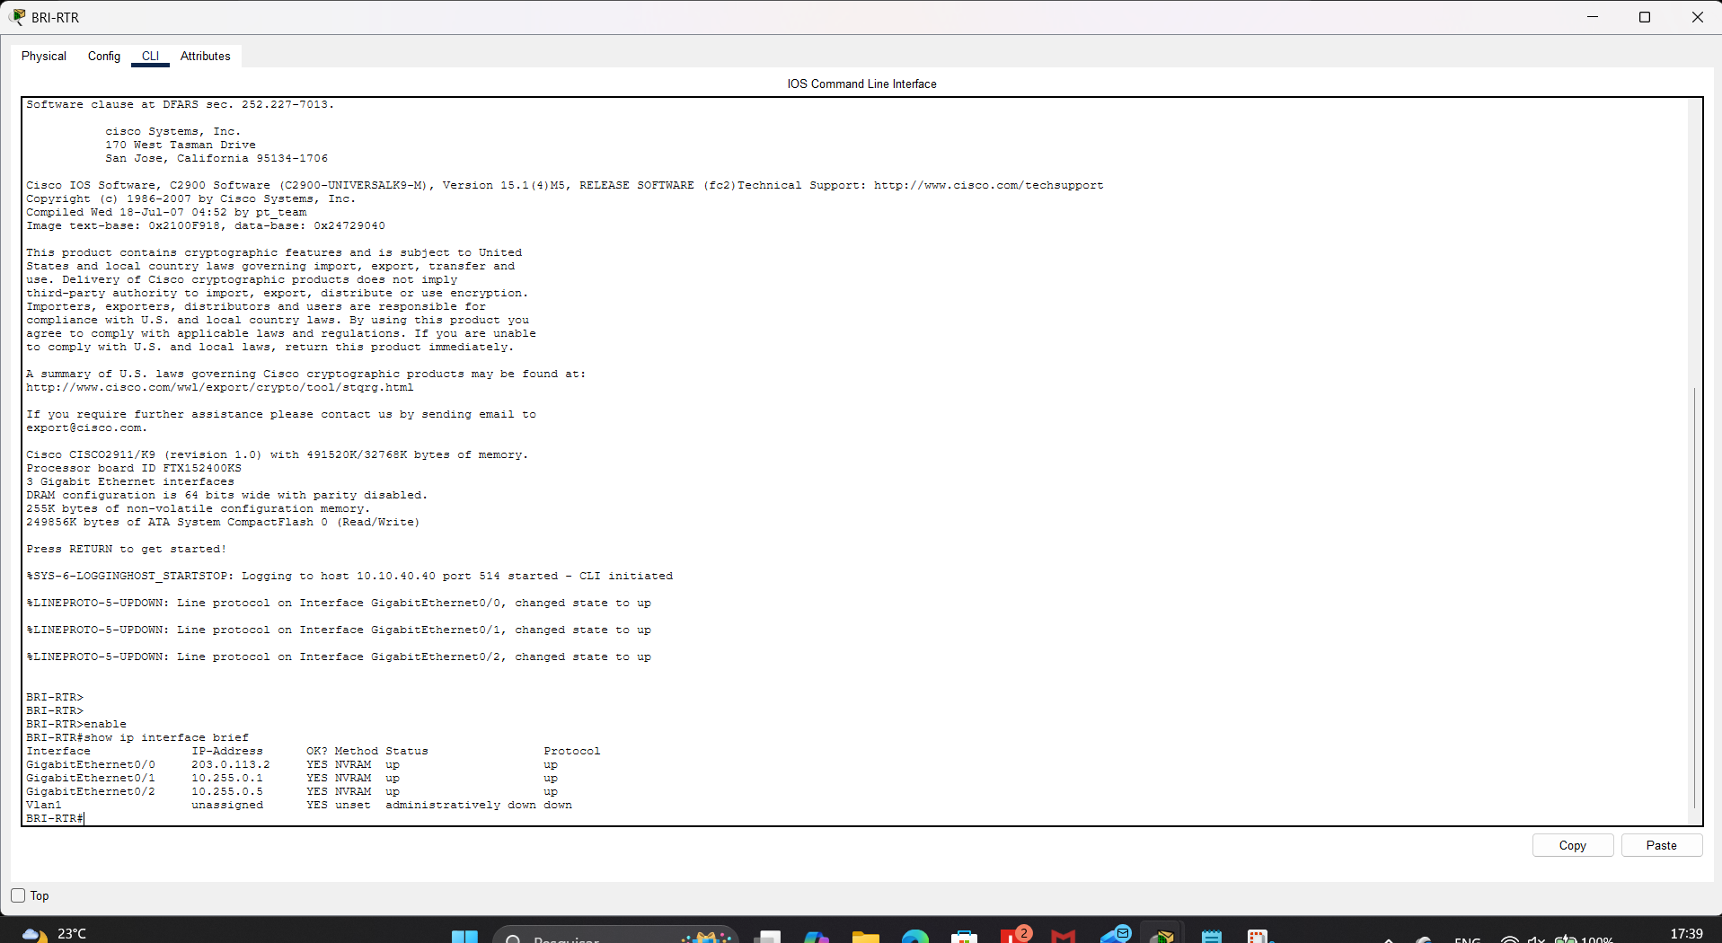
BRI-RTR
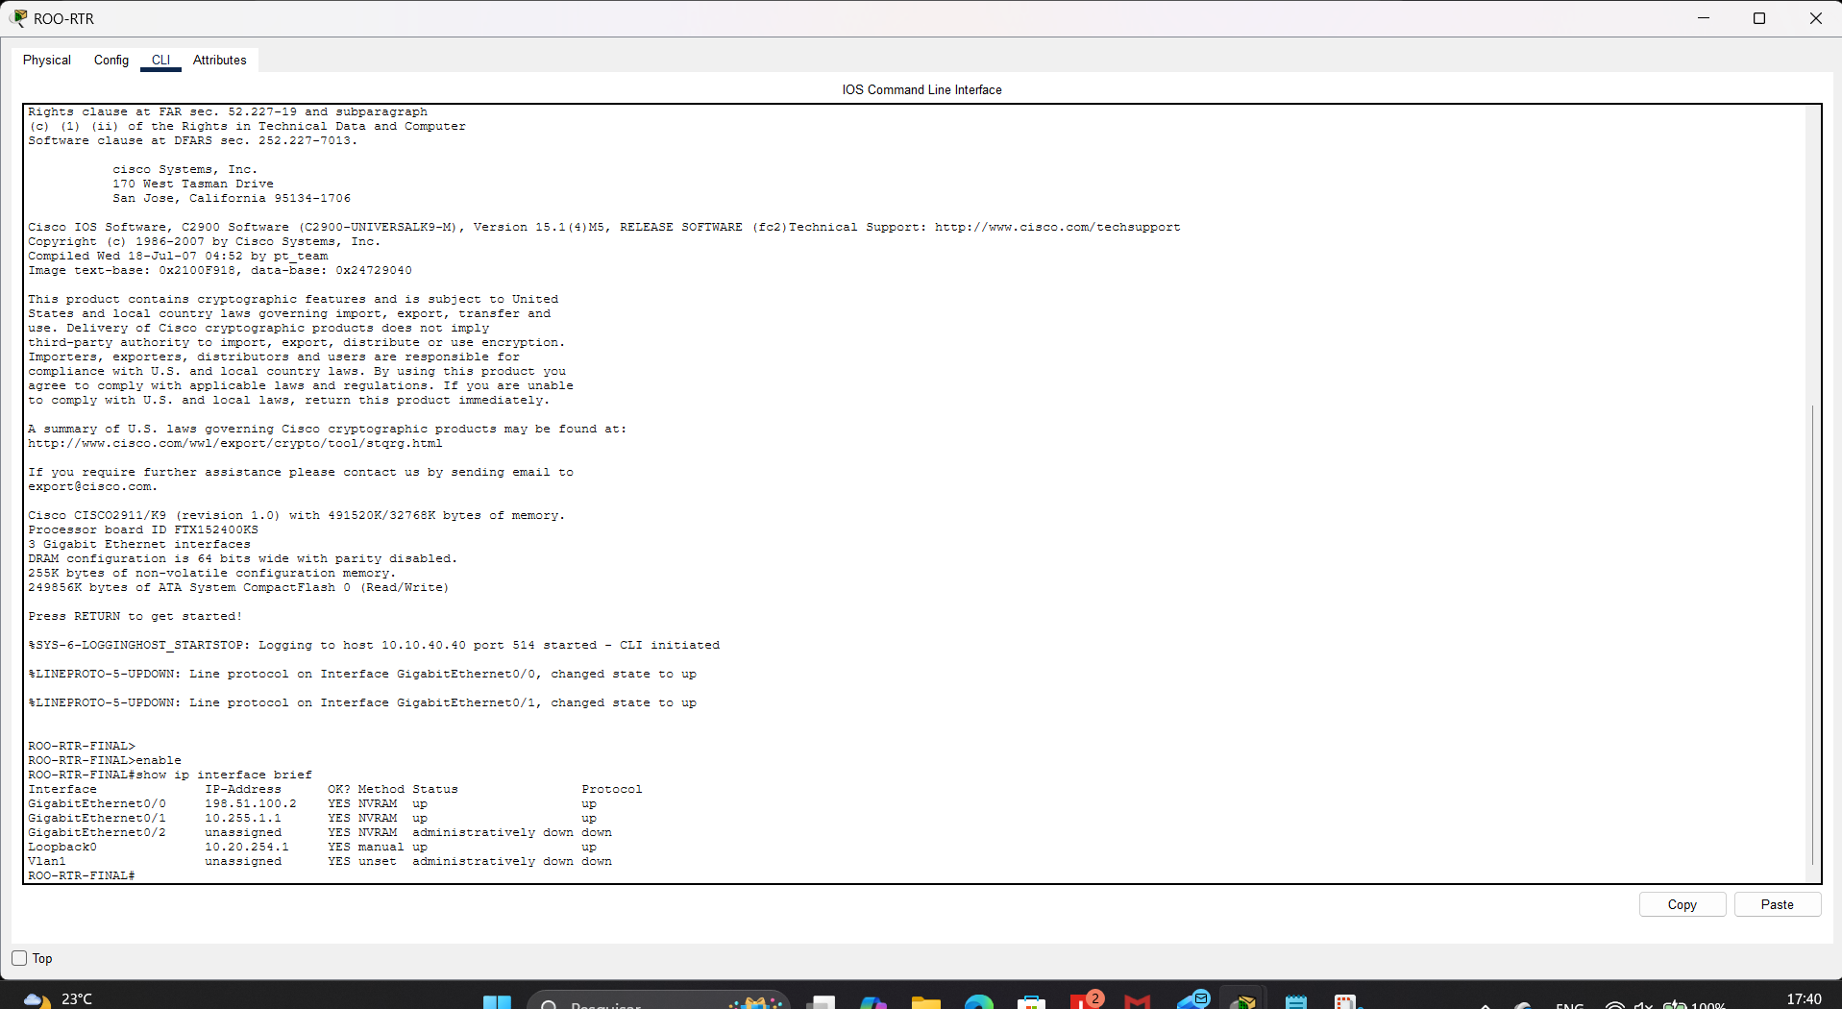
ROO-RTR
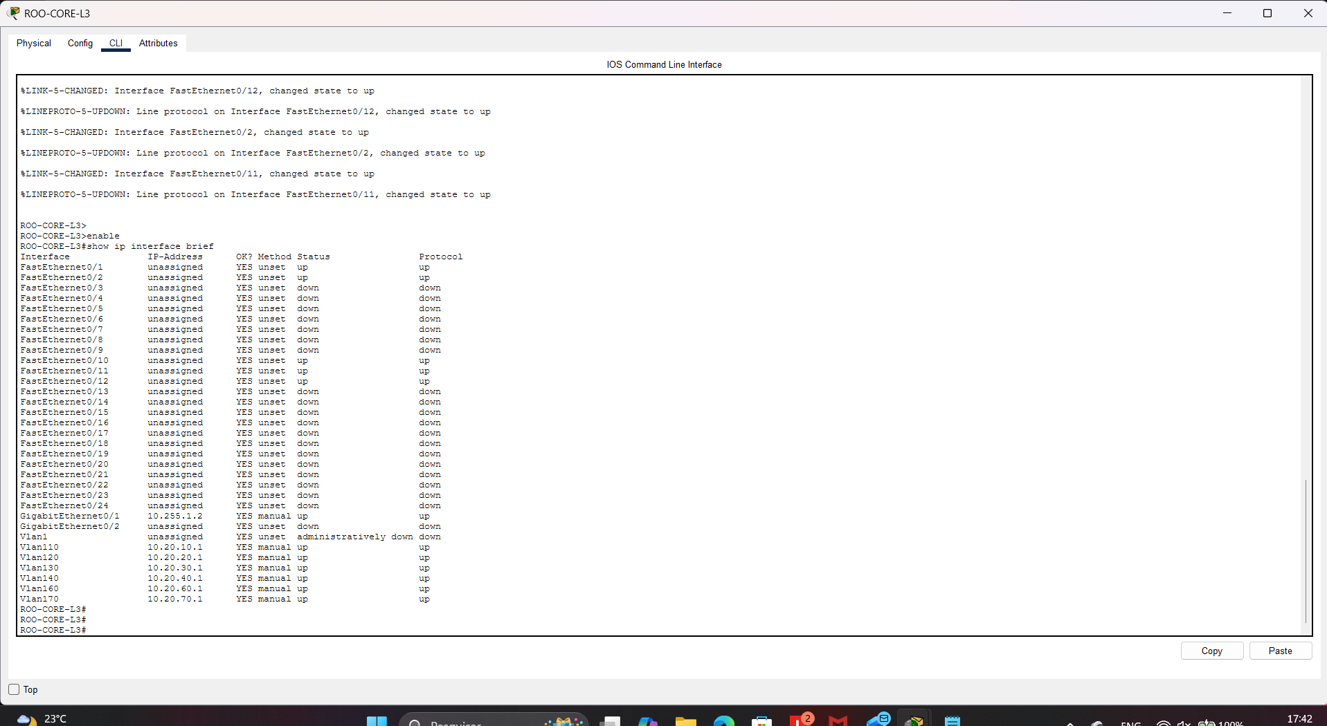
ROO-CORE-L3
Actual result:
Status: ☐ Pass ☐ Fail ☐ Retest required

Test T02 – Switch-to-switch trunk connectivity
Procedure:
- Run show interfaces trunk on both Brisbane core switches and the access switches.
- Confirm that each required uplink operates as a trunk.
- Confirm that Brisbane VLANs 10, 20, 30, 40, 60 and 70 are allowed.
Expected result:
The trunks are operational and carry the required VLANs.
Actual result:
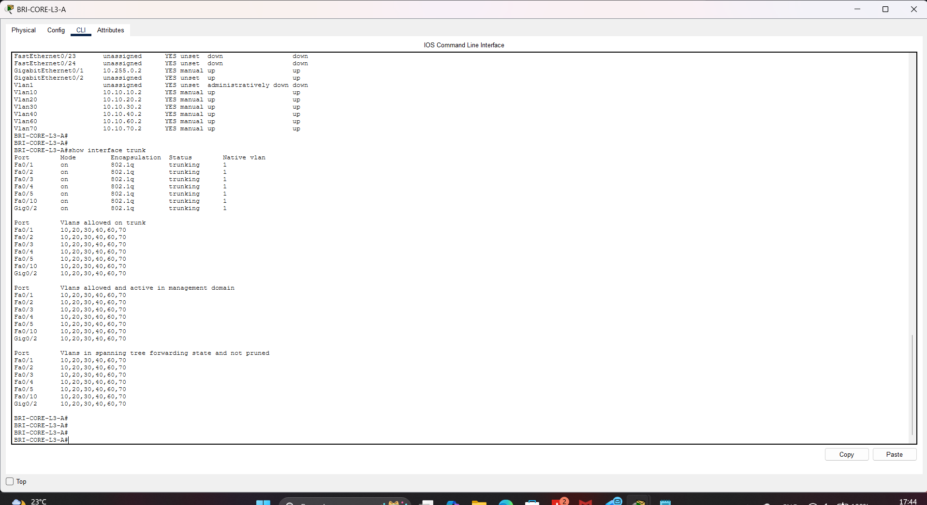
BRI-CORE-L3
Status: ☐ Pass ☐ Fail ☐ Retest required
Test T03 – Access ports and VLAN membership
Procedure:
- Run show vlan brief.
- Inspect the access port used by each representative PC, server and AP.
- Confirm staff ports use VLAN 20 or 120.
- Confirm student ports use VLAN 30 or 130.
- Confirm Brisbane servers and AP management use VLAN 40.
- Confirm Rookwood servers and AP management use VLAN 140.
Expected result:
Each endpoint is assigned to its approved VLAN.
Actual result:
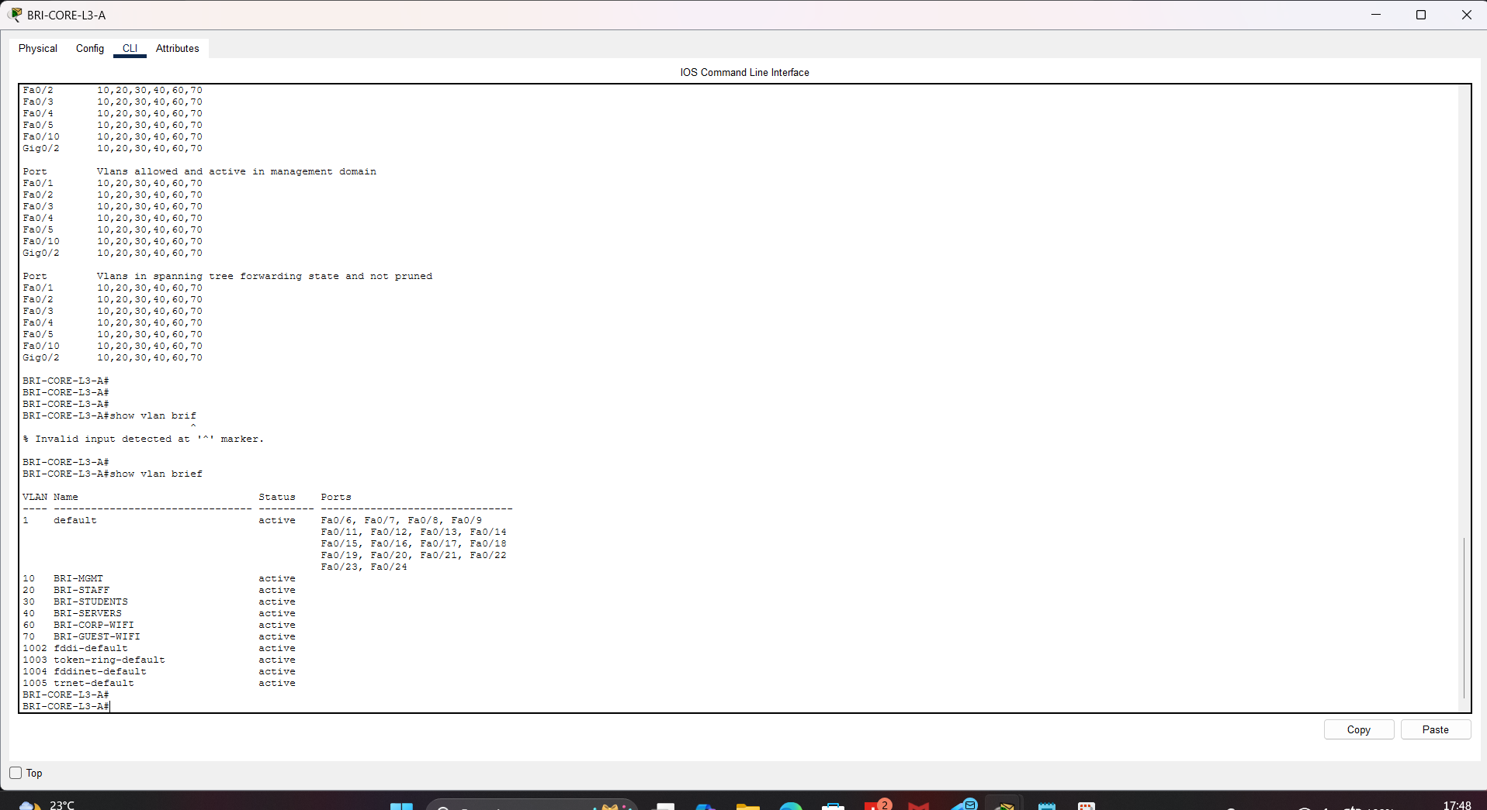
BRI-CORE-L3
Status: ☐ Pass ☐ Fail ☐ Retest required
Evidence: E03 – VLAN and access-port output
Test T04 – Loop-prevention test
Procedure:
- Run show spanning-tree.
- Identify the active and blocked redundant Brisbane uplinks.
- Start a repeated ping from a Brisbane client to its gateway.
- In the test copy, disconnect the currently forwarding uplink.
- Wait for Rapid-PVST to reconverge.
- Repeat the ping and reconnect the original link.
Expected result:
STP prevents a Layer 2 loop. The backup link changes to forwarding and connectivity returns after convergence.
Actual result:
V06 - Loop prevention before failure
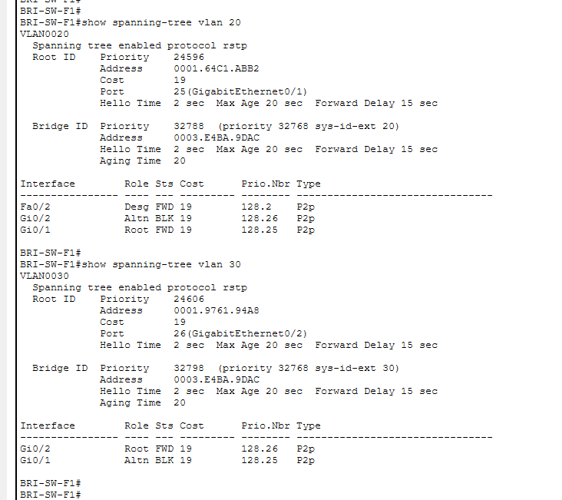
V07 – Connectivity after uplink failure
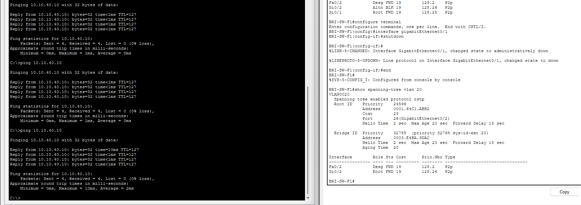
V08 – Restored network

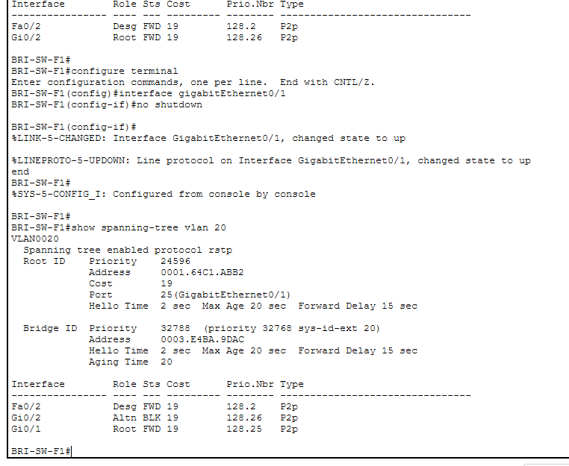
Status: ☐ Pass ☐ Fail ☐ Retest required
Evidence: E04 – STP status and failover screenshots
Test T05 – Private VLAN test
The approved A-Plus design uses standard VLAN separation and ACLs. A private VLAN test must therefore be conducted as a separate isolated assessment scenario so the approved final design is not changed.
Test arrangement:
- One primary private VLAN.
- One isolated secondary VLAN.
- Two isolated host ports.
- One promiscuous port connected to an authorised gateway or server.
Procedure:
- Confirm the primary and isolated VLAN relationship.
- Confirm the host-port and promiscuous-port assignments.
- Ping between the two isolated hosts.
- Ping from each isolated host to the promiscuous gateway or server.
Expected result:
The isolated hosts cannot communicate directly with each other, but each can communicate with the promiscuous port. This is the intended private-VLAN behaviour described by Cisco.
Actual result:

Status: ☐ Pass ☐ Fail ☐ Not executed – tool limitation
Evidence: E05 – Private VLAN configuration and ping results
Important limitation:
Do not claim that a standard guest VLAN ACL is a private VLAN. If the Packet Tracer switch rejects the private-VLAN commands, capture the rejection, record the test as Not executed – tool limitation, and obtain assessor approval to use supported Cisco equipment or another approved lab environment.
Test T06 – SVI and inter-VLAN routing
Procedure:
- Run show ip interface brief on the Layer 3 core switches.
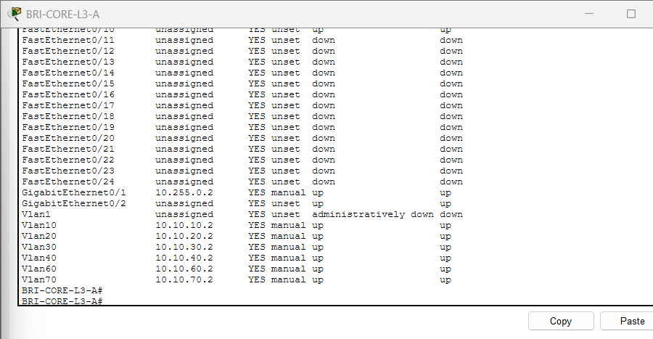

- Confirm the required SVIs are up/up.
- From BRI-ADMIN-PC, ping 10.10.20.1 and 10.10.40.10.
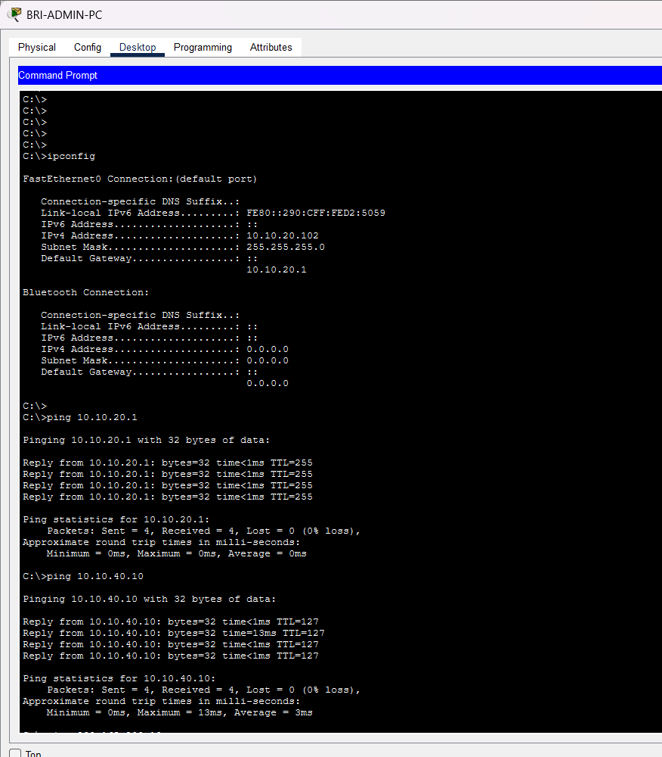
- From BRI-STUDENT-PC4, ping 10.10.30.1 and 10.10.40.10.
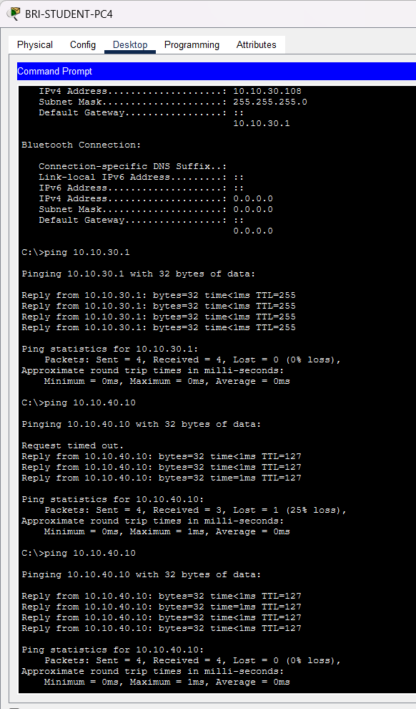
- From ROO-STAFF-PC, ping 10.20.20.1 and 10.20.40.10.
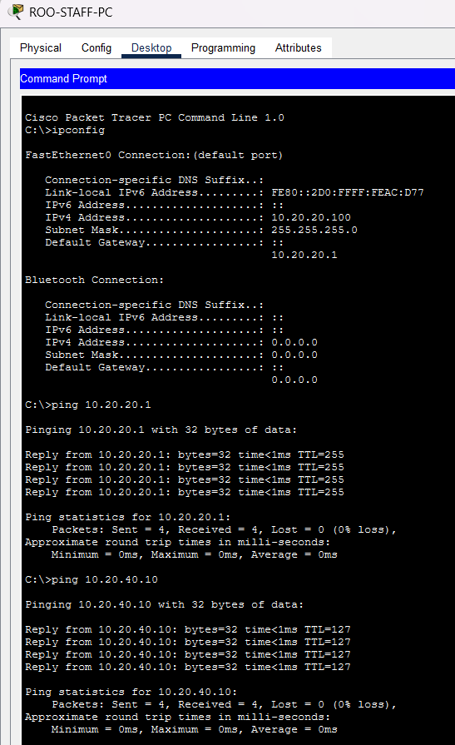
Expected result:
Each client reaches its gateway and authorised routed destination.
Status: ☐ Pass ☐ Fail ☐ Retest required

