Project: A-Plus Institute – Network Option 2
Prepared by: Leonardo Ciarcia
Test environment: Cisco Packet Tracer
Test date: 10/10/2025
The purpose of this test is to verify VLAN configuration, access and trunk ports, communication within and between authorised VLANs, and loop prevention on the redundant Brisbane switching network.

Evidence | Screenshot to include | What the evidence must show
V01 – Network topology | Brisbane topology showing BRI-CORE-L3-A, BRI-CORE-L3-B, floor switches and their uplinks. Include the Rookwood section separately. | Device names and connections clearly identify the network being tested.
V02 – VLAN creation | Run show vlan brief on BRI-CORE-L3-A and ROO-CORE-L3. Include the relevant VLAN configuration from show running-config if available. | Brisbane VLANs 10, 20, 30, 40, 60 and 70; Rookwood VLANs 110, 120, 130, 140, 160 and 170.
V03 – Access-port configuration | Run show interfaces fastEthernet0/2 switchport on BRI-SW-F1 and BRI-SW-F3. | F1’s client port operates as an access port in VLAN 20. F3’s client port operates as an access port in VLAN 30.
V04 – Trunk configuration | Run show interfaces trunk on BRI-SW-F1 and ROO-SW-CLASS. | Uplinks operate as trunks and allow the intended campus VLANs. Both Brisbane uplinks should be represented.
V05 – VLAN connectivity | Capture client IP information and the ping tests listed below. | Clients have the correct subnet and gateway, and the tested communication succeeds.
V06 – Loop prevention before failure | Run show spanning-tree vlan 20 and show spanning-tree vlan 30 on BRI-SW-F1. | Root information and uplink roles are visible. For each VLAN, the redundant topology has a forwarding path and an alternative blocked path.
V07 – Connectivity after uplink failure | Disable the active VLAN 20 uplink on BRI-SW-F1 in the test copy. Capture show spanning-tree vlan 20 and repeat the connectivity test. | The remaining uplink becomes the forwarding path and connectivity recovers after reconvergence.
V08 – Restored network | Re-enable the disabled uplink. Capture the STP output and repeat the ping. | Both physical uplinks are restored, STP again controls the redundant paths, and connectivity works.

V01– Network Topology

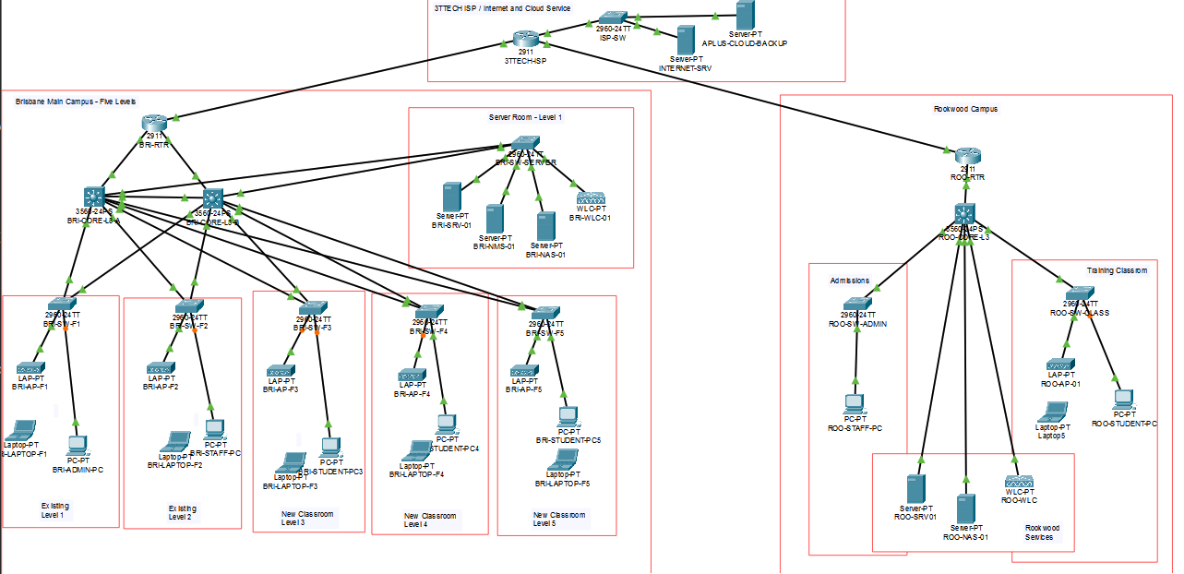

V02- VLAN creation Brisbane
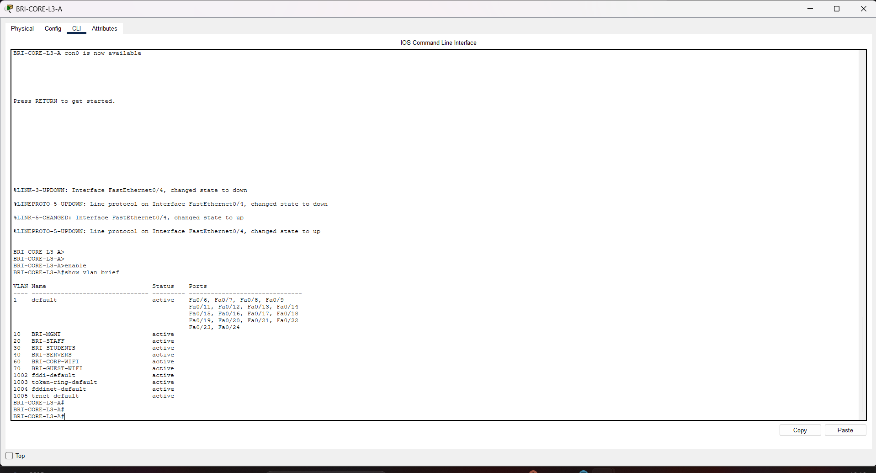
V02- VLAN creation Rookwood
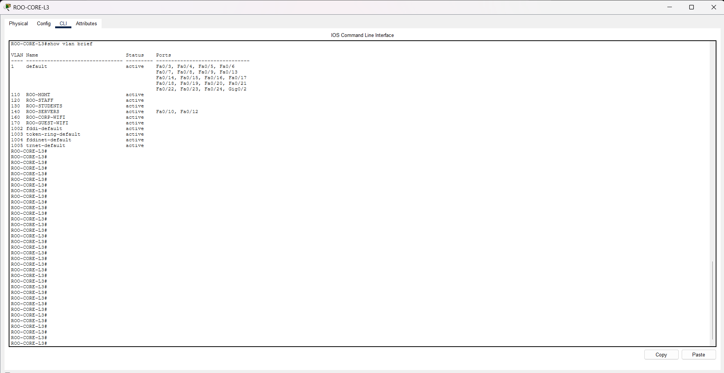

V03 – Access-port configuration BRI-SW-F1
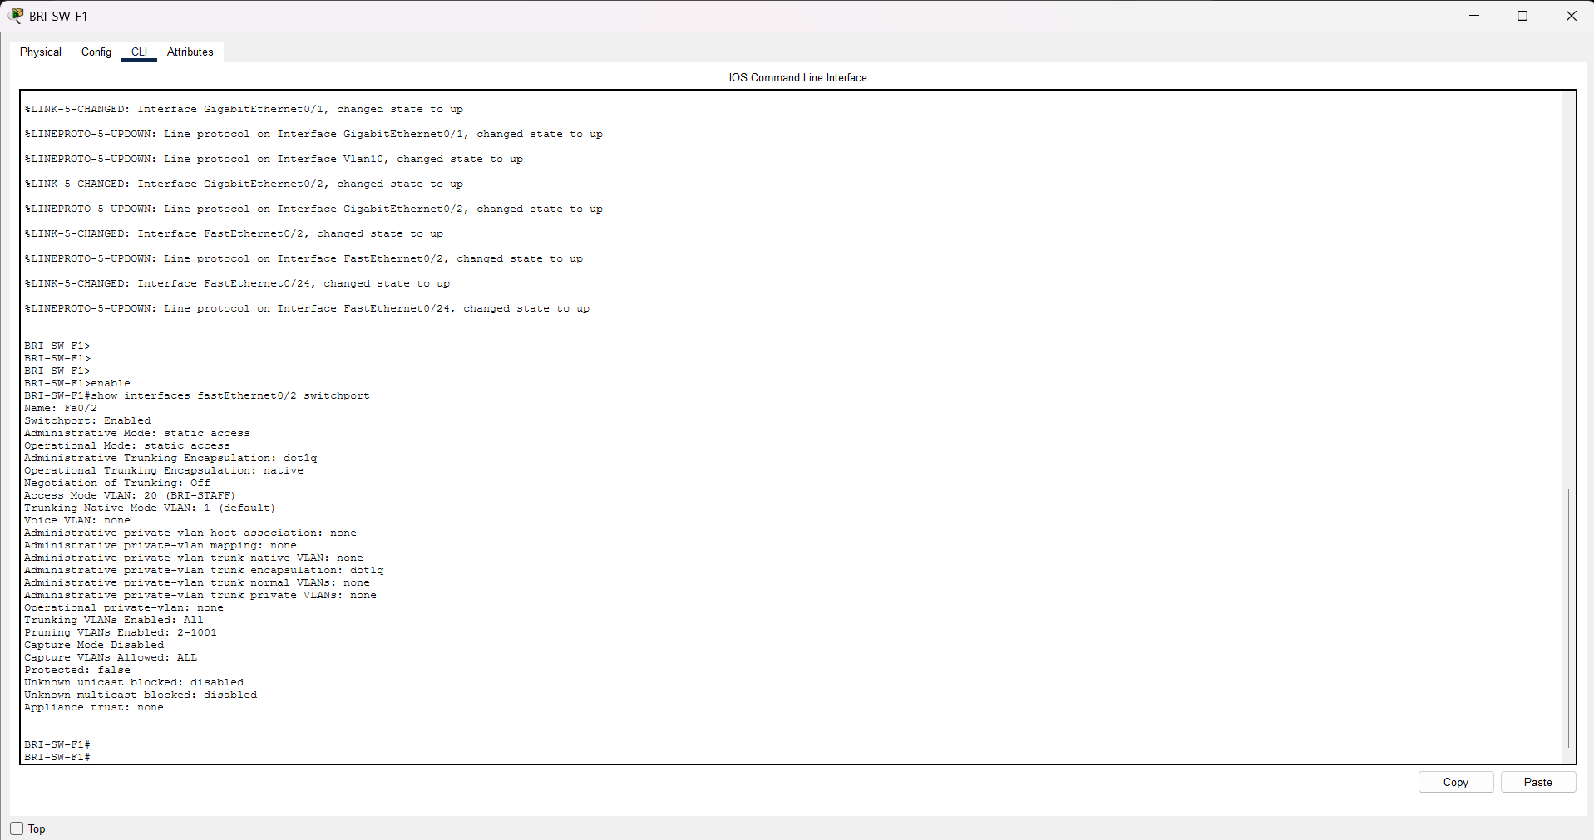
V03 – Access-port configuration BRI-SW-F1
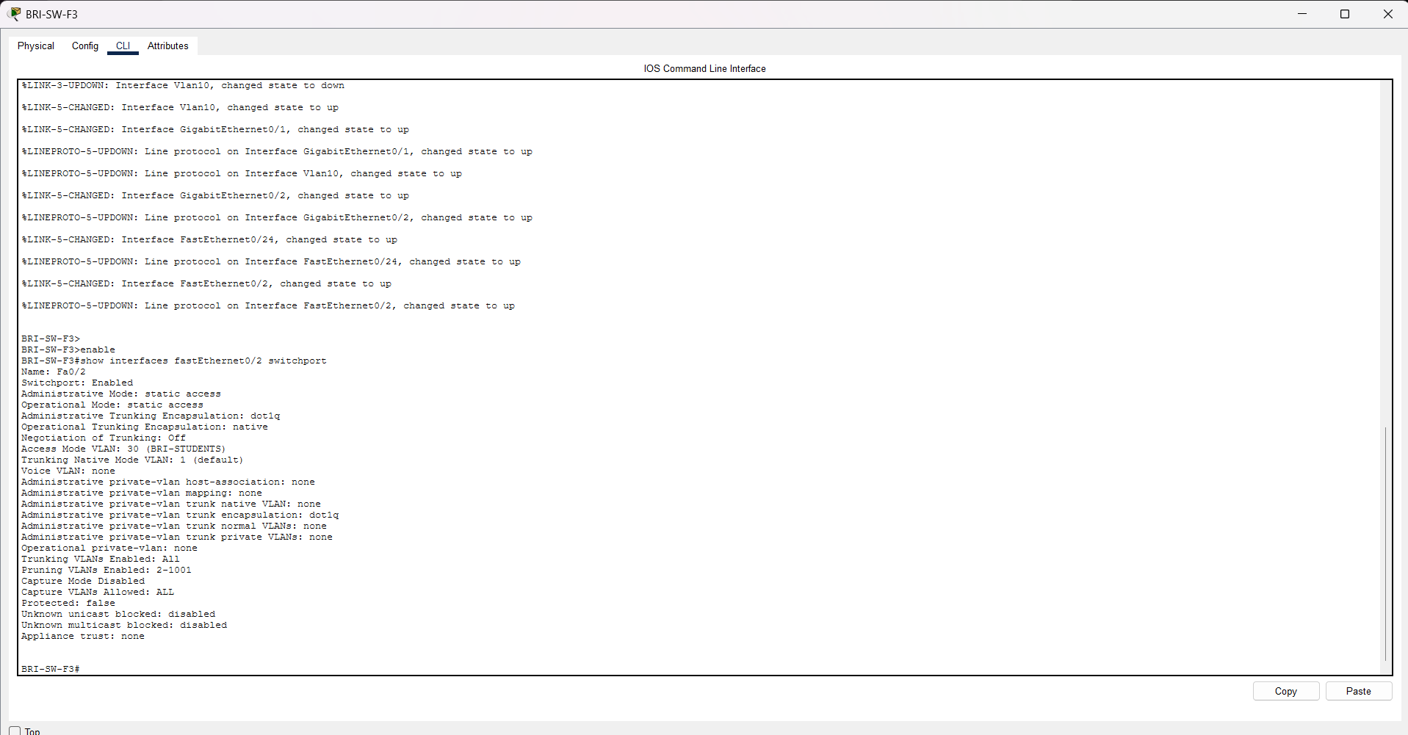

V04 – Trunk configuration BRI-SW-F1
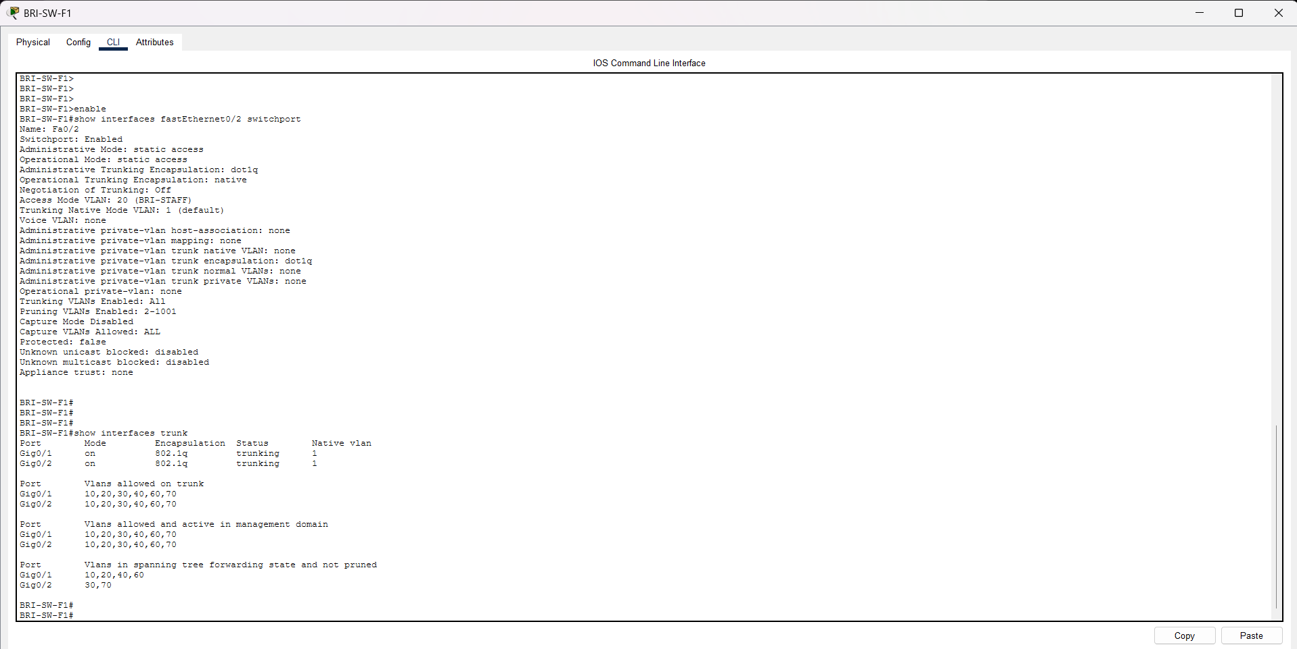
V04 – Trunk configuration ROO-SW-CLASS.
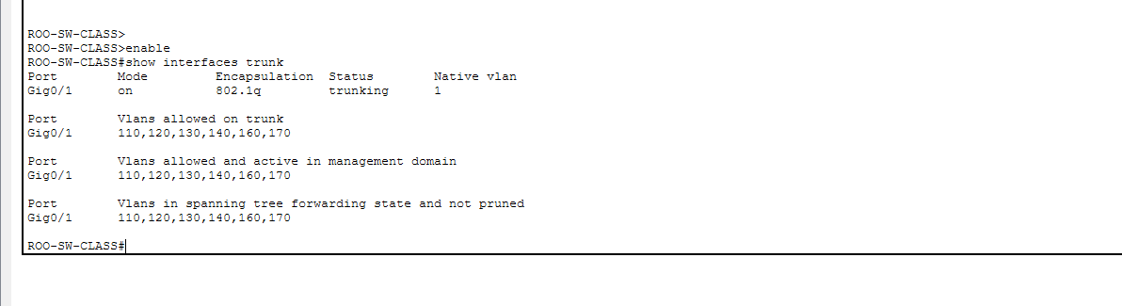
V05 – VLAN connectivity:
- BRI-ADMIN-PC, VLAN 20 -> BRI-STAFF-PC’s actual DHCP address, VLAN 20
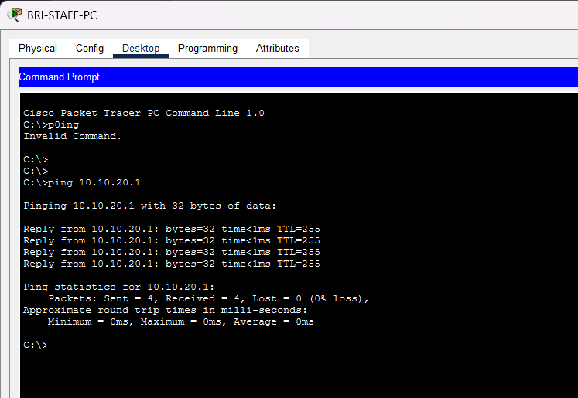
- BRI-ADMIN-PC, VLAN 20 -> BRI-SRV-01: 10.10.40.10, VLAN 40

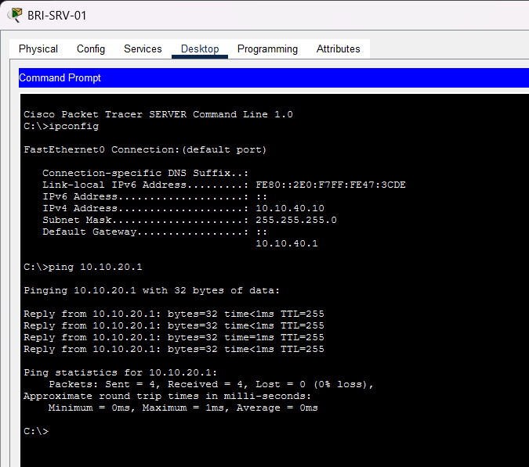
- ROO-STAFF-PC, VLAN 120 -> ROO-SRV-01: 10.20.40.10, VLAN 140
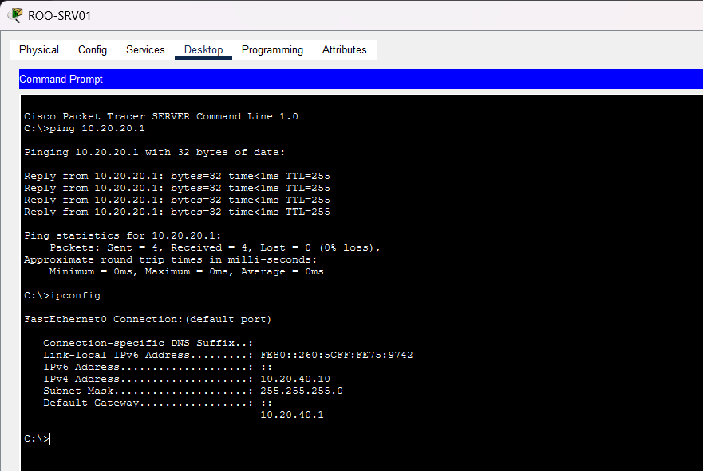
V06 - Loop prevention before failure
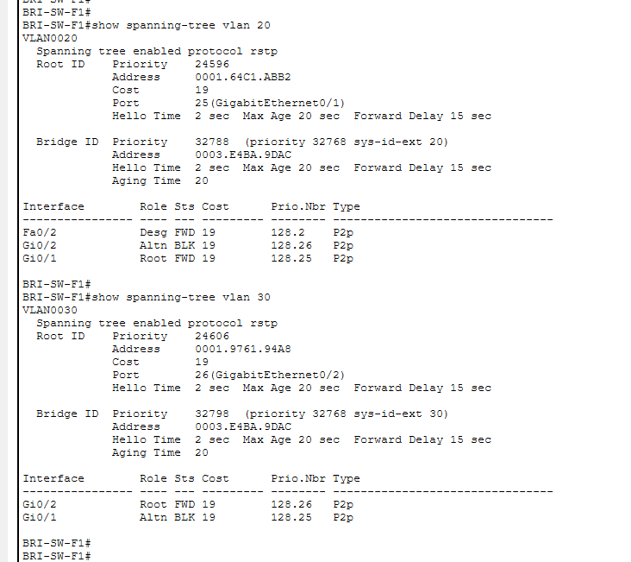
V07 – Connectivity after uplink failure
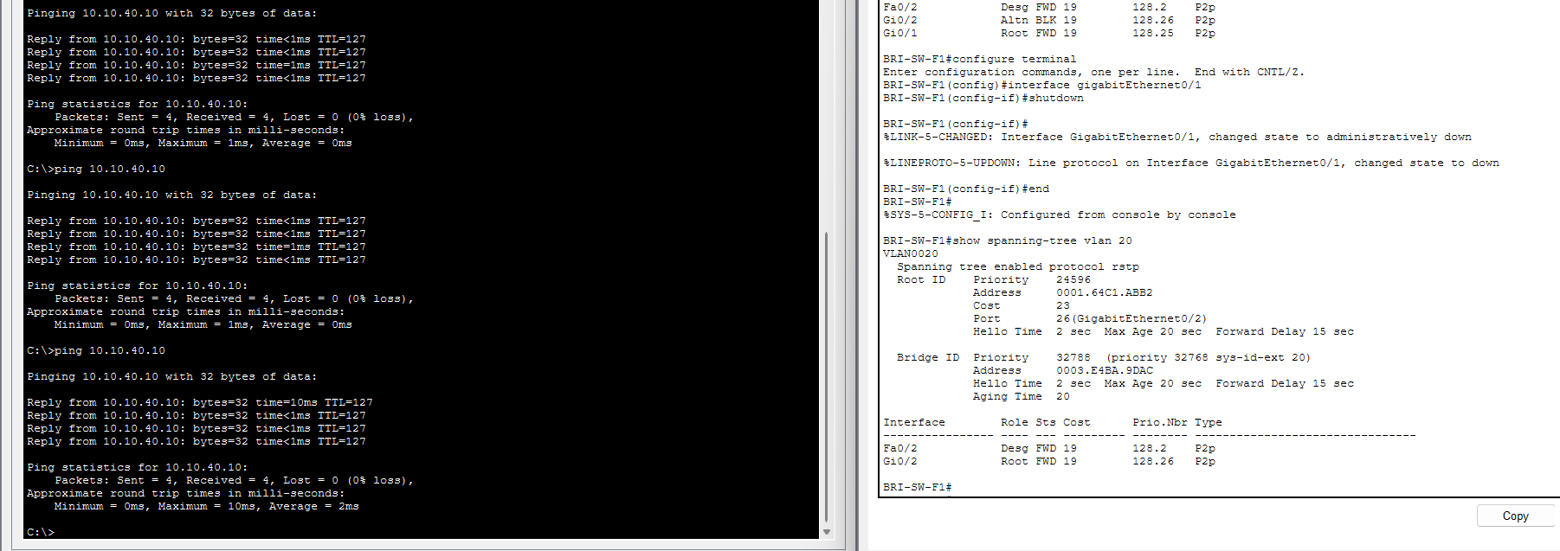
V08 – Restored network

