Project: A-Plus Institute network upgrade
Prepared by: Leonardo Ciarcia, Assistant IT Manager, HV Technologies
Test environment: Cisco Packet Tracer, Network 3
Test date: 10/10/2025
Status: Incomplete – isolation was unsuccessful in the latest reported attempt.
- Purpose and scope
Investigate isolation between the existing student computer, BRI-STUDENT-PC3, and a temporary computer named PC0, while retaining access to authorised campus services.
The attempted private-vlan command was not recognised on BRI-CORE-L3-A. Full private VLAN configuration and testing were therefore not completed. Full PVLANs use primary and secondary VLANs with isolated, community and promiscuous port roles.
A supplementary protected-port test was attempted on BRI-SW-F3. Protected ports provide local Layer 2 isolation between protected interfaces on the same switch; communication with unprotected interfaces remains permitted. This does not demonstrate full PVLAN functionality.
- Test setup
Use a separate copy of Network 3 for this activity. Confirm that the actual cable connections match this test arrangement.
Device | Role | Connection / addressing
BRI-STUDENT-PC3 | Existing student endpoint | BRI-SW-F3 Fa0/2; VLAN 30; DHCP
PC0 | Temporary isolation-test endpoint | BRI-SW-F3 Fa0/3; VLAN 30; DHCP
BRI-SW-F3 | Floor 3 access switch | Protection applied to the two test ports
Student gateway | Existing VLAN 30 gateway | 10.10.30.1
BRI-SRV-01 | Existing campus server | 10.10.40.10
Record the addresses displayed by ipconfig on each PC:
Setting | BRI-STUDENT-PC3 | PC0
Actual IPv4 address | 10.10.30.105 | 10.10.30.110
Expected subnet mask | 255.255.255.0 | 255.255.255.0
Expected default gateway | 10.10.30.1 | 10.10.30.1
PC0 previously had no IP address. Confirm a valid DHCP lease before repeating the connectivity tests.
- Configuration and repeat-test procedure
Confirm both test ports are access ports in the existing student VLAN 30. Apply the following configuration on BRI-SW-F3 after checking the cable-to-port mapping:
enable
configure terminal
interface range fastEthernet0/2 - 3
switchport mode access
switchport access vlan 30
switchport protected
no shutdown
end
Verify the settings:
show vlan brief
show interfaces fastEthernet0/2 switchport
show interfaces fastEthernet0/3 switchport
Both interfaces should show access VLAN 30 and Protected: true. Leave the existing uplinks unprotected.
In each PC’s Desktop > Command Prompt, run:
ipconfig
From BRI-STUDENT-PC3, ping PC0’s actual assigned address. From PC0, ping BRI-STUDENT-PC3’s actual assigned address. Record both directions separately.
From each PC, also run:
ping 10.10.30.1
ping 10.10.40.10
Run fresh tests and retain the displayed results. The server address 10.10.40.10 is used for the service-access check.
- Test results
The current record reflects the reported observations. Screenshots and outstanding test results must be added before submission.
Test | Expected result | Current observation | Status
Full private VLAN configuration | Primary/secondary VLANs and port roles available for testing | The private-vlan command was not recognised in the attempted configuration | Not tested
Port configuration verification | Both test ports in VLAN 30 with Protected: true | Verification output has not been supplied | Pending
Peer isolation: BRI-STUDENT-PC3 and PC0 | Peer pings blocked in both directions | Ping between the PCs still succeeded after protection was applied; both directions need separate evidence | Failed in reported attempt
Gateway access from both PCs | Replies from 10.10.30.1 | No result confirmed for this test | Pending
Server access from both PCs | Replies from 10.10.40.10 | No result confirmed after protection in this test | Pending
- Troubleshooting and outstanding actions
Confirm the physical ports, protection settings and actual source/destination IP addresses. Check for duplicate addresses or incorrect subnet masks. If the mappings remain uncertain, inspect the switch MAC address table:
show mac address-table
Repeat the tests after correcting any identified issue. Record the correction and new result. The cause of the continuing peer connectivity has not yet been established.
Corrective action: [Complete after investigation]
Retest date and outcome: [Complete after retesting]
- Evidence to attach

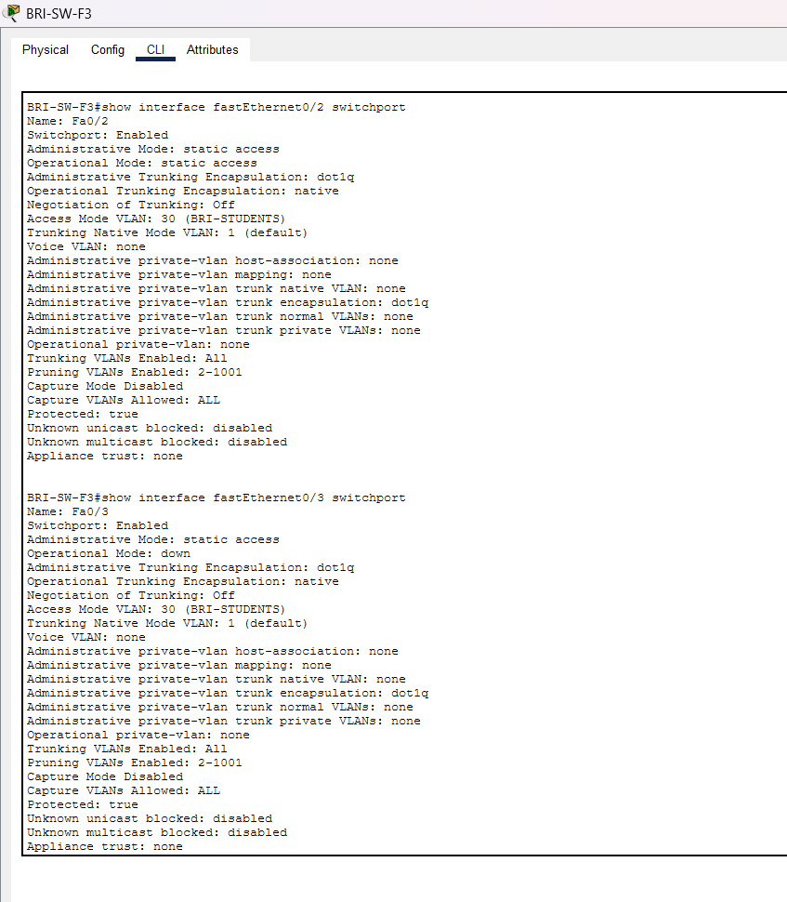
BRI-SW-F# - show interface fastEthernet0/2 and 0/3 switchport, showing that both is protected

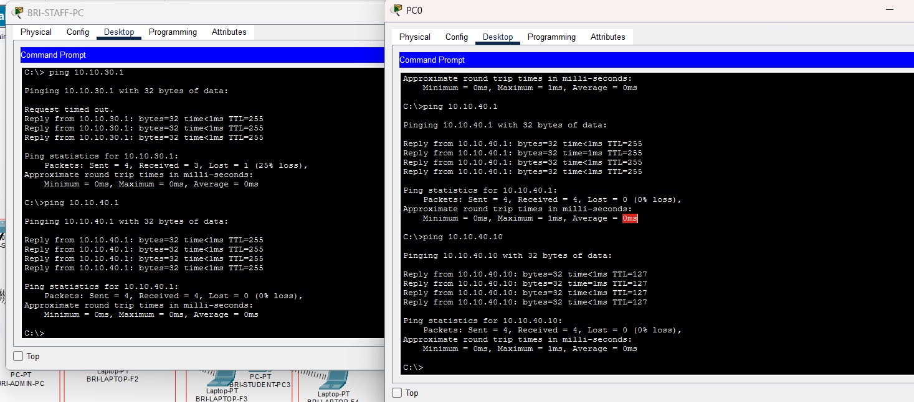
Both PCs have successful ping 10.10.30.1 and 10.10.40.10

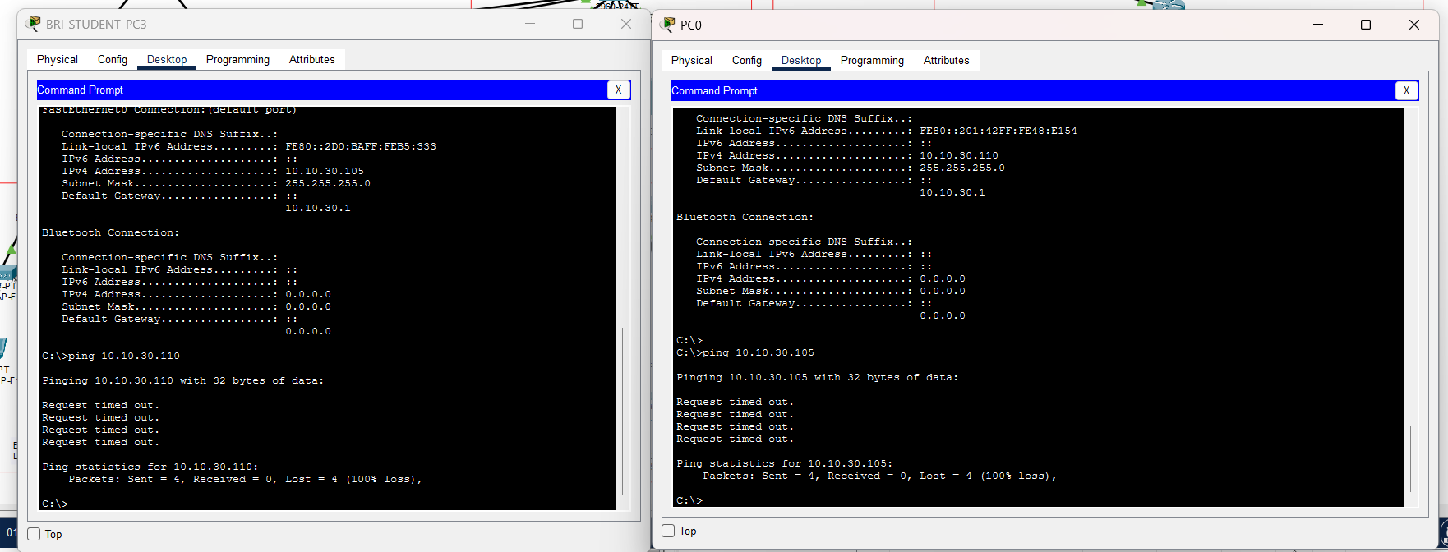
Student PC -> PC0 status: blocked
PC0 -> Student PC status: blocked

- Conclusion
The latest reported attempt did not establish isolation between PC0 and BRI-STUDENT-PC3. The protected-port test remains incomplete pending verification and retesting.
Full private VLAN functionality remains untested. A lab platform supporting the required PVLAN commands is needed to demonstrate primary/secondary VLAN configuration and isolated, community and promiscuous connectivity.

