Project: A-Plus Institute – Network Option 2
Prepared by: Leonardo Ciarcia
Test environment: Cisco Packet Tracer
Test date: 10/10/2025
SVI and inter-VLAN routing
Procedure:
- Run show ip interface brief on the Layer 3 core switches.
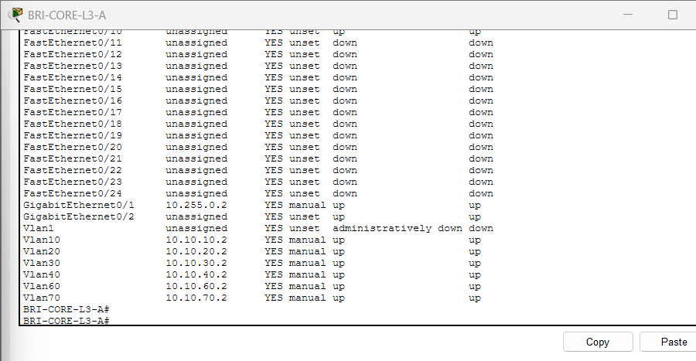

- Confirm the required SVIs are up/up.
- From BRI-ADMIN-PC, ping 10.10.20.1 and 10.10.40.10.
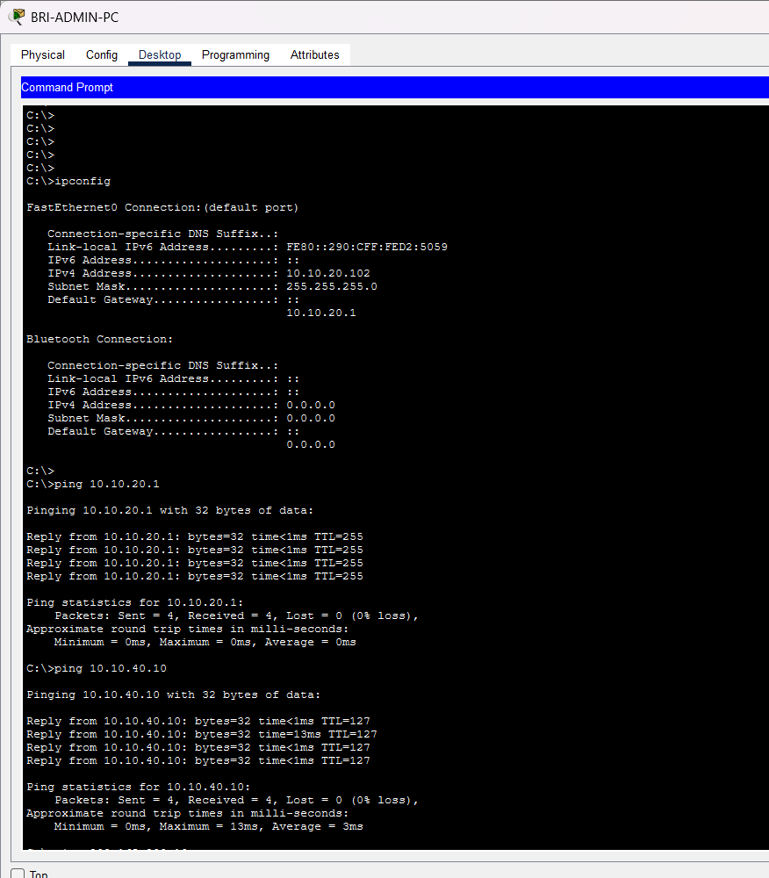
- From BRI-STUDENT-PC4, ping 10.10.30.1 and 10.10.40.10.
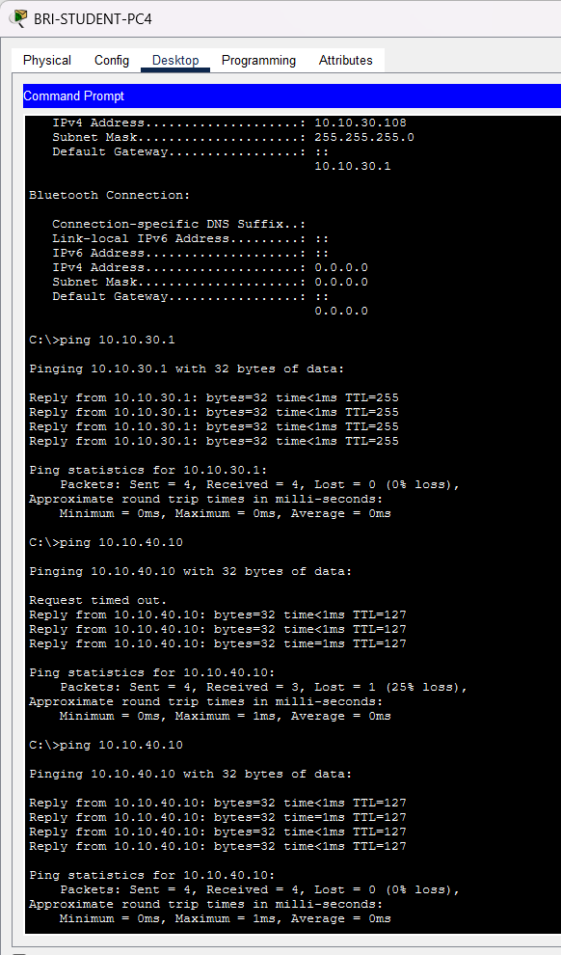
- From ROO-STAFF-PC, ping 10.20.20.1 and 10.20.40.10.
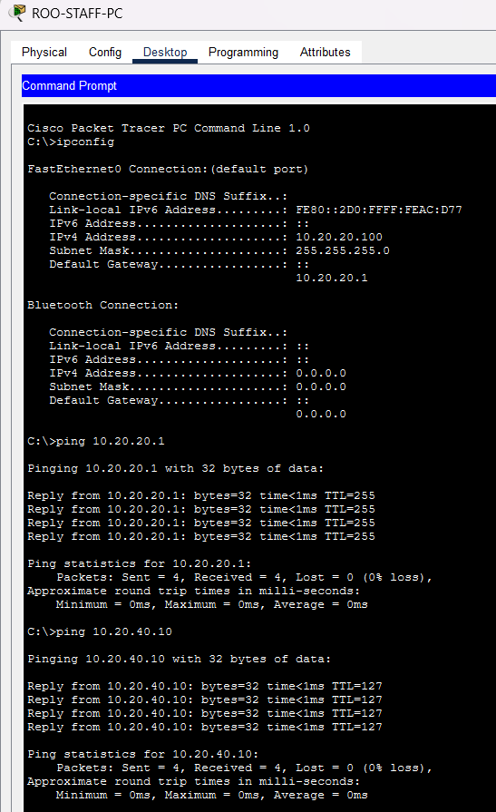
Expected result:
Each client reaches its gateway and authorised routed destination.
Status: ☐ Pass ☐ Fail ☐ Retest required

