Switch Configuration Troubleshooting Report

1. Project information
Project: A-Plus Institute Network Upgrade
Network tested: Network 3 – Final Network Solution
Testing software: Cisco Packet Tracer
Test device: Switch connected to BRI-ADMIN-PC
Test computer: BRI-ADMIN-PC
Test date:10/10/2025
Tested by: Leonardo Ciarcia

2. Purpose
The purpose of this test was to check the switch VLAN configuration, port status and Spanning Tree Protocol settings. A controlled switch port problem was created, diagnosed, repaired and retested.

3. Initial VLAN check
The following command was entered on the switch:
show vlan brief
The output displayed the VLANs configured on the switch and the access ports assigned to each VLAN. The port connected to BRI-ADMIN-PC was assigned to the correct VLAN.
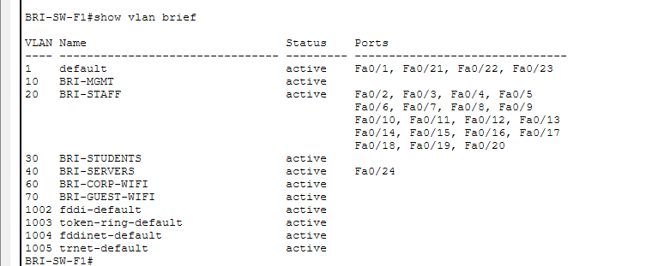
Figure 1 – VLAN configuration displayed using the show vlan brief command.
Result: Passed. The required VLANs were present and the tested port had the correct VLAN assignment.

4. Initial switch port check
The following command was used:
show interfaces status
The output showed that the port connected to BRI-ADMIN-PC was in connected status before the troubleshooting test.
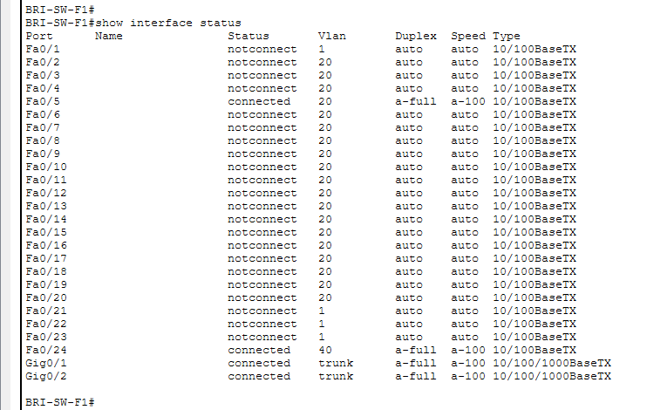
Figure 2 – Initial interface status showing the BRI-ADMIN-PC port connected.
Result: Passed. The switch port was initially active and operational.

5. STP settings check
The following command was entered:
show spanning-tree
The output showed the STP root, designated and forwarding port information. The STP configuration was operating correctly and preventing switching loops.
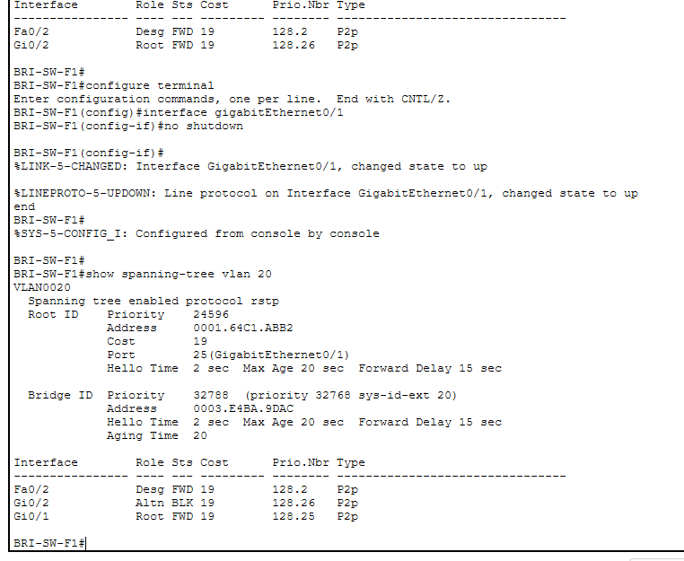
Figure 3 – Spanning Tree Protocol status and switch port roles.
Result: Passed. STP was active and no switching loop was detected.

6. Controlled switch fault
To simulate a switch configuration problem, the port connected to BRI-ADMIN-PC was disabled using the following commands:
configure terminal
interface fa0/X
shutdown
end
Note: fa0/X was replaced with the actual port connected to BRI-ADMIN-PC.
The interface status was checked again:
show interfaces status
The port displayed as disabled or down. A ping was then sent from BRI-ADMIN-PC:
ping 10.10.20.1
The ping failed because the computer’s switch port was disabled.
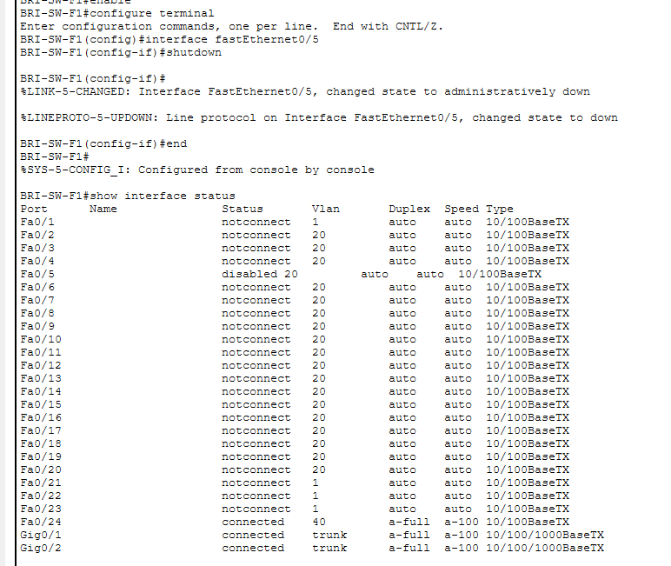
Figure 4 – Switch port showing disabled or down status.
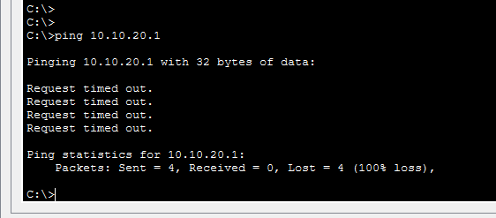
Figure 5 – Failed ping while the switch port was disabled.
Result: Failed as expected. The controlled fault successfully interrupted connectivity.

7. Corrective action
The problem was diagnosed using the show interfaces status command. The interface was administratively disabled.
The following commands were used to repair it:
configure terminal
interface fa0/X
no shutdown
end
After waiting for the link to become green, the interface was checked again:
show interfaces status
The port returned to connected status.
Connectivity was retested from BRI-ADMIN-PC:
ping 10.10.20.1
ping 10.10.40.10
Both destinations responded successfully.
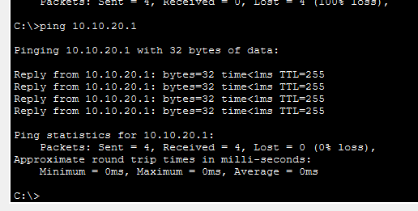
Figure 6 – Successful connectivity tests after the repair.
Result: Passed. The port and network connectivity were successfully restored.

8. Troubleshooting log
Item checked | Finding | Action taken | Retest result | Status
VLAN configuration | Required VLANs and port assignments were displayed | No change required | VLAN configuration remained operational | Passed
Initial port status | BRI-ADMIN-PC port was connected | No change required | Initial connectivity was available | Passed
STP settings | STP was active and showed the required port roles | No change required | No switching loop was detected | Passed
Controlled port fault | BRI-ADMIN-PC port was administratively disabled | Investigated with show interfaces status | Failed ping confirmed the fault | Identified
Port correction | Interface was disabled with the shutdown command | Applied the no shutdowncommand | Port returned to connected status | Resolved
Final connectivity | Network communication was restored | Pings were repeated | 10.10.20.1 and 10.10.40.10responded | Passed

9. Final outcome
The switch troubleshooting test was completed successfully. The VLAN configuration, interface status and STP settings were checked. A controlled disabled-port problem was identified using Cisco IOS diagnostic commands and corrected with the no shutdown command. Final ping tests confirmed that connectivity had been restored.

10. Evidence summary
The following evidence was collected:
- VLAN configuration using show vlan brief.
- Initial connected port using show interfaces status.
- STP configuration using show spanning-tree.
- Disabled switch port and failed ping.
- Restored switch port and successful final pings.

