Project: A-Plus Institute – Cluster 5
Unit: ICTNWK561
Prepared by: Leonardo Ciarcia – Assistant IT Manager, HV Technologies
Design reference: Updated Network Solution
Vendor information checked: 24 June 2026
- Purpose and scope
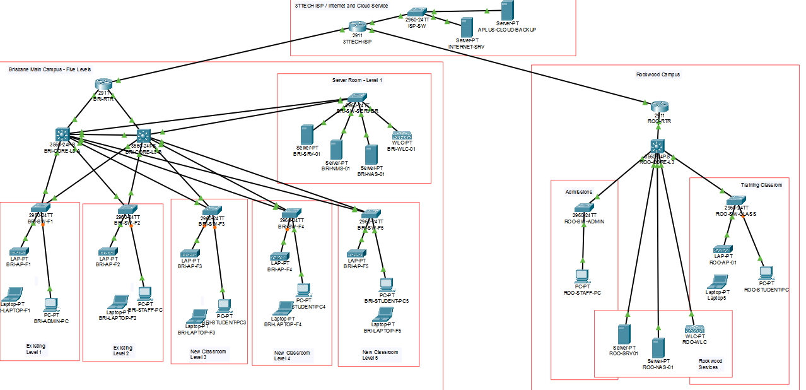Network Solution (Packet Tracer)

This document identifies the equipment required for A-Plus Institute’s Network Solution. It covers Brisbane’s five levels, the server room within Existing Level 1, and the separate Rookwood campus.
The equipment quantities follow the completed network design. Packet Tracer device names identify the simulation equipment. The commercial products listed later are proposed physical equivalents for obtaining specifications and quotations.
- Final equipment inventory for the Network Solution
Component | Packet Tracer representation | Brisbane | Rookwood | Total
Campus router/security gateway | Cisco 2911 | 1 | 1 | 2
Layer-3 core switch | Cisco 3560-24PS | 2 | 1 | 3
Floor/department access switch | Cisco 2960-24TT | 5 | 2 | 7
Dedicated server access switch | Cisco 2960-24TT | 1 | 0 | 1
Wireless LAN controller | WLC-PT / Cisco 3504 representation | 1 | 1 | 2
Managed wireless access point | LAP-PT / Cisco 3702i representation | 5 | 1 | 6
DHCP/DNS and local services server | Server-PT | 1 | 1 | 2
Network-attached storage | Server-PT representing NAS | 1 | 1 | 2
Network monitoring server | Server-PT | 1 | 0 | 1
Representative wired computer | PC-PT | 5 | 2 | 7
Representative wireless laptop | Laptop-PT | 5 | 1 | 6
The seven computers and six laptops represent users in the simulation. Actual computer purchases must follow the confirmed staffing, classroom and existing-equipment inventory.
The six APs follow the model. Their suitability for physical coverage and simultaneous user demand must be verified through the site survey.
- Equipment allocation and functions
Equipment group | Allocation and purpose
Brisbane router | BRI-RTR-FINAL connects Brisbane to 3TTech and provides routing, NAT, VPN and configured access controls.
Brisbane core switches | BRI-CORE-L3-A and BRI-CORE-L3-B provide inter-VLAN routing and the redundant core arrangement.
Brisbane floor switches | BRI-SW-F1 to BRI-SW-F5 connect the devices and AP on each level.
Brisbane server switch | BRI-SW-SERVER connects the central server, NAS, monitoring server and wireless controller.
Brisbane wireless infrastructure | BRI-WLC-01 manages BRI-AP-F1 to BRI-AP-F5.
Brisbane services | BRI-SRV-01 provides network services; BRI-NAS-01 provides storage; BRI-NMS-01 represents monitoring services.
Rookwood routing and switching | ROO-RTR-FINAL, ROO-CORE-L3, ROO-SW-ADMIN and ROO-SW-CLASS provide campus connectivity and connect to Brisbane through the proposed VPN.
Rookwood wireless infrastructure | ROO-WLC-01 manages ROO-AP-01.
Rookwood services | ROO-SRV-01 and ROO-NAS-01 provide local services and storage.
- Provider and cloud components represented in the diagram
Diagram component | Representation | Purchasing responsibility
3TTECH-ISP | Cisco 2911 | Provider infrastructure; obtain a service quotation rather than purchase this simulated router.
ISP-SW | Cisco 2960-24TT | Provider-side switching.
INTERNET-SRV | Server-PT | External internet service used for simulation tests.
APLUS-CLOUD-BACKUP | Server-PT | Represents a contracted cloud backup service; storage capacity and subscription require quotation.
Brisbane and Rookwood require separate ISP access services. Rookwood’s service remains dependent on the coverage extension described in the case study.
- Proposed physical equipment and vendor specifications
These products provide a procurement reference for the same network roles. Their selection must be checked against measured demand, the installation requirements and the supplier’s complete configuration.
Component / quantity | Proposed vendor product | Relevant specifications and official documentation
Campus routers – 2 | Cisco Catalyst C8200L-1N-4T | Four integrated Gigabit Ethernet interfaces: two copper and two SFP; modular expansion; Cisco IOS XE routing platform. Request the software entitlement appropriate for the required VPN and routing deployment. Cisco ordering specifications.
Core switches – 3 | Cisco Catalyst C9300-24T-A | 24 Gigabit Ethernet data ports, modular uplinks and Network Advantage software. Cisco lists HSRP under Network Advantage, supporting the Brisbane gateway redundancy requirement. Cisco Catalyst 9300 datasheet.
Core uplink modules – 3 | Cisco C9300-NM-8X | Eight 1/10 Gigabit Ethernet SFP/SFP+ uplink ports per module. Provides interfaces for the proposed backbone connections; optical modules are separate items. Cisco network-module specifications.
Floor/department switches – 7 | Cisco Catalyst C9200L-24PXG-4X-E | 24 PoE+ access ports, including eight multigigabit ports, and four 1/10 Gigabit uplinks. Multigigabit ports support the proposed AP connections. Cisco Catalyst 9200 datasheet.
Brisbane server switch – 1 | Cisco Catalyst C9200L-24T-4X-E | 24 Gigabit Ethernet data ports and four 1/10 Gigabit uplinks. Provides the dedicated server-network connections. Cisco Catalyst 9200 datasheet.
Wireless controllers – 2 | Cisco Catalyst C9800-L-C-K9 | Dedicated IOS XE wireless controller with copper uplink options. Supports centralised and FlexConnect deployments. Request compatible software, AP entitlements and support. Cisco controller datasheet.
Managed APs – 6 | Cisco Catalyst CW9162I-Z | Indoor Wi-Fi 6E AP with 2×2 radios across 2.4, 5 and 6 GHz and Catalyst 9800 controller support. Its Ethernet connection supports up to 2.5 Gbps and accepts PoE+. Request the appropriate Australian regulatory configuration and controller-managed operating mode. Cisco AP datasheet, Ethernet and power specifications.
Services and monitoring servers – 3 | Dell PowerEdge R360 | 1U, single-socket rack server supporting ECC DDR5 memory and multiple storage configurations. Allocate two to campus services and one to monitoring. CPU, RAM, RAID, storage and operating-system configurations require workload-based quotations. Dell specifications.
NAS appliances – 2 | Synology DiskStation DS925+ | Four drive bays, two 2.5GbE interfaces and two M.2 NVMe slots. Provides local storage and backup functions. Drives must be included separately. Synology specifications.
NAS drives – initial quotation allowance of 4 | Synology HAT3300-4T | 4 TB, 3.5-inch SATA drives. An initial configuration of two drives per NAS could provide mirrored storage. Confirm required usable capacity and retention before finalising this allowance. Synology drive specifications.
The server switch and standard core copper ports provide 1 Gbps connections. Higher-speed server or NAS connections would require suitable interfaces and a documented design adjustment if the capacity assessment identifies that need.
- Supporting items to include in the supplier quotation
Item | Requirement
Additional Brisbane router interface | Include a compatible routed Ethernet expansion interface if reproducing the three copper connections to the ISP and two cores. Cisco lists C-NIM-1M as a supported routed-port option. Cisco module compatibility.
Fibre and transceivers | Include compatible SFP/SFP+ modules, fibre links, patch leads and termination hardware. Quantities, fibre type and lengths must follow the physical cable plan.
Copper cabling | Include suitable structured cabling, patch leads, outlets, patch panels and cable management for APs and wired devices. Determine quantities during the survey.
Mounting and power | Include AP mounting kits, rack rails, cabinets, power distribution and suitable power cords.
UPS protection | Size protection for each equipment location using measured loads and required runtime. APC SMT1500RMI2UC is a reference option rated at 1500 VA/1000 W; this does not establish the required site quantity or runtime. APC specifications.
Software and subscriptions | Include required Cisco licences, server operating systems and access licences, monitoring software and backup subscriptions. Identify included and additional licences separately.
Support and implementation | Include warranty/support terms, installation, configuration, testing, documentation and training.
- Vendor quotation and published-price register
The following prices were displayed on supplier websites when checked on 6 September 2026. Amounts shown are AUD including GST. They are published price evidence; no formal supplier-issued quotation has been received.
Ref. | Product / required quantity | Published unit price or quotation status | Supplier evidence
Q01 | C8200L-1N-4T × 2 | $2,477.29. Listing indicated backorder; confirm lead time. | Melbourne Global router listing
Q02 | C9300-24T-A × 3 | $7,132.30 in the supplier catalogue; request the complete licensed configuration. | Techbuy switch catalogue
Q03 | C9300-NM-8X × 3 | $2,824.25. Confirm inclusion in the core-switch quotation. | Techbuy uplink-module listing
Q04 | C9200L-24PXG-4X-E × 7 | Formal quotation required for the exact multigigabit model. | Include in the Cisco equipment quotation request.
Q05 | C9200L-24T-4X-E × 1 | Formal quotation required. | Include in the Cisco equipment quotation request.
Q06 | C9800-L-C-K9 × 2 | $14,280.50. Confirm licences and support inclusions. | Melbourne Global controller listing
Q07 | CW9162I-Z × 6 | $1,417.87. Confirm availability of all six units and required entitlements. | Tech4U AP listing
Q08 | Dell PowerEdge R360 × 3 | Starting at $6,553.37. This is a base-price reference; obtain quotations for the required server configurations. | Dell Australia server listing
Q09 | DS925+ × 2, with compatible drives | Obtain a complete NAS-and-drive quotation. | Scorptec NAS listing
Q10 | Cabling, optics, power protection, software and installation | Itemised quotation required after the site requirements are confirmed. | Attach supplier quotation when received.

