Critique of Complex Technical Ideas

1. Project information
Project: A-Plus Institute Network Upgrade
Network reviewed: Network 3 – Final Network Solution
Prepared by: Leonardo Ciarcia
Date: 11/10/2025

2. Purpose
The purpose of this document is to review complex technical ideas contained in the A-Plus Institute network documentation. The review summarises the main ideas, identifies advantages and disadvantages, and evaluates whether the proposed technologies are suitable for the organisation.

3. Technical documents reviewed
Document reviewed | Information examined
Network 3 Technical Design Report | Network structure, devices, redundancy and connections
Network Diagram | Brisbane and Rocklea campus topology and five-floor design
IP Addressing and VLAN Scheme | Network segmentation, gateways and IP address allocation
Site Survey Report | Existing wireless coverage, interference and access point placement
VLAN and STP Test Report | VLAN connectivity, trunking and loop prevention
Private Network Isolation Test | Separation of student and temporary devices
Switch Troubleshooting Report | VLAN, port and STP troubleshooting procedures
IP Network Monitoring Plan | Performance metrics, monitoring schedule and response actions

4. Summary of the technical solution
Network 3 is a hybrid wired and wireless network designed for the A-Plus Institute Brisbane and Rocklea locations. The design supports five floors at the Brisbane campus and uses VLANs to separate different users and services.
The main technical ideas include:
- Two Layer 3 core switches for redundancy.
- VLAN segmentation for different user groups and services.
- STP to prevent switching loops.
- Wireless access points to provide coverage across the campuses.
- DHCP to automatically allocate IP addresses.
- A secure connection between Brisbane, Rocklea and the service provider.
- Monitoring and troubleshooting procedures.
- Isolation of student and temporary devices.
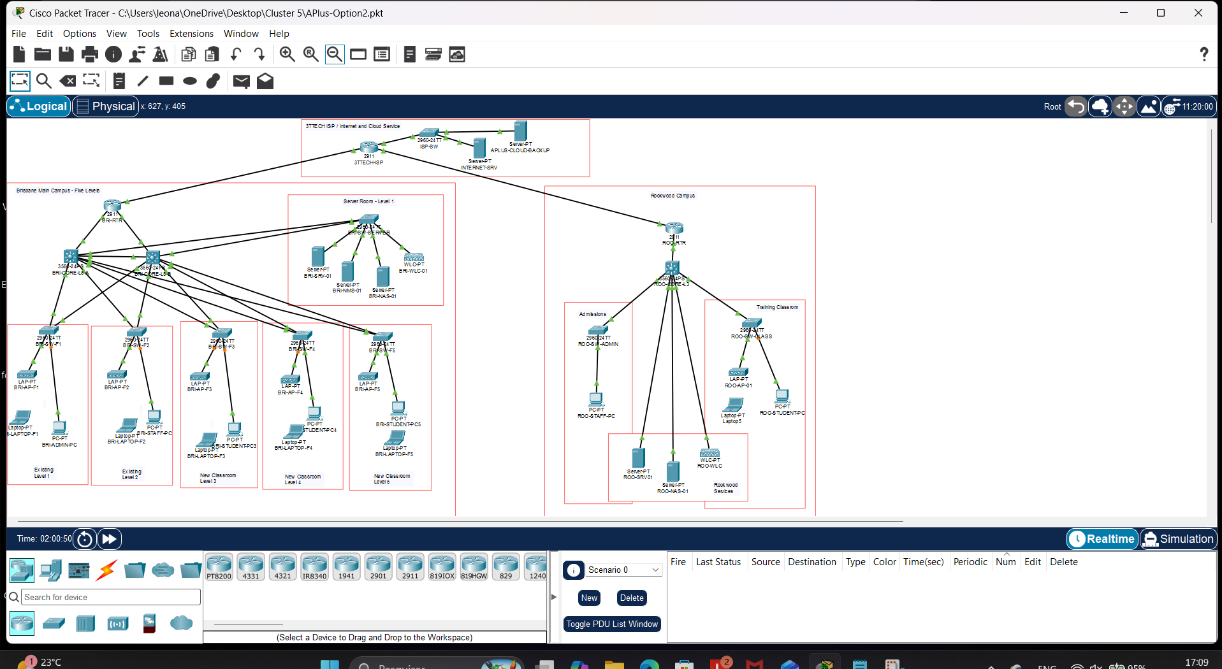Figure 1 – Network 3 final topology showing the main campus devices and connections.

5. Critique of the complex ideas
Technical idea | Advantages | Disadvantages or limitations | Evaluation
Dual Layer 3 core switches | Provide redundancy, improve availability and allow traffic to use an alternative path if one connection fails | Increase equipment cost and require more complex STP and routing configuration | Suitable because the institute requires reliable access to network services
VLAN segmentation | Reduces broadcast traffic, improves security and separates staff, students, servers and wireless users | Incorrect VLAN or trunk settings can cause connectivity problems | Appropriate, but VLAN assignments and trunk configurations must be documented and regularly tested
Spanning Tree Protocol | Prevents switching loops and supports redundant switch links | Incorrect root bridge selection can create inefficient network paths | Necessary because Network 3 contains redundant switch connections
Wireless network | Provides mobility and supports laptops and other wireless devices across multiple floors | Signal strength can be affected by walls, distance, interference and poor access point placement | Suitable when supported by the site survey and regular wireless monitoring
Centralised DHCP | Automatically provides IP addresses and reduces manual configuration | Clients may not receive an IP address if the DHCP server, pool or gateway configuration fails | Appropriate, but DHCP configuration should be backed up and monitored
Inter-campus secure connection | Allows Brisbane and Rocklea users to securely access shared resources | Performance depends on the internet connection and service-provider availability | Suitable, but an outage and recovery plan should be maintained
Student and temporary-device isolation | Reduces unauthorised communication and improves security | Packet Tracer does not support every private VLAN feature on all switch models | Useful, but production equipment should support full private VLANs or use ACLs for stronger control
Packet Tracer simulation | Allows configuration errors, failures and repairs to be tested safely | Cannot accurately reproduce real wireless interference, physical cabling problems or full device performance | Suitable for initial validation, but the final design should also be tested on real equipment

6. Supporting configuration evidence
The VLAN and switch documentation was reviewed to confirm that the network was divided into separate logical groups. The show vlan brief evidence demonstrated that the VLANs were created and that switch ports were assigned to them.
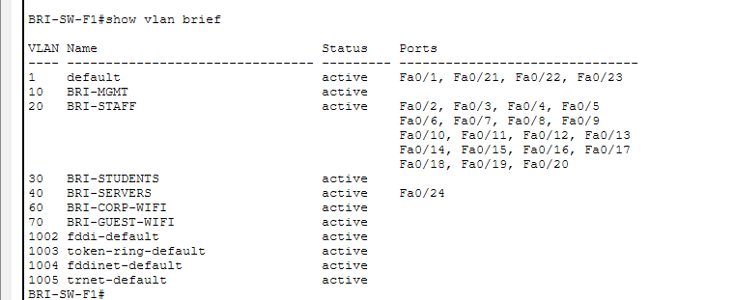Figure 2 – VLAN configuration reviewed as part of the technical critique.
The STP evidence demonstrated that the switches contained root, designated and forwarding port roles. This supported the design objective of preventing switching loops while retaining redundant connections.
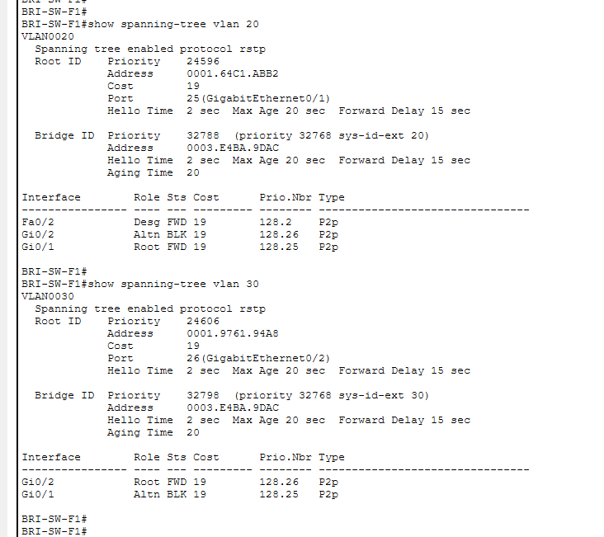
Figure 3 – STP information supporting the redundancy and loop-prevention design.
Connectivity evidence was also reviewed. Pings to addresses such as 10.10.20.1, 10.10.40.10 and 209.165.200.10demonstrated internal and external communication.
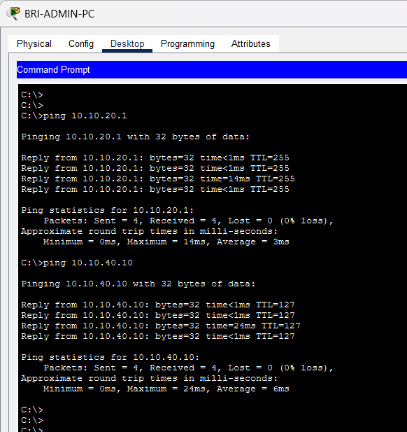
Figure 4 – Successful connectivity results from Network 3.

7. Overall findings
The main strength of Network 3 is that it combines segmentation, redundancy, wireless access and secure communication in one scalable design. It provides better availability and security than the existing network and supports the expansion of the Brisbane campus.
The principal disadvantage is increased complexity. VLANs, trunks, STP, DHCP, wireless access points and inter-campus connections must all be configured correctly. A configuration error in one area can affect multiple users.
The Packet Tracer tests demonstrate that the logical design is functional. However, the simulation cannot completely evaluate real wireless conditions, hardware performance or physical installation problems.

8. Recommendations
The following improvements are recommended:
- Maintain current network diagrams, IP tables and switch port records.
- Back up switch, router and wireless configurations.
- Monitor bandwidth, packet loss, latency and device availability.
- Repeat VLAN, STP and connectivity tests after configuration changes.
- Validate wireless coverage at the actual campus after installation.
- Use ACLs or supported private VLAN equipment for stronger device isolation.
- Provide administrator training for troubleshooting and maintenance.

9. Conclusion
The reviewed technical documents present a suitable solution for the A-Plus Institute. Network 3 provides redundancy, segmentation, wireless access, security and capacity for future expansion. Although the solution has higher cost and configuration complexity, its advantages are greater than its limitations. The design is recommended provided that it is supported by accurate documentation, monitoring, backups and regular testing.

