Audience-Focused Network Documentation Plan

1. Project information
Project: A-Plus Institute Network Upgrade
Network: Network 3 – Final Network Solution
Prepared by: Leonardo Ciarcia
Date:12/10/2025
Document version: 1.0

2. Purpose
The purpose of this plan is to explain how documentation for Network 3 will be created and presented to different audiences. The documentation will use clear headings, numbered procedures, diagrams, tables and language appropriate to each reader’s technical knowledge.

3. Documentation objectives
The documentation will:
- Explain the purpose and structure of Network 3.
- Help network administrators configure and maintain the network.
- Help IT support staff identify and resolve common problems.
- Provide simple instructions for staff and students.
- Give management a clear summary of benefits, risks and costs.
- Maintain accurate records of devices, VLANs, IP addresses and test results.

4. Intended audiences
Audience | Technical knowledge | Information required | Language and format
Management and client representatives | Low to moderate | Business benefits, risks, costs, reliability and project outcomes | Plain language, short summaries, tables and diagrams
Network administrators | High | VLANs, IP addresses, switch ports, routing, STP, DHCP, wireless and security configurations | Technical language, Cisco IOS commands, configuration tables and detailed diagrams
IT support staff | Moderate | Common symptoms, diagnostic steps, expected results and escalation procedures | Clear numbered instructions, checklists and screenshots
Staff and teachers | Low | Connecting to wired or wireless services and reporting faults | Short instructions without unnecessary technical terms
Students and guests | Low | Connecting approved devices and following network security requirements | Simple steps, screenshots and warning messages

5. Documents to be developed
Document | Main audience | Main content
Executive Network Summary | Management | Benefits, risks, redundancy, security and final recommendations
Network Administration Guide | Network administrators | Topology, IP scheme, VLANs, trunks, STP, DHCP, wireless and backup procedures
Troubleshooting Guide | IT support staff | Connectivity checks, common faults, diagnostic commands and corrective actions
Wireless Connection Guide | Staff and students | How to select the approved network, authenticate and report connection problems
Maintenance Schedule | Administrators and IT support | Daily, weekly, monthly and annual maintenance tasks
Test Results Report | Management and technical staff | VLAN, STP, connectivity, isolation and troubleshooting results

6. Standard document structure
Each document will use the following structure:
- Document title.
- Version and date.
- Purpose.
- Intended audience.
- Scope.
- Required tools or access.
- Procedure or technical information.
- Expected results.
- Troubleshooting or escalation information.
- Related diagrams and screenshots.
- Review and approval details.
- Revision history.

7. Documentation development steps

Step 1 – Identify the audience
The author will determine who will use the document and their level of technical knowledge.

Step 2 – Define the purpose
The purpose and expected outcome will be stated at the beginning. Information unrelated to that purpose will be excluded.

Step 3 – Collect technical information
Information will be collected from:
- Network 3 Packet Tracer file.
- Network topology diagram.
- IP addressing scheme.
- VLAN and port records.
- Site survey.
- Equipment list.
- Test and troubleshooting reports.
- Maintenance and monitoring plans.

Step 4 – Organise the content
Information will be divided into clear sections using descriptive headings. Procedures will be placed in the order in which they must be completed.

Step 5 – Tailor the language
Technical terms will be used for administrators but explained or replaced with plain language for non-technical readers.
For example:
Technical audience | Non-technical audience
“Verify the SVI and trunk configuration.” | “Check that the network groups are correctly connected between the switches.”
“STP provides Layer 2 loop prevention.” | “The switches automatically prevent duplicate connections from creating a network loop.”
“The interface is administratively down.” | “The switch port has been manually disabled.”
“Renew the DHCP lease.” | “Request a new automatic IP address.”

Step 6 – Add diagrams and screenshots
Screenshots will be placed directly after the relevant instruction. Each image will include a figure number and caption.
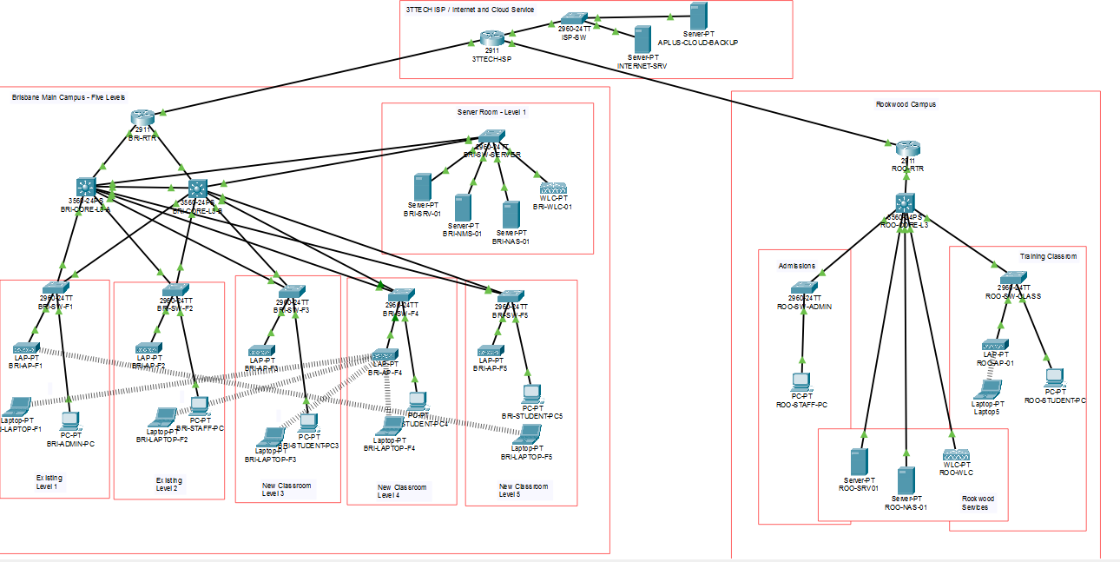Figure 1 – Network 3 topology used in the technical documentation.

Step 7 – Test the instructions
A person from the intended audience will follow the procedure. Any unclear, missing or incorrect instruction will be updated.

Step 8 – Review and approve
The completed document will be checked by the network administrator and client representative before distribution.

Step 9 – Publish and control the document
The approved document will receive a version number and review date. Previous versions will be archived to prevent staff from using outdated instructions.

8. Example of a clear technical procedure

Restoring a disabled switch port
Audience: IT support staff and network administrators
- Open the switch CLI.
- Enter privileged mode:
enable
- Check the interfaces:
show interfaces status
- Identify the port showing disabled.
- Enter the interface configuration:
configure terminal
interface fa0/X
no shutdown
end
- Wait until the port displays connected.
- Test the connection from the affected computer:
ping 10.10.20.1
- Record the result in the troubleshooting log.
- Escalate the problem if the port remains down.
This example uses a heading, numbered steps, short instructions, expected results and a clear escalation point.

9. Formatting standards
All documentation will use:
- Clear and descriptive headings.
- Short paragraphs.
- Numbered steps for procedures.
- Tables for detailed technical information.
- Consistent device and interface names.
- Captions below screenshots and diagrams.
- Warning notes before actions that may interrupt services.
- Defined abbreviations when first introduced.
- Page numbers, version numbers and review dates.

10. Security requirements
Sensitive information such as passwords, encryption keys and administrator credentials will not be included in general user documents. Technical documents will be stored in a restricted location accessible only to authorised personnel.
Staff and student guides will contain only the information required to connect to and use the network safely.

11. Review and approval
Review stage | Responsible person | Action
Technical accuracy review | Network administrator | Confirm configurations, commands and diagrams
Language review | IT support representative | Confirm that procedures are easy to understand
Business review | Client or manager | Confirm that the document addresses business needs
Final approval | Authorised stakeholder | Approve the document for distribution

12. Document maintenance
The documents will be reviewed:
- After major network changes.
- After adding or removing VLANs.
- After changing IP addresses or switch ports.
- After equipment replacement.
- After a serious network incident.
- At least once every six months.
All changes will be recorded in the revision history.

13. Conclusion
This plan ensures that Network 3 documentation is accurate, organised and appropriate for its intended audience. Management will receive concise business information, administrators will receive detailed technical instructions, IT support staff will receive troubleshooting procedures, and end users will receive simple connection guidance. Clear headings, numbered steps, diagrams and controlled language will make the documentation easier to understand and maintain.

