Technical Report – Network Option 2
Organisation: A-Plus Institute
Project: Brisbane Campus Expansion and Rookwood Network Integration
Prepared by: Leonardo Matias Ciarcia
Date: 04/09/2025
Document version: 1.0

1. Introduction
This technical report presents Network Option 2, the selected network solution for A-Plus Institute. The solution was developed to resolve the limitations of the current network and support the expansion of the Brisbane campus.
A-Plus currently operates across three existing Brisbane levels and is expanding into two new classroom levels. The proposed solution therefore supports five Brisbane levels in total. It also connects the separate Rookwood campus securely to the central services located in Brisbane.
The main objectives of Network Option 2 are to:
- Support the two new classroom levels.
- Improve wired and wireless performance.
- provide reliable wireless coverage across Brisbane.
- Reduce network bottlenecks and single points of failure.
- Separate staff, student, server, corporate wireless and guest traffic.
- Provide secure communication between Brisbane and Rookwood.
- Centralise network services, monitoring and wireless management.
- Support future employees, students, devices and applications.
- Improve data security, availability and backup arrangements.
The design was modelled and tested using Cisco Packet Tracer.

2. Existing Network Limitations
The current Brisbane network relies on one central access switch and one wireless access point to support users across three existing levels. This arrangement has limited capacity and does not provide sufficient wireless coverage or scalability.
The principal limitations are:
- One access switch supports users across multiple levels.
- One wireless access point supports the existing Brisbane wireless environment.
- The network uses a relatively flat structure.
- Staff, students, servers and guests are not sufficiently separated.
- The current design contains several single points of failure.
- Rookwood has limited or unreliable connectivity.
- Brisbane and Rookwood do not have a secure permanent inter-campus connection.
- The infrastructure cannot efficiently support two new classroom levels.
- Monitoring, backup and central wireless management are limited.
Network Option 2 was designed to address these limitations.

3. Network Design

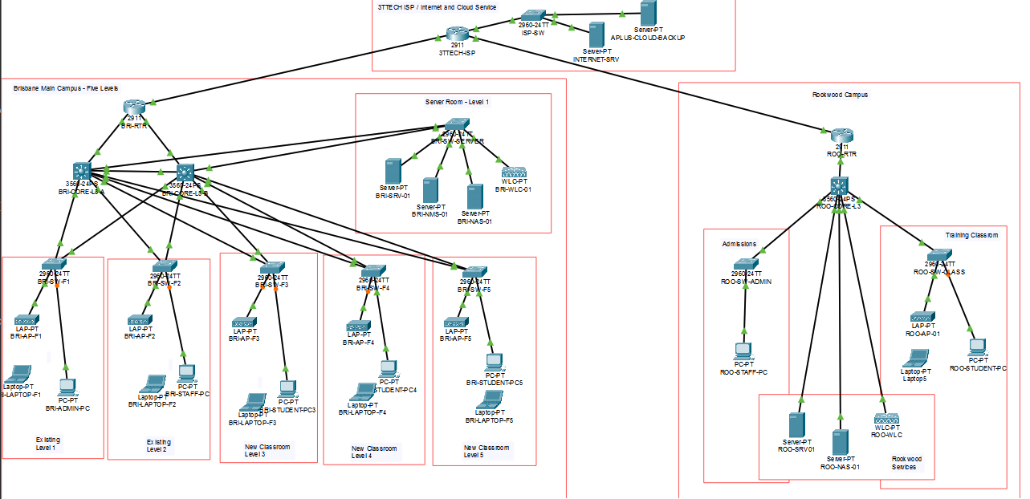

3.1 Overall Architecture
Network Option 2 uses a hierarchical network structure consisting of:
- Internet and 3TTech carrier infrastructure.
- WAN edge routers.
- A redundant Brisbane core layer.
- A dedicated access layer for each Brisbane level.
- A central Network and Services Area.
- Managed wireless infrastructure.
- A separate Rookwood campus network.
- A secure site-to-site IPsec VPN.
This structure separates the network into manageable sections and allows individual components to be expanded without redesigning the entire network.

3.2 Brisbane Campus
The Brisbane campus contains five represented levels:
- Existing Level 1
- Existing Level 2
- Existing Level 3
- New Classroom Level 4
- New Classroom Level 5
Each level has a dedicated access switch:
- BRI-SW-F1
- BRI-SW-F2
- BRI-SW-F3
- BRI-SW-F4
- BRI-SW-F5
The access switches connect the computers, laptops and wireless access points used on each level. Each switch connects to the Brisbane core using trunk links that carry the required VLANs.
Using one access switch per level distributes network traffic and provides additional ports for future users and devices.

3.3 Brisbane Core Layer
The Brisbane core layer contains two Layer 3 switches:
- BRI-CORE-L3-A
- BRI-CORE-L3-B
The core switches provide:
- Inter-VLAN routing.
- Default gateways for the Brisbane VLANs.
- High-capacity connections between floors.
- Connections to central network services.
- A connection towards the Brisbane WAN router.
- Redundant network paths.
HSRP is used to provide a virtual default gateway. If the active Layer 3 core switch becomes unavailable, the second core can provide the gateway service.
Spanning Tree Protocol prevents switching loops caused by the redundant connections. Packet Tracer may display one redundant switch link in amber because it has been placed in a backup state. This is normal and does not indicate a failed connection.

3.4 VLAN Design
Network Option 2 uses VLANs to separate users and services according to their business functions.
VLAN purpose | Brisbane subnet | Main use
Staff | 10.10.20.0/24 | Administration, teaching and other authorised staff
Students | 10.10.30.0/24 | Classroom and student computers
Services and management | 10.10.40.0/24 | Servers, network management, controllers and AP management
Corporate Wi-Fi | 10.10.60.0/24 | Authorised staff wireless devices
Guest Wi-Fi | 10.10.70.0/24 | Visitor and guest Internet access
The corresponding Rookwood networks use the 10.20.x.0/24 addressing structure.
VLANs reduce unnecessary broadcast traffic and improve security. Access Control Lists control communication between VLANs. Guest users are permitted to reach the Internet but are restricted from accessing internal staff, student, server and management networks.

3.5 Wireless Design
Each Brisbane level contains a managed wireless access point:
- BRI-AP-F1
- BRI-AP-F2
- BRI-AP-F3
- BRI-AP-F4
- BRI-AP-F5
The access points are managed by BRI-WLC-01. The Wireless LAN Controller provides centralised control of:
- Wireless network names.
- Wireless security.
- Access-point membership.
- Corporate and guest wireless services.
- VLAN association.
- Wireless authentication settings.
The primary wireless networks are:
- APlus-Secure for authorised corporate users.
- APlus-Guest for visitors and other guest users.
The secure wireless network uses WPA2-PSK with AES encryption in the Packet Tracer model. Guest traffic is separated from the internal network.
One managed AP per floor is a suitable logical starting point. The final number and physical position of access points should be confirmed through a wireless site survey using NetSpot or TamoGraph.

3.6 Brisbane Network and Services Area
The Brisbane Network and Services Area contains the central infrastructure and does not represent an additional level.
The area includes:
- Brisbane WAN router.
- Two Brisbane Layer 3 core switches.
- Server access switch.
- DHCP and DNS server.
- Network Attached Storage device.
- Network-monitoring server.
- Wireless LAN Controller.
The central server provides automatic IP addressing through DHCP pools. It also provides DNS and other simulated services.
The NAS represents local file storage and backup capacity. The monitoring server represents SNMP, Syslog and network-performance monitoring functions.
Centralising these resources simplifies administration, security, maintenance and backup.

3.7 Rookwood Campus
Rookwood remains a separate campus with its own:
- WAN router.
- Access switch.
- Managed wireless access point.
- Wireless LAN Controller where shown in the final design.
- Staff and student devices.
- Local VLANs and IP addressing.
- 3TTech carrier connection.
Rookwood uses the 10.20.x.0/24 addressing structure. Representative networks include:
- 10.20.20.0/24 for staff.
- 10.20.40.0/24 for services and management.
- Additional subnets for wireless users where configured.
Rookwood users receive their addresses automatically from the appropriate DHCP pools.

3.8 Internet and 3TTech Connectivity
The Brisbane and Rookwood WAN routers connect through the 3TTech provider infrastructure. The carrier network provides access to the simulated Internet and carries encrypted inter-campus traffic.
The edge routers perform functions including:
- WAN routing.
- Network Address Translation.
- Internet connectivity.
- Access-control filtering.
- Site-to-site VPN services.
The public test server at 209.165.200.10 represents an external Internet destination and can be used to demonstrate Internet reachability.

3.9 Site-to-Site VPN
A site-to-site IPsec VPN connects Brisbane and Rookwood through the 3TTech carrier network.
The VPN provides:
- Encryption of inter-campus traffic.
- Secure access to approved Brisbane services from Rookwood.
- Protection of organisational information while it crosses the provider network.
- A permanent logical connection between the two locations.
Only traffic matching the approved internal Brisbane and Rookwood networks should enter the VPN tunnel. General Internet traffic can continue to use the normal carrier path.

3.10 Servers, Storage and Backup
The solution includes central business services in Brisbane. These services include:
- DHCP.
- DNS.
- File and application services.
- Network monitoring.
- Syslog.
- Local storage.
- Local backup.
- Off-site or cloud backup representation.
This arrangement supports data availability and simplifies the management of shared services.

3.11 Capacity and Future Growth
The current estimated busy-hour demand is approximately 110 Mbps. Following the expansion, demand is expected to increase to approximately:
- 250 Mbps in Year 1.
- 360 Mbps in Year 3.
- 518 Mbps in Year 5.
A 25% capacity allowance increases the expected Year 5 requirement to approximately 648 Mbps.
The proposed design supports this demand through:
- Gigabit Ethernet access ports.
- A dedicated switch for each Brisbane level.
- Higher-capacity uplinks.
- Dual Layer 3 core switches.
- Managed wireless access.
- Expandable VLANs and subnets.
- Improved carrier capacity.
A 1 Gbps symmetrical Brisbane carrier connection is recommended. Rookwood should use a minimum 250 Mbps symmetrical connection, with 500 Mbps preferred for additional future capacity.

4. Network Diagram and Evidence

4.1 Primary Network Diagram
The best primary evidence is a full screenshot of the completed Packet Tracer Logical workspace.
Insert the screenshot under the following caption:
Figure 1 – Network Option 2 complete logical topology
The screenshot should clearly display:
- The 3TTech provider area.
- Brisbane campus boundary.
- Five Brisbane level blocks.
- Brisbane Network and Services Area.
- Both Brisbane Layer 3 core switches.
- Five Brisbane floor switches.
- Five Brisbane managed access points.
- Brisbane computers and wireless laptops.
- Rookwood campus boundary.
- Brisbane and Rookwood WAN routers.
- The ISP and VPN path.
- Device names.
- Green operational links.
- Any amber Spanning Tree backup links.
This full-topology screenshot is the most important visual evidence because it demonstrates that all required sections are included in one integrated solution.

4.2 Recommended Close-Up Evidence
Use the following additional screenshots if more than one diagram or evidence image is permitted.
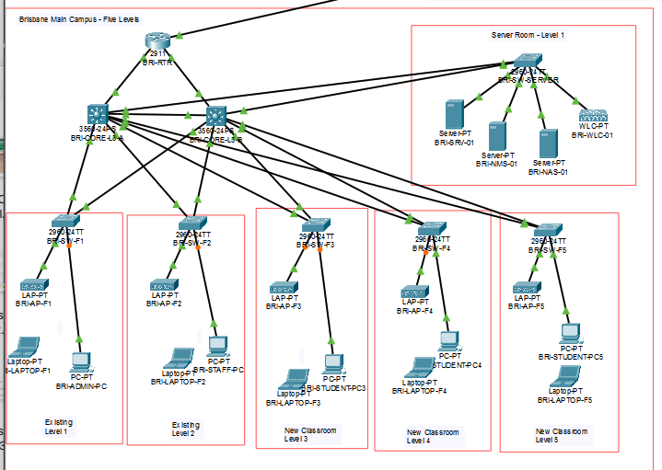
Figure 2 – Brisbane core and floor-switch architecture
Capture a close-up containing:
- BRI-CORE-L3-A
- BRI-CORE-L3-B
- BRI-SW-F1 to BRI-SW-F5
- Redundant trunk connections
- Brisbane router connection
- Server-area connection
This image demonstrates the hierarchical and redundant network design.
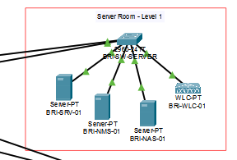
Figure 3 – Brisbane wireless and services design
Capture the Brisbane WLC, server, NAS, monitoring server and representative managed APs. If possible, include the WLC AP Groups page showing the access points with an Online status.
This demonstrates centralised services and wireless management.
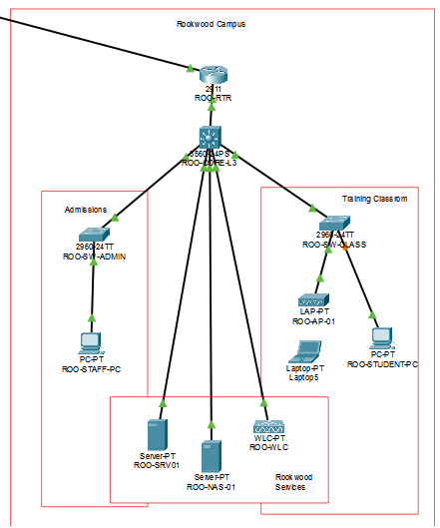
Figure 4 – 3TTech and Rookwood connection
Capture:
- Brisbane WAN router.
- 3TTech provider equipment.
- ISP switch or provider router.
- External Internet server.
- Rookwood WAN router.
- Rookwood switch, WLC, AP and clients.
- The note identifying the site-to-site IPsec VPN.
This demonstrates carrier connectivity and secure inter-campus communication.

5. Design Justification
Network Option 2 was selected because it provides a stronger long-term solution than the current network and the alternative proposal.
The dedicated floor switches distribute traffic and provide sufficient ports for users on each level. The dual Layer 3 core switches improve reliability and reduce the risk of the Brisbane campus depending on one central switching device.
VLAN segmentation improves performance and protects sensitive organisational resources. Staff, students, servers, wireless users and guests operate in separate logical networks. Access rules can therefore be applied according to the requirements of each user group.
Managed wireless infrastructure is more appropriate than independent access points because the WLC provides consistent SSID, security and AP configuration. This is particularly important when wireless coverage is required across five levels.
The site-to-site IPsec VPN allows Rookwood to access approved Brisbane resources securely without exposing private organisational traffic. The 3TTech carrier connection also provides Internet services to both locations.
Central DHCP, DNS, monitoring, storage and backup services improve administration and support. The network can be monitored more effectively, while configuration and service problems can be identified earlier.
The proposed architecture is scalable. Additional users, access points, switches, VLANs and services can be introduced without replacing the entire design. The capacity forecast also demonstrates that the proposed Gigabit access and higher-capacity core connections can support expected growth.

6. Conclusion
Network Option 2 provides A-Plus Institute with a secure, scalable and resilient network that supports five Brisbane levels and the separate Rookwood campus.
The design replaces the limited current structure with dedicated floor switches, managed wireless access, VLAN segmentation, centralised services, dual Layer 3 core switches and secure inter-campus communication.
The use of HSRP, Spanning Tree and redundant uplinks improves availability. The VLAN and ACL structure protects internal services and separates guest traffic. The WLC improves wireless management, while the VPN protects communication between Brisbane and Rookwood.
The capacity assessment indicates that the solution can support the expected growth in staff, students, wireless devices, online learning, cloud services and inter-campus traffic. Network Option 2 is therefore recommended as the preferred business and technical solution, subject to a final wireless site survey, confirmation of carrier services and successful completion of the implementation tests.

