Solution: Network Option 2 (Network 3 in Packet Tracer)
Prepared by: Leonardo Ciarcia, Assistant IT Manager, HV Technologies
Date: 12/10/2025
Status: Proposed plan for review
- Purpose
Identify risks to the Brisbane and Rookwood networks and define responses that protect teaching, administration and network services.
The plan uses the existing solution and available resources. Additional equipment, connections or expenditure must follow the project’s change and budget process.
- Risk evaluation and what-if plans
Priorities are planning judgements. High priority covers major service interruption, data loss or unauthorised access. Medium priority covers localised disruption or performance deterioration.
What-if scenario / risk | Priority | Immediate response | Contingency
A configuration change interrupts connectivity | High | Identify affected devices and compare the change with the last verified configuration. | Reverse the change or restore the verified configuration backup. Retest affected services before saving the corrected configuration.
A Brisbane core switch or one floor uplink fails | High | Check the failed component and the remaining core/uplink, gateway and STP states. | Use the configured alternate path where it remains operational. Repair the failed component and verify redundancy after restoration.
A floor access switch, campus router or ROO-CORE-L3 fails | High | Identify the affected floor or campus and inform the supervisor of the service impact. | Use a compatible spare if available and authorised, or arrange repair/replacement. Move essential work to available authorised facilities or offline activities.
The 3TTech connection fails | High | Check the local router/WAN connection and report the fault to 3TTech. | Continue available local campus services and offline teaching. Internet, off-site backup transfers and inter-campus VPN access depend on restoration; no independent backup ISP link is shown.
Internet access works, but the inter-campus VPN fails | High | Check peer reachability, VPN status, routing and recent configuration changes. | Continue local work at each campus while repairing the tunnel. Pause confidential transfers until the approved secure connection is restored.
A campus server or DHCP/DNS service fails, or data is lost | High | Check the server, service settings, storage and network connection. Identify a verified recovery source. | Restore the affected service/data from a tested local NAS or off-site backup, where available. Use approved offline activities during recovery. NAS storage is not an automatic replacement DHCP/DNS server.
An AP, WLC or wireless connection fails | Medium; High for campus-wide disruption | Determine whether the issue affects one AP or the campus WLAN; check links, addressing and controller status. | Use available wired devices. Use another AP only where coverage and operation are confirmed; repair the failed device or configuration.
Repeated packet loss or excessive delay affects classes | Medium; High if essential services become unusable | Compare monitoring results with the proposed targets and identify the affected link or traffic source. | Reschedule non-urgent backup/file transfers and retest. Propose a capacity change if measured demand continues to exceed the design.
A test reveals unintended access or failed isolation | High | Record the source, destination and expected access rule. Review VLANs, ports and access controls. | Contain affected access where necessary, correct the configuration and repeat permitted/blocked-access tests. Validate unsupported features on a suitable lab platform.
Campus power is lost | High | Follow campus safety and power procedures and notify the supervisor. | Use approved offline activities. Restore network devices and services in a controlled sequence when power is stable, then validate operation.
Brisbane’s HSRP configuration provides a shared gateway that a standby device can take over after an active-device failure. Recovery still depends on the remaining network paths being functional.
- Response and recovery procedure
- Record the fault, start time, affected users and affected services.
- Check the scope and notify the supervisor; prioritise security and essential teaching/administration.
- Apply the relevant contingency and record each action.
- Restore switching/routing and addressing/name services, then verify applications, wireless and inter-campus access as applicable.
- Repeat the affected connectivity, service and access-control tests.
- Record restoration time, remaining limitations and follow-up work.
- Responsibilities and resources
The Assistant IT Manager coordinates diagnosis, recovery, evidence collection and status updates. A-Plus management coordinates teaching/work arrangements. The supervisor authorises changes and additional costs. 3TTech handles faults within its service responsibility.
Keep the current diagram, IP/port tables, verified configuration backups, support contacts and tested recovery copies available to authorised staff. Confirm backup contents and restoration procedures before relying on them.
Recovery-time and acceptable-data-loss targets must be agreed before deployment. Record actual recovery times during tests and incidents.
- Current limitations and outstanding actions
The two Brisbane cores reduce selected core/link failure risks. Single access switches, campus routers, the Rookwood core, servers and wireless controllers still require their own recovery arrangements.
The latest reported protected-port test allowed ping between PC0 and BRI-STUDENT-PC3. This remains unresolved. Full private VLAN testing was not completed because the attempted command was unsupported in the selected simulation.
All contingencies are planned actions. Their effectiveness must be supported by actual test or incident records.
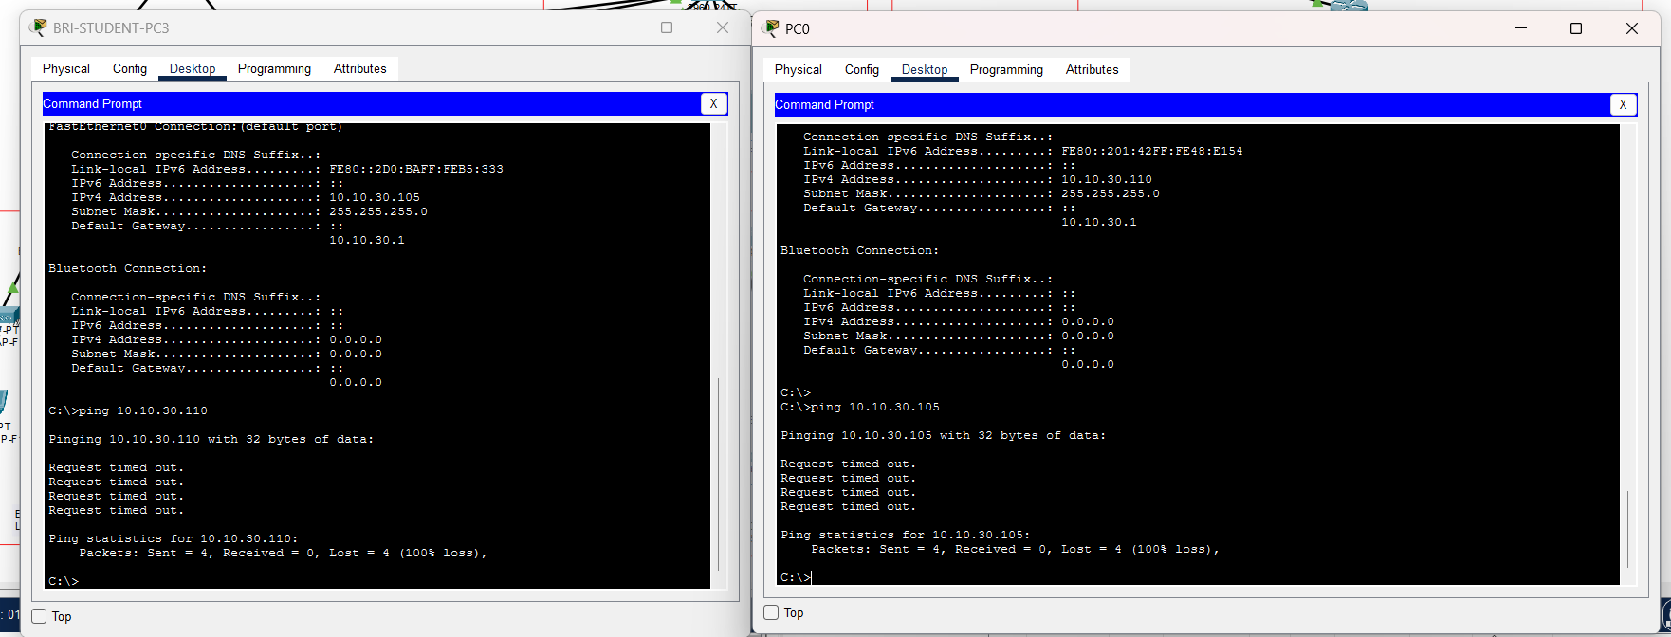
Figure1: Test allowed ping between PC0 and BRI-STUDENT-PC3

