NETWORK CONFIGURATION & TOPOLOGY
Prepared by: Leonardo Matias Ciarcia
Student ID: CTI20221062
Prepared for: A-Plus Institute
Date: 07/06/2026
Version: 1.0
1. Current topology map
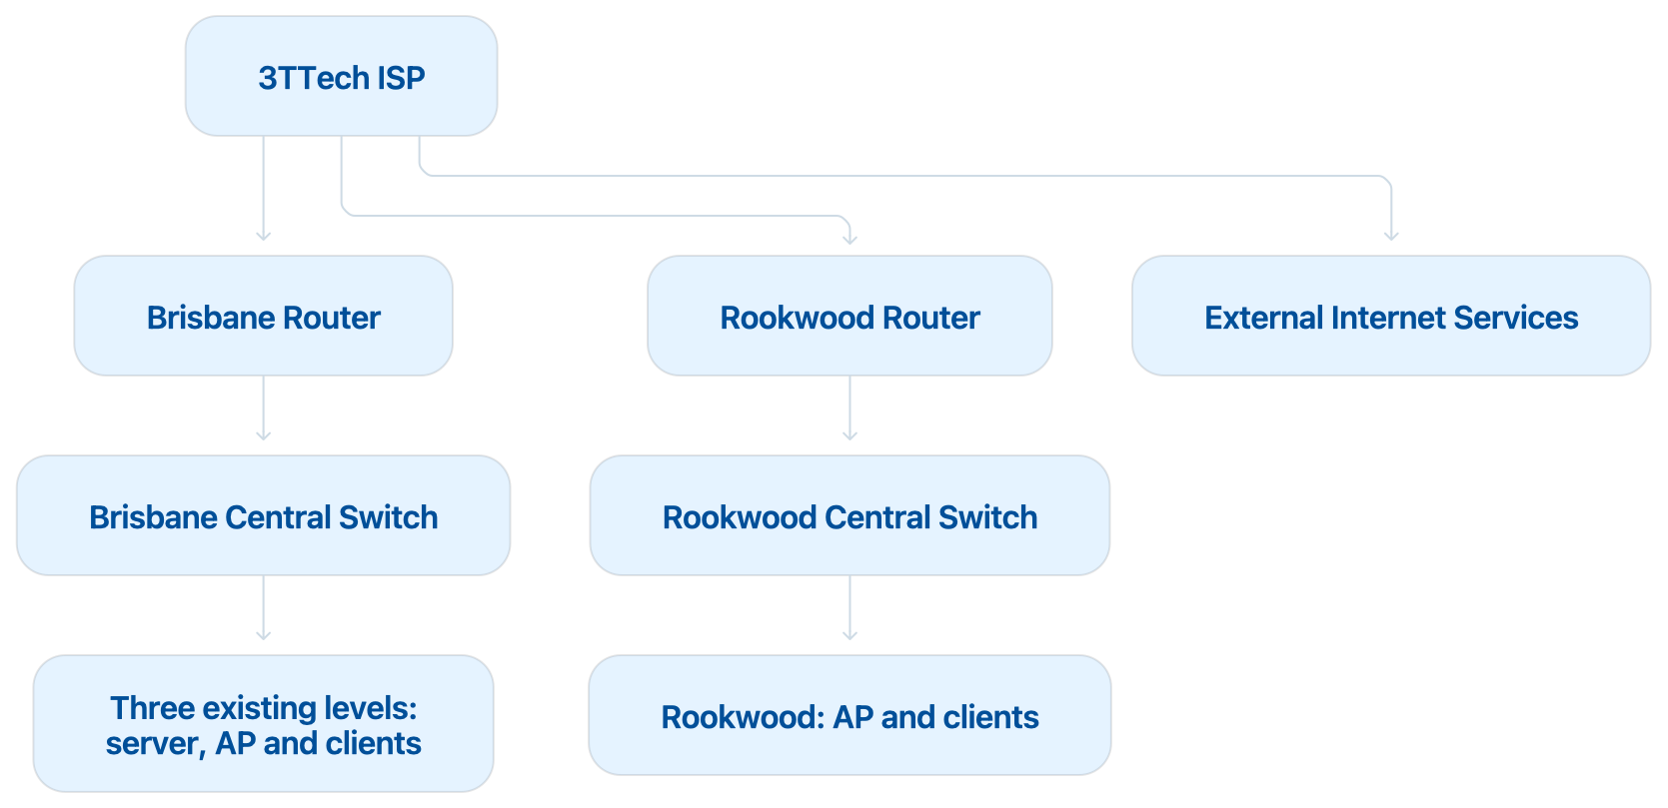

2. Network Diagram (Current – Packet Tracer)

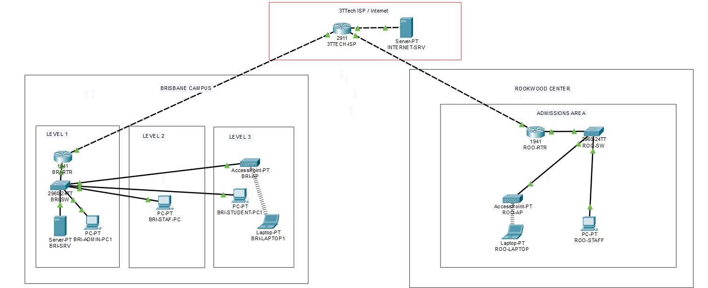

ZOOM1:
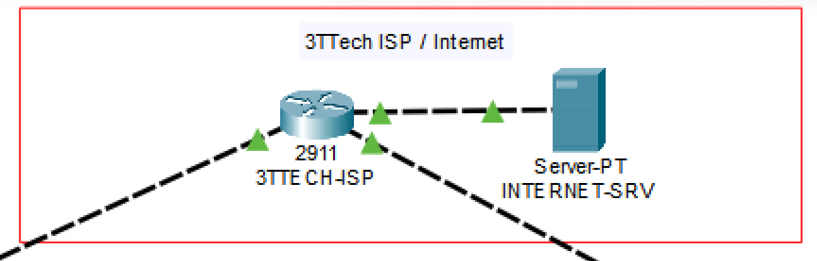
ZOOM2:
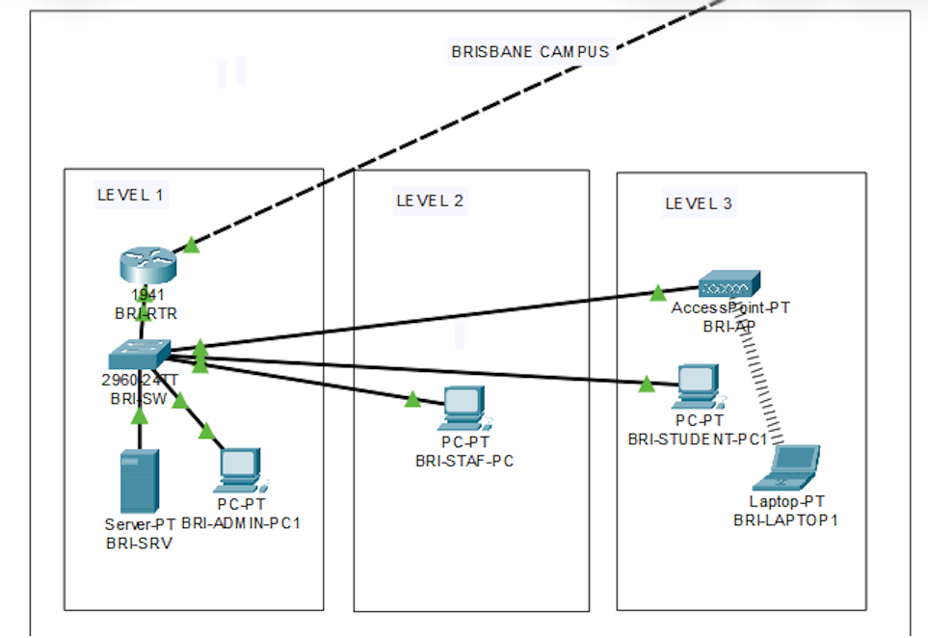
ZOOM3:
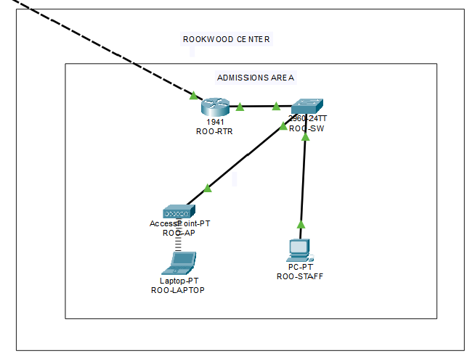

Brisbane device placement
Area | Devices
Existing Level 1 | BRI-RTR, BRI-SW, BRI-SRV, BRI-ADMIN-PC1
Existing Level 2 | BRI-STAFF-PC1
Existing Level 3 | BRI-AP, BRI-STUDENT-PC1, BRI-LAPTOP1
The three levels share one central switch and one autonomous access point. This represents the current coverage and capacity limitations.

Rookwood device placement
- ROO-RTR
- ROO-SW
- ROO-AP
- ROO-STAFF-PC1
- ROO-LAPTOP1
Rookwood is a separate campus, not another Brisbane level.

3. Link details

Carrier and external links
From | Port | To | Port | Link purpose
3TTECH-ISP | G0/0 | BRI-RTR | G0/0 | Brisbane carrier connection
3TTECH-ISP | G0/1 | ROO-RTR | G0/0 | Existing Rookwood carrier connection
3TTECH-ISP | G0/2 | ISP-SW | G0/1 | External services network
ISP-SW | Fa0/1 | INTERNET-SRV | Fa0 | Simulated Internet service
Use Copper Straight-Through or Automatic. Router ports require no shutdown.

Brisbane internal links
From | Port | To | Port | Link type
BRI-RT | G0/1 | BRI-SW | G0/1 | LAN uplink
BRI-SW | Fa0/2 | BRI-SRV | Fa0 | Server connection
BRI-SW | Fa0/3 | BRI-AP | Port 0 | Autonomous AP connection
BRI-SW | Fa0/4 | BRI-ADMIN-PC1 | Fa0 | Wired client
BRI-SW | Fa0/5 | BRI-STUDENT-PC1 | Fa0 | Wired client
BRI-SW | Fa0/6 | BRI-STAFF-PC1 | Fa0 | Wired client
BRI-AP | Wireless | BRI-LAPTOP1 | Wireless0 | Wireless connection

Rookwood internal links
From | Port | To | Port | Link type
ROO-RTR | G0/1 | ROO-SW | G0/1 | LAN uplink
ROO-SW | Fa0/2 | ROO-AP | Port 0 | Autonomous AP
ROO-SW | Fa0/3 | ROO-STAFF-PC1 | Fa0 | Wired client
ROO-SW | Fa0/4 | ROO-STUDENT-PC1 | Fa0 | Wired client, if included
ROO-AP | Wireless | ROO-LAPTOP1 | Wireless0 | Wireless connection
The laptops do not require Ethernet cables.

4. Network addressing
Network segment | Network/addressing
Brisbane WAN | 203.0.113.0/30
3TTECH-ISP G0/0 | 203.0.113.1
BRI-RTR G0/0 | 203.0.113.2
Brisbane LAN | 192.168.10.0/24
Brisbane gateway | 192.168.10.1
Brisbane server | 192.168.10.10
Brisbane clients | DHCP from 192.168.10.21
Rookwood WAN | 198.51.100.0/30
3TTECH-ISP G0/1 | 198.51.100.1
ROO-RTR G0/0 | 198.51.100.2
Rookwood LAN | 192.168.20.0/24
Rookwood gateway | 192.168.20.1
Rookwood clients | DHCP from 192.168.20.21
External-service network | 209.165.200.0/24
External gateway | 209.165.200.1
Internet server | 209.165.200.10
The AccessPoint-PT devices do not show a configurable management IP in your Packet Tracer version. They operate as Layer 2 wireless bridges.

5. Carrier information
Item | Current-network information
Carrier/service provider | 3TTech
Service | Business Internet/WAN connectivity
Brisbane carrier subnet | 203.0.113.0/30
Rookwood carrier subnet | 198.51.100.0/30
External-services subnet | 209.165.200.0/24
Connection type | Simulated Ethernet WAN connection
Brisbane status | Existing operational Internet connection
Rookwood status | Existing but limited/unreliable carrier connection
Inter-campus connectivity | No site-to-site VPN
Security | Basic NAT at each site router
Redundancy | No redundant WAN or core connection
Carrier limitation | Failure of one carrier link disconnects that campus

6. Current-network limitations
- One central switch supports all three existing Brisbane levels.
- Only one autonomous AP provides Brisbane wireless access.
- The network is flat and has no VLAN separation.
- Brisbane and Rookwood cannot communicate through private addresses.
- There is no site-to-site VPN.
- There is no WLAN controller.
- There is no redundant router, core switch or carrier link.
- Wireless capacity and coverage are insufficient for the two new floors.
- Rookwood’s existing carrier service is limited or unreliable.
- The network has limited monitoring, centralised security and scalability.

