Alternatives and Simulation Comparison
Project: A-Plus Institute Network Solution
Prepared by: Leonardo Ciarcia, Assistant IT Manager, HV Technologies
This document compares the two network proposals developed for A-Plus Institute. The assessment considers the Brisbane expansion to five levels, connectivity with Rookwood, security, reliability, maintenance and future growth.
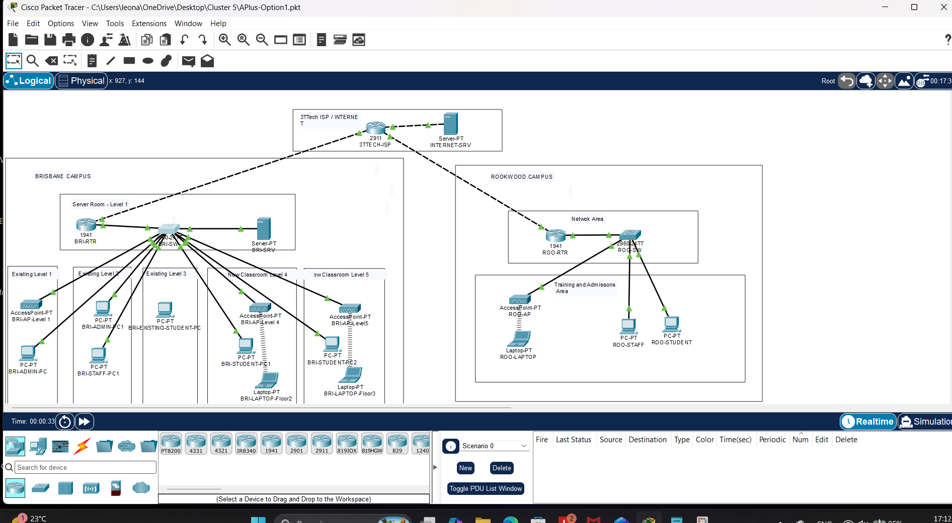
Network Option 1 refers to the alternative proposal previously called Network 2. Network Option 2 refers to the selected solution previously called Network 3.
Design consideration | Network Option 1 – Alternative proposal | Network Option 2 – Selected solution
Routing and switching | Uses router-on-a-stick, where traffic between VLANs passes through a shared router trunk. | Uses Layer 3 core switches for routing between campus VLANs.
Brisbane expansion | Concentrates connections through a single central switch and router trunk, creating shared capacity and availability dependencies. | Provides separate access switches for all five levels, connected to two Brisbane core switches.
Resilience | The single switch and routing trunk are points of failure. | Dual Brisbane cores and redundant floor uplinks provide alternative paths.
Wireless management | Autonomous access points require individual configuration and maintenance. | Wireless controllers centrally manage access points and WLAN settings.
Campus services | Relies on the central server arrangement, increasing Rookwood’s dependence on the inter-campus connection. | Provides local server services and storage at both campuses.
Security and connectivity | Can support VLAN separation, access controls, NAT and an IPsec VPN through 3TTech. | Includes defined staff, student, server, management and wireless VLANs, guest restrictions and the inter-campus IPsec VPN.
Cost and administration | Fewer components suggest a lower initial equipment cost, but manual administration increases as the network expands. | Requires more equipment and configuration effort, with better support for expansion and central management. Exact costs require supplier quotations.
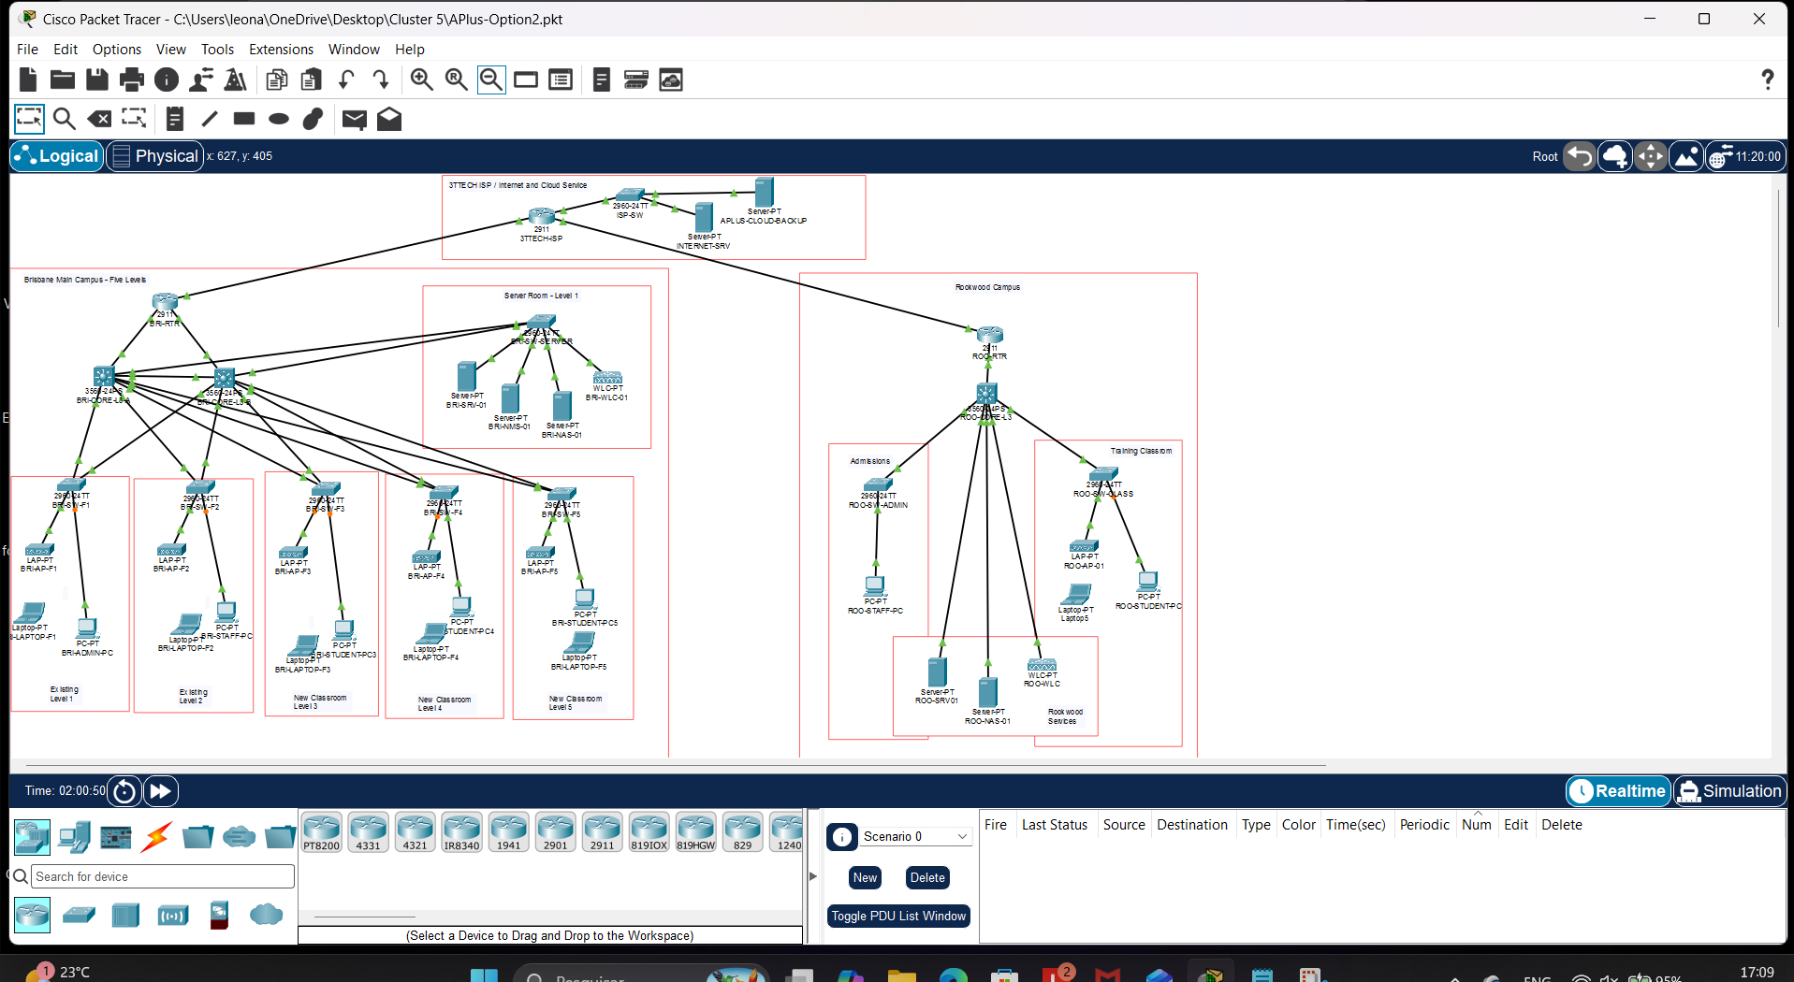
Network Option 2 is selected because its structure better supports the expanded Brisbane campus and ongoing administration across both locations. Option 1 remains a technically possible alternative, but its shared trunk, single switch and manual wireless configuration make it less suitable for the proposed growth.
The following simulation tests compare equivalent functions in both proposals. These are expected outcomes based on the designs; they are not recorded test results.
Test and method | Expected outcome – Option 1 | Expected outcome – Option 2
T1 – Automatic addressing: set a representative staff client to DHCP and inspect its IP configuration. | Receives an address, gateway and DNS information if the DHCP service and relay configuration are complete. | Receives addressing information for the correct staff VLAN. Brisbane staff clients use 10.10.20.0/24 with gateway 10.10.20.1.
T2 – Inter-campus connectivity: ping the Brisbane server from a Rookwood staff client. Inspect VPN status and counters on both routers. | Authorised traffic should pass through the configured IPsec VPN. | Authorised traffic should reach BRI-SRV-01 at 10.10.40.10, with VPN encryption and decryption counters increasing.
T3 – Guest isolation: test access to the simulated Internet server and an internal server from a guest client. | Passes only where a separate guest network and suitable access controls are implemented. Record any missing configuration as a gap. | Guest traffic should reach the simulated Internet server at 209.165.200.10 and be blocked from internal server networks.
T4 – Uplink failure: disconnect the sole routing trunk in Option 1 and an active floor-to-core uplink in Option 2. Repeat an inter-VLAN connectivity test. | Inter-VLAN connectivity should fail until the routing trunk is restored. Same-VLAN communication may continue. | Connectivity should recover through the remaining uplink after switching reconvergence, provided redundancy is correctly configured.

