Draft Netwirk Design
Prepared by: Leonardo Matias Ciarcia
Student ID: CTI20221062
Prepared for: A-Plus Institute
Date: 29/06/2026
Version: 1.0
1. Current topology map
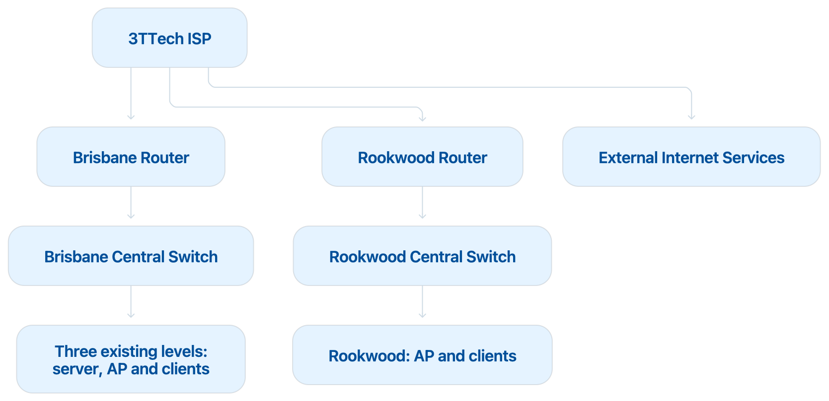

2. Network Diagram (Current – Packet Tracer) - DRAFT

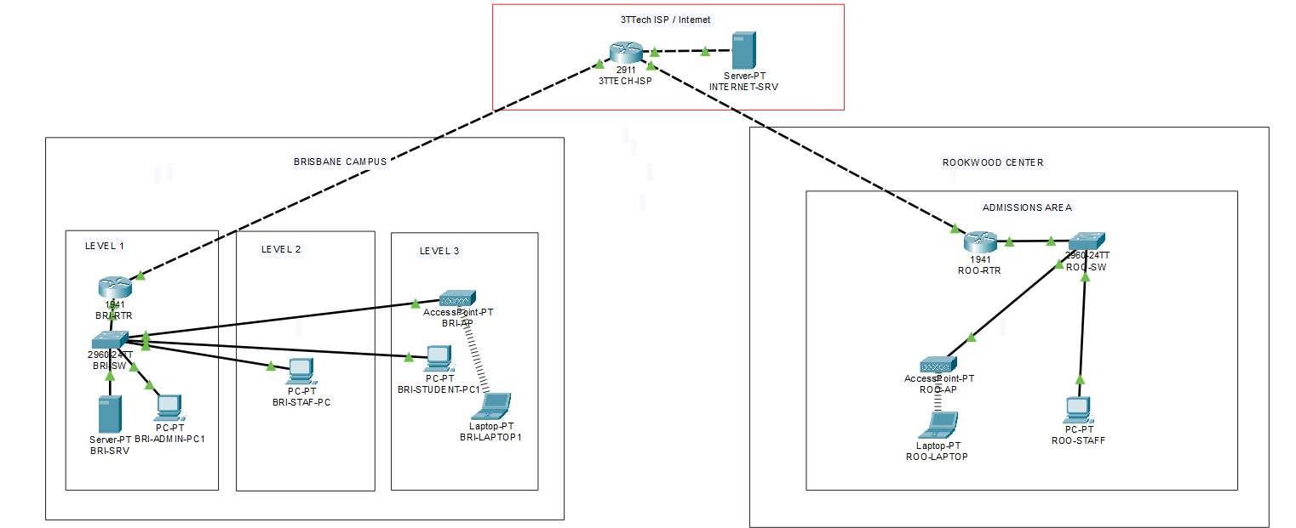

ZOOM1:
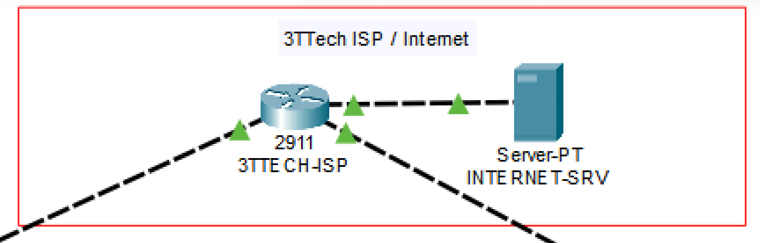
ZOOM2:
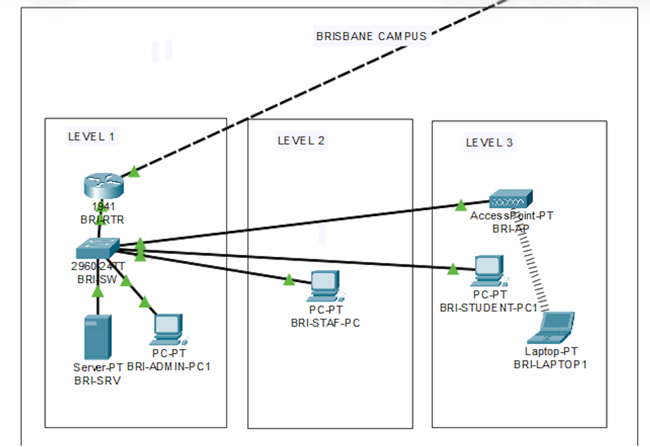
ZOOM3:
