

ebInterface 4.0

The Austrian e-Invoice standard

**Note:** This documentation is a translation of the German documentation of the ebInterface standard 4.0, available on <http://www.ebinterface.at>. This documentation is currently in status DRAFT and may contain typos and grammatical mistakes.

austriapro 

Table of contents

1 Introduction 3

1.1 Subject 3

1.2 Referenced XML standards and specifications 3

1.3 Changes in Version 2.0 3

1.4 Changes in Version 2.1 3

1.5 Changes in Version 2.2 4

1.6 Changes in Version 3.0 5

1.7 Changes in Version 3.01 7

1.8 Changes in Version 3.02 7

1.9 Changes in Version 4.0 7

2 Schema base information 9

3 ebInterface 4.0 12

3.1 Invoice 13

3.2 Signature 16

3.3 Delivery 18

3.3.1 Address 21

3.4 Biller 23

3.4.1 OrderReference 25

3.5 InvoiceRecipient 26

3.6 OrderingParty 29

3.7 Details 31

3.7.1 ListLineItem 34

3.8 ReductionAndSurchargeDetails 38

3.9 Tax 40

3.10 PaymentMethod 41

3.10.1 UniversalBankTransaction 42

3.10.2 DirectDebit 44

3.10.3 NoPayment 46

3.11 PaymentConditions 46

3.12 PresentationDetails 48

4 The ebInterface 4.0 Extension mechanism 50

4.1 Integration of the coupling scheme in ebInterface 51

4.2 Integration of ebInterface extension schemes in the ebInterfaceExtension coupling scheme 52

5 References 53

# Introduction

## Subject

This document describes the XML-Schema Invoice.xsd of the ebInterface 4.0 standard.

## Referenced XML standards and specifications

For the XML-structure of ebInterface the following specifications and standards were used:

|  |  |
| --- | --- |
| **Name** | **Standard** |
| http://www.w3.org/2000/09/xmldsig# | XML Digital Signatures (XMLDSIG) – W3C: electronic signatures [W3C02] |
| http://www.w3.org/2001/XMLSchema | W3C – XML Schema [W3C01] |
| http://www.ebinterface.at/schema/4p0/ | ebInterface 4.0 |

## Changes in Version 2.0

The following changes – in comparison to Version 1.0 – were adopted:

* The declaration of a tax identification number (VAT) is possible for the invoicing party (Invoice/Biller/VATIdentificationNumber) as well as for the invoice recipient (Invoice/InvoiceRecipient/VATIdentificationNumber).
* The previously used element TaxID (Invoice/Tax/VAT/TaxID) for reporting the tax identification number (VAT) of the invoicing party has been deleted.
* The scheme allows the definition of a cancelled invoice (Invoice/@Cancellation).
* A new own namespace has been defined. For version 2.0 of standard the namespace is "http://www.ebinterface.at/schema/2p0/".
* Electronic signature: XMLDSig (XML-Signature Syntax und Processing) for the Enveloped Signature has been included in the Schema.
* The element for the definition of the discounted amount (Invoice/PaymentConditions/Discount/DiscountedAmount) has been deleted, as it can be calculated and, therefore, has no additional benefit.
* If the discount does not refer to the total gross amount, a new element for reporting the base amount for calculating the discount has been implemented (Invoice/PaymentConditions/Discount/BaseAmount).
* Sum discounts: Version 2.0 allows granting a discount up to the entire invoice amount (Invoice/PaymentConditions/Reduction).
* The attribute SchemaVersion (Invoice/@SchemaVersion) for reporting the underlying ebInterface scheme has been deleted. This information is defined using the XML namespace.
* A new additional attribute – ConsolidatorPayable – for payment options "UniversalBankTransaction" has been added, which regulates the payment on a consolidator platform.

## Changes in Version 2.1

* The attribute ConsolidatorPayable for paying options UniversalBankTransaction has been explicitly set on optional and the default value "false" has been deleted. The usage, however, remains equal, which means only if the attribute ConsolidatorPayable is specified with "true" on an invoice it will affect the payment on a consolidator platform.
* The default value "false" of the attribute Cancellation of the route element Invoice has been deleted. The usage, however, remains equal, which means only if the attribute Cancellation is specified with "true" on an invoice, it is an invoice cancellation.
* The data type DecimalType also accepts negative values (bug fix in ebInterface 2.0).
* A new own namespace has been defined. For new version of the standard the namespace is "http://www.ebinterface.at/schema/2p1/".

## Changes in Version 2.2

* Implementation in the documentation that invoices are to be numbered not only clearly but also consecutively.
* For each invoice the day or, respectively, the delivery period has to be entered. Thus, the former optional element Delivery has been set on mandatory.
* In the documentation it has been explicitly stated that the invoicing party in the Biller element is either delivering or supplying party.
* It is an essential requirement to enter the tax identification number (VAT) of the invoicing party on the invoice. Thus, the element Biller/VATIdentification-Number is now mandatory. In case the invoice recipient has no tax identification number, the string "00000000" (eight times the zero) has to be entered.
* The data processing registration number, mentioned in the data protection law, has been added as an optional element Biller/DPRNumber (= Data Processing Register Number) to the invoicing party.
* It is an essential requirement to enter the tax identification number (VAT) of the invoice recipient on the invoice. Thus, the element InvoiceRecipient/VAT-IdentificationNumber is set on mandatory. In case the invoice recipient has no tax identification number, the string "00000000" (eight times the zero) has to be entered.
* The invoice has to contain name and address of both, delivering/supplying enterprise as well as the recipient information. As a result the elements Street, Town, ZIP and Country Address are to be changed in the Address-type. It is pointed out that the Address-type is not only used in the elements Biller and InvoiceRecipient but also in the element Delivery.
* In case the invoice is not subject to value added tax (VAT), this has to be marked explicitly. Thus, the empty element TaxExemption has been included as a sub-element from Tax/VAT, which may be used alternatively to the sub-element Item. Furthermore the elements Tax and Tax/VAT, respectively, have been set on mandatory.
* The statement of payment methods and terms of payment are not required. Thus, PaymentMethod and PaymentConditions have been set on OPTIONAL.
* In the documentation it was stated that an item row has to contain elements of quantity, usual commercial description and remuneration (including currency) of the delivery or service.
* It is ought to be possible for every item in the details to put in a classification according to accepted classification schemes (e.g. CPA, NACE Code). Thus, the item Classification in the code list UsageType has been adopted.
* In the documentation it was explicitly stated that every ebInterface invoice has to contain a reference to the used XSLT styles sheet.
* A new namespace has been defined. For the new version of the standard the namespace is "http://www.ebinterface.at/schema/2p2/".

## Changes in Version 3.0

**Changes in data type**

* DecimalType became Decimal2Type (decimal number with two decimal places)
* Decimal4Type has been added (decimal number with four decimal places)
* DocumentTypeType with a code list for several types of invoices has been added
* UsageType has been deleted

**Changes in attributes of Element Invoice**

* The attribute Cancellation for reporting of invoice cancellations has been deleted. This information is defined using the new, optional attribute CancelledOriginal-Document. In case another invoice is cancelled with this invoice, the number (Invoice/InvoiceNumber) of the cancelled invoice is mentioned in this attribute. In case of cancellation the original amounts are mentioned with inverse signs.
* Hence, the currency of the invoice will be defined in one place (Invoice/ @InvoiceCurrency). As a consequence the following types have been deleted:
  + BankAccountNrType henceforth String
  + AmountType henceforth Decimal2Type
  + TotalGrossAmountType henceforth Decimal2Type
* The optional attribute ManualProcessing of type of Boolean has been added. By way of using this attribute the issuer of the invoice is given the possibility to mark side agreements, mentioned in the text field.
* The mandatory attribute DocumentType with the coded DocumentTypeType for reporting types of invoices (invoice, final settlement, payment in advance, invoice for partial delivery, subsequent credit, credit memo, subsequent credit, self billing) has been added.

**Changes in element Invoice**

* The element Delivery has been set on optional because delivery details may be mentioned alternatively in the position lines of the invoice.
* The element Supplier has been deleted.
* The element OrderingParty for reporting the ordering party, in case it is not mentioned as the
  + Invoice recipient, has been added as an optional element after InvoiceRecipient and before Details.
* The Details have been set from optional to mandatory to ensure that at least one item or service is settled.
* After Details and before Tax the new optional element ReductionDetails for reporting discounts has been added.
* The attribute Language and the attribute DocumentTitle have been newly added – the corresponding elements have been deleted from PresentationDetails.

**Changes in element delivery**

* For entering a delivery number a new optional element DeliveryID has been added.
* Exactly one date or period has to be mentioned to every delivery which means the upper threshold in the selection of delivery date and delivery period have been set back from unlimited to one. Additionally, the delivery date and address, respectively, may be overwritten per position.
* The optional element Description has been added – replacing the element DeliveryDescription in PresentationDetails.

**Changes in element Biller**

* The optional and repeatable element FurtherIdentification with Further-IdentificationType has been added. The FurtherIdentificationType is of type AlphaNumIDType and contains the attribute IdentificationType of type of string.
* The element DPRNumber for entering the DVR number has been deleted, as it can be displayed with FurtherIdentification.
* The upper threshold in OrderReference was set back from unlimited to one.

**Changes in element OrderReference**

* The element ID has been renamed in OrderID

**Changes in element InvoiceRecipient**

* As for the element Biller the upper threshold in OrderReference has been set back from unlimited to one.

**New element OrderingParty**

* The structure of OrderingParty for entering the ordering party, in case the party is not equivalent to the invoice recipient, is similar to InvoiceRecipient, only the second element is called BillersOrderingPartyID.

**Changes in element details**

* The optional elements HeaderDescription and FooterDescription have been added.
* The structure of this element has been rebuilt completely.

**New element ReductionDetails**

* The element ReductionDetails consists of one to several Reduction elements.
* The element Reduction of type of ReductionType is already available in ebInterface 2.2 (in PaymentConditions). The ReductionType, however, has been changed:
  + BaseAmount has been set on compulsory
  + Additionally, the element TaxRate has been added

As a result the element Reduction will be deleted from PaymentConditions.

**Changes in element Tax**

* The type of element TaxExemption has been changed to string from empty element. In this string the reason for tax exemption is to be entered.
* The structure of VAT Item has been defined as follows:
  + TaxedAmount
  + TaxRate: TaxRateType = PercentageType + attribute TaxCode (string to entering of "AT" + UVACode 3). ATXXX is equivalent to not taxable
  + Amount

**Changes in element PaymentConditions**

* The element Reduction has been deleted (see new element ReductionDetails).

**Changes in element PresentationDetails**

* The elements HeaderComment and FooterComment have been deleted – this semantic is now available in the attributes HeaderDescription and FooterDescription in the element Details/ItemList and on the other hand in the correspondent attributes of Details.
* The element DeliveryDescription has been deleted – instead an element Description in the element Delivery has been added.
* The elements Language and DocumentTitle have been deleted. These have been added as attributes in the root element Invoice.
* The element ShortComment has been deleted without replacement.

**Changes in field Custom**

* In the version ebInterface 2.1 the elements from the Custom section have been directly displayed in the sub element Invoice. In the version ebInterface 3.0 these elements have to be entered as sub elements in the henceforth explicit element Custom (Invoice/Custom).
* The attribute processContents has been set from strict to lax in in the scheme. This means that elements in the Custom elements can only be validated, if a scheme definition is available for them. If no scheme definition is available, these elements will not be validated and no error indication appears from the parser.

## Changes in Version 3.01

**Changes in data types**

* The restriction of Decimal2Type has been changed from a regular expression to fractionDigits.
* The restriction of Decimal4Type has been changed from a regular expression to fractionDigits.

A new namespace has been defined. For new version of the standard the namespace is "http://www.ebinterface.at/schema/3p01/".

## Changes in Version 3.02

**Changes in data types**

* The restriction of PercentageType has been changed from a regular expression to fractionDigits with minInclusive and maxInclusive.

A new own namespace has been defined. For new version of the standard the namespace is "http://www.ebinterface.at/schema/3p02/".

## Changes in Version 4.0

**Introduction of structural extensions**

* A significant change in ebInterface 4.0 is the introduction of structural extensions in the ebInterface XML scheme. With the help of predefined extension, an ebInterface coupling scheme (ebInterfaceExtension.xsd) and from ebInterface standardized extension schemes, the integration of domain-specific extensions is now possible. The functionality of the extensions will be explained in chapter 4.

**Changes in element „Address“**

* A new optional element AddressIdentifier has been added to the element Address, which serves as an explicit identification of an address. Additionally the element AddressIdentifier has an optional attribute AddressIdentifierType. With the help of this attribute it is possible to define what kind of AddressIdentifier is to be dealt with. For the valid values of AddressIdentifierType a code list was stored AddressIdentifierTypeType.

**Changes in element „InvoiceRecipient“**

* To the element InvoiceRecipient new optional elements AccountingArea and SubOrganizationID have been added. With the help of these two elements accounting areas and more accurate details of in-house invoice recipients (i.e. organizational unit) can be stated.

**Changes in the element „ListLineItem“**

* Both elements BillersArticleNumber and InvoiceRecipientsArticleNumber have been deleted. Instead a new optional element ArticleNumber has been added, subsequently with the help of this element one or several item numbers can be displayed. The element ArticleNumber has an optional attribute ArticleNumberType, which is able to display the ArticleNumber. As for the valid values of ArticleNumberType a code list was stored ArticleNumberTypeType.

**Changes in element „ReductionDetails“at ROOT level**

* On the ROOT level of the scheme the element ReductionDetails has been renamed in ReductionAndSurchargeDetails. The element Percentage has been set on optional. In order to enter additional charges, a new optional element Surcharge has been added to the element ReductionAndSurchargeDetails. The type of Surcharge corresponds with the type of Reduction.

**Changes in element „ReductionDetails“ at ListLineItem level**

* The element ReductionDetails on the ListLineItem has been renamed in ReductionAndSurchargeListLineItemDetails. The type of this element is from now on not the same as the type of ReductionDetails on the ROOT level but a new type ReductionAndSurchargeListLineItemDetailsType has been added. In contrast with the old type TaxRate was left out. Additionally, as it was for the ROOT level, the element Percentage has been set on optional and the optional element SurchargeListLineItem has been added to enable the possibility of giving additional charges. The element Reduction has been renamed in ReductionListLineItem.

**Changes in element „PaymentReference“**

* The type of PaymentReference has been changed from xs:integer to Digit12Type. Additionally, a new optional element CheckSum has been added.

**Changes in element „PaymentConditions“**

* The element Percentage of the element Discount has been set on optional.

**Changes in element „Country“**

* A new optional element CountryCode has been added to the element Country, which enables to display an IOS 3166-1 Country Code to the free text element Country.

**Changes in type „CountryCodeType“**

* The values of the enumeration have been adapted to the last version of the ISO 3166-1 standards [ISO3166-1].

**Changes in type „CurrencyType“**

* The values of the enumeration have been adapted to the last version of the ISO-4217 standards [ISO4217].

**Changes in attribute „TaxCode“**

* The type of TaxCode has been changed from xs:string to TaxCodeType. TaxCodeType has been added as simpleType.

A new namespace has been defined. For the new version of the standard the namespace is "http://www.ebinterface.at/schema/4p0/".

# Schema base information

The Schema-description has been built on the basis of the tree view. If XML composite elements appear several times in the scheme (i.e. *Address* or *OrderReference*), the sub elements of those elements will be explained only in the first appearance of the element in order to avoid double listing and to improve readability.

The list of XML-elements and attributes contains the following information:

**Name**

This column contains the names of the XML-elements/attributes. All names can be interpreted as paths relatively to the ROOT-element ”Invoice”. Attributes are marked with the identifier "@". Arbitrary paths are marked with the identifier "*".

**Meaning**

This column contains an explanation for the usage of the XML-elements/attributes.

**Type**

This column contains the type of the XML element or XML attribute, respectively.

**Cardinality**

This column contains the explanation of the cardinality.

|  |  |
| --- | --- |
| **Cardinality** | **Meaning** |
| 0..1 | Zero times or once. |
| 0..* | Zero or several times. |
| 1..1 | Exactly once. |
| 1..* | Once or several times. |

**Format**

The column "Format" contains information on the used data type and used structure by creation of the data type, respectively. Furthermore, it is possible to enter maximum length and/or other references.

The following SimpleTypes have been used in ebInterface standard.

|  |  |
| --- | --- |
| **Data type** | **Allowed characters** |
| AccountingAreaType | xs:string with maximum length 20 |
| AddressIdentifierTypeType | xs:token with the following allowed values:   * GLN – Global Location Number. Is used as explicit, worldwide non-overlapping identification of all enterprises, operations and organizational units. [GLN11] * DUNS – Data Universal Numbering System. Nine digit coding scheme for an explicit, worldwide identification of enterprises. [DUNS11] * ProprietaryAddressID. Shows that a proprietary number for address identification is used. |
| AlphaNumType | 1234567890 ABCDEFGHIJKLMNOPQRSTUVWXYZ  abcdefghijklmnopqrstuvwxyz  -_ äöüÄÖÜß |
| AlphaNumIDType | AlphaNumType with maximum length 35 |
| ArticleNumberTypeType | xs:token with the following allowed values:   * PZN. Standardised identification key for medicines and pharmaceutical products. [PZN11] * GTIN. GTIN-Global Trade Item Number (also known as the “barcode”) is displayed on all trading units in the form of using a bar code and can be written explicitly and non-overlapping by all worldwide point-of sale systems. [GTIN11] * InvoiceRecipientsArticleNumber. An item number provided by the invoice recipient. * BillersArticleNumber. An item number provided by the invoicing party. |
| BankAccountOwnerType | xs:string with maximum length 70 |
| BankNameType | xs:string with maximum length 255 |
| BICType | Allowed character:  [0-9 | A-Z | a-z]{8}([0-9 | A-Z | a-z]{3})?  8 or 11 digits in accordance with ISO 9362 |
| CheckSumType | Allowed character:  [0-9 | X]{1} |
| CountryCodeType | Country code in accordance with ISO 3166-1, i.e. "AT", "US", etc. |
| CurrencyType | A currency code in accordance with ISO 4217, i.e. "EUR", "USD", "CHF", etc. |
| Decimal2Type | -#.99 Decimal number with 2 digits after the decimal point and any number of digits before the decimal point. In case of negative numbers, a minus sign (-) will be put in front directly without previous blank spaces) .  *Note:* A decimal point (.) is used instead of a comma (,). |
| Decimal4Type | -#.9999 Decimal number with 4 digits after the decimal point and any number of digits before the decimal point. In case of negative numbers, a minus sign (-) will be put in front directly without previous blank spaces) .  *Note:* A decimal point (.) is used instead of a comma (,). |
| Digit12Type | Allowed character:  (\d){1,12} |
| DocumentTypeType | One of the following strings:   * Invoice, * FinalSettlement, * InvoiceForAdvancePayment, * InvoiceForPartialDelivery, * SubsequentCredit, * CreditMemo, * SubsequentDebit, * SelfBilling   *Note*: CreditMemo has the semantics of Invoice but should be used in case the TotalGrossAmount is negative. The relation of SubsequentDebit and SubsequentCredit is analogical. |
| IBANType | ISO 13616 and EBS-Standard (European Banking Standard):  max. 34 digits, alphanumeric |
| LanguageType | A language type in accordance ISO 639-2, i.e. "GER", "ENG", etc. |
| PercentageType | 0.00 – 100.00 Decimal number in range of values from 0 to 100 with the maximum of two digits after the decimal point.  *Note:* A decimal point (.) is used instead of a comma (,). |
| TaxCodeType | Allowed character:  AT(XXX|[0-9]{3}) |
| XML composite | complexType – contains further XML-elements |
| xs:anyURI | A Uniform Resource Identifier [RFC3986] |
| xs:boolean | true | false, 1 | 0, whereas 1 means true and 0 – false |
| xs:date | A date in accordance to ISO 8601 in format "YYYY-MM-DD" consisting of four-digit year format , two-digit month format and two-digit day-format. In case month or day format is only one-digit this has to be marked with a leading zero (0) i.e. 2008-11-09 (9. November 2008) |
| xs:integer | {...,-2,-1,0,1,2,...} |
| xs:positiveInteger | {0,1,2,...} |
| xs:string | space character  !#$%&'()*+,-./:;=?@[\]^_`{|}~  1234567890  ABCDEFGHIJKLMNOPQRSTUVWXYZ  abcdefghijklmnopqrstuvwxyz  äöüÄÖÜß |

The keywords MUST, MUST NOT, REQUIRED, SHALL, SHALL NOT, SHOULD, SHOULD NOT, RECOMMENDED, MAY and OPTIONAL, when they appear in this document, are to be interpreted as described in [RFC2119] as quoted here:

* MUST: This word, or the terms "REQUIRED" or "SHALL", means that the definition is an absolute requirement of the specification.
* MUST NOT: This phrase, or the phrase "SHALL NOT", means that the definition is an absolute prohibition of the specification.
* SHOULD: This word, or the adjective "RECOMMENDED", means that there may exist valid reasons in particular circumstances to ignore a particular item, but the full implications MUST be understood and carefully weighed before choosing a different course.
* SHOULD NOT: This phrase, or the phrase "NOT RECOMMENDED", means that there may exist valid reasons in particular circumstances when the particular behavior is acceptable or even useful, but the full implications should be understood and the case carefully weighed before implementing any behavior described with this label.
* MAY: This word, or the adjective "OPTIONAL", means that an item is truly optional. One vendor may choose to include the item because a particular marketplace requires it or because the vendor feels that it enhances the product while another vendor may omit the same item. An implementation that does not include a particular option MUST be prepared to interoperate with another implementation which does include the option, though perhaps with reduced functionality. In the same vein an implementation that does include a particular option MUST be prepared to interoperate with another implementation which does not include the option (except, of course, for the feature the option provides).

# ebInterface 4.0

Each ebInterface invoice SHOULD contain a reference to the used XSL transformation. This transformation may be the default-style sheet from ebInterface (freely available at http://www.ebinterface.at) or a different style sheet provided by the invoicing party. Referencing a style sheet from a remote location such as <http://www.ebinterface.at/Invoice.xslt> should be avoided, given that a browser of new generation displays an error if XML document and style sheet are not loaded from the same domain. Instead of that it should be referred to a local copy of the Invoice.xslt file.

***Example of referencing from an external domain:***

The following example of use of the Invoice.xslt style sheet generates an error, in case the ebInterface instance is opened in a browser of new generation on the local hard drive.

<?xml version="1.0" encoding="UTF-8"?>

<?xml-stylesheet type="text/xsl" href="http://www.ebinterface.at/download/invoiceexample/4p0/Invoice.xslt"?>

<Invoice n1:ManualProcessing="true" n1:DocumentTitle="Eine Rechnung" n1:Language="ger" n1:DocumentType="Invoice" n1:InvoiceCurrency="EUR" n1:GeneratingSystem="ERP System xyz" xsi:schemaLocation="http://www.ebinterface.at/schema/4p0/ Invoice.xsd" xmlns="http://www.ebinterface.at/schema/4p0/" xmlns:n2="http://www.altova.com/samplexml/other-namespace" xmlns:n1="http://www.ebinterface.at/schema/4p0/" xmlns:ext="http://www.ebinterface.at/schema/4p0/extensions/ext" xmlns:sv="http://www.ebinterface.at/schema/4p0/extensions/sv" xmlns:dsig="http://www.w3.org/2000/09/xmldsig#" xmlns:xsi="http://www.w3.org/2001/XMLSchema-instance">

…

</Invoice>

***Example of correct referencing***

The following example of use of the Invoice.xslt style sheet refers to a version of the style sheet saved on local hard disk. Browsers of new generation are able to process this sample without errors.

<?xml version="1.0" encoding="UTF-8"?>

<?xml-stylesheet type="text/xsl" href="Invoice.xslt"?>

<Invoice n1:ManualProcessing="true" n1:DocumentTitle="Eine Rechnung" n1:Language="ger" n1:DocumentType="Invoice" n1:InvoiceCurrency="EUR" n1:GeneratingSystem="ERP System xyz" xsi:schemaLocation="http://www.ebinterface.at/schema/4p0/ Invoice.xsd" xmlns="http://www.ebinterface.at/schema/4p0/" xmlns:n2="http://www.altova.com/samplexml/other-namespace" xmlns:n1="http://www.ebinterface.at/schema/4p0/" xmlns:ext="http://www.ebinterface.at/schema/4p0/extensions/ext" xmlns:sv="http://www.ebinterface.at/schema/4p0/extensions/sv" xmlns:dsig="http://www.w3.org/2000/09/xmldsig#" xmlns:xsi="http://www.w3.org/2001/XMLSchema-instance">

…

</Invoice>

## Invoice

The *Invoice* element MUST be used as root element and, therefore, initiates the electronic invoice.

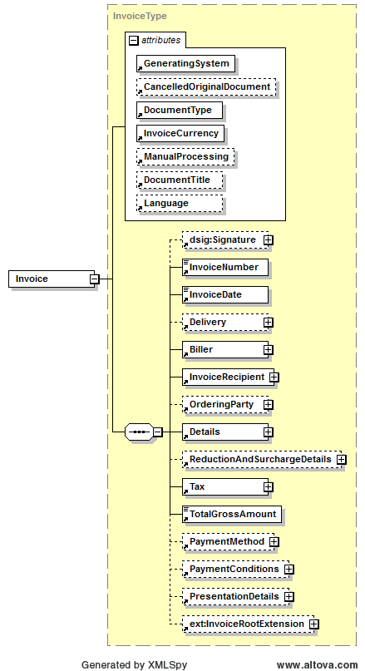

|  |  |  |  |  |
| --- | --- | --- | --- | --- |
| **Name** | **Meaning** | **Type** | **Card.** | **Format** |
| @GeneratingSystem | Name of the ERP/FIBU-System, which has generated the invoice | Attribute | 1..1 | xs:string |
| @CancelledOriginalDocument | Optional attribute for entering invoice cancellation. If another invoice is cancelled with this invoice, the number (Invoice-Number) of the cancelled invoice will be displayed in this attribute. | Attribute | 0..1 | AlphaNumIDType  max. 35 digits |
| @DocumentType | Is used to report the type of invoice. MUST be one of the following strings:   * Invoice, * FinalSettlement, * InvoiceForAdvancePayment, * InvoiceForPartialDelivery, * SubsequentCredit, * CreditMemo, * SubsequentDebit, * SelfBilling   *Note*: CreditMemo has the semantics of Invoice but SHOULD be used in case the TotalGrossAmount is negative. The relation of SubsequentDebit and SubsequentCredit is analogical. | Attribute | 1..1 | DocumentType-Type |
| @InvoiceCurrency | Explicit currency code for the invoice. All amounts of the invoice will be displayed in this currency. | Attribute | 1..1 | CurrencyType |
| @ManualProcessing | If this optional attribute is set to true the invoicing party signalizes that the invoice should be checked manually before automated processing is carried on. This is usually the case if side agreements have been made in the text fields. | Attribute | 0..1 | xs:boolean |
| @DocumentTitle | Document title: May be used to select a random title (i.e. "final settlement", etc.). | Attribute | 0..1 | xs:string |
| @Language | Language, in which the invoice is settled. | Attribute | 0..1 | LanguageType |
| dsig:Signature | This element has been preceded in his definition from W3C-XMLDSig [W3C02] and contains the signature of the electronic invoice. | Element | 0..1 | XML composite |
| InvoiceNumber | Invoice number, MUST be explicit and consecutive for each invoicing party and must be assigned only once by this invoicing party. | Element | 1..1 | AlphaNumIDType  max. 35 digits |
| InvoiceDate | Date of invoice | Element | 1..1 | xs:date |
| Delivery | Details of delivery, which is settled. This element MUST be used if there is only one delivery associated with the invoice. If several deliveries are settled, the element Invoice/ Details/ItemList/ListLineItem/ Delivery has to be used in each item row. | Element | 0..1 | XML composite |
| Biller | Details on invoicing party | Element | 1..1 | XML composite |
| InvoiceRecipient | Details on invoice recipient | Element | 1..1 | XML composite |
| OrderingParty | In case the invoice recipient is not equivalent to the ordering party of the delivery/service, information about the ordering party are to be entered in this element. | Element | 0..1 | XML composite |
| Details | Contains individual invoice items. | Element | 1..1 | XML composite |
| ReductionAndSurchargeDetails | Details of reduction or surcharges | Element | 0..1 | XML composite |
| Tax | Summary of value added tax and other taxes | Element | 1..1 | XML composite |
| TotalGrossAmount | Total gross invoice amount | Element | 1..1 | Decimal2Type |
| PaymentMethod | Offers a range for entering different payment methods. | Element | 0..1 | XML composite |
| PaymentConditions | Details of payment conditions such as discount or minimum amount, which is to be settled. | Element | 0..1 | XML composite |
| PresentationDetails | Details, which are relevant for displaying or printing the invoice. | Element | 0..1 | XML composite |
| InvoiceRootExtension | Element for integration of elements that are referenced in the InvoiceRootExtension element of the ebInterfaceExtension.xsd Schema or originate from another arbitrary namespace. | Element | 0..* | XML composite (defined in ebInterfaceExtension.xsd) |

***Example:***

<?xml version="1.0" encoding="UTF-8"?>

<Invoice n1:ManualProcessing="true" n1:DocumentTitle="Eine Rechnung" n1:Language="ger" n1:DocumentType="Invoice" n1:InvoiceCurrency="EUR" n1:GeneratingSystem="ERP System xyz" xsi:schemaLocation="http://www.ebinterface.at/schema/4p0/ http://www.ebinterface.at/schema/4p0/" xmlns="http://www.ebinterface.at/schema/4p0/" xmlns:n2="http://www.altova.com/samplexml/other-namespace" xmlns:n1="http://www.ebinterface.at/schema/4p0/" xmlns:ext="http://www.ebinterface.at/schema/4p0/extensions/ext" xmlns:sv="http://www.ebinterface.at/schema/4p0/extensions/sv" xmlns:dsig="http://www.w3.org/2000/09/xmldsig#" xmlns:xsi="http://www.w3.org/2001/XMLSchema-instance"> <InvoiceNumber>993433000298</InvoiceNumber>

<InvoiceDate>2011-09-20</InvoiceDate>

...

<TotalGrossAmount>1349.26</TotalGrossAmount>

...

</Invoice>

## Signature

The *Signature* element is OPTIONAL. The structure follows the W3C specification of XML-Signature Syntax and Processing (XMLDSig) [W3C02].

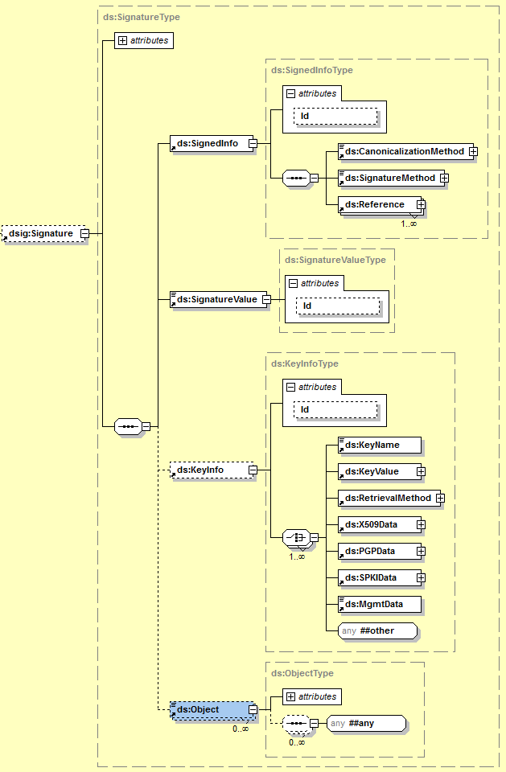

***Example:***

<ds:Signature xmlns:ds="http://www.w3.org/2000/09/xmldsig#">

<ds:SignedInfo>

<ds:CanonicalizationMethod

Algorithm="http://www.w3.org/TR/2001/REC-xml-c14n-20010315"/>

<ds:SignatureMethod

Algorithm="http://www.w3.org/2000/09/xmldsig#rsa-sha1"/>

<ds:Reference URI="">

<ds:Transforms>

<ds:Transform Algorithm=

"http://www.w3.org/2000/09/xmldsig#enveloped-signature"/>

<ds:Transform Algorithm="http://www.w3.org/TR/2001/

REC-xml-c14n-20010315#WithComments"/>

</ds:Transforms>

<ds:DigestMethod

Algorithm="http://www.w3.org/2000/09/xmldsig#sha1"/>

<ds:DigestValue>bi6Qy0MjrmN62eS2Xoi… </ds:DigestValue>

</ds:Reference>

</ds:SignedInfo>

<ds:SignatureValue>

OnXGLaP12+44gmOCWvooi3yaUo9RXW3IXToAs/g7idC2CsXGudb

YotK75S6j2F6YAlzEBhe7M/ky0qqoR6kY …

</ds:SignatureValue>

<ds:KeyInfo>

<ds:X509Data>

<ds:X509Certificate>

zQwDQYJKoZIhvcNAQEFBQAwVTEZMBcGA1UEA

xMQVGVzdCBDZXJ0F0ZTEUMBIGA1UEC…

</ds:X509Certificate>

</ds:X509Data>

<ds:KeyValue>

<ds:RSAKeyValue>

<ds:Modulus>

OqjmcRZh2dh4bsDooq0OGWxRD/sRaR1PqiO

A9o8KpzKdMgq9bY+oQIGXxEOO2…

</ds:Modulus>

<ds:Exponent>AQAB</ds:Exponent>

</ds:RSAKeyValue>

</ds:KeyValue>

</ds:KeyInfo>

</ds:Signature>

## Delivery

The *Delivery* element is OPTIONAL and consists of all necessary delivery details. In the *Delivery* element exactly one delivery date (*Date*) or delivery period (*Period*) MUST be entered. The element Invoice/Delivery MUST be used if there is only one delivery associated with the invoice. If several deliveries are settled, the element Invoice/Details/ItemList/ListLineItem/Delivery has to be used in each item row. In case Invoice/Delivery is entered and further in one item row the element Invoice/Details/ItemList/ListLineItem/Delivery, the latter takes precedence over the first mentioned.

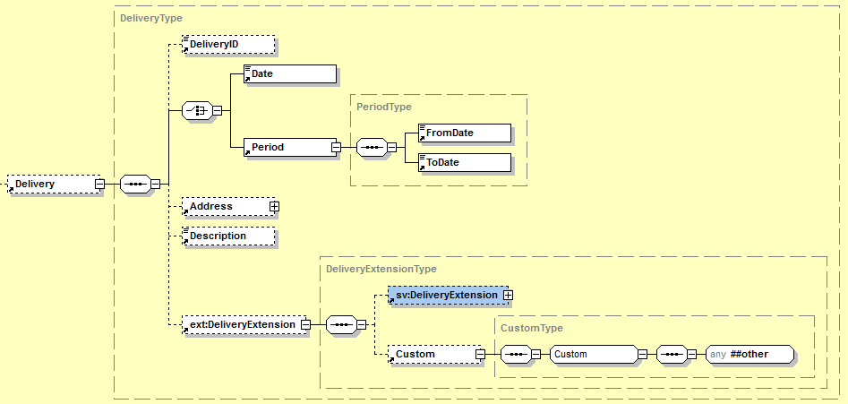

|  |  |  |  |  |
| --- | --- | --- | --- | --- |
| **Name** | **Meaning** | **Type** | **Card.** | **Format** |
| DeliveryID | Delivery number | Element | 0..1 | AlphaNumIDType  max. 35 digits |
| Date | Date of delivery (is used alternatively to delivery period) | Element | 1..1 | xs:date |
| Period | Delivery period (is used alternatively to date of delivery) | Element | 1..1 | XML composite |
| Period/FromDate | Beginning of delivery period | Element | 1..1 | xs:date |
| Period/ToDate | End of delivery period | Element | 1..1 | xs:date |
| Address | Details of delivery address. This address is only to be used if the delivery address is not equivalent to the invoice recipient’s address. | Element | 0..1 | XML composite |
| Description | Additional details of delivery in free text | Element | 0..1 | xs:string |
| DeliveryExtension | Element for integration of elements that are referenced in the DeliveryExtension element of the ebInterfaceExtension.xsd Schema or originate from another arbitrary namespace. | Element | 0..1 | XML composite (defined in ebInterfaceExtension.xsd) |

***Example 1 (Entering date of delivery):***

…

<Delivery>

<DeliveryID>Lieferung 2011/1</DeliveryID>

<Date>2011-09-20</Date>

<Address>

<AddressIdentifier  
 n1:AddressIdentifierType="GLN">9123456789013  
 </AddressIdentifier>

<Salutation>Firma</Salutation>

<Name>Mustermann GmbH</Name>

<Street>Hauptstraße 10</Street>

<Town>Graz</Town>

<ZIP>8020</ZIP>

<Country n1:CountryCode="AT">Österreich</Country>

<Contact>Hr. Max Mustermann</Contact>

</Address>

<Description>Lieferung wie Anfang September vereinbart.</Description>

<ext:DeliveryExtension>

<sv:DeliveryExtension>

<sv:SV_Domain_Specific_DeliveryExtensionElement>Ein von ebInterface standardisiertes Erweiterungselement

</sv:SV_Domain_Specific_DeliveryExtensionElement>

</sv:DeliveryExtension>

<ext:Custom>

<n2:auto-generated_for_wildcard>Irgendein beliebiges Erweiterungselement aus einem anderen Namespace

</n2:auto-generated_for_wildcard>

</ext:Custom>

</ext:DeliveryExtension>

</Delivery>

…

***Example 2 (Entering delivery period):***

…

<Delivery>

<DeliveryID>Lieferung 2011/1</DeliveryID>

<Period>

<FromDate>2011-09-15</FromDate>

<ToDate>2011-09-20</ToDate>

</Period>

<Address>

<AddressIdentifier   
 n1:AddressIdentifierType="GLN">9123456789013  
 </AddressIdentifier>

<Salutation>Firma</Salutation>

<Name>Mustermann GmbH</Name>

<Street>Hauptstraße 10</Street>

<Town>Graz</Town>

<ZIP>8020</ZIP>

<Country n1:CountryCode="AT">Österreich</Country>

<Contact>Hr. Max Mustermann</Contact>

</Address>

<Description>Lieferung wie Anfang September vereinbart.</Description>

<ext:DeliveryExtension>

<sv:DeliveryExtension>

<sv:SV_Domain_Specific_DeliveryExtensionElement>Ein von ebInterface standardisiertes Erweiterungselement</sv:SV_Domain_Specific_DeliveryExtensionElement>

</sv:DeliveryExtension>

<ext:Custom>

<n2:auto-generated_for_wildcard>Irgendein beliebiges Erweiterungselement aus einem anderen Namespace  
 </n2:auto-generated_for_wildcard>

</ext:Custom>

</ext:DeliveryExtension>

</Delivery>

…

### Address

The *Address* element is used to report various kind of address. If the *Address* element is entered, at least *Name*, *Street*, *Town, ZIP* and *Country* of the addressed enterprise or addressed person MUST be entered. The *AddressExtension* element SHOULD be used for additional details and information, which cannot be displayed in the remaining structure.

Note: The AddressExtension element is part of the ebInterface core scheme and will not be embedded from the ebInterfaceExtension.xsd scheme.

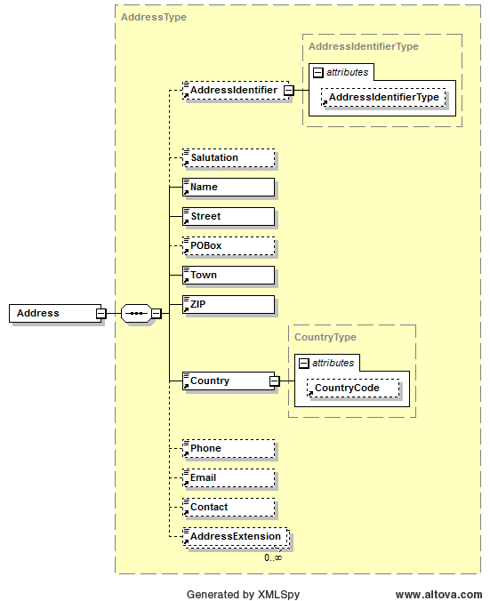

|  |  |  |  |  |
| --- | --- | --- | --- | --- |
| **Name** | **Meaning** | **Type** | **Card.** | **Format** |
| AddressIdentifier | Identifier for a certain address | Element | 0..1 | xs:string |
| AddressIdentifier/@AddressIdentifierType | Defines the type of the element AddressIdentifier | Attribute | 0..1 | AddressIdentifierTypeType |
| Salutation | Salutation | Element | 0..1 | xs:string |
| Name | Name of enterprise or person | Element | 1..1 | xs:string |
| Street | Street including house number | Element | 1..1 | xs:string |
| POBox | Post office box | Element | 0..1 | xs:string |
| Town | Town | Element | 1..1 | xs:string |
| ZIP | ZIP code | Element | 1..1 | xs:string |
| Country | Country (free text) | Element | 1..1 | XML composite |
| Country/  @CountryCode | ISO 3166-1 Code, which stands for an explicit identification of the element Country. | Attribute | 0..1 | CountryCodeType |
| Phone | Phone number | Element | 0..1 | xs:string |
| Email | Email-Address | Element | 0..1 | xs:string |
| Contact | Contact person or responsible department/unit | Element | 0..1 | xs:string |
| AddressExtension | Additional name or addition to address as free text | Element | 0..* | xs:string |

## Biller

The *Biller* element is mandatory. It consists of all details of the invoicing party   
(= supplying or providing enterprise).

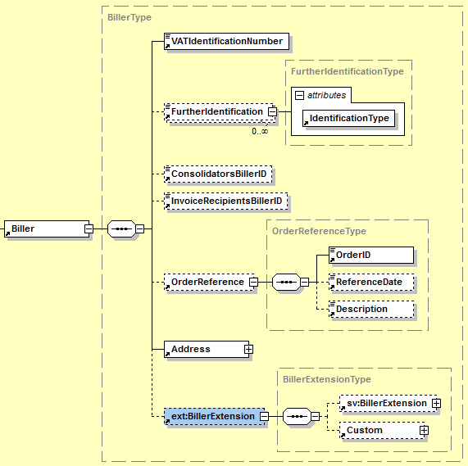

|  |  |  |  |  |
| --- | --- | --- | --- | --- |
| **Name** | **Means** | **Type** | **Card.** | **Format** |
| VATIdentification Number | Value Added Tax identification number (VAT) of invoicing party. In case the invoicing party has no value added tax identification number the string „00000000“(eight times the zero) has to be entered. „00000000“may also be entered, if the declaration of the VAT is not required by the Value Added Tax Act. | Element | 1..1 | xs:string |
| FurtherIdentification | For reporting further invoicing party-related identifications. | Element | 0..* | AlphaNumIDType  max. 35 digits |
| FurtherIdentification/@Identification-Type | Defines the kind of identification in free text form, e.g., commercial register number, court of justice, ARA number, DVR number | Attribute | 1..1 | xs:string |
| Consolidators  BillerID | Identification of invoicing party at Consolidator. | Element | 0..1 | AlphaNumIDType max. 35 digits |
| InvoiceRecipients  BillerID | Identification of invoicing party at invoice recipient | Element | 0..1 | AlphaNumIDType max. 35 digits |
| OrderReference | Order reference of underlying order assigned by invoicing party. This element is used if only one order is associated with the invoice. If several references to orders are applied, the element Invoice/Details/Item List/ListLineItem/Biller OrderReference has to be used for each item row. An invoice MAY also have no references to orders. | Element | 0..1 | XML composite |
| Address | Address of invoicing party  (*Note*: the structure of the element *Address*  is equivalent to structure shown in chapter 3.3.1) | Element | 1..1 | XML composite |
| BillerExtension | Element for integration of elements that are referenced in the InvoiceRootExtension element of the ebInterfaceExtension.xsd Schema or originate from another arbitrary namespace. | Element | 0..1 | XML composite (defined in ebInterfaceExtension.xsd) |

***Example:***

…

<Biller>

<VATIdentificationNumber>ATU51507409</VATIdentificationNumber>

<FurtherIdentification   
 n1:IdentificationType="DVR">0012345</FurtherIdentification>

<ConsolidatorsBillerID>CFF45KL</ConsolidatorsBillerID>

<InvoiceRecipientsBillerID>ID4456</InvoiceRecipientsBillerID>

<OrderReference>

<OrderID>OR3456</OrderID>

<ReferenceDate>2011-09-20</ReferenceDate>

<Description>Eingegangen per Fax.</Description>

</OrderReference>

<Address>

<AddressIdentifier   
 n1:AddressIdentifierType="ProprietaryAddressID">  
 AnyOtherProprietaryID

</AddressIdentifier>

<Name>Schrauben Willi</Name>

<Street>Lassallestraße 5</Street>

<Town>Wien</Town>

<ZIP>1020</ZIP>

<Country n1:CountryCode="AT">Österreich</Country>

<Phone>+43 / 1 / 78 56 789</Phone>

<Email>schraube@willi.at</Email>

<Contact>Sachbearbeiter Meier</Contact>

<AddressExtension>Zentrale Verwaltung Wien</AddressExtension>

</Address>

<ext:BillerExtension>

<sv:BillerExtension>

<sv:SV_Domain_Specific_BillerExtensionElement>Ein von ebInterface   
 standardisiertes Erweiterungselement  
 </sv:SV_Domain_Specific_BillerExtensionElement>

</sv:BillerExtension>

<ext:Custom>

<n2:auto-generated_for_wildcard>Irgendein beliebiges   
 Erweiterungselement aus einem anderen Namespace  
 </n2:auto-generated_for_wildcard>

</ext:Custom>

</ext:BillerExtension>

</Biller>

…

### OrderReference

The *OrderReference* element is OPTIONAL and consists of delivery details. This element is used if only one order is associated with the invoice. If several references to orders are applied, the element Invoice/Details/ItemList/ListLineItem/BillersOrderReference has to be used for each item row. An invoice MAY also not include references to orders.

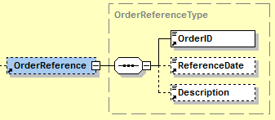

|  |  |  |  |  |
| --- | --- | --- | --- | --- |
| **Name** | **Meaning** | **Type** | **Card.** | **Format** |
| OrderID | Purchase number | Element | 1..1 | AlphaNumIDType max. 35 digits |
| ReferenceDate | Date of order | Element | 0..1 | xs:date |
| Description | Information about the order in free text. | Element | 0..1 | xs:string |

## InvoiceRecipient

The *InvoiceRecipient* element is mandatory and consists of details of the invoice recipient. The InvoiceRecipient is the party able to claim input tax deduction based on the invoice.

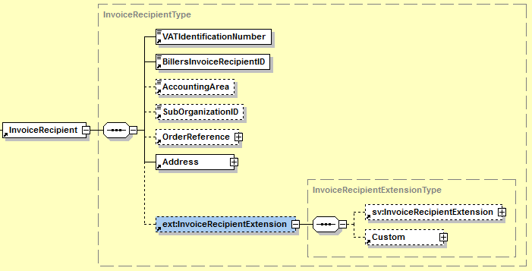

|  |  |  |  |  |
| --- | --- | --- | --- | --- |
| **Name** | **Meaning** | **Type** | **Card.** | **Format** |
| VATIdentificationNumber | Value added tax identification number (VAT) of invoice recipient. In case the invoice recipient has no value added tax identification number the string „00000000“ (eight times the zero) has to be entered. „00000000“may also be entered, if the declaration of the VAT is not required by the Value Added Tax Act. | Element | 1..1 | xs:string |
| BillersInvoice  RecipientID | Identification of invoice recipient by the invoicing party. | Element | 1..1 | AlphaNumIDType  max. 35 digits |
| AccountingArea | Reporting of the accounting area the invoice recipient. | Element | 0..1 | xs:string |
| SubOrganizationID | Reporting of a further internal reference by the invoice recipient. This could, for example, be a client number or an identification of a sub organizational unit. | Element | 0..1 | xs:string |
| OrderReference | Order reference of underlying order assigned by invoice recipient. This element is used if only one order is associated with the invoice. If several references to orders are used, the element Invoice/Details/Item List/ListLineItem/ InvoiceRecipientOrderReference has to be used for each item row. An invoice MAY also consist of no references to orders.  (*Note*: the structure of the *OrderReference* element is equivalent as shown in chapter 3.4.1) | Element | 0..1 | XML composite |
| Address | Address of invoice recipient  (*Note*: the structure of the *Address* element is equivalent as it is shown in chapter 3.3.1) | Element | 1..1 | XML composite |
| InvoiceRecipientsExtension | Element for integration of elements that are referenced in the InvoiceRecipientExtension element of the ebInterfaceExtension.xsd Schema or originate from another arbitrary namespace. | Element | 0..1 | XML composite (defined in ebInterfaceExtension.xsd) |

***Example:***

…

<InvoiceRecipient>

<VATIdentificationNumber>ATU18708634</VATIdentificationNumber>

<BillersInvoiceRecipientID>12345678</BillersInvoiceRecipientID>

<AccountingArea>BK372</AccountingArea>

<SubOrganizationID>2938</SubOrganizationID>

<OrderReference>

<OrderID>ID3456</OrderID>

<ReferenceDate>2011-09-20</ReferenceDate>

<Description>Bestellung per Fax.</Description>

</OrderReference>

<Address>

<AddressIdentifier   
 n1:AddressIdentifierType="ProprietaryAddressID">35354

</AddressIdentifier>

<Salutation>Firma</Salutation>

<Name>Mustermann GmbH</Name>

<Street>Haupstraße 10</Street>

<Town>Graz</Town>

<ZIP>8010</ZIP>

<Country n1:CountryCode="AT">Österreich</Country>

<Contact>Hr. Max Mustermann</Contact>

</Address>

<ext:InvoiceRecipientExtension>

<sv:InvoiceRecipientExtension>

<sv:SV_Domain_Specific_InvoiceRecipientExtensionElement>Ein von   
 ebInterface standardisiertes Erweiterungselement

</sv:SV_Domain_Specific_InvoiceRecipientExtensionElement>

</sv:InvoiceRecipientExtension>

<ext:Custom>

<n2:auto-generated_for_wildcard>Irgendein beliebiges

Erweiterungselement aus einem anderen Namespace

</n2:auto-generated_for_wildcard>

</ext:Custom>

</ext:InvoiceRecipientExtension>

</InvoiceRecipient>

…

## OrderingParty

The element *OrderingParty* is OPTIONAL and is used to report the ordering party, in case the party is not equivalent to the invoice recipient.

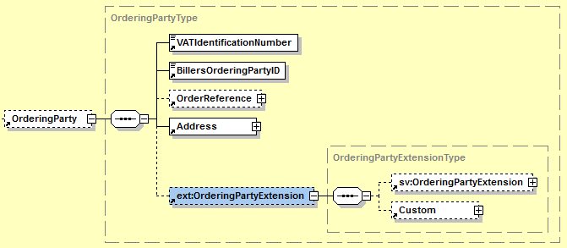

|  |  |  |  |  |
| --- | --- | --- | --- | --- |
| **Name** | **Meaning** | **Type** | **Card.** | **Format** |
| VATIdentificationNumber | Value added tax identification number (VAT) of ordering party. In case the invoice recipient has no value added tax identification number the string „00000000“ (eight times the zero) has to be entered. „00000000“may also be entered, if the declaration of the VAT is not required by the Value Added Tax Act. | Element | 1..1 | xs:string |
| BillersOrderingPartyID | Identification of ordering party at the invoicing party. | Element | 1..1 | AlphaNumIDType  max. 35 digits |
| OrderReference | Order reference of underlying order assigned by ordering party.  (*Note:* the structure of the element *OrderReference* is equivalent as shown in chapter 3.4.1) | Element | 0..1 | XML composite |
| Address | Address of the ordering party  (*Note:* the structure of the element *Address* is equivalent as it is shown in chapter 3.3.1) | Element | 1..1 | XML composite |
| OrderingPartyExtension | Element for integration of elements that are referenced in the OrderingPartyExtension element of the ebInterfaceExtension.xsd Schema or originate from another arbitrary namespace. | Element | 0..1 | XML composite (defined in ebInterfaceExtension.xsd) |

***Example:***

…

<OrderingParty>

<VATIdentificationNumber>00000000</VATIdentificationNumber>

<BillersOrderingPartyID>98765432</BillersOrderingPartyID>

<OrderReference>

<OrderID>558741</OrderID>

<ReferenceDate>2011-09-20</ReferenceDate>

<Description>Per Fax empfangen.</Description>

</OrderReference>

<Address>

<AddressIdentifier   
 n1:AddressIdentifierType="ProprietaryAddressID">  
 OI393K3

</AddressIdentifier>

<Name>Der Dritte Mann GmbH</Name>

<Street>Lassallestraße 7</Street>

<POBox>Wien</POBox>

<Town>Wien</Town>

<ZIP>1020</ZIP>

<Country n1:CountryCode="AT">Österreich</Country>

</Address>

<ext:OrderingPartyExtension>

<sv:OrderingPartyExtension>

<sv:SV_Domain_Specific_OrderingPartyExtensionElement>Ein von

ebInterface standardisiertes Erweiterungselement

</sv:SV_Domain_Specific_OrderingPartyExtensionElement>

</sv:OrderingPartyExtension>

<ext:Custom>

<n2:auto-generated_for_wildcard>Irgendein beliebiges

Erweiterungselement aus einem anderen Namespace

</n2:auto-generated_for_wildcard>

</ext:Custom>

</ext:OrderingPartyExtension>

</OrderingParty>

…

## Details

The *Details* element is mandatory and consists of all details of invoiced items or services.

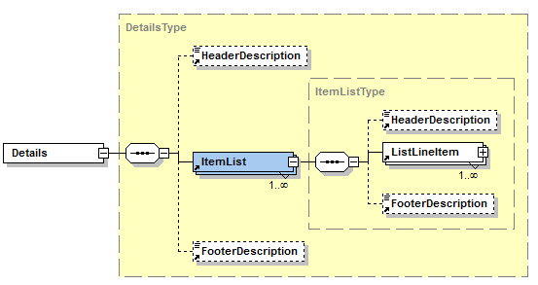

|  |  |  |  |  |
| --- | --- | --- | --- | --- |
| **Name** | **Meaning** | **Type** | **Card.** | **Format** |
| Header Description | Header of billing details in free text | Element | 0..1 | xs:string |
| ItemList | The invoiced positions can be classified in several sections. Each ItemList element contains a section. | Element | 1..* | XML composite |
| ItemList/Header Description | Header of particular section in free text | Element | 0..1 | xs:string |
| ItemList/ListLine Item | This element complies with a position line. | Element | 1..* | XML composite |
| ItemList/Footer Description | Footer of particular section in free text | Element | 0..1 | xs:string |
| Footer Description | Footer of billing details in free text | Element | 0..1 | xs:string |

***Example:***

…

<Details>

<HeaderDescription>Wir stellen Ihnen folgende Leistungen in   
 Rechnung.

</HeaderDescription>

<ItemList>

<HeaderDescription>Aus unserer Schrauben-Abteilung:</HeaderDescription>

<ListLineItem>

<PositionNumber>1</PositionNumber>

<Description>Schraubenzieher</Description>

<ArticleNumber   
 n1:ArticleNumberType="BillersArticleNumber">I3939

</ArticleNumber>

<ArticleNumber   
 n1:ArticleNumberType="InvoiceRecipientsArticleNumber">E3949  
 </ArticleNumber>

<ArticleNumber   
 n1:ArticleNumberType="GTIN">00012345678905  
 </ArticleNumber>

<Quantity n1:Unit="Units">100.00</Quantity>

<UnitPrice>10.20</UnitPrice>

<TaxRate n1:TaxCode="AT022">20.00</TaxRate>

<AdditionalInformation>

<SerialNumber>124302393</SerialNumber>

<ChargeNumber>CN393</ChargeNumber>

<Weight n1:Unit="kilogram">5</Weight>

<Boxes>2</Boxes>

</AdditionalInformation>

<LineItemAmount>1020.00</LineItemAmount>

<ext:ListLineItemExtension>

<sv:ListLineItemExtension>

<sv:SV_Domain_Specific_ListLineItemExtensionElement>Ein von

ebInterface standardisiertes Erweiterungselement

</sv:SV_Domain_Specific_ListLineItemExtensionElement>

</sv:ListLineItemExtension>

<ext:Custom>

<n2:auto-generated_for_wildcard>Irgendein beliebiges

Erweiterungselement aus einem anderen Namespace

</n2:auto-generated_for_wildcard>

</ext:Custom>

</ext:ListLineItemExtension>

</ListLineItem>

</ItemList>

<ItemList>

<HeaderDescription>Aus unserer Buch-Abteilung:</HeaderDescription>

<ListLineItem>

<PositionNumber>1</PositionNumber>

<Description>Handbuch zur Schraube</Description>

<ArticleNumber   
 n1:ArticleNumberType="BillersArticleNumber">K34838  
 </ArticleNumber>

<ArticleNumber   
 n1:ArticleNumberType="InvoiceRecipientsArticleNumber">E4938  
 </ArticleNumber>

<ArticleNumber   
 n1:ArticleNumberType="GTIN">00012345678897

</ArticleNumber>

<Quantity n1:Unit="Units">1.00</Quantity>

<UnitPrice>5.00</UnitPrice>

<TaxRate n1:TaxCode="AT022">10.00</TaxRate>

<LineItemAmount>5.00</LineItemAmount>

<ext:ListLineItemExtension>

<sv:ListLineItemExtension>   
 <sv:SV_Domain_Specific_ListLineItemExtensionElement>Ein von

ebInterface standardisiertes Erweiterungselement

</sv:SV_Domain_Specific_ListLineItemExtensionElement>

</sv:ListLineItemExtension>

<ext:Custom>

<n2:auto-generated_for_wildcard>Irgendein beliebiges

Erweiterungselement aus einem anderen Namespace

</n2:auto-generated_for_wildcard>

</ext:Custom>

</ext:ListLineItemExtension>

</ListLineItem>

</ItemList>

<FooterDescription>Wir danken für Ihren Auftrag</FooterDescription>

</Details>

…

### ListLineItem

The ListLineItem is used to report details within a position line.

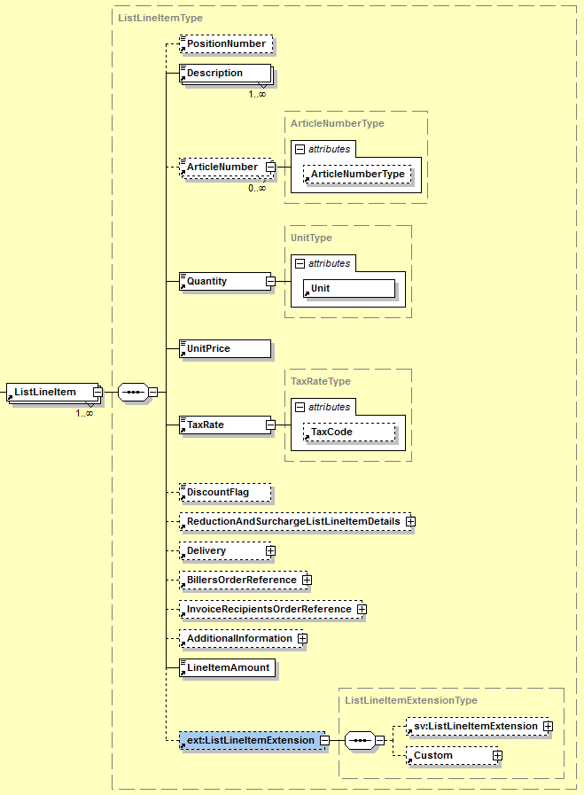

|  |  |  |  |  |
| --- | --- | --- | --- | --- |
| **Name** | **Meaning** | **Type** | **Card.** | **Format** |
| PositionNumber | Consecutive position number | Element | 0..1 | xs:positiveInteger |
| Description | Commercial description of item or service | Element | 1..* | xs:string |
| ArticleNumber | Article number | Element | 0..* | xs:string |
| ArticleNumber/  @ArticleNumberType | Defines the type of article number | Attribute | 0..1 | ArticleNumberType |
| Quantity | Invoiced quantity. In case of reporting further quantity, this should be entered in the element AdditionalInformation/ AlternativeQuantity. | Element | 1..1 | Decimal4Type |
| Quantity/@Unit | Quantity unit in free text | Attribute | 1..1 | xs:string |
| UnitPrice | Unit price (net) | Element | 1..1 | Decimal4Type |
| TaxRate | Value added tax rate | Element | 1..1 | PercentageType |
| TaxRate/@TaxCode | „AT“+UVACode. ATXXX is equivalent to not taxable. The particular UVA Codes should be taken from the U30 form of the Federal Ministry of Finance [BMF11]. The reporting of TaxCodes is only of informative character. The reporting of the tax rate in the field „Tax Rate“is normative. | Attribute | 0..1 | TaxCodeType |
| DiscountFlag | Defines whether or not the invoice line item is qualified for discount. | Element | 0..1 | xs:boolean |
| ReductionAndSurchargeListLineItemDetails | This field is used to report reductions or surcharges to the invoice line item. | Element | 0..1 | XML composite |
| Delivery | Reporting of delivery details of this invoice line item. (*Note*: the structure of the element *Delivery* is equivalent to chapter 3.3) | Element | 0..1 | XML composite |
| BillersOrderReference | Reference of underlying order or order item assigned by invoicing party.  (*Note*: In case this element is used, it takes precedence over a potential entry in *Invoice/Biller/Order-Reference*). | Element | 0..1 | XML composite |
| BillersOrderReference/OrderID | Purchase order number at invoicing party. | Element | 1..1 | AlphaNumIDType  max. 35 digits |
| BillersOrderReference/OrderPositionNumber | Order position number of order at invoicing party | Element | 0..1 | AlphaNumType |
| InvoiceRecipientsOrderReference | Reference of underlying order or order item assigned by invoice recipient (or ordering party eventually).  (*Note*: In case this element is used, it takes precedence over a potential reporting in *Invoice/InvoiceRecipient/ OrderReference* or *Invoice/Ordering-Party/OrderReference*). | Element | 0..1 | XML composite |
| InvoiceRecipientsOrderReference/Order ReferenceOrderID | Purchase number at invoice recipient | Element | 1..1 | AlphaNumType  max. 35 digits |
| InvoiceRecipientsOrderReference/Order PositionNumber | Order position number of order at invoice recipient | Element | 0..1 | AlphaNumType |
| AdditionalInformation | Additional information about invoiced item or service | Element | 0..1 | XML composite |
| LineItemAmount | Invoice line item amount (net) | Element | 1..1 | Decimal2Type |
| ListLineItemExtension | Element for integration of elements referenced in the ListLineItemExtension element of the ebInterfaceExtension.xsd Schema or originate from another arbitrary namespace. | Element | 0..1 | XML composite (defined in ebInterfaceExtension.xsd) |

#### ReductionAndSurchargeListLineItemDetails

The element ReductionAndSurchargeListLineItemDetails is OPTIONAL. It is used to report one or several reductions or to report one or several surcharges, respectively. The entered reductions or surcharges only refer to the particular invoice line (ListLineItem).

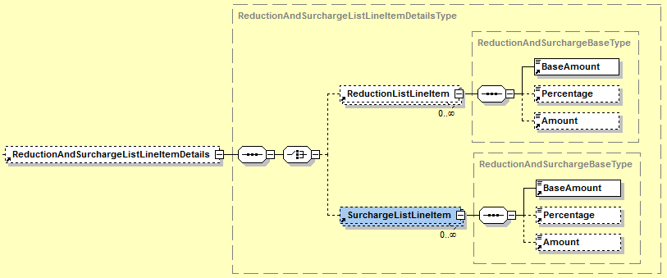

|  |  |  |  |  |
| --- | --- | --- | --- | --- |
| **Name** | **Meaning** | **Type** | **Card.** | **Format** |
| ReductionListLineItem | Details of reduction | Element | 0..* | XML composite |
| ReductionListLineItem /BaseAmount | Defines the base amount, to which the reduction refers | Element | 1..1 | Decimal2Type |
| ReductionListLineItem /Percentage | Percentage of granted reduction | Element | 0..1 | PercentageType |
| ReductionListLineItem /Amount | Amount of granted reduction. Usually defines itself by BaseAmount × Percentage. In case an amount is entered, there is no need entering a percentage (but can be entered). In case both are entered, Amount is prior-ranked. | Element | 0..1 | Decimal2Type |
| SurchargeListLineItem | Details of surcharge | Element | 0..* | XML composite |
| SurchargeListLineItem/BaseAmount | Defines the base amount, to which the surcharge refers | Element | 1..1 | Decimal2Type |
| SurchargeListLineItem/Percentage | Percentage of surcharge | Element | 0..1 | PercentageType |
| SurchargeListLineItem/Amount | Amount of surcharge. Usually defines itself by BaseAmount × Percentage. In case an amount is entered, there is no need entering a percentage (but can be entered). In case both are entered, Amount is prior-ranked. | Element | 0..1 | Decimal2Type |

#### AdditionalInformation

The element AdditionalInformation is OPTIONAL and consists of further details of the particular position line in the invoice.

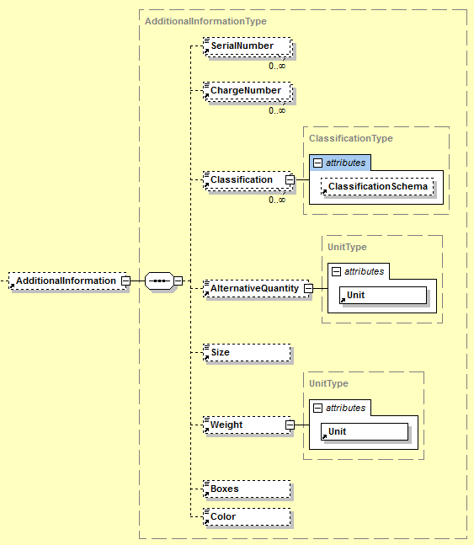

|  |  |  |  |  |
| --- | --- | --- | --- | --- |
| **Name** | **Meaning** | **Type** | **Card.** | **Format** |
| SerialNumber | Serial number | Element | 0..* | AlphaNumType |
| ChargeNumber | Charge number | Element | 0..* | AlphaNumType |
| Classification | Code of delivered item or service in accordance with a classification scheme | Element | 0..* | xs:string |
| Classification/ @ClassificationSchema | Classification scheme in free text | Attribute | 0..1 | xs:string |
| AlternativeQuantity | An alternative quantity reporting, additionally to ListLineItem/Quantity | Element | 0..1 | Decimal4Type |
| AlternativeQuantity/ @Unit | Quantity unit | Attribute | 0..1 | xs:string |
| Size | Size | Element | 0..1 | AlphaNumType |
| Weight | Weight | Element | 0..1 | Decimal4Type |
| Weight/@Unit | Weight unit | Attribute | 1..1 | xs:string |
| Boxes | Amount of boxes or containers | Element | 0..1 | xs:positiveInteger |
| Color | Color | Element | 0..1 | xs:string |

## ReductionAndSurchargeDetails

The element ReductionAndSurchargeDetails is OPTIONAL. It is used to report one or several reductions or to report one or several surcharges, respectively.

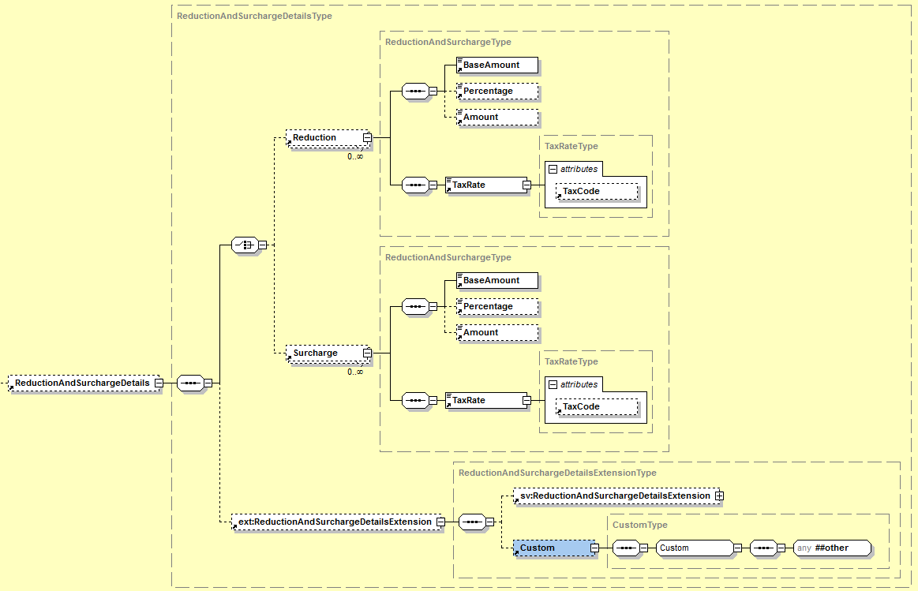

|  |  |  |  |  |
| --- | --- | --- | --- | --- |
| **Name** | **Meaning** | **Type** | **Card.** | **Format** |
| Reduction | Details of reduction | Element | 0..* | XML composite |
| Reduction/BaseAmount | Defines the base amount, to which the reduction refers. | Element | 1..1 | Decimal2Type |
| Reduction/Percentage | Percentage of granted reduction | Element | 0..1 | PercentageType |
| Reduction/Amount | Amount of granted reduction. Usually defines itself by BaseAmount × Percentage. In case an amount is entered, there is no need entering a percentage (but can be entered). In case both are entered, Amount is prior-ranked. | Element | 0..1 | Decimal2Type |
| Reduction/TaxRate | Value added tax rate of underlying articles or services. | Element | 1..1 | PercentageType |
| Reduction/TaxRate/ @TaxCode | „AT“+UVACode. ATXXX is equivalent to not taxable. The particular UVA Codes should be taken from the U30 form of the Federal Ministry of Finance [BMF11]. The reporting of TaxCodes is only of informative character. The reporting of the tax rate in the field „Tax Rate“is normative. | Attribute | 0..1 | TaxCodeType |
| Surcharge | Details on surcharge | Element | 0..* | XML composite |
| Surcharge/BaseAmount | Defines the base amount, to which the surcharge refers. | Element | 1..1 | Decimal2Type |
| Surcharge/Percentage | Percentage of surcharge | Element | 0..1 | PercentageType |
| Surcharge/Amount | Amount of granted reduction. Usually defines itself by BaseAmount × Percentage. In case an amount is entered, there is no need entering a percentage (but can be entered). In case both are entered, Amount is prior-ranked. | Element | 0..1 | Decimal2Type |
| Surcharge/TaxRate | Value added tax rate of underlying articles or services. | Element | 1..1 | PercentageType |
| Surcharge/TaxRate/ @TaxCode | „AT“+UVACode. ATXXX is equivalent to not taxable. The particular UVA Codes should be taken from the U30 form of the Federal Ministry of Finance [BMF11]. The reporting of TaxCodes is only of informative character. The reporting of the tax rate in the field „Tax Rate“ is normative. | Attribute | 0..1 | TaxCodeType |
| ReductionAndSurchargeDetailsExtension | Element for integration of elements that are referenced in the ReductionAndSurchargeDetailsExtension element of the ebInterfaceExtension.xsd Schema or originate from another arbitrary namespace. | Element | 0..1 | XML composite (defined in ebInterfaceExtension.xsd) |

***Example:***

…

<ReductionAndSurchargeDetails>

<Reduction>

<BaseAmount>1020.00</BaseAmount>

<Percentage>1.00</Percentage>

<Amount>10.20</Amount>

<TaxRate n1:TaxCode="AT022">20.00</TaxRate>

</Reduction>

<Surcharge>

<BaseAmount>1020.00</BaseAmount>

<Percentage>0.5</Percentage>

<Amount>5.10</Amount>

<TaxRate n1:TaxCode="AT022">20</TaxRate>

</Surcharge>

<ext:ReductionAndSurchargeDetailsExtension>

<sv:ReductionAndSurchargeDetailsExtension>   
 <sv:SV_Domain_Specific_ReductionAndSurchargeDExtensionElement>  
 Ein von ebInterface standardisiertes Erweiterungselement

</sv:SV_Domain_Specific_ReductionAndSurchargeDxtensionElement>

</sv:ReductionAndSurchargeDetailsExtension>

<ext:Custom>

<n2:auto-generated_for_wildcard>Irgendein beliebiges

Erweiterungselement aus einem anderen Namespace

</n2:auto-generated_for_wildcard>

</ext:Custom>

</ext:ReductionAndSurchargeDetailsExtension>

</ReductionAndSurchargeDetails>

…

## Tax

The *Tax* element is mandatory and is used for description and summary of any taxes (i.e. Value added tax)

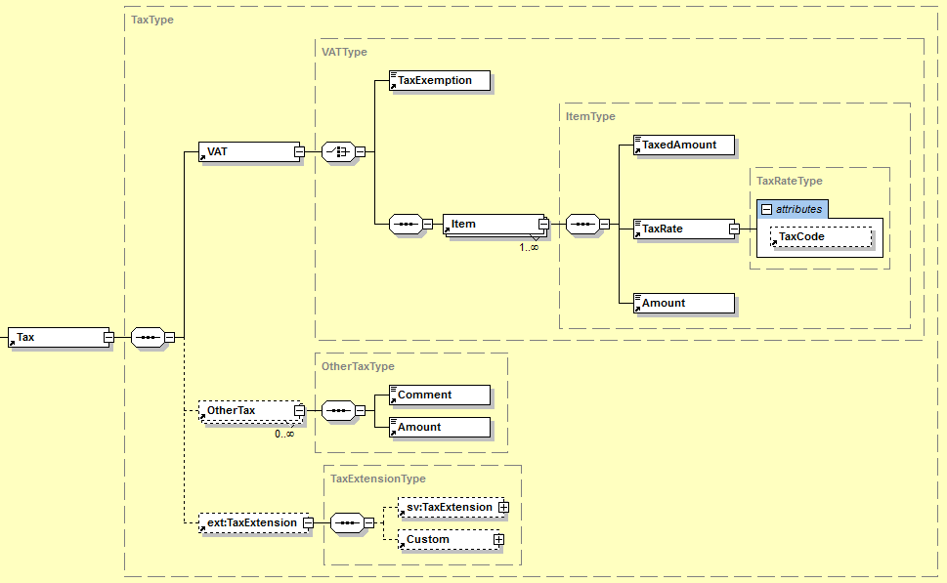

|  |  |  |  |  |
| --- | --- | --- | --- | --- |
| **Name** | **Meaning** | **Type** | **Card.** | **Format** |
| VAT | Is used to report the value added tax or for explicit marking of value added tax exemption. | Element | 1..1 | XML composite |
| VAT/ TaxExemption | The element TaxExemption is used to signalize a value added tax exemption. The reason for tax exemption is to be entered as value. The element is only used alternatively to the VAT/Item. | Element | 1..1 | xs:string |
| VAT/Item | Line of tax summary. Is used to display several, different VAT rates. Is used alternatively to VAT/TaxExemption. | Element | 1..* | XML composite |
| VAT/Item/  TaxedAmount | Base amount, to which the tax refers | Element | 1..1 | Decimal2Type |
| VAT/Item/  TaxRate | Tax rate of the respective articles or services | Element | 1..1 | PercentageType |
| VAT/Item/TaxRate/@TaxCode | „AT“+UVACode. ATXXX is equivalent to not taxable. The particular UVA Codes should be taken from the U30 form of the Federal Ministry of Finance [BMF11]. The reporting of TaxCodes is only of informative character. The reporting of the tax rate in the field „Tax Rate“ is normative. | Attribute | 0..1 | TaxCodeType |
| VAT/Item/Amount | Tax amount. Usually defines itself by TaxedAmount × TaxedRate/100. | Element | 1..1 | Decimal2Type |
| OtherTax | Element to report other taxes. | Element | 0..* | XML composite |
| OtherTax/ Comment | Reporting kind of other tax in free text | Element | 1..1 | xs:string |
| OtherTax/Amount | Amount of other tax | Element | 1..1 | Decimal2Type |
| TaxExtension | Element for integration of elements that are referenced in the TaxExtension element of the ebInterfaceExtension.xsd Schema or originate from another arbitrary namespace. | Element | 0..1 | XML composite (defined in ebInterfaceExtension.xsd) |

***Example:***

…

<Tax>

<VAT>

<Item>

<TaxedAmount>1130.00</TaxedAmount>

<TaxRate n1:TaxCode="AT022">20.00</TaxRate>

<Amount>226.00</Amount>

</Item>

<Item>

<TaxedAmount>5.00</TaxedAmount>

<TaxRate n1:TaxCode="AT022">10.00</TaxRate>

<Amount>0.50</Amount>

</Item>

</VAT>

<OtherTax>

<Comment>Eine andere Steuer</Comment>

<Amount>10.00</Amount>

</OtherTax>

<ext:TaxExtension>

<sv:TaxExtension>

<sv:SV_Domain_Specific_TextExtensionElement>Ein von

ebInterface standardisiertes Erweiterungselement

</sv:SV_Domain_Specific_TextExtensionElement>

</sv:TaxExtension>

<ext:Custom>

<n2:auto-generated_for_wildcard>Irgendein beliebiges

Erweiterungselement aus einem anderen Namespace

</n2:auto-generated_for_wildcard>

</ext:Custom>

</ext:TaxExtension>

</Tax>

…

## PaymentMethod

The *PaymentMethod* element is OPTIONAL and shows how the invoice should be settled. The following payment options are available at the moment:

|  |  |
| --- | --- |
| *UniversalBankTransaction*: | payment by bank transfer or using a consolidator platform |
| *DirectDebit*: | payment using direct debiting |
| *NoPayment* | no payment |

All three payment options inherit from the element PaymentMethod.

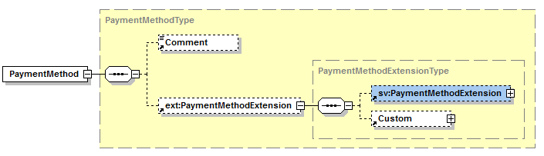

|  |  |  |  |  |
| --- | --- | --- | --- | --- |
| **Name** | **Meaning** | **Type** | **Card.** | **Format** |
| Comment | Comment to payment option | Element | 0..1 | xs:string |
| PaymentMethodExtension | Element for integration of elements referenced in the PaymentMethodExtension element of the ebInterfaceExtension.xsd Schema or originate from another arbitrary namespace. | Element | 0..1 | XML composite (defined in ebInterfaceExtension.xsd) |

### UniversalBankTransaction

The usage of UniversalBankTransaction provides details about payment by bank transfer or by using a payment consolidator platform.

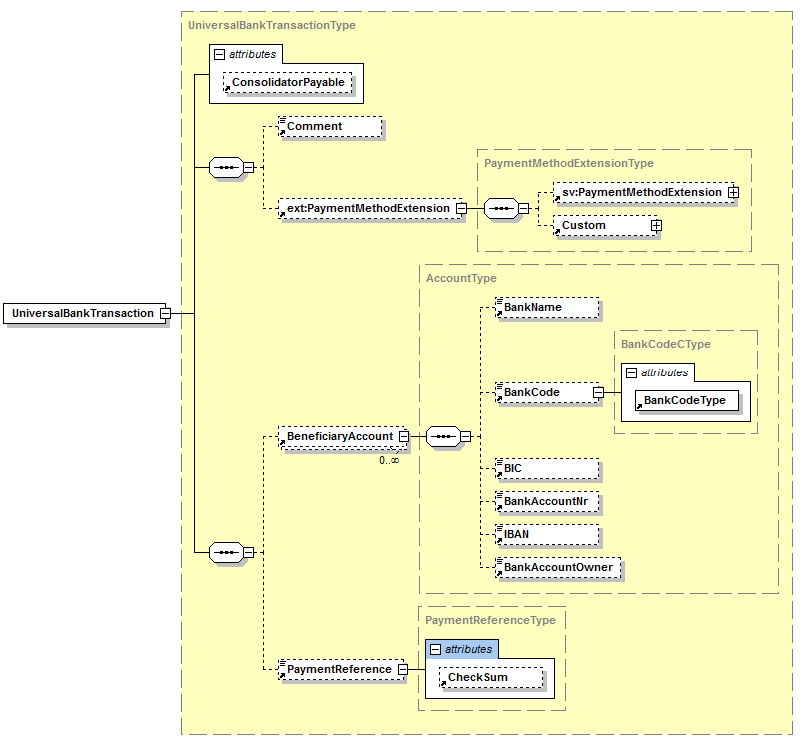

|  |  |  |  |  |
| --- | --- | --- | --- | --- |
| **Name** | **Meaning** | **Type** | **Card.** | **Format** |
| @Consolidator-Payable | This attribute is used to operate a payment on a consolidator platform. In case the attribute is set on “true“, the payment of an invoice on a consolidator platform is possible. The default value is “false“. | Attribute | 0..1 | xs:boolean |
| Comment | Comment to payment option | Element | 0..1 | xs:string |
| PaymentMethodExtension | Element for integration of elements that are referenced in the PaymentMethodExtension element of the ebInterfaceExtension.xsd Schema or originate from another arbitrary namespace. | Element | 0..1 | XML composite (defined in ebInterfaceExtension.xsd) |
| Beneficiary  Account | Account of beneficiary | Element | 0..* | XML composite |
| Beneficiary  Account/  BankName | Bank name | Element | 0..1 | xs:string  max. 255 digits |
| Beneficiary  Account/  BankCode | Bank code | Element | 0..1 | xs:integer |
| Beneficiary  Account/  BankCode/  @BankCodeType | Defines the type of bank code by additionally stating the country of bank code comes from. | Attribute | 1..1 | CountryCode  Type |
| Beneficiary  Account/BIC | Bank Identification Code (BIC) | Element | 0..1 | BICType |
| Beneficiary  Account/  BankAccountNr | Account number | Element | 0..1 | xs:string |
| Beneficiary  Account/IBAN | International Bank Account Number (IBAN) | Element | 0..1 | IBANType |
| Beneficiary  Account/  BankAccount  Owner | Name of account owner | Element | 0..1 | xs:string  max. 70 digits |
| PaymentReference | Payment reference (customer data), which is used for automated booking of payment entry. The respective obligations of Stuzza[1] are to be considered. | Element | 0..1 | Digit12Type, maximum numeric digits |
| PaymentReference/@CheckSum | Check sum for payment reference | Attribute | 0..1 | CheckSumType  One-digit string with allowed values 0-9 and X |

***Example:***

…

<PaymentMethod xsi:type="UniversalBankTransactionType">

<Comment>String</Comment>

<ext:PaymentMethodExtension>

<sv:PaymentMethodExtension>

<sv:SV_Domain_Specific_PaymentMethodExtensionElement>Ein von

ebInterface standardisiertes Erweiterungselement  
 </sv:SV_Domain_Specific_PaymentMethodExtensionElement>

</sv:PaymentMethodExtension>

<ext:Custom>

<n2:auto-generated_for_wildcard>Irgendein beliebiges

Erweiterungselement aus einem anderen Namespace  
 </n2:auto-generated_for_wildcard>

</ext:Custom>

</ext:PaymentMethodExtension>

<BeneficiaryAccount>

<BankName>Bank Austria</BankName>

<BankCode n1:BankCodeType="AT">12000</BankCode>

<BIC>BKAUATWW</BIC>

<BankAccountNr>11111111111</BankAccountNr>

<IBAN>AT491200011111111111</IBAN>

<BankAccountOwner>Max Mustermann</BankAccountOwner>

</BeneficiaryAccount>

<PaymentReference n1:CheckSum="X">123456789012</PaymentReference>

</PaymentMethod>

…

### DirectDebit

The declaration of DirectDebit shows that the invoice is settled using direct debiting. The element DirectDebit extends the generic type PaymentMethod, but does not add any new elements or attributes.

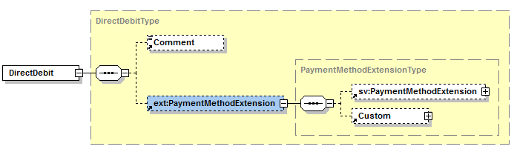

***Example:***

…

<PaymentMethod xsi:type="DirectDebitType">

<Comment>Der Rechnungsbetrag wird per Bankeinzug am 03.10.2011   
 belastet

</Comment>

<ext:PaymentMethodExtension>

<sv:PaymentMethodExtension>

<sv:SV_Domain_Specific_PaymentMethodExtensionElement>Ein von

ebInterface standardisiertes Erweiterungselement

</sv:SV_Domain_Specific_PaymentMethodExtensionElement>

</sv:PaymentMethodExtension>

<ext:Custom>

<n2:auto-generated_for_wildcard>Irgendein beliebiges

Erweiterungselement aus einem anderen Namespace

</n2:auto-generated_for_wildcard>

</ext:Custom>

</ext:PaymentMethodExtension>

</PaymentMethod>

…

### NoPayment

The declaration of NoPayment shows that no payment of the invoice should be effected. The element NoPayment extends the generic type PaymentMethod, but does not add any new elements or attributes.

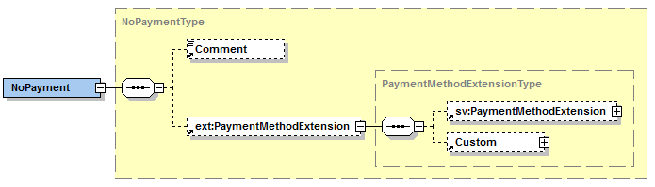

***Example:***

…

<PaymentMethod xsi:type="NoPaymentType">

<Comment>Bitte nicht einzahlen</Comment>

<ext:PaymentMethodExtension>

<sv:PaymentMethodExtension>

<sv:SV_Domain_Specific_PaymentMethodExtensionElement>Ein von

ebInterface standardisiertes Erweiterungselement

</sv:SV_Domain_Specific_PaymentMethodExtensionElement>

</sv:PaymentMethodExtension>

<ext:Custom>

<n2:auto-generated_for_wildcard>Irgendein beliebiges

Erweiterungselement aus einem anderen Namespace

</n2:auto-generated_for_wildcard>

</ext:Custom>

</ext:PaymentMethodExtension>

</PaymentMethod>

…

## PaymentConditions

The element PaymentConditions CAN be used to report details of payment conditions of the invoice.

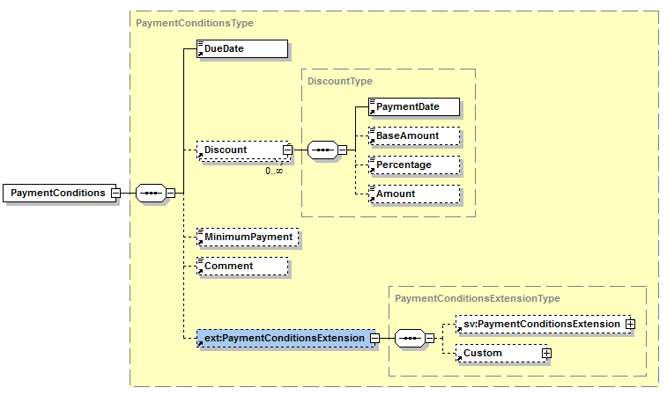

|  |  |  |  |  |
| --- | --- | --- | --- | --- |
| **Name** | **Meaning** | **Type** | **Card.** | **Format** |
| DueDate | Due date | Element | 1..1 | xs:date |
| Discount | Discount | Element | 0..* | XML composite |
| Discount/  PaymentDate | Latest date for use of percentage of discount | Element | 1..1 | xs:date |
| Discount/  BaseAmount | In case the discount does not refer to the entire gross amount, the discount-relevant base amount is entered in this element. | Element | 0..1 | Decimal2Type |
| Discount/  Percentage | Percentage of discount | Element | 0..1 | PercentageType |
| Discount/  Amount | Amount of discount. In case an amount is entered, there is no need entering a percentage (but can be entered). In case both are entered, Amount is prior-ranked. | Element | 0..1 | Decimal2Type |
| Minimum-Payment | In case the invoice should not be settled completely on the due date, this element is used to enter a minimum amount, which is to be settled on the due date. | Element | 0..1 | Decimal2Type |
| Comment | Comment to the payment conditions in free text | Element | 0..1 | xs:string |
| PaymentConditionsExtension | Element for integration of elements that are referenced in the PaymentConditionsExtension element of the ebInterfaceExtension.xsd Schema or originate from another arbitrary namespace. | Element | 0..1 | XML composite (defined in ebInterfaceExtension.xsd) |

***Example:***

…

<PaymentConditions>

<DueDate>2011-09-30</DueDate>

<Discount>

<PaymentDate>2011-09-25</PaymentDate>

<BaseAmount>1349.26</BaseAmount>

<Percentage>3.00</Percentage>

<Amount>40.48</Amount>

</Discount>

<MinimumPayment>512.00</MinimumPayment>

<Comment>Kommentar zu den Zahlungsbedingungen</Comment>

<ext:PaymentConditionsExtension>

<sv:PaymentConditionsExtension> <sv:SV_Domain_Specific_PaymentConditionsExtensionElement>Ein von  
 ebInterface standardisiertes Erweiterungselement

</sv:SV_Domain_Specific_PaymentConditionsExtensionElement>

</sv:PaymentConditionsExtension>

<ext:Custom>

<n2:auto-generated_for_wildcard>Irgendein beliebiges

Erweiterungselement aus einem anderen Namespace

</n2:auto-generated_for_wildcard>

</ext:Custom>

</ext:PaymentConditionsExtension>

</PaymentConditions>

…

## PresentationDetails

The *PresentationDetails* element CAN be used to process the layout (aka rendering) of printed version of invoice.

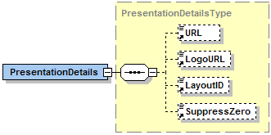

|  |  |  |  |  |
| --- | --- | --- | --- | --- |
| **Name** | **Meaning** | **Type** | **Card.** | **Format** |
| URL | Link underlying the logo. | Element | 0..1 | xs:anyURI |
| LogoURL | URL of the corporate symbol for heading: The logo may be hosted on the server and, therefore, is available with the billing data at the same time. Optionally, the URL can refer to any picture generally displayable in a browser. . | Element | 0..1 | xs:anyURI |
| LayoutID | LayoutID defines which layout is used to display the billing details. | Element | 0..1 | AlphaNumType max. 35 digits |
| SuppressZero | Defines whether or not an invoice amount of 0 should be displayed. | Element | 0..1 | xs:boolean |

***Example:***

…

<eb:PresentationDetails>

<eb:URL>http://www.willi.at</eb:URL>

<eb:LogoURL>

https://b-test.ebpp.at/comres/ebinterface-willi.gif

</eb:LogoURL>

<eb:LayoutID>0100</eb:LayoutID>

</eb:PresentationDetails>

…

# The ebInterface 4.0 Extension mechanism

A significant innovation of ebInterface, in comparison to the previous versions, is the possibility to include structural extensions in an ebInterface 4.0 instance. In the previous versions of ebInterface extensions were only possible on the highest (=Invoice) level and on the billing details (=ListLineItem) level.

In ebInterface 4.0 extensions are possible on every different element on root (=Invoice) level, as well as on ListLineItem level. For this purpose, a coupling scheme (ebInterfaceExtension.xsd) is included in the ebInterface 4.0 scheme, in which the allowed extensions are referenced. The following figure demonstrates the concept of the ebInterfaceExtension.xsd coupling scheme.



For each element on the root level (i.e., Delivery, Biller, etc.) an extension point is defined. Additionally, there is, as it already existed in the previous versions of ebInterface, a root extension point on the highest level. Each extension point refers to a particular element, which is defined in the coupling scheme ebInterfaceExtension.xsd.

On the one hand, elements of ebInterface-allowed extension schemes are referenced in the different extension elements of the coupling scheme. On the other hand, a custom element is defined in each extension element, according to the previous versions of ebInterface. The following figure exemplarily demonstrates the extension element DeliveryExtension of the ebInterfaceExtension.xsd Schema.

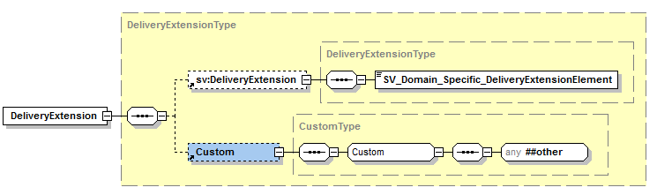

The extension schemes of ebInterface are maintained for each industrial sector (i.e., telecom, pharmaceutical industry, etc.) and represent domain-specific attributes and elements, which are not included in the core scheme of ebInterface. The above figure shows the extension scheme of the Austrian social insurance system (sv:DeliveryExtension) exemplarily.

Additionally, the custom element allows the integration of arbitrary XML elements and attributes in every extension point. Making use of including any kind of XML should only be done in case of specific (i.e. bilateral) requirements. In case arbitrary XML elements are included in the extension points, it should not be assumed that the receiver is able to process with all elements.

If, however, the used elements originate from an ebInterface certified extension scheme, and the receiver supports this extension scheme, it can be assumed that the receiver of the ebInterface instance is able to process with all elements.

## Integration of the coupling scheme in ebInterface

The coupling scheme ebInterfaceExtension.xsd is included by default in the ebInterface scheme, whereby all in the coupling scheme referenced elements are available in every ebInterface instance. The namespace of the ebInterface coupling scheme is http://www.ebinterface.at/schema/4p0/extensions/ext

The scheme ebInterfaceExtension.xsd serves as coupling point between the ebInterface core scheme and further ebInterface standardized domain-specific extension schemes.

***Scheme extract***

<?xml version="1.0" encoding="UTF-8"?>

<xs:schema xmlns="http://www.ebinterface.at/schema/4p0/" xmlns:xs="http://www.w3.org/2001/XMLSchema" xmlns:dsig="http://www.w3.org/2000/09/xmldsig#" xmlns:ext="http://www.ebinterface.at/schema/4p0/extensions/ext" targetNamespace="http://www.ebinterface.at/schema/4p0/" elementFormDefault="qualified" attributeFormDefault="unqualified">

<xs:import namespace="http://www.w3.org/2000/09/xmldsig#" schemaLocation="http://www.w3.org/TR/2002/REC-xmldsig-core-20020212/xmldsig-core-schema.xsd"/>

<xs:import namespace="http://www.ebinterface.at/schema/4p0/extensions/ext" schemaLocation="ebInterfaceExtension.xsd"/>

<!-- === Root Element === -->

<xs:element name="Invoice" type="InvoiceType"/>

…

</xs:schema>

## Integration of ebInterface extension schemes in the ebInterfaceExtension coupling scheme

Together with every release of ebInterface, an ebInterfaceExtension coupling scheme is adopted, in which the ebInterface standardized extension schemes are referenced. In the ebInterface coupling scheme it is referred to further coupling schemes allowed by ebInterface, whose elements are integrated in the specific extension elements of the coupling scheme.

The following scheme extract shows the integration of the ebInterface extension scheme of the Austrian social partner system in the ebInterfaceExtension.xsd coupling scheme.

***Scheme extract***

<?xml version="1.0" encoding="UTF-8"?>

<xs:schema xmlns:xs="http://www.w3.org/2001/XMLSchema" xmlns="http://www.ebinterface.at/schema/4p0/extensions/ext" xmlns:sv="http://www.ebinterface.at/schema/4p0/extensions/sv" xmlns:pharmaceuticals="http://www.ebinterface.at/schema/4p0/extensions/pharmaceuticals" targetNamespace="http://www.ebinterface.at/schema/4p0/extensions/ext" elementFormDefault="qualified" attributeFormDefault="unqualified">

<!-- Import the industry specific namespaces -->

<xs:import namespace="http://www.ebinterface.at/schema/4p0/extensions/sv"   
 schemaLocation="ext/ebInterfaceExtension_SV.xsd"/>

<!-- === Element declarations === -->

<xs:element name="DeliveryExtension" type="DeliveryExtensionType"/>

…

<xs:complexType name="DeliveryExtensionType">

<xs:sequence>

<xs:element ref="sv:DeliveryExtension" minOccurs="0"/>

<xs:element ref="Custom" minOccurs="0"/>

</xs:sequence>

</xs:complexType>

…

</xs:schema>

As it can be seen in the extract the same extension elements (i.e. sv:DeliveryExtension) are defined in the extension scheme of the Austrian social partner system, which are included in the extension elements (i.e. DeliveryExtensionType) of the coupling schemes.

The namespace of the ebInterface extension scheme of the Austrian social partner system is

http://www.ebinterface.at/schema/4p0/extensions/sv, whereas the last part of the namespace particularly stands for the valid scheme of the specific industry (i.e. <http://www.ebinterface.at/schema/4p0/extensions/pharmaceuticals> for the pharmaceutical industry).

# References

|  |  |
| --- | --- |
| [BMF11] | Advance VAT return from 1st of July 2010, Federal Ministry of Finance, <http://formulare.bmf.gv.at/service/formulare/inter-Steuern/pdfs/2010/U30.pdf> |
| [DUNS11] | DUNS (Data Universal Numbering System). <http://www.dnb.ch/htm/690/de/Eindeutige-Identifikation.htm> (last visited: 20.09.2011) |
| [GLN11] | GLN (Global Location Number). <http://www.gs1austria.at/index.php?option=com_content&view=article&id=83&Itemid=156> (last visited: 20.09.2011) |
| [GTIN11] | GTIN (Global Trade Item Number). <http://gs1.at/index.php?option=com_content&view=article&id=85&Itemid=158> (last visited: 20.09.2011) |
| [ISO3166-1] | ISO 3166-1, Version VI-10, International Organization for Standardization, <http://www.iso.org/iso/country_codes/iso_3166_code_lists.htm>, |
| [ISO4217] | ISO 4217, International Organization for Standardization, <http://www.currency-iso.org/iso_index/iso_tables/iso_tables_a1.htm> |
| [PZN11] | PZN (Pharmazentralnummer). <http://www.ifaffm.de/download/Technische%20Hinweise%20PZN-Codierung.pdf> (last visited: 20.09.2011) |
| [RFC2119] | RFC 2119: Keywords for use in RFCs to Indicate Requirement Levels. March 1997. <http://www.rfc-archive.org/getrfc.php?rfc=2119> (last visited: 20.09.2011) |
| [RFC3986] | RFC 3986: Uniform Resource Identifier (URI): Generic Syntax. <http://tools.ietf.org/html/rfc3986> (last visited: 20.09.2011). |
| [W3C01] | XML Schema. W3C Recommendation. <http://www.w3.org/XML/Schema> (last visited: 20.09.2011) |
| [W3C02] | XML-Signature Syntax and Processing (XMLDSig). W3C Recommendation. <http://www.w3.org/TR/xmldsig-core/> (last visited: 20.09.2011) |
|  |  |
|  |  |

1. http://www.stuzza.at/9417_DE.64FE7D4599b8cea548f52f7c39fac26b8205a6f0