

ebInterface 4.1

The Austrian e-Invoice standard

Published: December 16, 2013

austriapro 

Table of contents

1 Introduction 3

1.1 Subject of this document 3

1.2 Referenced XML standards and specifications 3

1.3 Changes in Version 4.1 3

2 Schema basics 6

3 ebInterface 4.1 9

3.1 Invoice 9

3.2 Signature 14

3.3 CancelledOriginalDocument 15

3.4 RelatedDocument 16

3.5 Delivery 17

3.5.1 Address 20

3.6 Biller 22

3.6.1 OrderReference 23

3.7 InvoiceRecipient 25

3.8 OrderingParty 28

3.9 Details 30

3.9.1 ListLineItem 33

3.9.2 BelowTheLineItem 39

3.10 ReductionAndSurchargeDetails 40

3.11 Tax 44

3.12 PaymentMethod 46

3.12.1 NoPayment 46

3.12.2 DirectDebit 47

3.12.3 SEPADirectDebit 48

3.12.4 UniversalBankTransaction 49

3.13 PaymentConditions 51

3.14 PresentationDetails 52

4 Der ebInterface 4.x Extension Mechanismus 54

4.1 Integration of the coupling scheme in ebInterface 55

4.2 Integration of ebInterface extension schemes in the ebInterfaceExtension coupling scheme 56

5 Recommendations on standard use 56

5.1 Use of negative/positive signs for amounts in invoices and credit notes 56

6 References 58

# Introduction

## Subject of this document

This document describes the XML-Schema of the ebInterface 4.1 standard.

## Referenced XML standards and specifications

For the XML structure of ebInterface the following specifications and standards were used:

|  |  |
| --- | --- |
| **Name** | **Standard** |
| http://www.w3.org/2000/09/xmldsig# | XML Digital Signatures (XMLDSIG) – W3C: electronic signatures [W3C02] |
| http://www.w3.org/2001/XMLSchema | W3C – XML Schema [W3C01] |
| <http://www.ebinterface.at/schema/4p1/> | ebInterface 4.1 |

## Changes in Version 4.1

In the following the changes being made to ebInterface 4p1 in comparison to ebInterface 4p0 are briefly described.

**Changes to complexType AddressIdentifierType**

* The implementation of the complexType AddressIdentifierType has been changed. It now extends xs:string and does not use *mixed content* any more.

**Changes to complexType AddressType**

* The element AddressIdentifier in an Address may now appear multiple times.

**Deletion of AlphaNumType and changes to AlphaNumIDType**

* The complexType AlphaNumType has been replaced by xs:string.
* AlphaNumIDType has been renamed to IDType and its length has been restricted to 255.
* In addition a new type ID35Type has been introduced, which may be used for Strings with a maximum length of 35.

**Changes to BICType**

* The erroneous regular expression for BICType has been corrected.

**Remarks for correct calculation added**

* Elements whose content is calculated based on other elements are now outlined with remarks on how the calculation is done. These remarks are noted with "calculation".

**Comment elements added to ReductionAndSurchargeListLineItemDetails and ReductionAndSurchargeDetails**

* A comment element has been added to surcharges and reductions on list line item and ROOT-level. The comment element may be used to indicate the exact reason why a surcharge or reduction has been applied.

**New attribute in order to indicate a copy of an invoice**

* The ROOT element Invoice now contains an attribute IsDuplicate, which may be used to indicate, that the current invoice instance is an invoice copy.

**Adaption and extension of complexType PaymentMethod**

* Instead of xsi:type the complexType PaymentMethod now uses xs:choice.
* SEPA direct debit has been added to PaymentMethod.

**New comment element on ROOT level**

* The ROOT level of the document now contains a Comment element, which may be used to add free-text comments and remarks to an invoice.

**New chapter „Recommendation of use“**

* The new chapter gives advice on how to use the ebInterface 4p1 standard for credit notes.

**New element PayableAmount and BelowTheLineItems**

* In order to add invoice positions which are not relevant for tax calculations, a new dedicated section BelowTheLineItems has been added to the Details section.
* In addition there is a new element PayableAmount on the ROOT level, indicating the amount which has to be paid by the recipient. In case BelowTheLineItems are present, the payable amount may deviate from the total gross amount.

**Distinction between Tax and TaxExemption on ListLineItem level**

* On list line item level either Tax or TaxExemption may be provided. Using TaxExemption invoice positions, which are exempted from the tax may be defined.
* On the ROOT level the structure of Tax has been adapted, now allowing to define Tax and TaxExemption entries.

**New abstract super type for InvoiceRecipient, OrderingParty und Biller**

* For the three types InvoiceRecipient, OrderingParty and Biller a new supertype AbstractPartyType has been introduced. The introduction of the supertype has slightly changed the order of the child elements of the respective sub-types.

**BillersInvoiceRecipientID is now optional**

* The definition of BillersInvoiceRecipientID in InvoiceRecipient is now optional.

**ConsolidatorsBillerID removed**

* The element ConsolidatorsBillerID in Biller has been removed. If required the consolidator’s biller ID may still be provided using the FurtherIdentification element.

**Further use of element FurtherIdentification**

* The element FurtherIdentification is now also available in the elements InvoiceRecipient and OrderingParty.

**Adaption of complexTypes ReductionAndSurchargeListLineItemDetailsType**

* On list line item level both, Reduction and Surcharge elements, may now be provided.

**Added recommended code lists**

* The appendix of this documentation contains a set of recommendations for code lists to be used in an ebInterface invoice.

**New attribute BaseQuantity for UnitPrice**

* On list line item level the element UnitPrice has a new attribute BaseQuantity. Using this attribute the base quantity of a unit price may be provided.

**New element RelatedDocument on ROOT level**

* On ROOT level the element RelatedDocument can be used to provide related ebInterface documents, which are referenced by the current ebInterface document. An application for related documents are for example final invoices, which reference several previously issued part-invoices.

**New element CancelledOriginalDocument**

* In order to cancel a previously issued ebInterface invoice, the new element CancelledOriginalDocument on ROOT level may be used. In case of a cancelled invoice, the invoice number and the invoice date of the invoice to be cancelled must be provided. This element replaces the previously used attribute CancelledOriginalDocument in the ROOT element. The attribute CancelledOriginalDocument has been removed.

**PaymentReference adapted to SEPA requirements**

* The payment reference in the element UniversalBankingTransaction has been extended to 35 characters in order to be compliant with SEPA requirements. Furthermore the attribute for the checksum has been extended to 4 characters.

**Support for OtherVATableTax**

* In order to be able to define taxes, which in turn are subject to value-added tax (VAT) calculations (beer tax, taxes on gas, etc.), two new elements OtherVATableTaxListLineItem and OtherVATableTax have been added on list line item and ROOT level respectively.

**Rename of TaxRate**

* The element TaxRate has been renamed to VATRate.

The namespace for ebInterface 4.1 is: http://www.ebinterface.at/schema/4p1/

# Schema basics

The Schema-description has been built on the basis of the tree view. If XML composite elements appear several times in the schema (e.g., *Address* or *OrderReference*), the sub elements of those elements will be explained only in the first appearance of the element in order to avoid double listing and to improve readability.

The list of XML-elements and attributes contains the following information:

**Name**

This column contains the name of the XML-element/attribute. All names can be interpreted as paths relatively to the ROOT-element ”Invoice”. Attributes are marked with the identifier "@". Arbitrary paths are marked with the identifier "*".

**Meaning**

This column contains an explanation for the usage of the XML-elements/attributes.

**Type**

This column contains the type of the XML element or XML attribute, respectively.

**Cardinality**

This column contains the explanation of the cardinality.

|  |  |
| --- | --- |
| **Cardinality** | **Meaning** |
| 0..1 | Zero times or once. |
| 0..* | Zero or several times. |
| 1..1 | Exactly once. |
| 1..* | Once or several times. |

**Format**

The column "Format" contains information on the used data type and used structure. Furthermore, maximum/minimum length and/or other references are provided.

The following SimpleTypes are used in the ebInterface standard.

|  |  |
| --- | --- |
| **Datentyp** | **Erlaubte Zeichen** |
| AccountingAreaType | xs:string with maximum length 20 |
| AddressIdentifierTypeType | xs:token with the following allowed values:   * GLN – Global Location Number. Is used as explicit, worldwide non-overlapping identification of all enterprises, operations and organizational units. [GLN11] * DUNS – Data Universal Numbering System. Nine digit coding scheme for an explicit, worldwide identification of enterprises. [DUNS11] * ProprietaryAddressID. Shows that a proprietary number for address identification is used. |
| ArticleNumberTypeType | xs:token with the following allowed values:   * PZN. Standardised identification key for medicines and pharmaceutical products. [PZN11] * GTIN. GTIN-Global Trade Item Number (also known as the “barcode”) is displayed on all trading units in the form of using a bar code and can be written explicitly and non-overlapping by all worldwide point-of sale systems. [GTIN11] * InvoiceRecipientsArticleNumber. An item number provided by the invoice recipient. * BillersArticleNumber. An item number provided by the invoicing party. |
| BankAccountOwnerType | xs:string with maximum length 70 |
| BankNameType | xs:string with maximum length 255 |
| BICType | Allowed character:  [0-9 | A-Z | a-z]{8}([0-9 | A-Z | a-z]{3})?  8 or 11 digits in accordance with ISO 9362 |
| CheckSumType | Allowed character:  [0-9 | X]{1} |
| CountryCodeType | Country code in accordance with ISO 3166-1, i.e. "AT", "US", etc. |
| CurrencyType | A currency code in accordance with ISO 4217, i.e. "EUR", "USD", "CHF", etc. |
| Decimal2Type | -#.99 Decimal number with 2 digits after the decimal point and any number of digits before the decimal point. In case of negative numbers, a minus sign (-) will be put in front directly without previous blank spaces) .  *Note:* A decimal point (.) is used instead of a comma (,). |
| Decimal4Type | -#.9999 Decimal number with 4 digits after the decimal point and any number of digits before the decimal point. In case of negative numbers, a minus sign (-) will be put in front directly without previous blank spaces) .  *Note:* A decimal point (.) is used instead of a comma (,). |
| DocumentTypeType | One of the following strings:   * Invoice, * FinalSettlement, * InvoiceForAdvancePayment, * InvoiceForPartialDelivery, * SubsequentCredit, * CreditMemo, * SubsequentDebit, * SelfBilling   For the correct use of the different document types except “invoice” see section  5.1. |
| IBANType | ISO 13616 and EBS-Standard (European Banking Standard):  max. 34 digits, alphanumeric |
| IDType | xs:string with a maximum length of 255 |
| ID35Type | xs:string with a maximum length of 35. |
| LanguageType | A language type in accordance ISO 639-2, i.e. "GER", "ENG", etc. |
| PercentageType | 0.00 – 100.00 Decimal number in range of values from 0 to 100 with the maximum of two digits after the decimal point.  *Note:* A decimal point (.) is used instead of a comma (,). |
| SEPADirectDebitTypeType | One of the following strings:   * B2C * B2B |
| TaxCodeType | Allowed pattern:  AT(XXX|[0-9]{3}) |
| xs:anyURI | A Uniform Resource Identifier [RFC3986] |
| xs:boolean | true | false, 1 | 0, whereas 1 means true and 0 – false |
| xs:date | A date in accordance to ISO 8601 in format "YYYY-MM-DD" consisting of four-digit year format , two-digit month format and two-digit day-format. In case month or day format is only one-digit this has to be marked with a leading zero (0) i.e. 2008-11-09 (9. November 2008) |
| xs:integer | {...,-2,-1,0,1,2,...} |
| xs:positiveInteger | {0,1,2,...} |
| xs:string | Any characters. |

In case an element references a complexType, its data type is outlined as XML composite. The section where the XML complexType is explained, is mentioned in the description of the element.

The keywords MUST, MUST NOT, REQUIRED, SHALL, SHALL NOT, SHOULD, SHOULD NOT, RECOMMENDED, MAY and OPTIONAL, when they appear in this document, are to be interpreted as described in [RFC2119] as quoted here:

* MUST: This word, or the terms "REQUIRED" or "SHALL", means that the definition is an absolute requirement of the specification.
* MUST NOT: This phrase, or the phrase "SHALL NOT", means that the definition is an absolute prohibition of the specification.
* SHOULD: This word, or the adjective "RECOMMENDED", means that there may exist valid reasons in particular circumstances to ignore a particular item, but the full implications MUST be understood and carefully weighed before choosing a different course.
* SHOULD NOT: This phrase, or the phrase "NOT RECOMMENDED", means that there may exist valid reasons in particular circumstances when the particular behavior is acceptable or even useful, but the full implications should be understood and the case carefully weighed before implementing any behavior described with this label.
* MAY: This word, or the adjective "OPTIONAL", means that an item is truly optional. One vendor may choose to include the item because a particular marketplace requires it or because the vendor feels that it enhances the product while another vendor may omit the same item. An implementation that does not include a particular option MUST be prepared to interoperate with another implementation which does include the option, though perhaps with reduced functionality. In the same vein an implementation that does include a particular option MUST be prepared to interoperate with another implementation which does not include the option (except, of course, for the feature the option provides).

# ebInterface 4.1

Each ebInterface invoice SHOULD contain a reference to the used XSL transformation. This transformation may be the default-style sheet from ebInterface (freely available at http://www.ebinterface.at) or a different style sheet provided by the invoicing party. Referencing a style sheet from a remote location such as <http://www.ebinterface.at/Invoice.xslt> should be avoided, given that a browser of new generation displays an error if XML document and style sheet are not loaded from the same domain. Instead of that it should be referred to a local copy of the Invoice.xslt file.

***Example for referencing from an external domain:***

The following example of use of the Invoice.xslt style sheet generates an error, in case the ebInterface instance is opened in a browser of new generation on the local hard drive.

<?xml version="1.0" encoding="UTF-8"?>

<?xml-stylesheet type="text/xsl"

href="http://www.beispielurl.at/Invoice.xslt"?>

<n1:Invoice n1:ManualProcessing="true" n1:DocumentTitle="Eine Rechnung" n1:Language="ger" n1:DocumentType="Invoice" n1:InvoiceCurrency="EUR" n1:GeneratingSystem="ERP System xyz" n1:IsDuplicate="false" xmlns:n1="http://www.ebinterface.at/schema/4p1/">

…

</n1:Invoice>

***Example for correct referencing***

The following example of use of the Invoice.xslt style sheet refers to a version of the style sheet saved on local hard disk. Browsers of new generation are able to process this sample without errors.

<?xml version="1.0" encoding="UTF-8"?>

<?xml-stylesheet type="text/xsl" href="Invoice.xslt"?>

<n1:Invoice n1:ManualProcessing="true" n1:DocumentTitle="Eine Rechnung" n1:Language="ger" n1:DocumentType="Invoice" n1:InvoiceCurrency="EUR" n1:GeneratingSystem="ERP System xyz" n1:IsDuplicate="false" xmlns:n1="http://www.ebinterface.at/schema/4p1/">

…

</n1_Invoice>



## Invoice

The *Invoice* element MUST be used as root element and, therefore, initiates the electronic invoice.

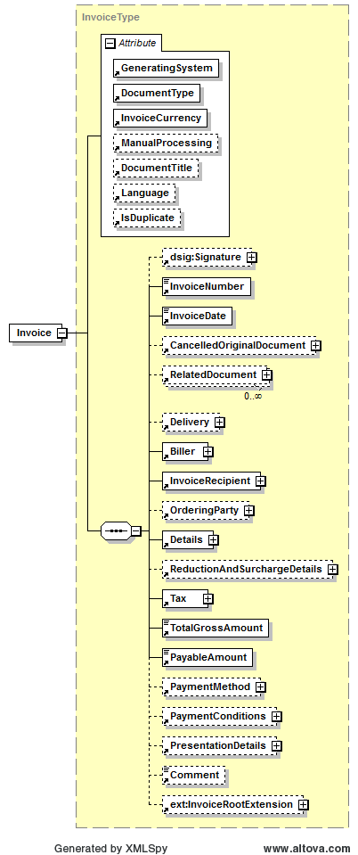

|  |  |  |  |  |
| --- | --- | --- | --- | --- |
| **Name** | **Meaning** | **Type** | **Card.** | **Format** |
| @GeneratingSystem | Name of the ERP/FIBU-System, which has generated the invoice | Attribute | 1..1 | xs:string |
| @DocumentType | Is used to report the type of invoice. MUST be one of the following strings:   * Invoice, * FinalSettlement, * InvoiceForAdvancePayment, * InvoiceForPartialDelivery, * SubsequentCredit, * CreditMemo, * SubsequentDebit, * SelfBilling   For he correct use of the different DocumentTypes, except „Invoice“, see section 5.1. | Attribute | 1..1 | DocumentType-Type |
| @InvoiceCurrency | Explicit currency code for the invoice. All amounts of the invoice will be displayed in this currency. | Attribute | 1..1 | CurrencyType |
| @ManualProcessing | If this optional attribute is set to true the invoicing party signalizes that the invoice should be checked manually before automated processing is carried on. This is usually the case if side agreements have been made in the text fields. This attribute should for example be set to true in case of repeating issued invoices. | Attribute | 0..1 | xs:boolean |
| @DocumentTitle | Document title: May be used to select a random title (i.e. "final settlement", etc.). | Attribute | 0..1 | xs:string |
| @Language | Language, in which the invoice is settled. | Attribute | 0..1 | LanguageType |
| @IsDuplicate | Defines whether this invoice is an original invoice (value false) or an invoice copy (value true). In case the attribute is not provided, the invoice is an original invoice. | Attribute | 0..1 | xs:Boolean |
| dsig:Signature | This element has been defined in accordance with W3C-XMLDSig [W3C02] and contains the optional signature of the electronic invoice. | Element | 0..1 | XML composite |
| InvoiceNumber | Invoice number | Element | 1..1 | IDType |
| InvoiceDate | Date of invoice | Element | 1..1 | xs:date |
| CancelledOriginalDocument | Used to cancel a previously issued ebInterface invoice. The exact description is provided in section 3.3. | Element | 0..1 | XML composite |
| RelatedDocument | Used to reference other ebInterface invoices, to which the current ebInterface invoice relates to. The exact description is provided in section 3.4. | Element | 0..* | XML composite |
| Delivery | Details of the delivery. This element MUST be used, if there is only one delivery associated with the invoice. If several deliveries are settled, the element Invoice/ Details/ItemList/ListLineItem/ Delivery has to be used in each item row. | Element | 0..1 | XML composite |
| Biller | Details on invoicing party | Element | 1..1 | XML composite |
| InvoiceRecipient | Details on invoice recipient | Element | 1..1 | XML composite |
| OrderingParty | In case the invoice recipient is not equivalent to the ordering party of the delivery/service, information about the ordering party is to be entered in this element. | Element | 0..1 | XML composite |
| Details | Contains individual invoice items. | Element | 1..1 | XML composite |
| ReductionAndSurchargeDetails | Details of reduction or surcharges on the ROOT level.  **Calculation:**  The reductions and surcharges provided in this element are calculated from the invoice net amount. | Element | 0..1 | XML composite |
| Tax | Summary of value added tax and other taxes.  **Calculation:**  The taxes and tax exemptions provided in this element are a summary of the taxes and tax exception on list line item level. | Element | 1..1 | XML composite |
| TotalGrossAmount | Invoice gross amount  **Calculation:**  Sum of LineItemAmounts  + Sum of Surcharges on ROOT level  + Sum of OtherVATableTaxListLineItems on ROOT level  - Sum of Reductions on ROOT level  + Taxes | Element | 1..1 | Decimal2Type |
| PayableAmount | The invoice amount to be paid.  **Calculation:**  In case there are no BelowTheLineItems in Details, the following condition must be met: PayableAmount = TotalGrossAmount.  In case there are BelowTheLineItems: PayableAmount = TotalGrossAmount + Sum of BelowTheLineItems | Element | 1..1 | Decimal2Type |
| PaymentMethod | Offers a range for entering different payment methods. | Element | 0..1 | XML composite |
| PaymentConditions | Details of payment conditions such as discount or minimum amount, which is to be settled. | Element | 0..1 | XML composite |
| PresentationDetails | Details, which are relevant for displaying or printing the invoice. | Element | 0..1 | XML composite |
| Comment | Comments and remarks in free-text form. | Element | 0..1 | xs:string |
| InvoiceRootExtension | Element for integration of elements that are referenced in the InvoiceRootExtension element of the ebInterfaceExtension.xsd Schema or originate from another arbitrary namespace. | Element | 0..* | XML composite (defined in ebInterfaceExtension.xsd) |

***Example:***

<?xml version="1.0" encoding="UTF-8"?>

<n1:Invoice n1:ManualProcessing="true" n1:DocumentTitle="Eine Rechnung" n1:Language="ger" n1:DocumentType="Invoice" n1:InvoiceCurrency="EUR" n1:GeneratingSystem="ERP System xyz" n1:IsDuplicate="false" xmlns:n1="http://www.ebinterface.at/schema/4p1/"> <InvoiceNumber>993433000298</n1:InvoiceNumber>

<n1:InvoiceDate>2011-09-20</n1:InvoiceDate>

...

<n1:TotalGrossAmount>1349.26</n1:TotalGrossAmount>

<n1:PayableAmount>1349.26</n1:PayableAmount>

...

</n1:Invoice>

## Signature

The *Signature* element is OPTIONAL. The structure follows the W3C specification of XML-Signature Syntax and Processing (XMLDSig) [W3C02].

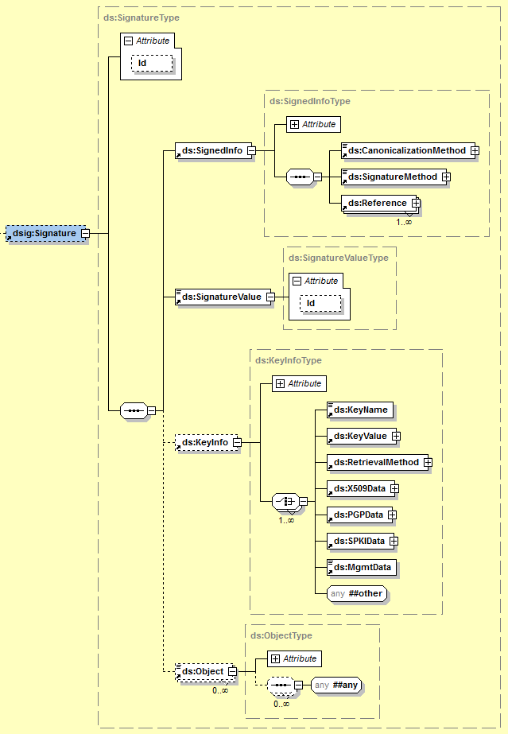

***Beispiel:***

<ds:Signature xmlns:ds="http://www.w3.org/2000/09/xmldsig#">

<ds:SignedInfo>

<ds:CanonicalizationMethod

Algorithm="http://www.w3.org/TR/2001/REC-xml-c14n-20010315"/>

<ds:SignatureMethod

Algorithm="http://www.w3.org/2000/09/xmldsig#rsa-sha1"/>

<ds:Reference URI="">

<ds:Transforms>

<ds:Transform Algorithm=

"http://www.w3.org/2000/09/xmldsig#enveloped-signature"/>

<ds:Transform Algorithm="http://www.w3.org/TR/2001/

REC-xml-c14n-20010315#WithComments"/>

</ds:Transforms>

<ds:DigestMethod

Algorithm="http://www.w3.org/2000/09/xmldsig#sha1"/>

<ds:DigestValue>bi6Qy0MjrmN62eS2Xoi… </ds:DigestValue>

</ds:Reference>

</ds:SignedInfo>

<ds:SignatureValue>

OnXGLaP12+44gmOCWvooi3yaUo9RXW3IXToAs/g7idC2CsXGudb

YotK75S6j2F6YAlzEBhe7M/ky0qqoR6kY …

</ds:SignatureValue>

<ds:KeyInfo>

<ds:X509Data>

<ds:X509Certificate>

zQwDQYJKoZIhvcNAQEFBQAwVTEZMBcGA1UEA

xMQVGVzdCBDZXJ0F0ZTEUMBIGA1UEC…

</ds:X509Certificate>

</ds:X509Data>

<ds:KeyValue>

<ds:RSAKeyValue>

<ds:Modulus>

OqjmcRZh2dh4bsDooq0OGWxRD/sRaR1PqiO

A9o8KpzKdMgq9bY+oQIGXxEOO2…

</ds:Modulus>

<ds:Exponent>AQAB</ds:Exponent>

</ds:RSAKeyValue>

</ds:KeyValue>

</ds:KeyInfo>

</ds:Signature>

## CancelledOriginalDocument

This element may be used to cancel a previously issued ebInterface invoice.

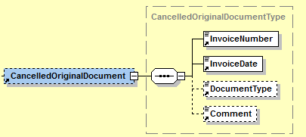

|  |  |  |  |  |
| --- | --- | --- | --- | --- |
| **Name** | **Meaning** | **Type** | **Card.** | **Format** |
| InvoiceNumber | The number of the invoice to be cancelled. The value is taken from the element Invoice/InvoiceNumber of the invoice which shall be cancelled. | Element | 1..1 | IDType |
| InvoiceDate | The date of the invoice to be cancelled. The value is taken from the element Invoice/InvoiceDate of the invoice which shall be cancelled. | Element | 1..1 | xs:date |
| DocumentType | Document type of the invoice to be cancelled. The value is taken from the attribute Invoice[@DocumentType] of the invoice which shall be cancelled. | Element | 0..1 | DocumentType-Type |
| Comment | Optional free-text information. | Element | 0..1 | xs:string |

***Beispiel:***

<CancelledOriginalDocument>

<InvoiceNumber>2013/41/1234</InvoiceNumber>

<InvoiceDate>2013-08-13</InvoiceDate>

<DocumentType>Invoice</DocumentType>

<Comment>Storniert die 2013/41/1234 vom 13.8.2013</Comment>

</CancelledOriginalDocument>

## RelatedDocument

The element may be used to specify previously issued ebInterface invoices, to which the current invoice relates to. An example a final invoice statements, which reference previously issued invoices.

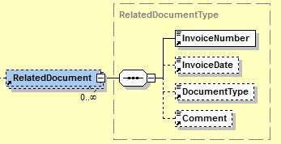

|  |  |  |  |  |
| --- | --- | --- | --- | --- |
| **Name** | **Meaning** | **Type** | **Card.** | **Format** |
| InvoiceNumber | The number of the related invoice, taken from the element Invoice/InvoiceNumber of the referenced document. | Element | 1..1 | IDType |
| InvoiceDate | The date of the referenced invoice, taken from the element Invoice/InvoiceDate of the referenced document. | Element | 0..1 | xs:date |
| DocumentType | Document type of the referenced invoice, taken from the attribute Invoice[@DocumentType] of the referenced document. | Element | 0..1 | DocumentType-Type |
| Comment | Optional free-text comment. | Element | 0..1 | xs:string |

***Beispiel:***

<RelatedDocument>

<InvoiceNumber>2013/233/3893</InvoiceNumber>

<InvoiceDate>2013-01-01</InvoiceDate>

<DocumentType>Invoice</DocumentType>

<Comment>Teilrechnung 1</Comment>

</RelatedDocument>

<RelatedDocument>

<InvoiceNumber>2013/233/3894</InvoiceNumber>

<InvoiceDate>2013-02-02</InvoiceDate>

<DocumentType>Invoice</DocumentType>

<Comment>Teilrechnung 2</Comment>

</RelatedDocument>

## Delivery

The *Delivery* element is OPTIONAL and consists of all necessary delivery details. In the *Delivery* element exactly one delivery date (*Date*) or delivery period (*Period*) MUST be entered. The element Invoice/Delivery MUST be used if there is only one delivery associated with the invoice. If several deliveries are settled, the element Invoice/Details/ItemList/ListLineItem/Delivery has to be used in each item row. In case Invoice/Delivery is entered and further in one item row the element Invoice/Details/ItemList/ListLineItem/Delivery, the latter takes precedence over the first mentioned.

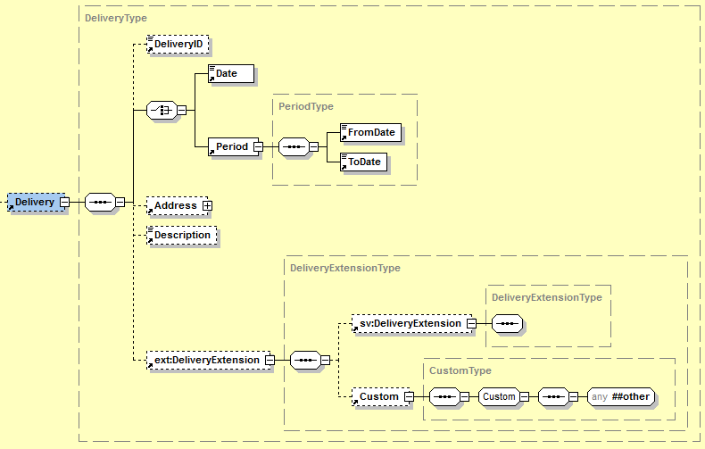

|  |  |  |  |  |
| --- | --- | --- | --- | --- |
| **Name** | **Meaning** | **Type** | **Card.** | **Format** |
| DeliveryID | Delivery number | Element | 0..1 | IDType |
| Date | Date of delivery (is used alternatively to delivery period) | Element | 1..1 | xs:date |
| Period | Delivery period (is used alternatively to date of delivery) | Element | 1..1 | XML composite |
| Period/FromDate | Beginning of delivery period | Element | 1..1 | xs:date |
| Period/ToDate | End of delivery period | Element | 1..1 | xs:date |
| Address | Details of delivery address. This address is only to be used if the delivery address is not equivalent to the invoice recipient’s address. The exact definition is provided in section 3.5.1. | Element | 0..1 | XML composite |
| Description | Additional details of delivery in free text | Element | 0..1 | xs:string |
| DeliveryExtension | Element for integration of elements that are referenced in the DeliveryExtension element of the ebInterfaceExtension.xsd Schema or originate from another arbitrary namespace. | Element | 0..1 | XML composite (defined in ebInterfaceExtension.xsd) |

***Example 1 (with delivery date):***

…

<Delivery>

<DeliveryID>Lieferung 2011/1</DeliveryID>

<Date>2011-09-20</Date>

<Address>

<AddressIdentifier  
 n1:AddressIdentifierType="GLN">9123456789013  
 </AddressIdentifier>

<Salutation>Firma</Salutation>

<Name>Mustermann GmbH</Name>

<Street>Hauptstraße 10</Street>

<Town>Graz</Town>

<ZIP>8020</ZIP>

<Country n1:CountryCode="AT">Österreich</Country>

<Contact>Hr. Max Mustermann</Contact>

</Address>

<Description>Lieferung wie Anfang September vereinbart.</Description>

<ext:DeliveryExtension>

<sv:DeliveryExtension>

<sv:SV_Domain_Specific_DeliveryExtensionElement>Ein von ebInterface standardisiertes Erweiterungselement

</sv:SV_Domain_Specific_DeliveryExtensionElement>

</sv:DeliveryExtension>

<ext:Custom>

<n2:auto-generated_for_wildcard>Irgendein beliebiges Erweiterungselement aus einem anderen Namespace

</n2:auto-generated_for_wildcard>

</ext:Custom>

</ext:DeliveryExtension>

</Delivery>

…

***Example 2 (with delivery period):***

…

<Delivery>

<DeliveryID>Lieferung 2011/1</DeliveryID>

<Period>

<FromDate>2011-09-15</FromDate>

<ToDate>2011-09-20</ToDate>

</Period>

<Address>

<AddressIdentifier   
 n1:AddressIdentifierType="GLN">9123456789013  
 </AddressIdentifier>

<Salutation>Firma</Salutation>

<Name>Mustermann GmbH</Name>

<Street>Hauptstraße 10</Street>

<Town>Graz</Town>

<ZIP>8020</ZIP>

<Country n1:CountryCode="AT">Österreich</Country>

<Contact>Hr. Max Mustermann</Contact>

</Address>

<Description>Lieferung wie Anfang September vereinbart.</Description>

</Delivery>

…

### Address

The *Address* element is used to report various kind of address. If the *Address* element is entered, at least *Name*, *Street*, *Town, ZIP* and *Country* of the addressed enterprise or addressed person MUST be entered. The *AddressExtension* element SHOULD be used for additional details and information, which cannot be displayed in the remaining structure.

Note: The AddressExtension element is part of the ebInterface core scheme and will not be embedded from the ebInterfaceExtension.xsd scheme.

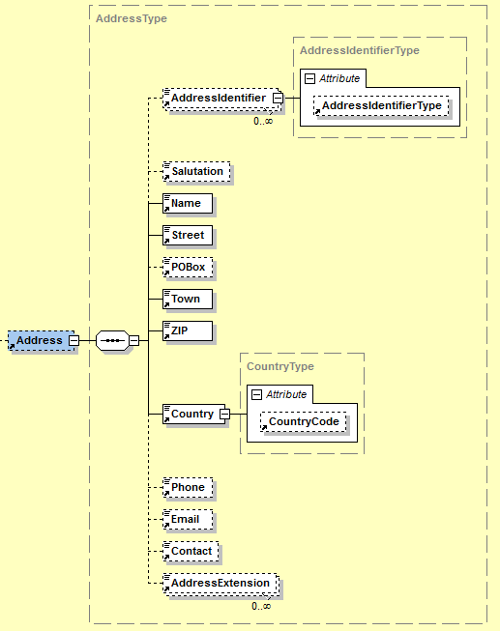

|  |  |  |  |  |
| --- | --- | --- | --- | --- |
| **Name** | **Meaning** | **Type** | **Card.** | **Format** |
| AddressIdentifier | Identifier for a certain address | Element | 0..* | xs:string |
| AddressIdentifier/@AddressIdentifierType | Defines the type of the element AddressIdentifier | Attribute | 0..1 | AddressIdentifierTypeType |
| Salutation | Salutation | Element | 0..1 | xs:string |
| Name | Name of enterprise or person | Element | 1..1 | xs:string |
| Street | Street including house number | Element | 1..1 | xs:string |
| POBox | Post office box | Element | 0..1 | xs:string |
| Town | Town | Element | 1..1 | xs:string |
| ZIP | ZIP code | Element | 1..1 | xs:string |
| Country | Country (free text) | Element | 1..1 | XML composite |
| Country/  @CountryCode | ISO 3166-1 Code, which stands for an explicit identification of the element Country. | Attribute | 0..1 | CountryCodeType |
| Phone | Phone number | Element | 0..1 | xs:string |
| Email | Email-Address | Element | 0..1 | xs:string |
| Contact | Contact person or responsible department/unit | Element | 0..1 | xs:string |
| AddressExtension | Additional name or addition to address as free text | Element | 0..* | xs:string |

## Biller

The *Biller* element is mandatory. It consists of all details of the invoicing party   
(= supplying or providing enterprise).

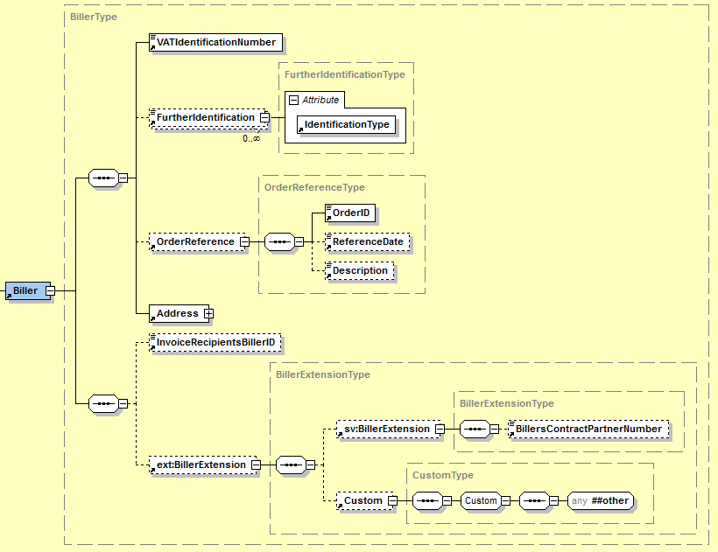

|  |  |  |  |  |
| --- | --- | --- | --- | --- |
| **Name** | **Meaning** | **Type** | **Card.** | **Format** |
| VATIdentification Number | Value Added Tax identification number (VAT) of invoicing party. In case the invoicing party has no value added tax identification number the string „00000000“(eight times the zero) has to be entered. „00000000“may also be entered, if the declaration of the VAT is not required by the Value Added Tax Act. | Element | 1..1 | xs:string |
| FurtherIdentification | For reporting further invoicing party-related identifications. | Element | 0..* | IDType |
| FurtherIdentification/@Identification-Type | Defines the kind of identification in free text form, e.g., commercial register number, court of justice, ARA number, DVR number, etc. It is recommended to use the codes provided in the code list in the appendix of this document. | Attribute | 1..1 | xs:string |
| OrderReference | Order reference of underlying order assigned by invoicing party. This element is used if only one order is associated with the invoice. If several references to orders are applied, the element Invoice/Details/Item List/ListLineItem/Biller OrderReference has to be used for each item row. An invoice MAY also have no references to orders. | Element | 0..1 | XML composite |
| Address | Address of invoicing party  (*Note*: the structure of the element *Address*  is equivalent to structure shown in chapter 3.5.1) | Element | 1..1 | XML composite |
| InvoiceRecipients  BillerID | Identification of invoicing party at invoice recipient | Element | 0..1 | IDType |
| BillerExtension | Element for integration of elements that are referenced in the InvoiceRootExtension element of the ebInterfaceExtension.xsd Schema or originate from another arbitrary namespace. | Element | 0..1 | XML composite (defined in ebInterfaceExtension.xsd) |

***Beispiel:***

…

<Biller>

<VATIdentificationNumber>ATU51507409</VATIdentificationNumber>

<FurtherIdentification   
 n1:IdentificationType="DVR">0012345</FurtherIdentification>

<OrderReference>

<OrderID>OR3456</OrderID>

<ReferenceDate>2011-09-20</ReferenceDate>

<Description>Eingegangen per Fax.</Description>

</OrderReference>

<Address>

<AddressIdentifier   
 n1:AddressIdentifierType="ProprietaryAddressID">  
 AnyOtherProprietaryID

</AddressIdentifier>

<Name>Schrauben Willi</Name>

<Street>Lassallestraße 5</Street>

<Town>Wien</Town>

<ZIP>1020</ZIP>

<Country n1:CountryCode="AT">Österreich</Country>

<Phone>+43 / 1 / 78 56 789</Phone>

<Email>schraube@willi.at</Email>

<Contact>Sachbearbeiter Meier</Contact>

<AddressExtension>Zentrale Verwaltung Wien</AddressExtension>

</Address>

<InvoiceRecipientsBillerID>ID4456</InvoiceRecipientsBillerID>

<ext:BillerExtension>

<sv:BillerExtension>

<sv:SV_Domain_Specific_BillerExtensionElement>Ein von ebInterface   
 standardisiertes Erweiterungselement  
 </sv:SV_Domain_Specific_BillerExtensionElement>

</sv:BillerExtension>

<ext:Custom>

<n2:auto-generated_for_wildcard>Irgendein beliebiges   
 Erweiterungselement aus einem anderen Namespace  
 </n2:auto-generated_for_wildcard>

</ext:Custom>

</ext:BillerExtension>

</Biller>

…

### OrderReference

The *OrderReference* element is OPTIONAL and consists of delivery details. This element is used if only one order is associated with the invoice. If several references to orders are applied, the element Invoice/Details/ItemList/ListLineItem/BillersOrderReference has to be used for each item row. An invoice MAY also not include references to orders.

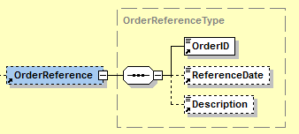

|  |  |  |  |  |
| --- | --- | --- | --- | --- |
| **Name** | **Meaning** | **Type** | **Card.** | **Format** |
| OrderID | Order number | Element | 1..1 | IDType |
| ReferenceDate | Date of order | Element | 0..1 | xs:date |
| Description | Information about the order in free text. | Element | 0..1 | xs:string |

## InvoiceRecipient

The *InvoiceRecipient* element is mandatory and consists of details of the invoice recipient. The InvoiceRecipient is the party able to claim VAT refund, based on the invoice.

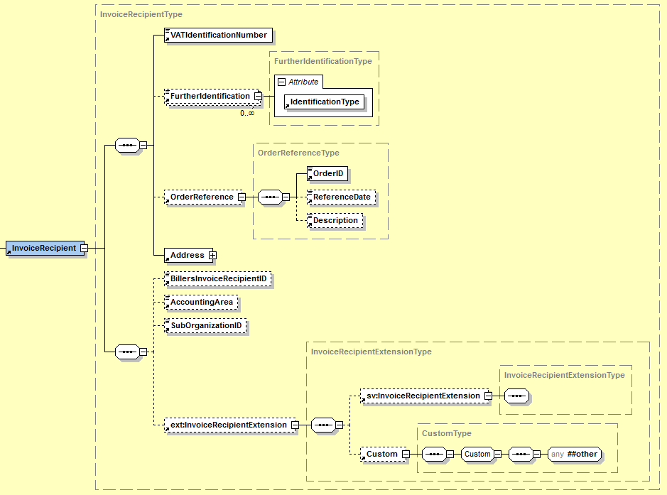

|  |  |  |  |  |
| --- | --- | --- | --- | --- |
| **Name** | **Meaning** | **Type** | **Card.** | **Format** |
| VATIdentification Number | Value Added Tax identification number (VAT) of the invoice recipient. In case the invoice recipient has no value added tax identification number, the string „00000000“(eight times the zero) has to be entered. „00000000“may also be entered, if the declaration of the VAT is not required by the Value Added Tax Act. | Element | 1..1 | xs:string |
| FurtherIdentification | For reporting further invoice recipient party-related identifications. | Element | 0..* | IDType |
| FurtherIdentification/@Identification-Type | Defines the kind of identification in free text form, e.g., commercial register number, court of justice, ARA number, DVR number, etc. It is recommended to use the codes provided in the code list in the appendix of this document. | Attribute | 1..1 | xs:string |
| OrderReference | Order reference of underlying order assigned by the invoice recipient. This element is used if only one order is associated with the invoice. If several references to orders are applied, the element Invoice/Details/Item List/ListLineItem/Biller OrderReference has to be used for each item row. An invoice MAY also have no references to orders. | Element | 0..1 | XML composite |
| Address | Address of the invoice recipient  (*Note*: the structure of the element *Address*  is equivalent to structure shown in chapter 3.5.1) | Element | 1..1 | XML composite |
| BillersInvoice  RecipientID | Identification of invoice recipient by the invoicing party. | Element | 0..1 | IDType |
| AccountingArea | Accounting area of the invoice recipient. | Element | 0..1 | xs:string |
| SubOrganizationID | Further internal reference of the invoice recipient. This could, for example, be a client number or an identification of a sub organizational unit. | Element | 0..1 | xs:string |
| InvoiceRecipientsExtension | Element for integration of elements that are referenced in the InvoiceRecipientExtension element of the ebInterfaceExtension.xsd Schema or originate from another arbitrary namespace. | Element | 0..1 | XML composite (definiert in ebInterfaceExtension.xsd) |

***Beispiel:***

…

<InvoiceRecipient>

<VATIdentificationNumber>ATU18708634</VATIdentificationNumber>

<FurtherIdentification   
 n1:IdentificationType="DVR">7654543</FurtherIdentification>

<OrderReference>

<OrderID>ID3456</OrderID>

<ReferenceDate>2011-09-20</ReferenceDate>

<Description>Bestellung per Fax.</Description>

</OrderReference>

<Address>

<AddressIdentifier   
 n1:AddressIdentifierType="ProprietaryAddressID">35354

</AddressIdentifier>

<Salutation>Firma</Salutation>

<Name>Mustermann GmbH</Name>

<Street>Haupstraße 10</Street>

<Town>Graz</Town>

<ZIP>8010</ZIP>

<Country n1:CountryCode="AT">Österreich</Country>

<Contact>Hr. Max Mustermann</Contact>

</Address>

<BillersInvoiceRecipientID>12345678</BillersInvoiceRecipientID>

<AccountingArea>BK372</AccountingArea>

<SubOrganizationID>2938</SubOrganizationID>

<ext:InvoiceRecipientExtension>

<sv:InvoiceRecipientExtension>

<sv:SV_Domain_Specific_InvoiceRecipientExtensionElement>Ein von   
 ebInterface standardisiertes Erweiterungselement

</sv:SV_Domain_Specific_InvoiceRecipientExtensionElement>

</sv:InvoiceRecipientExtension>

<ext:Custom>

<n2:auto-generated_for_wildcard>Irgendein beliebiges

Erweiterungselement aus einem anderen Namespace

</n2:auto-generated_for_wildcard>

</ext:Custom>

</ext:InvoiceRecipientExtension>

</InvoiceRecipient>

…

## OrderingParty

The element *OrderingParty* is OPTIONAL and is used to report the ordering party, in case the party is not equivalent to the invoice recipient.

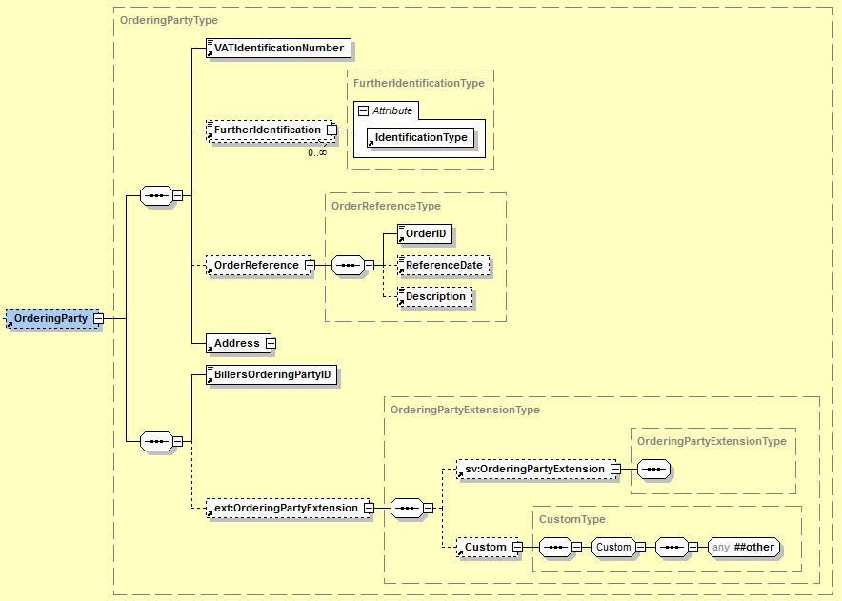

|  |  |  |  |  |
| --- | --- | --- | --- | --- |
| **Name** | **Meaning** | **Type** | **Card.** | **Format** |
| VATIdentification Number | Value Added Tax identification number (VAT) of the ordering party. In case the ordering party has no value added tax identification number, the string „00000000“(eight times the zero) has to be entered. „00000000“may also be entered, if the declaration of the VAT is not required by the Value Added Tax Act. | Element | 1..1 | xs:string |
| FurtherIdentification | For reporting further ordering party-related identifications. | Element | 0..* | IDType |
| FurtherIdentification/@Identification-Type | Defines the kind of identification in free text form, e.g., commercial register number, court of justice, ARA number, DVR number, etc. It is recommended to use the codes provided in the code list in the appendix of this document. | Attribute | 1..1 | xs:string |
| OrderReference | Order reference of underlying order assigned by the ordering party. This element is used if only one order is associated with the invoice. If several references to orders are applied, the element Invoice/Details/Item List/ListLineItem/Biller OrderReference has to be used for each item row. An invoice MAY also have no references to orders. | Element | 0..1 | XML composite |
| Address | Address of the ordering party  (*Note*: the structure of the element *Address*  is equivalent to structure shown in chapter 3.5.1) | Element | 1..1 | XML composite |
| BillersOrderingPartyID | Identification of ordering party at the invoicing party. | Element | 1..1 | IDType |
| OrderingPartyExtension | Element for integration of elements that are referenced in the OrderingPartyExtension element of the ebInterfaceExtension.xsd Schema or originate from another arbitrary namespace. | Element | 0..1 | XML composite (defined in ebInterfaceExtension.xsd) |

***Example:***

…

<OrderingParty>

<VATIdentificationNumber>00000000</VATIdentificationNumber>

<OrderReference>

<OrderID>558741</OrderID>

<ReferenceDate>2011-09-20</ReferenceDate>

<Description>Per Fax empfangen.</Description>

</OrderReference>

<Address>

<AddressIdentifier   
 n1:AddressIdentifierType="ProprietaryAddressID">OI393K3

</AddressIdentifier>

<Name>Der Dritte Mann GmbH</Name>

<Street>Lassallestraße 7</Street>

<POBox>Wien</POBox>

<Town>Wien</Town>

<ZIP>1020</ZIP>

<Country n1:CountryCode="AT">Österreich</Country>

</Address>

<BillersOrderingPartyID>98765432</BillersOrderingPartyID>

<ext:OrderingPartyExtension>

<sv:OrderingPartyExtension>

<sv:SV_Domain_Specific_OrderingPartyExtensionElement>Ein von

ebInterface standardisiertes Erweiterungselement

</sv:SV_Domain_Specific_OrderingPartyExtensionElement>

</sv:OrderingPartyExtension>

<ext:Custom>

<n2:auto-generated_for_wildcard>Irgendein beliebiges

Erweiterungselement aus einem anderen Namespace

</n2:auto-generated_for_wildcard>

</ext:Custom>

</ext:OrderingPartyExtension>

</OrderingParty>

…

## Details

The *Details* element is mandatory and consists of all details of invoiced items or services.

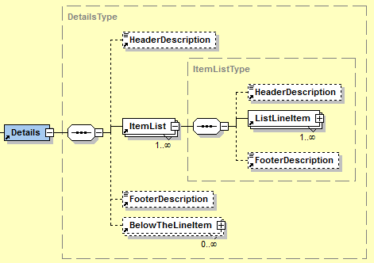

|  |  |  |  |  |
| --- | --- | --- | --- | --- |
| **Name** | **Meaning** | **Type** | **Card.** | **Format** |
| Header Description | Header of billing details in free text | Element | 0..1 | xs:string |
| ItemList | The invoiced positions can be classified in several sections. Each ItemList element contains a section. | Element | 1..* | XML composite |
| ItemList/Header Description | Header of particular section in free text | Element | 0..1 | xs:string |
| ItemList/ListLine Item | This element complies with a position line. | Element | 1..* | XML composite |
| ItemList/Footer Description | Footer of particular section in free text | Element | 0..1 | xs:string |
| Footer Description | Footer of billing details in free text | Element | 0..1 | xs:string |
| BelowTheLineItem | Used to specify items, which shall not be included in tax calculations. The exact description is provided in section3.9.2. | Element | 0..* | XML composite |

***Example:***

…

<Details>

<HeaderDescription>Wir stellen Ihnen folgende Leistungen in   
 Rechnung.

</HeaderDescription>

<ItemList>

<HeaderDescription>Aus unserer Schrauben-Abteilung:</HeaderDescription>

<ListLineItem>

<PositionNumber>1</PositionNumber>

<Description>Schraubenzieher</Description>

<ArticleNumber   
 n1:ArticleNumberType="BillersArticleNumber">I3939

</ArticleNumber>

<ArticleNumber   
 n1:ArticleNumberType="InvoiceRecipientsArticleNumber">E3949  
 </ArticleNumber>

<ArticleNumber   
 n1:ArticleNumberType="GTIN">00012345678905  
 </ArticleNumber>

<Quantity n1:Unit="C62">100.00</Quantity>

<UnitPrice>10.20</UnitPrice>

<VATRate n1:TaxCode="AT022">20.00</VATRate>

<AdditionalInformation>

<SerialNumber>124302393</SerialNumber>

<ChargeNumber>CN393</ChargeNumber>

<Weight n1:Unit="KGM">5</Weight>

<Boxes>2</Boxes>

</AdditionalInformation>

<LineItemAmount>1020.00</LineItemAmount>

<ext:ListLineItemExtension>

<sv:ListLineItemExtension>

<sv:SV_Domain_Specific_ListLineItemExtensionElement>Ein von

ebInterface standardisiertes Erweiterungselement

</sv:SV_Domain_Specific_ListLineItemExtensionElement>

</sv:ListLineItemExtension>

<ext:Custom>

<n2:auto-generated_for_wildcard>Irgendein beliebiges

Erweiterungselement aus einem anderen Namespace

</n2:auto-generated_for_wildcard>

</ext:Custom>

</ext:ListLineItemExtension>

</ListLineItem>

</ItemList>

<ItemList>

<HeaderDescription>Aus unserer Buch-Abteilung:</HeaderDescription>

<ListLineItem>

<PositionNumber>1</PositionNumber>

<Description>Handbuch zur Schraube</Description>

<ArticleNumber   
 n1:ArticleNumberType="BillersArticleNumber">K34838  
 </ArticleNumber>

<ArticleNumber   
 n1:ArticleNumberType="InvoiceRecipientsArticleNumber">E4938  
 </ArticleNumber>

<ArticleNumber   
 n1:ArticleNumberType="GTIN">00012345678897

</ArticleNumber>

<Quantity n1:Unit="C62">1.00</Quantity>

<UnitPrice>5.00</UnitPrice>

<VATRate n1:TaxCode="AT022">10.00</VATRate>

<LineItemAmount>5.00</LineItemAmount>

<ext:ListLineItemExtension>

<sv:ListLineItemExtension>   
 <sv:SV_Domain_Specific_ListLineItemExtensionElement>Ein von

ebInterface standardisiertes Erweiterungselement

</sv:SV_Domain_Specific_ListLineItemExtensionElement>

</sv:ListLineItemExtension>

<ext:Custom>

<n2:auto-generated_for_wildcard>Irgendein beliebiges

Erweiterungselement aus einem anderen Namespace

</n2:auto-generated_for_wildcard>

</ext:Custom>

</ext:ListLineItemExtension>

</ListLineItem>

</ItemList>

<FooterDescription>Wir danken für Ihren Auftrag</FooterDescription>

</Details>

…

### ListLineItem

The ListLineItem is used to report details within a position line.

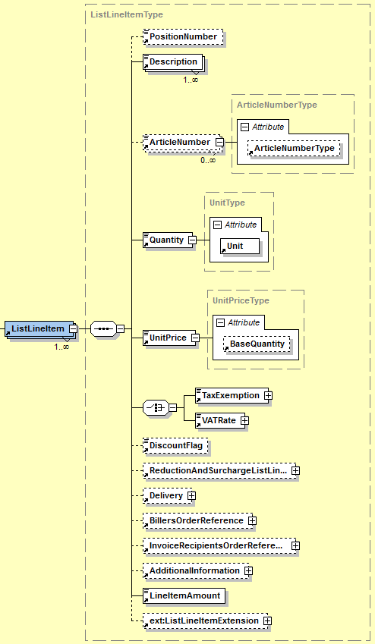

|  |  |  |  |  |
| --- | --- | --- | --- | --- |
| **Name** | **Meaning** | **Type** | **Card.** | **Format** |
| PositionNumber | Consecutive position number | Element | 0..1 | xs:positiveInteger |
| Description | Commercial description of item or service | Element | 1..* | xs:string |
| ArticleNumber | Article number | Element | 0..* | xs:string |
| ArticleNumber/  @ArticleNumberType | Defines the type of the article number. Possible values are PZN, GTIN buyer’s article number, seller’s article number. | Attribute | 0..1 | ArticleNumberType |
| Quantity | Invoiced quantity. In case of reporting further quantity, this should be entered in the element AdditionalInformation/ AlternativeQuantity. | Element | 1..1 | Decimal4Type |
| Quantity/@Unit | Quantity unit in free text. In order to allow for an automated processing of the information at the recipient’s side, it is recommended to use the UnitCodes provided in the appendix of this document. | Attribute | 1..1 | xs:string |
| UnitPrice | Unit price (net) | Element | 1..1 | Decimal4Type |
| UnitPrice/@BaseQuantity | Defines the base quantity, for which the unit price is provided. In case the attribute is omitted, the default value of 1 is anticipated. | Attribute | 0..1 | Decimal4Type |
| TaxExemption | The element tax exemption is used to indicated that the item is exempted from VAT. This element may then be used to specify the exact reason for the tax exemption in free-text form. | Element | 1..1 | XML composite |
| TaxExemption/@TaxExemptionCode | The attribute may be used to provide the exact reason for the tax exemption using a code. The relevant codes are provided in the appendix of this document. | Attribute | 0..1 | xs:string |
| VATRate | Value added tax rate. | Element | 1..1 | PercentageType |
| VATRate/@TaxCode | „AT“+UVACode. ATXXX is equivalent to not taxable. The particular UVA Codes should be taken from the U30 form of the Federal Ministry of Finance [BMF11]. The reporting of TaxCodes is only of informative character. The reporting of the tax rate in the field „Tax Rate“ is normative. | Attribute | 0..1 | TaxCodeType |
| DiscountFlag | Defines whether or not the invoice line item is qualified for discount. | Element | 0..1 | xs:boolean |
| ReductionAndSurchargeListLineItemDetails | This field is used to report reductions or surcharges to the invoice line item.  Furthermore, this element may be used to provide information about taxes, which in turn are subject to VAT calculations (e.g. beer tax, petrol tax, etc.). The exact definition of this element is provided in section 3.9.1.1. | Element | 0..1 | XML composite |
| Delivery | Reporting of delivery details of this invoice line item. (*Note*: the structure of the element is explained in detail in section 3.5) | Element | 0..1 | XML composite |
| BillersOrderReference | Reference of underlying order or order item assigned by invoicing party.  (*Note*: In case this element is used, it takes precedence over a potential entry in *Invoice/Biller/Order-Reference*). The exact definition of this element is provided in section 3.6.1. | Element | 0..1 | XML composite |
| BillersOrderReference/OrderID | Purchase order number at invoicing party. | Element | 1..1 | IDType  max. 255 characters |
| BillersOrderReference/ReferenceDate | Date of the order at the invoicing party. | Element | 0..1 | xs:date |
| BillersOrderReference/Description | Description of the order at the invoicing party. | Element | 0..1 | xs:string |
| BillersOrderReference/OrderPositionNumber | Position number of the order at the invoicing party. | Element | 0..1 | xs:string |
| InvoiceRecipientsOrderReference | Reference of underlying order or order item assigned by invoice recipient (or ordering party eventually).  (*Note*: In case this element is used, it takes precedence over a potential reporting in *Invoice/InvoiceRecipient/ OrderReference* or *Invoice/Ordering-Party/OrderReference*).  The exact definition of the element is provided in section 3.6.1. | Element | 0..1 | XML composite |
| InvoiceRecipientsOrderReference/OrderID | Number of the order at the invoice recipient. | Element | 1..1 | IDType  max. 255 characters |
| InvoiceRecipientsOrderReference/Description | Description of the order at the invoice recipient. | Element | 0..1 | xs:string |
| InvoiceRecipientsOrderReference/ReferenceDate | Date of the order at the invoice recipient. | Element | 0..1 | xs:date |
| InvoiceRecipientsOrderReference/Order PositionNumber | Position number of the order at the invoice recipient. | Element | 0..1 | xs:string |
| AdditionalInformation | Additional information about invoiced item or service. The exact definition if provided in section 3.9.1.2. | Element | 0..1 | XML composite |
| LineItemAmount | The net line item amount.  **Calculation:**  The net line item amount is calculated using the following formula:  LineItemAmount =  Quantity * UnitPrice / BaseQuantity  + Sum of all SurchargeListLineItem/Amounts  + Sum of all  OtherVATableTaxListLineItem/Amounts  – Sum of all ReductionListLineItem/Amounts | Element | 1..1 | Decimal2Type |
| ListLineItemExtension | Element for integration of elements referenced in the ListLineItemExtension element of the ebInterfaceExtension.xsd Schema or originate from another arbitrary namespace. | Element | 0..1 | XML composite (definiert in ebInterfaceExtension.xsd) |

#### ReductionAndSurchargeListLineItemDetails

The element ReductionAndSurchargeListLineItemDetails is OPTIONAL. It is used to report one or several reductions or to report one or several surcharges, respectively. Furthermore, taxed which in turn are subject to VAT calculations (e.g., beer tax, petrol tax). The entered reductions/surcharges/taxes only refer to the particular invoice line (ListLineItem). Reductions/surcharges/taxes are calculated from the net value.

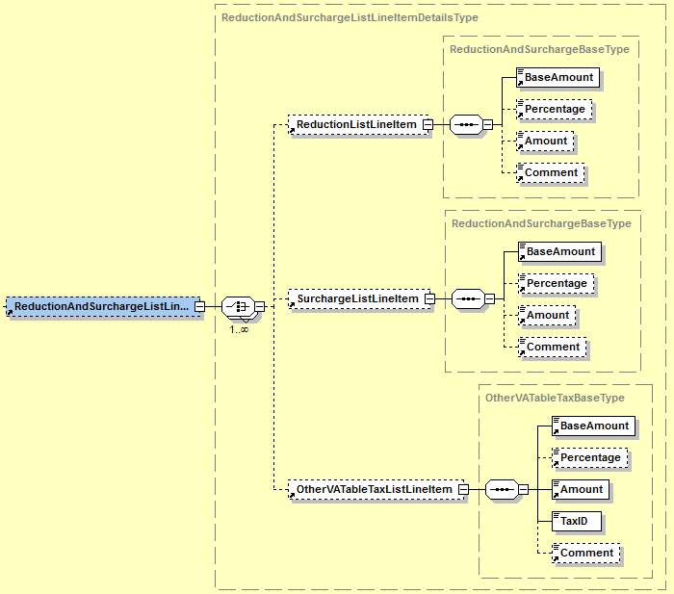

|  |  |  |  |  |
| --- | --- | --- | --- | --- |
| **Name** | **Meaning** | **Type** | **Card.** | **Format** |
| ReductionListLineItem | Details of reduction | Element | 0..* | XML composite |
| ReductionListLineItem /BaseAmount | Defines the base amount, to which the reduction refers | Element | 1..1 | Decimal2Type |
| ReductionListLineItem /Percentage | Percentage of granted reduction | Element | 0..1 | PercentageType |
| ReductionListLineItem /Amount | Amount of the granted reduction.  **Calculation:**  The amount is calculated using the following formula: BaseAmount * Percentage / 100.  In case an amount is entered, there is no need entering a percentage value (but it can be entered). In case both are entered, Amount is prior-ranked. | Element | 0..1 | Decimal2Type |
| ReductionListLineItem/Comment | Optional free-text related to the reduction. | Element | 0..1 | xs:string |
| SurchargeListLineItem | Details of surcharge. | Element | 0..* | XML composite |
| SurchargeListLineItem/BaseAmount | Defines the base amount, to which the surcharge refers. | Element | 1..1 | Decimal2Type |
| SurchargeListLineItem/Percentage | Percentage of surcharge. | Element | 0..1 | PercentageType |
| SurchargeListLineItem/Amount | Amount of the surcharge.  **Calculation:**  The amount is calculated using the following formula: BaseAmount * Percentage / 100.  In case an amount is entered, there is no need entering a percentage value (but it can be entered). In case both are entered, Amount is prior-ranked. | Element | 0..1 | Decimal2Type |
| SurchargeListLineItem/Comment | Optional comment related to the surcharge. | Element | 0..1 | xs:string |
| OtherVATableTaxListLineItem | Used to define an additionl tax, which in turn is subject to VAT calculations (e.g., beer tax, petrol tax). | Element | 0..1 | XML composite |
| OtherVATableTaxListLineItem/BaseAmount | The net base amount, which is used to calculate the tax. | Element | 1..1 | Decimal2Type |
| OtherVATableTaxListLineItem/Percentage | The tax rate. | Element | 0..1 | PercentageType |
| OtherVATableTaxListLineItem/Amount | Tax amount.  **Calculation:**  The amount is calculated using the following formula: BaseAmount * Percentage / 100  In case an amount is entered, there is no need entering a percentage value (but it can be entered). In case both are entered, Amount is prior-ranked. | Element | 1..1 | Decimal2Type |
| OtherVATableTaxListLineItem/TaxID | Used to provide a unique identifier for the used tax. It is recommended to use the predefined codes, provided in the appendix of this document. | Element | 1..1 | IDType |
| OtherVATableTaxListLineItem/Comment | Optional comment related to the tax. | Element | 0..1 | xs:string |

**Note**: In case more reductions/surcharges/taxes are provided, the calculation is conducted in the order in which the reduction/surcharges/taxes are provided.

**Note**: Reductions with a negative amount MUST be interpreted as surcharges. Surcharges with a negative amount MUST be interpreted as reductions. Other taxes SHOULD NOT be provided using a negative amount.

#### AdditionalInformation

The element AdditionalInformation is OPTIONAL and consists of further details of the particular position line in the invoice.

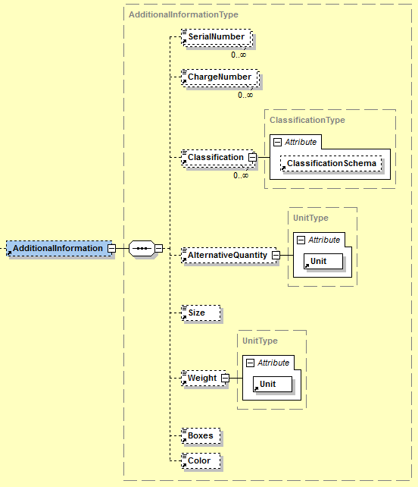

|  |  |  |  |  |
| --- | --- | --- | --- | --- |
| **Name** | **Meaning** | **Type** | **Card.** | **Format** |
| SerialNumber | Serial number | Element | 0..* | xs:string |
| ChargeNumber | Charge number | Element | 0..* | xs:string |
| Classification | Code of delivered item or service in accordance with a classification scheme | Element | 0..* | xs:string |
| Classification/ @ClassificationSchema | Classification scheme in free text | Attribute | 0..1 | xs:string |
| AlternativeQuantity | An alternative quantity in addition to ListLineItem/Quantity | Element | 0..1 | Decimal4Type |
| AlternativeQuantity/ @Unit | Quantity unit.  In order to allow for an automated processing of this information at the recipient’s side, it is recommended to use the codes provided in the appendix of this document. | Attribute | 0..1 | xs:string |
| Size | Size | Element | 0..1 | xs:string |
| Weight | Weight | Element | 0..1 | Decimal4Type |
| Weight/@Unit | Weight unit.  In order to allow for an automated processing of this information at the recipient’s side, it is recommended to use the codes provided in the appendix of this document. | Attribute | 1..1 | xs:string |
| Boxes | Amount of boxes or containers | Element | 0..1 | xs:positiveInteger |
| Color | Color | Element | 0..1 | xs:string |

### BelowTheLineItem

The element *BelowTheLineItem* is used to provide additional amounts, which are not tax-relevant, but which increase/decrease the payable amount (e.g., third party services, interest to be paid due to late payments, etc.).

This element shall not be used to provide entries, which are exempted from tax (§6 UStG etc.). For such entries the element *TaxExemption* on list line item level shall be used.

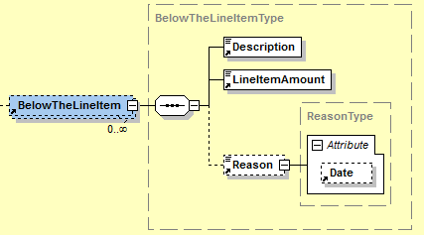

|  |  |  |  |  |
| --- | --- | --- | --- | --- |
| **Name** | **Meaning** | **Type** | **Card.** | **Format** |
| Description | The description of the below-the-line entry. | Element | 1..1 | xs:string |
| LineItemAmount | The amount of the below-the-line entry.  **Calculation (in the context of an invoice):**  Entries which lead to a reduction of the payable amount, must be provided with a negative sign. Entries which lead to an increase of the payable amount, must be provided with a positive sign. | Element | 1..1 | Decimal2Type |
| Reason | The reason for the below the line item in free-text form. | Element | 0..1 | xs:string |
| Reason/@Date | An optional date. | Attribute | 0..1 | xs:date |

## ReductionAndSurchargeDetails

The element ReductionAndSurchargeDetails is OPTIONAL. It is used to report one or several reductions or to report one or several surcharges, respectively. Furthermore, it may be used to provide taxes, which in turn are subject to VAT calculations (e.g., beer tax, petrol tax, etc.). Reductions/surcharges/taxes are calculated on the basis of net values.

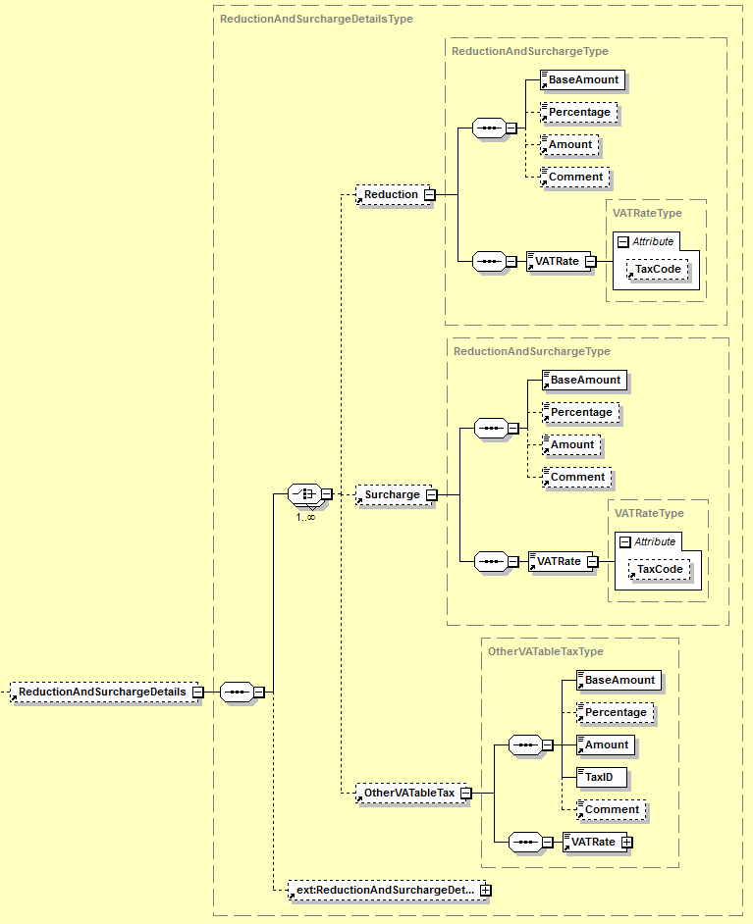

|  |  |  |  |  |
| --- | --- | --- | --- | --- |
| **Name** | **Meaning** | **Type** | **Card.** | **Format** |
| Reduction | Details of reduction | Element | 0..* | XML composite |
| Reduction/BaseAmount | Defines the base amount, to which the reduction refers. | Element | 1..1 | Decimal2Type |
| Reduction/Percentage | Percentage of granted reduction | Element | 0..1 | PercentageType |
| Reduction/Amount | Amount of the reduction.  **Calculation:**  The amount is calculated using the following formula: BaseAmount * Percentage / 100.  In case an amount is entered, there is no need entering a percentage value (but it can be entered). In case both are entered, Amount is prior-ranked. | Element | 0..1 | Decimal2Type |
| Reduction/Comment | Optional comment related to the reduction. | Element | 0..1 | xs:string |
| Reduction/VATRate | Applicable VAT rate of the underlying article. | Element | 1..1 | PercentageType |
| Reduction/VATRate/ @TaxCode | „AT“+UVACode. ATXXX is equivalent to not taxable. The particular UVA Codes should be taken from the U30 form of the Federal Ministry of Finance [BMF11]. The reporting of TaxCodes is only of informative character. The reporting of the tax rate in the field „Tax Rate“ is normative. | Attribute | 0..1 | TaxCodeType |
| Surcharge | Details on surcharge | Element | 0..* | XML composite |
| Surcharge/BaseAmount | Defines the base amount, to which the surcharge refers. | Element | 1..1 | Decimal2Type |
| Surcharge/Percentage | Percentage of surcharge | Element | 0..1 | PercentageType |
| Surcharge/Amount | Amount of the surcharge.  **Calculation:**  The amount is calculated using the following formula: BaseAmount * Percentage / 100.  In case an amount is entered, there is no need entering a percentage value (but it can be entered). In case both are entered, Amount is prior-ranked. | Element | 0..1 | Decimal2Type |
| Surcharge/Comment | Optional comment related to the surcharge. | Element | 0..1 | xs:string |
| Surcharge/VATRate | Applicable VAT rate of the underlying article. | Element | 1..1 | PercentageType |
| Surcharge/VATRate/ @TaxCode | „AT“+UVACode. ATXXX is equivalent to not taxable. The particular UVA Codes should be taken from the U30 form of the Federal Ministry of Finance [BMF11]. The reporting of TaxCodes is only of informative character. The reporting of the tax rate in the field „Tax Rate“ is normative. | Attribute | 0..1 | TaxCodeType |
| OtherVATableTax | Using this element other taxes, which in turn are subject to VAT calculations, may be represented (e.g., beer tax, petrol tax etc.).  Note: In case a VATableTax has already been defined on the list line item level, it is not necessary to define it on the ROOT level again. | Element | 0..1 | XML composite |
| OtherVATableTax/BaseAmount | The net base amount, from which the other vatable tax is calucate. | Element | 1..1 | Decimal2Type |
| OtherVATableTax/Percentage | The tax rate. | Element | 0..1 | PercentageType |
| OtherVATableTax/Amount | Tax amount.  **Berechnung:**  The amount is calculated using the following formula: BaseAmount * Percentage / 100.  In case an amount is entered, there is no need entering a percentage value (but it can be entered). In case both are entered, Amount is prior-ranked. | Element | 1..1 | Decimal2Type |
| OtherVATableTax/TaxID | Used to provide a unique identifier for the used tax. It is recommended to use the predefined codes, provided in the appendix of this document. | Element | 1..1 | IDType |
| OtherVATableTax/Comment | Optional comment related to the tax. | Element | 0..1 | xs:string |
| OtherVATableTax/VATRate | Applicable VAT rate of the underlying article. | Element | 1..1 | PercentageType |
| OtherVATableTax/VATRate/@TaxCode | „AT“+UVACode. ATXXX is equivalent to not taxable. The particular UVA Codes should be taken from the U30 form of the Federal Ministry of Finance [BMF11]. The reporting of TaxCodes is only of informative character. The reporting of the tax rate in the field „Tax Rate“ is normative. | Attribute | 0..1 | TaxCodeType |
| ReductionAndSurchargeDetailsExtension | Element for integration of elements that are referenced in the ReductionAndSurchargeDetailsExtension element of the ebInterfaceExtension.xsd Schema or originate from another arbitrary namespace. | Element | 0..1 | XML composite (defined in ebInterfaceExtension.xsd) |

**Note**: In case more reductions/surcharges/taxes are provided, the calculation is conducted in the order in which the reduction/surcharges/taxes are provided.

**Note**: Reductions with a negative amount MUST be interpreted as surcharges. Surcharges with a negative amount MUST be interpreted as reductions. Other taxes SHOULD NOT be provided using a negative amount.

***Example:***

…

<ReductionAndSurchargeDetails>

<Reduction>

<BaseAmount>1020.00</BaseAmount>

<Percentage>1.00</Percentage>

<Amount>10.20</Amount>

<Comment>Kundenrabatt</Comment>

<VATRate n1:TaxCode="AT022">20.00</VATRate>

</Reduction>

<Surcharge>

<BaseAmount>1020.00</BaseAmount>

<Percentage>0.5</Percentage>

<Amount>5.10</Amount>

<VATRate n1:TaxCode="AT022">20</VATRate>

</Surcharge>

<OtherVATableTax>

<BaseAmount>1020.00</BaseAmount>

<Amount>51</Amount>

<TaxID>WA</TaxID>

<Comment>5% Werbeabgabe</Comment>

<VATRate n1:TaxCode="AT022">20</VATRate>

</OtherVATableTax>

<ext:ReductionAndSurchargeDetailsExtension>

<sv:ReductionAndSurchargeDetailsExtension>   
 <sv:SV_Domain_Specific_ReductionAndSurchargeDExtensionElement>  
 Ein von ebInterface standardisiertes Erweiterungselement

</sv:SV_Domain_Specific_ReductionAndSurchargeDxtensionElement>

</sv:ReductionAndSurchargeDetailsExtension>

<ext:Custom>

<n2:auto-generated_for_wildcard>Irgendein beliebiges

Erweiterungselement aus einem anderen Namespace

</n2:auto-generated_for_wildcard>

</ext:Custom>

</ext:ReductionAndSurchargeDetailsExtension>

</ReductionAndSurchargeDetails>

…

## Tax

The *Tax* element is mandatory and is used for description and summary of taxes (e.g., Value Added Tax)

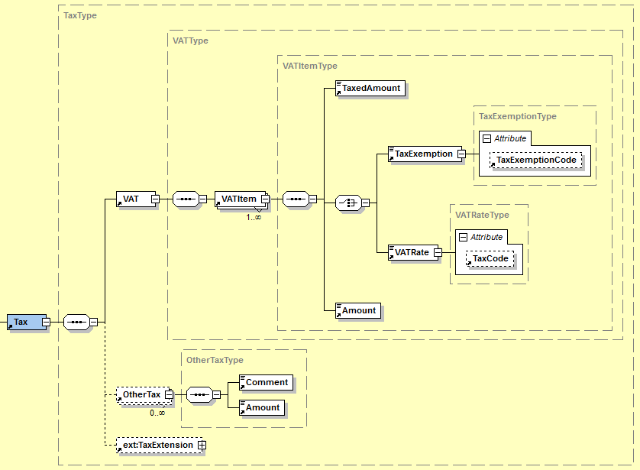

|  |  |  |  |  |
| --- | --- | --- | --- | --- |
| **Name** | **Meaning** | **Type** | **Card.** | **Format** |
| VAT | Is used to report the value added tax or for explicit marking of value added tax exemption. | Element | 1..1 | XML composite |
| VAT/VATItem | Used to define a VAT or a VAT exemption. | Element | 1..* | XML composite |
| VAT/VATItem/  TaxedAmount | Base amount from which the tax is calculated.  **Calculation:**  The sum of all net amounts from the different list line items, which have the same VAT rate as this element. | Element | 1..1 | Decimal2Type |
| VAT/VATItem/  TaxExemption | This element is used to represent information about invoice amounts, which are excempted from tax calculations. This element may be used to provide the reason for a tax exemption. | Element | 1..1 | xs:string |
| VAT/VATItem/  TaxExemption/@TaxExemptionCode | This attribute may be used to provide the reason for a tax excemption, using a code value. It is recommend to use the predefined codes, provided in the appendix of this document. | Element | 0..1 | xs:string |
| VAT/VATItem/  VATRate | The VAT rate of the underlying article/service. | Element | 1..1 | VATRateType |
| VAT/VATItem/  VATRate/  @TaxCode | „AT“+UVACode. ATXXX is equivalent to not taxable. The particular UVA Codes should be taken from the U30 form of the Federal Ministry of Finance [BMF11]. The reporting of TaxCodes is only of informative character. The reporting of the tax rate in the field „Tax Rate“ is normative. | Attribute | 0..1 | TaxCodeType |
| VAT/VATItem/  Amount | The tax amount.  **Calculation:**  The amount is calculated using the formula:  TaxedAmount * VATRate / 100.  In case of TaxExemption the value is always 0. | Element | 1..1 | Decimal2Type |
| OtherTax | Element used to provide other taxes, which are not subject to VAT calculations. | Element | 0..* | XML composite |
| OtherTax/  Comment | The type of tax using free-text. | Element | 1..1 | xs:string |
| OtherTax/Amount | The tax amount. | Element | 1..1 | Decimal2Type |
| TaxExtension | Element for integration of elements that are referenced in the TaxExtension element of the ebInterfaceExtension.xsd Schema or originate from another arbitrary namespace. | Element | 0..1 | XML composite (defined in ebInterfaceExtension.xsd) |

***Example:***

…

<Tax>

<VAT>

<VATItem>

<TaxedAmount>1130.00</TaxedAmount>

<VATRate TaxCode="AT022">20.00</VATRate>

<Amount>226.00</Amount>

</VATItem>

<VATItem>

<TaxedAmount>5.00</TaxedAmount>

<VATRate TaxCode="AT029">10.00</VATRate>

<Amount>0.50</Amount>

</VATItem>

<VATItem>

<TaxedAmount>100.00</TaxedAmount>

<TaxExemption>Reverse Charge</TaxExemption>

<Amount>0</Amount>

</VATItem>

</VAT>

<OtherTax>

<Comment>Eine andere Steuer</Comment>

<Amount>10.00</Amount>

</OtherTax>

<ext:TaxExtension>

<sv:TaxExtension/>

<ext:Custom />

</ext:TaxExtension>

</Tax>

…

## PaymentMethod

The *PaymentMethod* element is OPTIONAL and shows how the invoice should be settled. The following payment options are available at the moment:

|  |  |
| --- | --- |
| *NoPayment* | no payment |
| *DirectDebit*: | payment using direct debiting |
| *SEPADirectDebit* | payment using SEPA direct debit |
| *UniversalBankTransaction*: | payment using a bank transaction or payment via a consolidator platform |

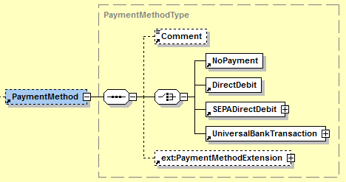

|  |  |  |  |  |
| --- | --- | --- | --- | --- |
| **Name** | **Meaning** | **Type** | **Card.** | **Format** |
| Comment | Comment to payment option | Element | 0..1 | xs:string |
| NoPayment | NoPayment indicates, that no payment of the invoice is necessary. This element contains no content. The exact definition of this element is provided in section 3.12.1. | Element | 1..1 | empty |
| DirectDebit | This element indicates, that the invoice is paid using direct debiting. The element does not contain any content. The exact definition of this element is provided in section 3.12.2. | Element | 1..1 | empty |
| SEPADirectDebit | This element indicates, that the invoice is paid using SEPA direct debit. The exact definition of this element is provided in section 3.12.3. | Element | 1..1 | XML composite |
| UniversalBankTransaction | This element indicates, that the invoice is paid using a bank transaction or via a consolidator platform. The exact definition is provided in section 3.12.4. | Element | 1..1 | XML composite |
| PaymentMethodExtension | Element for integration of elements referenced in the PaymentMethodExtension element of the ebInterfaceExtension.xsd Schema or originate from another arbitrary namespace. | Element | 0..1 | XML composite (defined in ebInterfaceExtension.xsd) |

### NoPayment

*NoPayment* indicates, that no payment of the invoice is necessary. The element does not contain any content.

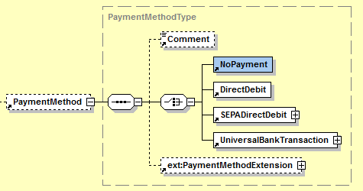

***Example:***

…

<PaymentMethod>

<Comment>Bitte nicht einzahlen.</Comment>

<NoPayment/>

<ext:PaymentMethodExtension>

<sv:PaymentMethodExtension/>

<ext:Custom>

<n2:auto-generated_for_wildcard>Irgendein beliebiges

Erweiterungselement aus einem anderen Namespace

</n2:auto-generated_for_wildcard>

</ext:Custom>

</ext:PaymentMethodExtension>

</PaymentMethod>  
…

### DirectDebit

*DirectDebit* indicates, that the invoice is paid using direct debit. The element does not contain any content.

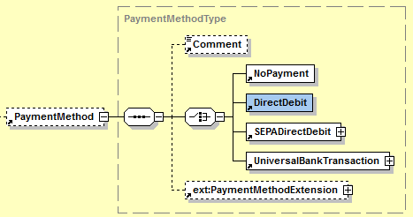

***Example:***

…

<PaymentMethod>

<Comment>Der Rechnungsbetrag wird am 03.10.2013 von Ihrem Konto   
 eingezogen.</Comment>

<DirectDebit />

<ext:PaymentMethodExtension>

<sv:PaymentMethodExtension/>

<ext:Custom>

<n2:auto-generated_for_wildcard>Irgendein beliebiges

Erweiterungselement aus einem anderen Namespace

</n2:auto-generated_for_wildcard>

</ext:Custom>

</ext:PaymentMethodExtension>

</PaymentMethod>  
…

### SEPADirectDebit

*SEPADirectDebit* indicates, that the invoice is paid using SEPA direct debit.

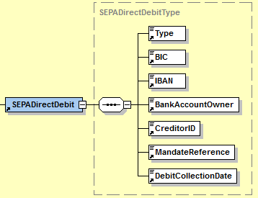

|  |  |  |  |  |
| --- | --- | --- | --- | --- |
| **Name** | **Meaning** | **Type** | **Card.** | **Format** |
| Type | The type of direct debit. May either be B2B or B2C. The default value is ‘B2C’. | Element | 1..1 | xs:string |
| BIC | Bank Identification Code (BIC) | Element | 1..1 | BICType |
| IBAN | International Bank Account Number (IBAN) | Element | 1..1 | IBANType |
| BankAccountOwner | Name of the bank account owner | Element | 1..1 | BankAccountOwnerType |
| CreditorID | The SEPA Creditor ID (CID) of the invoicing party. | Element | 1..1 | ID35Type |
| MandateReference | The SEPA mandate reference. | Element | 1..1 | ID35Type |
| DebitCollectionDate | The planned debit collection date. | Element | 1..1 | xs:date |

***Example:***

…

<SEPADirectDebit>

<Type>B2C</Type>

<BIC>BKAUATWW</BIC>

<IBAN>AT491200011111111111</IBAN>

<BankAccountOwner>Max Mustermann</BankAccountOwner>

<CreditorID>AT12ZZZ00000000001</CreditorID>

<MandateReference>123</MandateReference>

<DebitCollectionDate>2013-11-30</DebitCollectionDate>

</SEPADirectDebit>

…

### UniversalBankTransaction

The usage of UniversalBankTransaction provides details about payment by bank transfer or by using a payment consolidator platform.

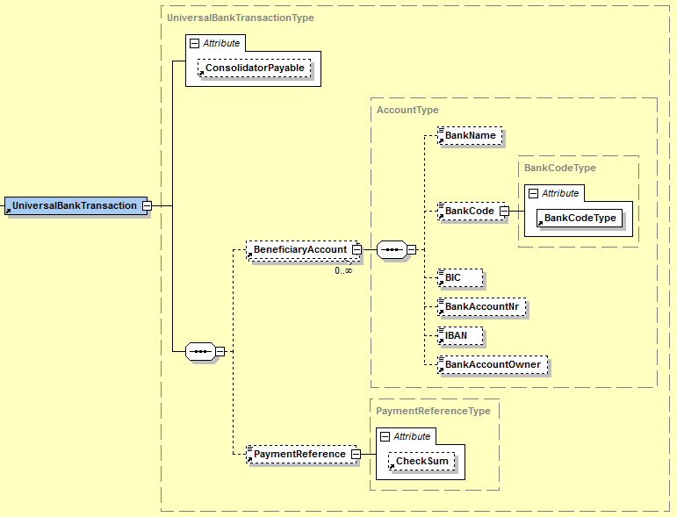

|  |  |  |  |  |
| --- | --- | --- | --- | --- |
| **Name** | **Meaning** | **Type** | **Card.** | **Format** |
| @Consolidator-Payable | This attribute is used to operate a payment on a consolidator platform. In case the attribute is set on “true“, the payment of an invoice on a consolidator platform is possible. The default value is “false“. | Attribute | 0..1 | xs:boolean |
| Beneficiary  Account | Account of beneficiary | Element | 0..* | XML composite |
| Beneficiary  Account/  BankName | Bank name | Element | 0..1 | xs:string  max. 255 characters |
| Beneficiary  Account/  BankCode | Bank code | Element | 0..1 | xs:integer |
| Beneficiary  Account/  BankCode/  @BankCodeType | Defines the type of bank code by additionally stating the country of bank code comes from. | Attribute | 1..1 | CountryCode  Type |
| Beneficiary  Account/BIC | Bank Identification Code (BIC) | Element | 0..1 | BICType |
| Beneficiary  Account/  BankAccountNr | Account number | Element | 0..1 | xs:string |
| Beneficiary  Account/IBAN | International Bank Account Number (IBAN) | Element | 0..1 | IBANType |
| Beneficiary  Account/  BankAccount  Owner | Name of account owner | Element | 0..1 | xs:string  max. 70 characters |
| PaymentReference | Payment reference (customer data), which is used for automated booking of payment entry. The respective obligations of Stuzza[1] are to be considered. | Element | 0..1 | ID35Type |
| PaymentReference/@CheckSum | Check sum for payment reference | Attribute | 0..1 | CheckSumType |

***Example:***

…

<UniversalBankTransaction>

<BeneficiaryAccount>

<BankName>Länderbank</BankName>

<BankCode n1:BankCodeType="AT">12000</BankCode>

<BIC>BKAUATWW</BIC>

<BankAccountNr>11111111111</BankAccountNr>

<IBAN>AT491200011111111111</IBAN>

<BankAccountOwner>Max Mustermann</BankAccountOwner>

</BeneficiaryAccount>

<PaymentReference n1:CheckSum="X">123456789012</PaymentReference>

</UniversalBankTransaction>  
…

## PaymentConditions

The element PaymentConditions CAN be used to report details of payment conditions of the invoice.

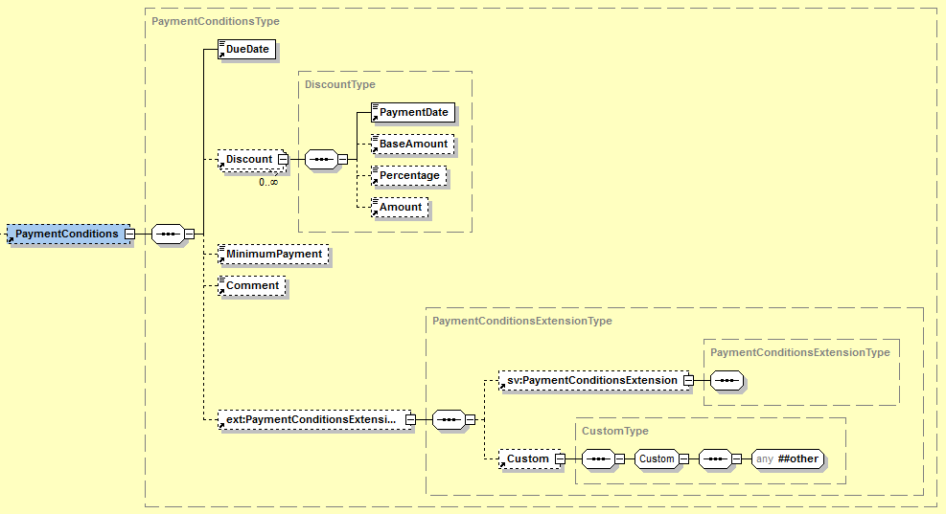

|  |  |  |  |  |
| --- | --- | --- | --- | --- |
| **Name** | **Meaning** | **Type** | **Card.** | **Format** |
| DueDate | Due date | Element | 1..1 | xs:date |
| Discount | Discount | Element | 0..* | XML composite |
| Discount/  PaymentDate | Latest date for use of percentage of discount | Element | 1..1 | xs:date |
| Discount/  BaseAmount | In case the discount does not refer to the entire gross amount, the discount-relevant base amount is entered in this element. | Element | 0..1 | Decimal2Type |
| Discount/  Percentage | Percentage of discount | Element | 0..1 | PercentageType |
| Discount/  Amount | Discount amount.  **Calculation:**  The amount is calculated using the following formula: BaseAmount * Percentage / 100.  In case an amount is entered, there is no need entering a percentage value (but it can be entered). In case both are entered, Amount is prior-ranked. | Element | 0..1 | Decimal2Type |
| Minimum-Payment | In case the invoice should not be settled completely on the due date, this element is used to enter a minimum amount, which is to be settled on the due date. | Element | 0..1 | Decimal2Type |
| Comment | Comment to the payment conditions in free text | Element | 0..1 | xs:string |
| PaymentConditionsExtension | Element for integration of elements that are referenced in the PaymentConditionsExtension element of the ebInterfaceExtension.xsd Schema or originate from another arbitrary namespace. | Element | 0..1 | XML composite (defined in ebInterfaceExtension.xsd) |

***Example:***

…

<PaymentConditions>

<DueDate>2011-09-30</DueDate>

<Discount>

<PaymentDate>2011-09-25</PaymentDate>

<BaseAmount>1349.26</BaseAmount>

<Percentage>3.00</Percentage>

<Amount>40.48</Amount>

</Discount>

<MinimumPayment>512.00</MinimumPayment>

<Comment>Kommentar zu den Zahlungsbedingungen</Comment>

<ext:PaymentConditionsExtension>

<sv:PaymentConditionsExtension>

<sv:SV_Domain_Specific_PaymentConditionsExtensionElement>Ein von

ebInterface standardisiertes Erweiterungselement

</sv:SV_Domain_Specific_PaymentConditionsExtensionElement>

</sv:PaymentConditionsExtension>

<ext:Custom>

<n2:auto-generated_for_wildcard>Irgendein beliebiges

Erweiterungselement aus einem anderen Namespace

</n2:auto-generated_for_wildcard>

</ext:Custom>

</ext:PaymentConditionsExtension>

</PaymentConditions>

…

## PresentationDetails

The *PresentationDetails* element CAN be used to process the layout (aka rendering) of printed version of invoice.

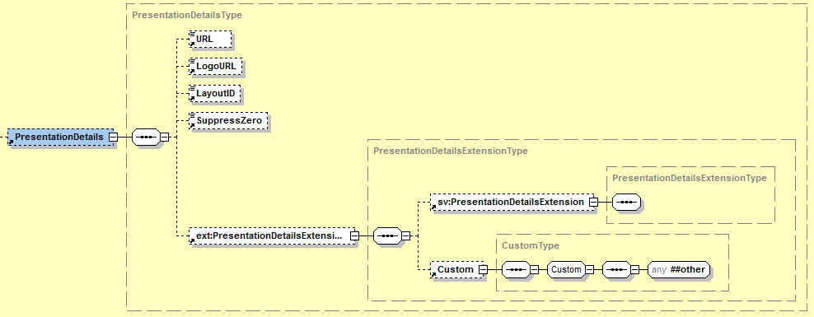

|  |  |  |  |  |
| --- | --- | --- | --- | --- |
| **Name** | **Meaning** | **Type** | **Card.** | **Format** |
| URL | Link underlying the logo. | Element | 0..1 | xs:anyURI |
| LogoURL | URL of the corporate symbol for heading: The logo may be hosted on the server and, therefore, is available with the billing data at the same time. Optionally, the URL can refer to any picture generally displayable in a browser. . | Element | 0..1 | xs:anyURI |
| LayoutID | LayoutID defines which layout is used to display the billing details. | Element | 0..1 | IDType max. 255 characters |
| SuppressZero | Defines whether or not an invoice amount of 0 should be displayed. | Element | 0..1 | xs:boolean |
| PresentationDetailsExtension | Element for integration of elements that are referenced in the PresentationDetailsExtension element of the ebInterfaceExtension.xsd Schema or originate from another arbitrary namespace. | Element | 0..1 | XML composite (defined in ebInterfaceExtension.xsd) |

***Example:***

…

<eb:PresentationDetails>

<eb:URL>http://www.willi.at</eb:URL>

<eb:LogoURL>

https://b-test.ebpp.at/comres/ebinterface-willi.gif

</eb:LogoURL>

<eb:LayoutID>0100</eb:LayoutID>

</eb:PresentationDetails>

…

# Der ebInterface 4.x Extension Mechanismus

A significant innovation of ebInterface, in comparison to the previous versions, is the possibility to include structural extensions in an ebInterface 4.x instance. In the previous versions of ebInterface extensions were only possible on the highest (=Invoice) level and on the billing details (=ListLineItem) level.

In ebInterface 4.x extensions are possible on every different element on root (=Invoice) level, as well as on ListLineItem level. For this purpose, a coupling scheme (ebInterfaceExtension.xsd) is included in the ebInterface 4.x scheme, in which the allowed extensions are referenced. The following figure demonstrates the concept of the ebInterfaceExtension.xsd coupling scheme.



For each element on the root level (i.e., Delivery, Biller, etc.) an extension point is defined. Additionally, there is, as it already existed in the previous versions of ebInterface, a root extension point on the highest level. Each extension point refers to a particular element, which is defined in the coupling scheme ebInterfaceExtension.xsd.

On the one hand, elements of ebInterface-allowed extension schemes are referenced in the different extension elements of the coupling scheme. On the other hand, a custom element is defined in each extension element, according to the previous versions of ebInterface. The following figure exemplarily demonstrates the extension element DeliveryExtension of the ebInterfaceExtension.xsd Schema.

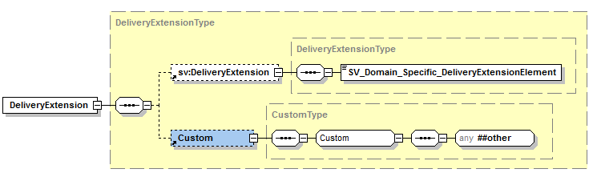

The extension schemes of ebInterface are maintained for each industrial sector (i.e., telecom, pharmaceutical industry, etc.) and represent domain-specific attributes and elements, which are not included in the core scheme of ebInterface. The above figure shows the extension scheme of the Austrian social insurance system (sv:DeliveryExtension) exemplarily.

Additionally, the custom element allows the integration of arbitrary XML elements and attributes in every extension point. Making use of including any kind of XML should only be done in case of specific (i.e. bilateral) requirements. In case arbitrary XML elements are included in the extension points, it should not be assumed that the receiver is able to process with all elements.

If, however, the used elements originate from an ebInterface certified extension scheme, and the receiver supports this extension scheme, it can be assumed that the receiver of the ebInterface instance is able to process with all elements.

## Integration of the coupling scheme in ebInterface

The coupling scheme ebInterfaceExtension.xsd is included by default in the ebInterface scheme, whereby all in the coupling scheme referenced elements are available in every ebInterface instance. The namespace of the ebInterface coupling scheme is http://www.ebinterface.at/schema/4p1/extensions/ext

The scheme ebInterfaceExtension.xsd serves as coupling point between the ebInterface core scheme and further ebInterface standardized domain-specific extension schemes.

***Schema extract***

<?xml version="1.0" encoding="UTF-8"?>

<xs:schema xmlns="http://www.ebinterface.at/schema/4p1/" xmlns:xs="http://www.w3.org/2001/XMLSchema" xmlns:dsig="http://www.w3.org/2000/09/xmldsig#" xmlns:ext="http://www.ebinterface.at/schema/4p1/extensions/ext" targetNamespace="http://www.ebinterface.at/schema/4p1/" elementFormDefault="qualified" attributeFormDefault="unqualified">

<xs:import namespace="http://www.w3.org/2000/09/xmldsig#" schemaLocation="http://www.w3.org/TR/2002/REC-xmldsig-core-20020212/xmldsig-core-schema.xsd"/>

<xs:import namespace="http://www.ebinterface.at/schema/4p1/extensions/ext" schemaLocation="ebInterfaceExtension.xsd"/>

<!-- === Root Element === -->

<xs:element name="Invoice" type="InvoiceType"/>

…

</xs:schema>

## Integration of ebInterface extension schemes in the ebInterfaceExtension coupling scheme

Together with every release of ebInterface, an ebInterfaceExtension coupling scheme is adopted, in which the ebInterface standardized extension schemes are referenced. In the ebInterface coupling scheme it is referred to further coupling schemes allowed by ebInterface, whose elements are integrated in the specific extension elements of the coupling scheme.

The following scheme extract shows the integration of the ebInterface extension scheme of the Austrian social partner system in the ebInterfaceExtension.xsd coupling scheme.

***Schema extract***

<?xml version="1.0" encoding="UTF-8"?>

<xs:schema xmlns:xs="http://www.w3.org/2001/XMLSchema" xmlns="http://www.ebinterface.at/schema/4p1/extensions/ext" xmlns:sv="http://www.ebinterface.at/schema/4p1/extensions/sv" targetNamespace="http://www.ebinterface.at/schema/4p1/extensions/ext" elementFormDefault="qualified" attributeFormDefault="unqualified">

<!-- Import the industry specific namespaces -->

<xs:import namespace="http://www.ebinterface.at/schema/4p1/extensions/sv"   
 schemaLocation="ext/ebInterfaceExtension_SV.xsd"/>

<!-- === Element declarations === -->

<xs:element name="DeliveryExtension" type="DeliveryExtensionType"/>

…

<xs:complexType name="DeliveryExtensionType">

<xs:sequence>

<xs:element ref="sv:DeliveryExtension" minOccurs="0"/>

<xs:element ref="Custom" minOccurs="0"/>

</xs:sequence>

</xs:complexType>

…

</xs:schema>

As it can be seen in the extract the same extension elements (i.e. sv:DeliveryExtension) are defined in the extension scheme of the Austrian social partner system, which are included in the extension elements (i.e. DeliveryExtensionType) of the coupling schemes.

The namespace of the ebInterface extension scheme of the Austrian social partner system is

http://www.ebinterface.at/schema/4p1/extensions/sv, whereas the last part of the namespace particularly stands for the valid scheme of the specific industry (i.e. <http://www.ebinterface.at/schema/4p1/extensions/pharmaceuticals> for the pharmaceutical industry).

# Recommendations on standard use

## Use of negative/positive signs for amounts in invoices and credit notes

Using ebInterface not only invoices may be represented, but also credit notes. Based on the used DocumentType the following recommendations are relevant:

* In case DocumentType is set to Invoice, InvoiceForAdvancePayment, InvoiceForPartialDelivery, FinalSettlement or SubsequentDebit
  + If PayableAmount is positive, it is an invoice.
  + If PayableAmount is negative, it is a credit note.
* In case DocumentType is set to CreditMemo, SelfBilling, or SubsequentCredit
  + If PayableAmount is positive, it is a credit note
  + If PaybleAmount is negative, it is an invoice.

# References

|  |  |
| --- | --- |
| [BMF11] | Umsatzsteuervoranmeldung ab 2013, Bundesministerium für Finanzen, <http://formulare.bmf.gv.at/service/formulare/inter-Steuern/pdfs/2013/U30.pdf> (last visited: 14.10.2013) |
| [DUNS11] | DUNS (Data Universal Numbering System). <http://www.dnb.ch/htm/690/de/Eindeutige-Identifikation.htm> (last visited: 14.10.2013) |
| [GLN11] | GLN (Global Location Number). <http://www.gs1austria.at/index.php?option=com_content&view=article&id=83&Itemid=156> (last visited: 14.10.2013) |
| [GTIN11] | GTIN (Global Trade Item Number). <http://gs1.at/index.php?option=com_content&view=article&id=85&Itemid=158> (last visited: 14.10.2013) |
| [ISO3166-1] | ISO 3166-1, Version VI-10, International Organization for Standardization, <http://www.iso.org/iso/country_codes/iso_3166_code_lists.htm>, (last visited: 14.10.2013) |
| [ISO4217] | ISO 4217, International Organization for Standardization, <http://www.iso.org/iso/home/standards/currency_codes.htm> (last visited: 14.10.2013) |
| [PZN11] | PZN (Pharmazentralnummer). <http://www.ifaffm.de/> (last visited: 14.10.2013) |
| [RFC2119] | RFC 2119: Keywords for use in RFCs to Indicate Requirement Levels. March 1997. <http://www.rfc-archive.org/getrfc.php?rfc=2119> (last visited: 14.10.2013) |
| [RFC3986] | RFC 3986: Uniform Resource Identifier (URI): Generic Syntax. <http://tools.ietf.org/html/rfc3986> (last visited: 14.10.2013) |
| [W3C01] | XML Schema. W3C Recommendation. <http://www.w3.org/XML/Schema> (last visited: 14.10.2013) |
| [W3C02] | XML-Signature Syntax and Processing (XMLDSig). W3C Recommendation. <http://www.w3.org/TR/xmldsig-core/> (last visited: 14.10.2013) |

**Appendix**

**Recommended codes for Unit Types**

Based on CEFACT code list 66411 (2001).

|  |  |  |  |  |  |
| --- | --- | --- | --- | --- | --- |
| **Group** | **ID** | **Description DE** | **Description EN** | **Remark** | **German abbrev.** |
| Masse | MGM | Milligramm | milligram |  | mg |
| Masse | GRM | Gramm | gram | =1.000 MGM | g |
| Masse | DJ | Dekagramm | decagram | =10 GRM | dg |
| Masse | KGM | Kilogramm | kilogramme | =100 DJ oder =1.000 GRM | kg |
| Masse | TNE | Tonne | ton | =1.000 KGM | t |
| Länge | MMT | Millimeter | millimetre |  | mm |
| Länge | CMT | Zentimeter | centimetre | =10 MMT | cm |
| Länge | DMT | Dezimeter | decimetre | =10 CMT | dm |
| Länge | MTR | Meter | metre | =10 DMT | m |
| Länge | KTM | Kilometer | kilometre | =1.000 MTR | km |
| Fläche | MMK | Quadratmillimeter | square millimetre |  | mm² |
| Fläche | CMK | Quadratzentimeter | square centimetre | =100 MMK | cm² |
| Fläche | DMK | Quadratdezimeter | square decimetre | =100 CMK | dm² |
| Fläche | MTK | Quadratmeter | square metre | =100 DMK | m² |
| Fläche | HAR | Hektar | hectare | =10.000 MTK | ha |
| Fläche | KMK | Quadratkilometer | square kilometre | =1.000.000 MTK | km² |
| Volumen | MMQ | Kubikmillimeter | cubic millimetre |  | mm³ |
| Volumen | CMQ | Kubikzentimeter | cubic centimetre | =1.000 MMQ | cm³ |
| Volumen | DMQ | Kubikdezimeter | cubic decimetre | =1.000 CMQ | dm³ |
| Volumen | MTQ | Kubikmeter | cubic metre | =1.000 DMQ | m³ |
| Volumen | LTR | Liter | litre |  | l |
| Numerisch | STK | Stück | piece |  | Stk. |
| Numerisch | C62 | Eins/mal | one |  | Stk. |
| Numerisch | LS | Pauschal | lump sum |  | Pauschal |
| Numerisch | NAR | Artikelanzahl | number of articles |  | Anz. |
| Numerisch | NPR | Anzahl Paare | number of pairs |  | Anz. Paare |
| Numerisch | P1 | Prozent | percent | Im Bereich 0-100 | % |
| Numerisch | SET | Satz | set |  | Satz |
| Numerisch | PK | Packung | pack |  | Pkg. |
| Datenmenge | A99 | Bit | bit |  | b |
| Datenmenge | AD | Byte | byte | =8 bits | B |
| Datenmenge | 2P | Kilobyte | kilobyte | =10^3 bytes | KB |
| Datenmenge | 4L | Megabyte | megabyte | =10^6 bytes | MB |
| Datenmenge | E34 | Gigabyte | gigabyte | =10^9 bytes | GB |
| Datenmenge | E35 | Terabyte | terabyte | =10^12 bytes | TB |
| Datenmenge | E36 | Petabyte | petabyte | =10^15 bytes | PB |
| Währung | EUR | Euro | Euro | für Finanztransaktionen | € |
| Zeit | LH | Arbeitsstunde | labour hour |  | Std. |
| Zeit | SEC | Sekunde | second |  | Sek. |
| Zeit | MIN | Minute | minute |  | Min |
| Zeit | HUR | Stunde | hour |  | Std. |
| Zeit | DAY | Tag | day |  | Tage |
| Zeit | WEE | Woche | week |  | Wo. |
| Zeit | MON | Monat | month |  | Mo. |
| Zeit | QAN | Quartal | quarter |  | Qu. |
| Zeit | ANN | Jahr | year |  | a |
| Energie | KWH | Kilowattstunde | kilowatt hour |  | kWh |

**Recommended codes for tax exemptions**

|  |  |
| --- | --- |
| **Code** | **Description** |
| S67 | Steuerfrei (unter Umsatzgrenze): Gemäß § 6 Abs. 1 Z 27 ist die Lieferung bzw. Leistung steuerfrei |
| S69 | Steuerfrei (Glückspielumsätze, Brieflose): Gemäß § 6 Abs. 1 Z 9 ist die Lieferung bzw. Leistung steuerfrei |
| IGL | Innergemeinschaftliche Lieferung: Steuerfreie Innergemeinschaftliche Lieferung gemäß Art. 6 Abs. 1 UStG |
| RCH | Reverse Charge: Nur bei Leistungen, gemäß § 19 Abs. 1 UStG geht die Steuerschuld auf den Leistungsempfänger über |
| SA7 | Bei Exporten in ein Drittland: Steuerfreie Ausfuhrlieferung gem. § 7 UStG |
| IGLDE | Innergemeinschaftliche Lieferung gemäß §4 Nr. 1b i. V. m. §6a UStG, EUST befreit, aber erwerbsteuerpflichtig |
| DB | Differenzbesteuerung gemäß § 24 UStG |
| RL | Besteuerung von Reiseleistungen gemäß § 23 UStG |

**Recommended codes for tax code**

Based on U30 form 2013.

|  |  |
| --- | --- |
| AT022 | Normalsteuersatz (20%) |
| AT029 | ermäßigter Steuersatz (10%) |
| AT025 | für Weinumsätze durch landwirtschaftliche Betriebe (12%) |
| AT037 | für Jungholz und Mittelberg (ab 2007; 19%) |
| AT052 | Zusatzsteuer für pauschalierte land- und forstwirtschaftliche Betriebe (10%) |
| AT038 | Zusatzsteuer für pauschalierte land- und forstwirtschaftliche Betriebe (8%) |
| ATXXX | nicht steuerbar (ebInterface spezifisch; 0%) |

**Recommended codes for further identification**

|  |  |
| --- | --- |
| FN | Firmenbuchnummer |
| FR | Firmenregisternummer beim Firmengericht |
| ARA | ARA Nummer |
| DVR | DVR Nummer |
| Consolidator | ID des Consolidators |
| Contract | Vertragsnummer |
| Payer | ID des Payers |

**Recommended codes for OtherVATableTax/TaxID**

|  |  |
| --- | --- |
| MS | Mineralölsteuer |
| TS | Tabaksteuer |
| BS | Biersteuer |
| AS | Alkoholsteuer |
| WA | Werbeabgabe |

1. http://www.stuzza.at/9417_DE.64FE7D4599b8cea548f52f7c39fac26b8205a6f0