Smart water management

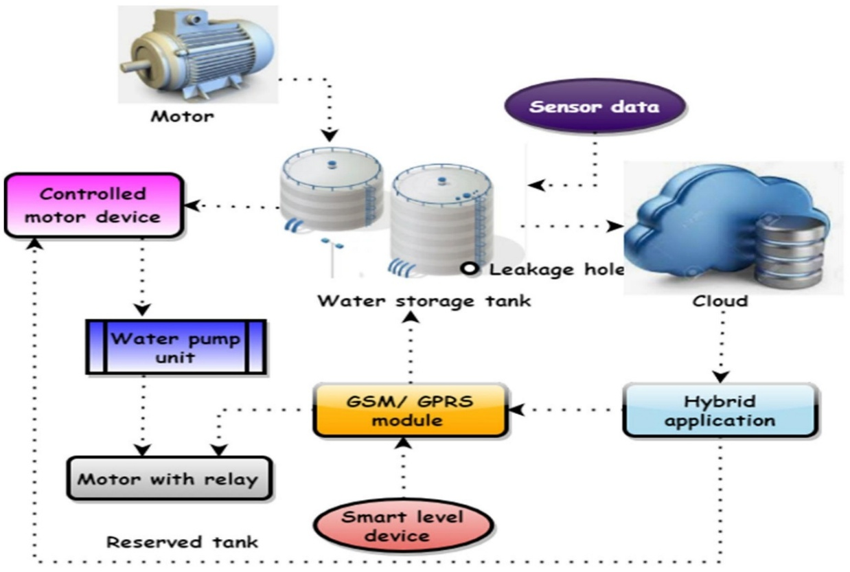

# **Problem Definition :**

**Smart water management addresses several critical issues. Firstly, it tackles water scarcity and inefficient water usage, which are global concerns. Secondly, it addresses aging water infrastructure, which often leads to leaks and wastage. Finally, it also deals with the lack of real-time data and insights into water usage patterns.**

Design Thinking :

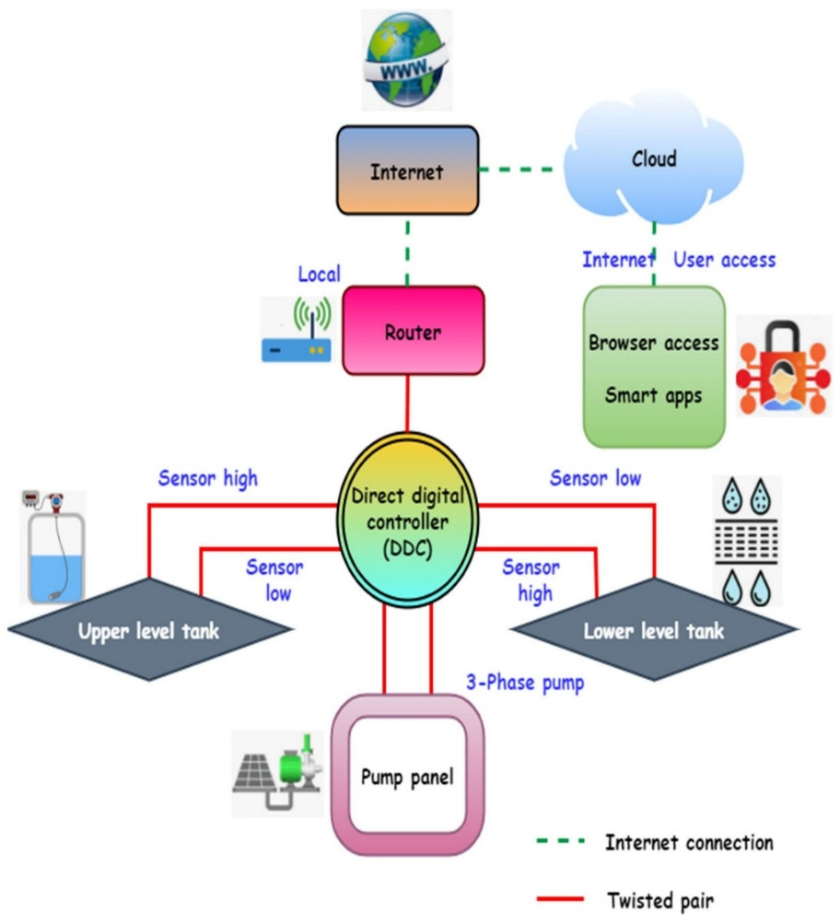Design thinking in smart water management involves a user-centric approach. It starts by understanding the needs of consumers and stakeholders. It then moves on to ideation and prototyping of solutions, considering both technological and user experience aspects. It emphasizes simplicity, reliability, and accessibility of the system to encourage sustainable water practices.

Innovation and Problem Solving:

Innovation in smart water management revolves around leveraging IoT (Internet of Things) technology. IoT sensors can be deployed to monitor water usage, detect leaks, and provide real-time data. Advanced analytics and AI can process this data to identify patterns and anomalies. Problem-solving involves developing algorithms to optimize water distribution, prioritize maintenance, and enable predictive actions. Innovative technologies such as IoT sensors enable real-time monitoring of water quality and usage. These sensors can detect leaks, track water flow, and provide valuable data for optimizing distribution.