**CHATCONNECT-A REAL TIME CHAT AND COMMUNICATION APP**

**TEAM MEMBERS:**

1. **Gracelin Rubavathy. R [D1CE56E5AE9F14895C9413D574282CEB]**
2. **Jasmine Rithika. P [BCA3B0A8D88C397BD304CFE6D1D0F8EA]**
3. **Sriharini. A [D36FF5D72DB29FD81CB443C5329137A6]**
4. **Menaga. S [CAFD7556E648727B8604886C3DE603C5]**
5. **Prisha. S [CCE90DC38569FD891514871ACAD5425E]**

SCREENSHOT-1:

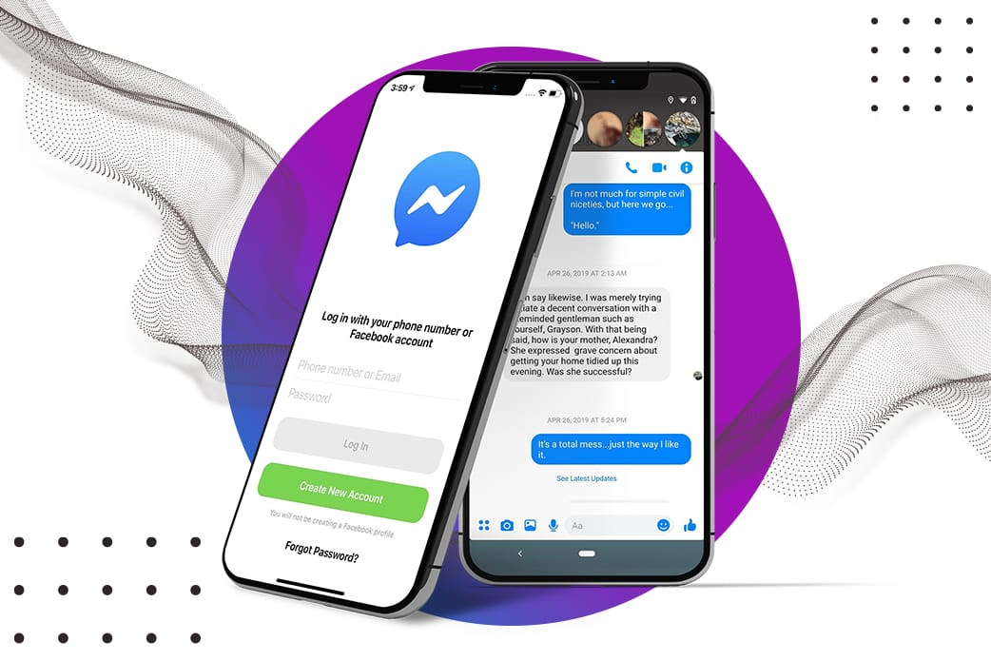

SCREENSHOT-2:

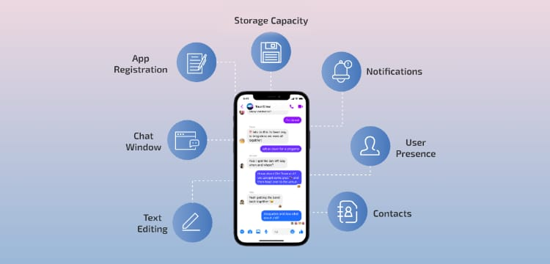

SCREENSHOT-3:

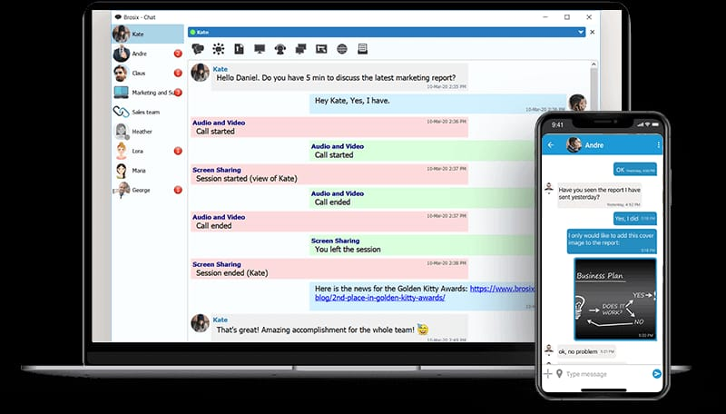

SCREENSHOT-4:

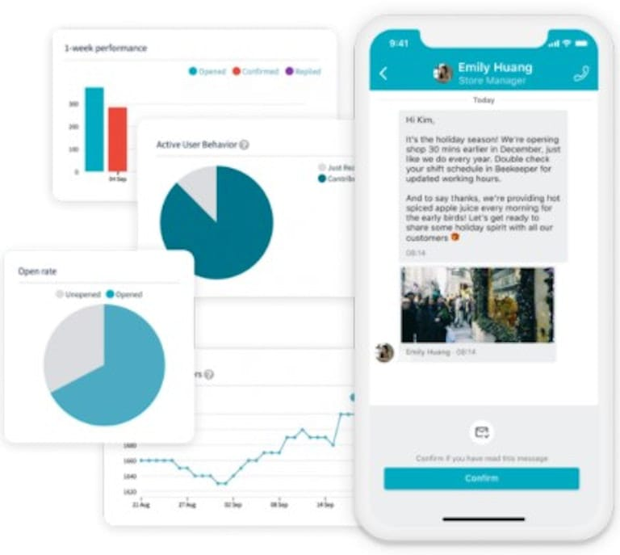

SCREENSHOT-5:

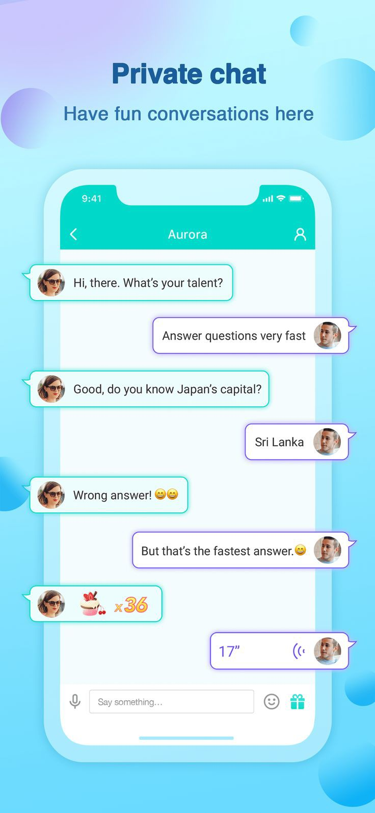

SCREENSHOT-6:

