Appendix No. 5

**Drawings, flow charts, algorithms, schemes**

**Module B. (*Configuration of technical and software tools of information and communication systems*) (invariant)**

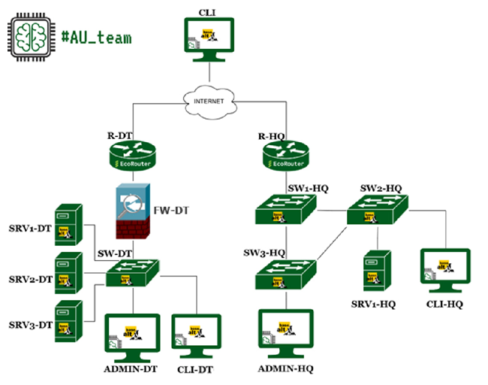

Figure 1 - Network diagram of module B

*You don't have access to the ISP!*

|  |  |  |
| --- | --- | --- |
| Device name | OS | FQDN |
| R-DT | EcoRouter | r-dt.au.team |
| FW-DT | xFirewall | fw-dt |
| ADMIN-DT | Alt Workstation 10 | admin-dt.au.team |
| SW-DT | Virtual switch | - |
| SRV1-DT | Alt Server 10 | srv1-dt.au.team. |
| SRV2-DT | Alt Server 10 | srv2-dt.au.team. |
| SRV3-DT | Alt Server 10 | srv3-dt.au.team. |
| CLI-DT | Alt Workstation 10 | cli-dt.au.team |
| R-HQ | EcoRouter | r-hq.au.team |
| SW1-HQ | Alt Server 10 | sw1-hq.au.team |
| SW2-HQ | Alt Server 10 | sw2-hq.au.team |
| SW3-HQ | Alt Server 10 | sw3-hq.au.team |
| ADMIN-HQ | Alt Workstation 10 | admin-hq.au.team |
| SRV1-HQ | Alt Server 10 | srv1-hq.au.team. |
| CLI-HQ | Alt Workstation 10 | cli-hq.au.team |
| CLI | Alt Workstation 10 | cli |

**Module D. (*Fault Tolerance*) (option)**

**Participant Instructions:**

The expert group performs access to the cloud provider and authorization on the server. The chief expert independently selects the cloud infrastructure provider.

All stages of the assignment must be implemented on the platform of the selected cloud provider. Experts will verify the availability of workable infrastructure elements in accordance with the assignment.

Cloud customization tasks require you to write automated scripts to deploy the infrastructure. The choice of specific tools for this is left to you. Once the assignment is completed, you are expected to completely delete the automatically created virtual machines, network configurations, and other resources in the cloud infrastructure. Experts will validate your scenario, expecting that in the allotted time (20 minutes), the entire infrastructure will be successfully created and ready for use.

To test the performance of automated infrastructure deployment scripts, experts can test their execution in a separate account with the same cloud provider. You should consider specifying the necessary parameters for the scripts to run in a different cloud provider account.

The test will be performed from the ControlVM instance. You can install all the tools you need to work on this machine.

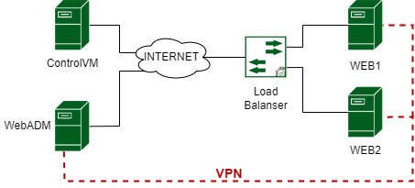

Figure 1 - Network diagram of module D

All machines with white IPs, the main emphasis is that access to them via SSH is strictly limited, and there is a VPN tunnel from WebAdm to Web1 and Web2.